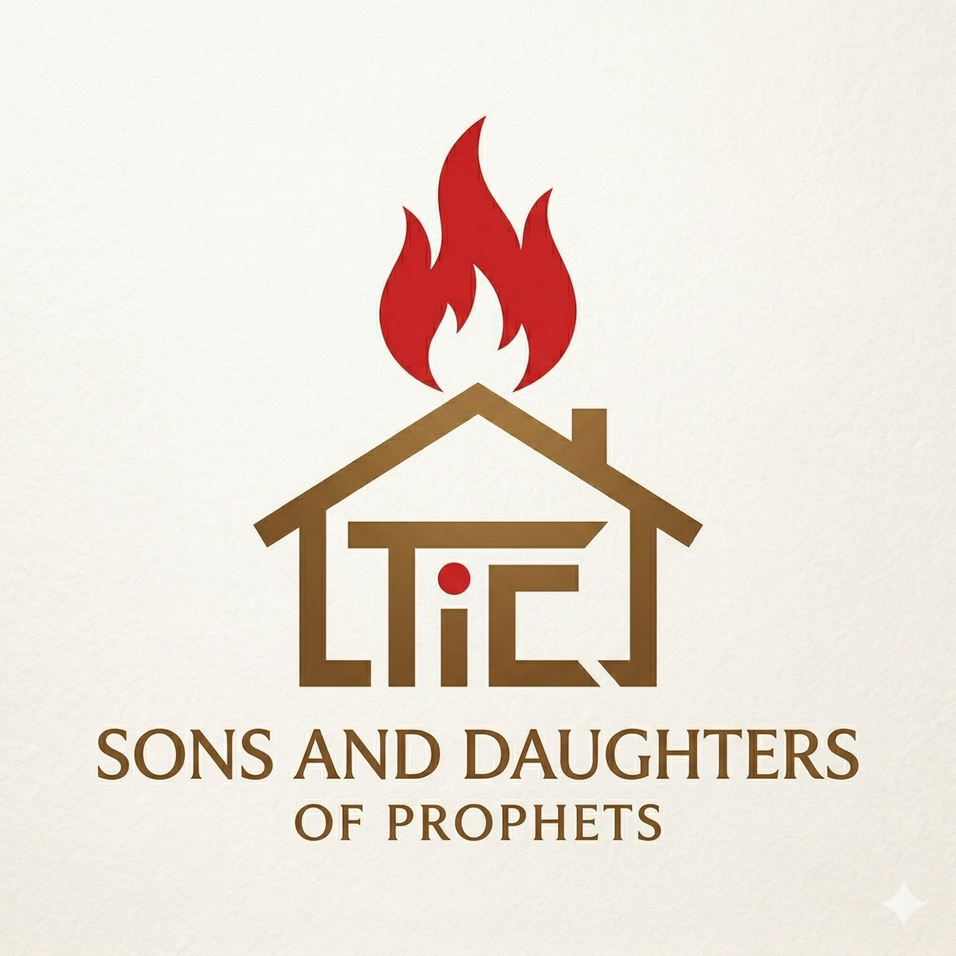
SONS AND DAUGHTERS OF PROPHETS
Prophetic Training School | Treasures in Clay Ministries
ACADEMIC CALENDAR
Year 1 — 2026 Cohort
Certificate in Prophetic Ministry
Modules open Sundays 8:00am · Close Saturdays 11:59pm · Live sessions Thursdays

Prophet Abiodun Sule
Founder & Dean

How to Read This Calendar

Each module runs for two weeks — opening Sunday at 8:00am and closing the following Saturday at 11:59pm. Weekly live sessions are held on Thursdays unless otherwise communicated via Telegram. All dates are in 2026.

Colour Key:
██ Module Open/Close — Course content period
██ Live Session — Zoom class (Thursdays)
██ Special Event — Time Out, Taster Sessions, Orientation
██ Examination / Assessment period

Full Academic Calendar — Year 1, 2026

DATE | EVENT
 | ── MAY 2026 ──
Wed 7 May | 🎓 ORIENTATION — Live on Zoom, 6:00pm WAT
Sun 10 May — Sat 23 May | MODULE 1 OPEN: Introduction to NT Prophecy
Thu 15 May | Live Session — Module 1 Teaching
Fri 30 May | Student Time Out with Prophet Sule (date TBC)
 | ── JUNE 2026 ──
Sun 24 May — Sat 6 Jun | MODULE 2 OPEN: Person & Work of the Holy Spirit
Thu 29 May | Live Session — Module 2 Teaching
Sat 6 Jun | Module 2 Closes — 11:59pm
Sun 7 Jun — Sat 20 Jun | MODULE 3 OPEN: Biblical Hermeneutics
Thu 12 Jun | 🎤 TASTER SESSION — Guest Speaker (Module 3 Topic)
Thu 19 Jun | Live Session — Module 3 Teaching
Sat 20 Jun | Module 3 Closes — 11:59pm
 | ── JULY 2026 ──
Sun 21 Jun — Sat 4 Jul | MODULE 4 OPEN: Spirituality vs Spiritism
Thu 26 Jun | 🎤 TASTER SESSION — Guest Speaker (Module 4 Topic)
Thu 3 Jul | Live Session — Module 4 Teaching
Sat 4 Jul | Module 4 Closes — 11:59pm
Sun 5 Jul — Sat 18 Jul | MODULE 5 OPEN: Prayer & Intimacy with God
Thu 10 Jul | Live Session — Module 5 Teaching
Sat 18 Jul | Module 5 Closes — 11:59pm
Sun 19 Jul — Sat 1 Aug | MODULE 6 OPEN: Character & Ethics in Ministry
Thu 24 Jul | Live Session — Module 6 Teaching
Fri 31 Jul | Student Time Out with Prophet Sule — date to be communicated
 | ── AUGUST 2026 ──
Sat 1 Aug | Module 6 Closes — 11:59pm
Mon 3 – Fri 8 Aug | REVISION WEEK — Assignment submission deadline
Mon 10 – Fri 15 Aug | YEAR 1 EXAMINATIONS
Aug / Sep TBD | Certificate Award Ceremony — date to be announced

Module Summary — Year 1

No. | Open | Module Title | Credits | Closes
01 | Sun 10 May | Introduction to NT Prophecy | 3 cr | Sat 23 May
02 | Sun 24 May | Person & Work of the Holy Spirit | 3 cr | Sat 6 Jun
03 | Sun 7 Jun | Biblical Hermeneutics | 3 cr | Sat 20 Jun
04 | Sun 21 Jun | Spirituality vs Spiritism | 2 cr | Sat 4 Jul
05 | Sun 5 Jul | Prayer & Intimacy with God | 2 cr | Sat 18 Jul
06 | Sun 19 Jul | Character & Ethics in Ministry | 2 cr | Sat 1 Aug

Important Notes
- All modules open at 8:00am WAT on Sunday and close at 11:59pm WAT on Saturday.
- Live sessions are held on Thursdays via Zoom unless otherwise announced on Telegram.
- Taster Sessions feature guest speakers and are scheduled mid-module (Week 2) for Modules 3 and 4.
- Student Time Out with Prophet Sule — exact time and Zoom link will be shared on Telegram in advance.
- Assignments must be submitted through the student portal before the revision week deadline.
- All students must join the Telegram community group for real-time updates: t.me/+zoXkAa9bjCtmZmY8

"Eagerly desire gifts of the Spirit, especially prophecy." — 1 Corinthians 14:1
S&D Prophetic Training School | 2026 | sandd.abiodunsule.uk

