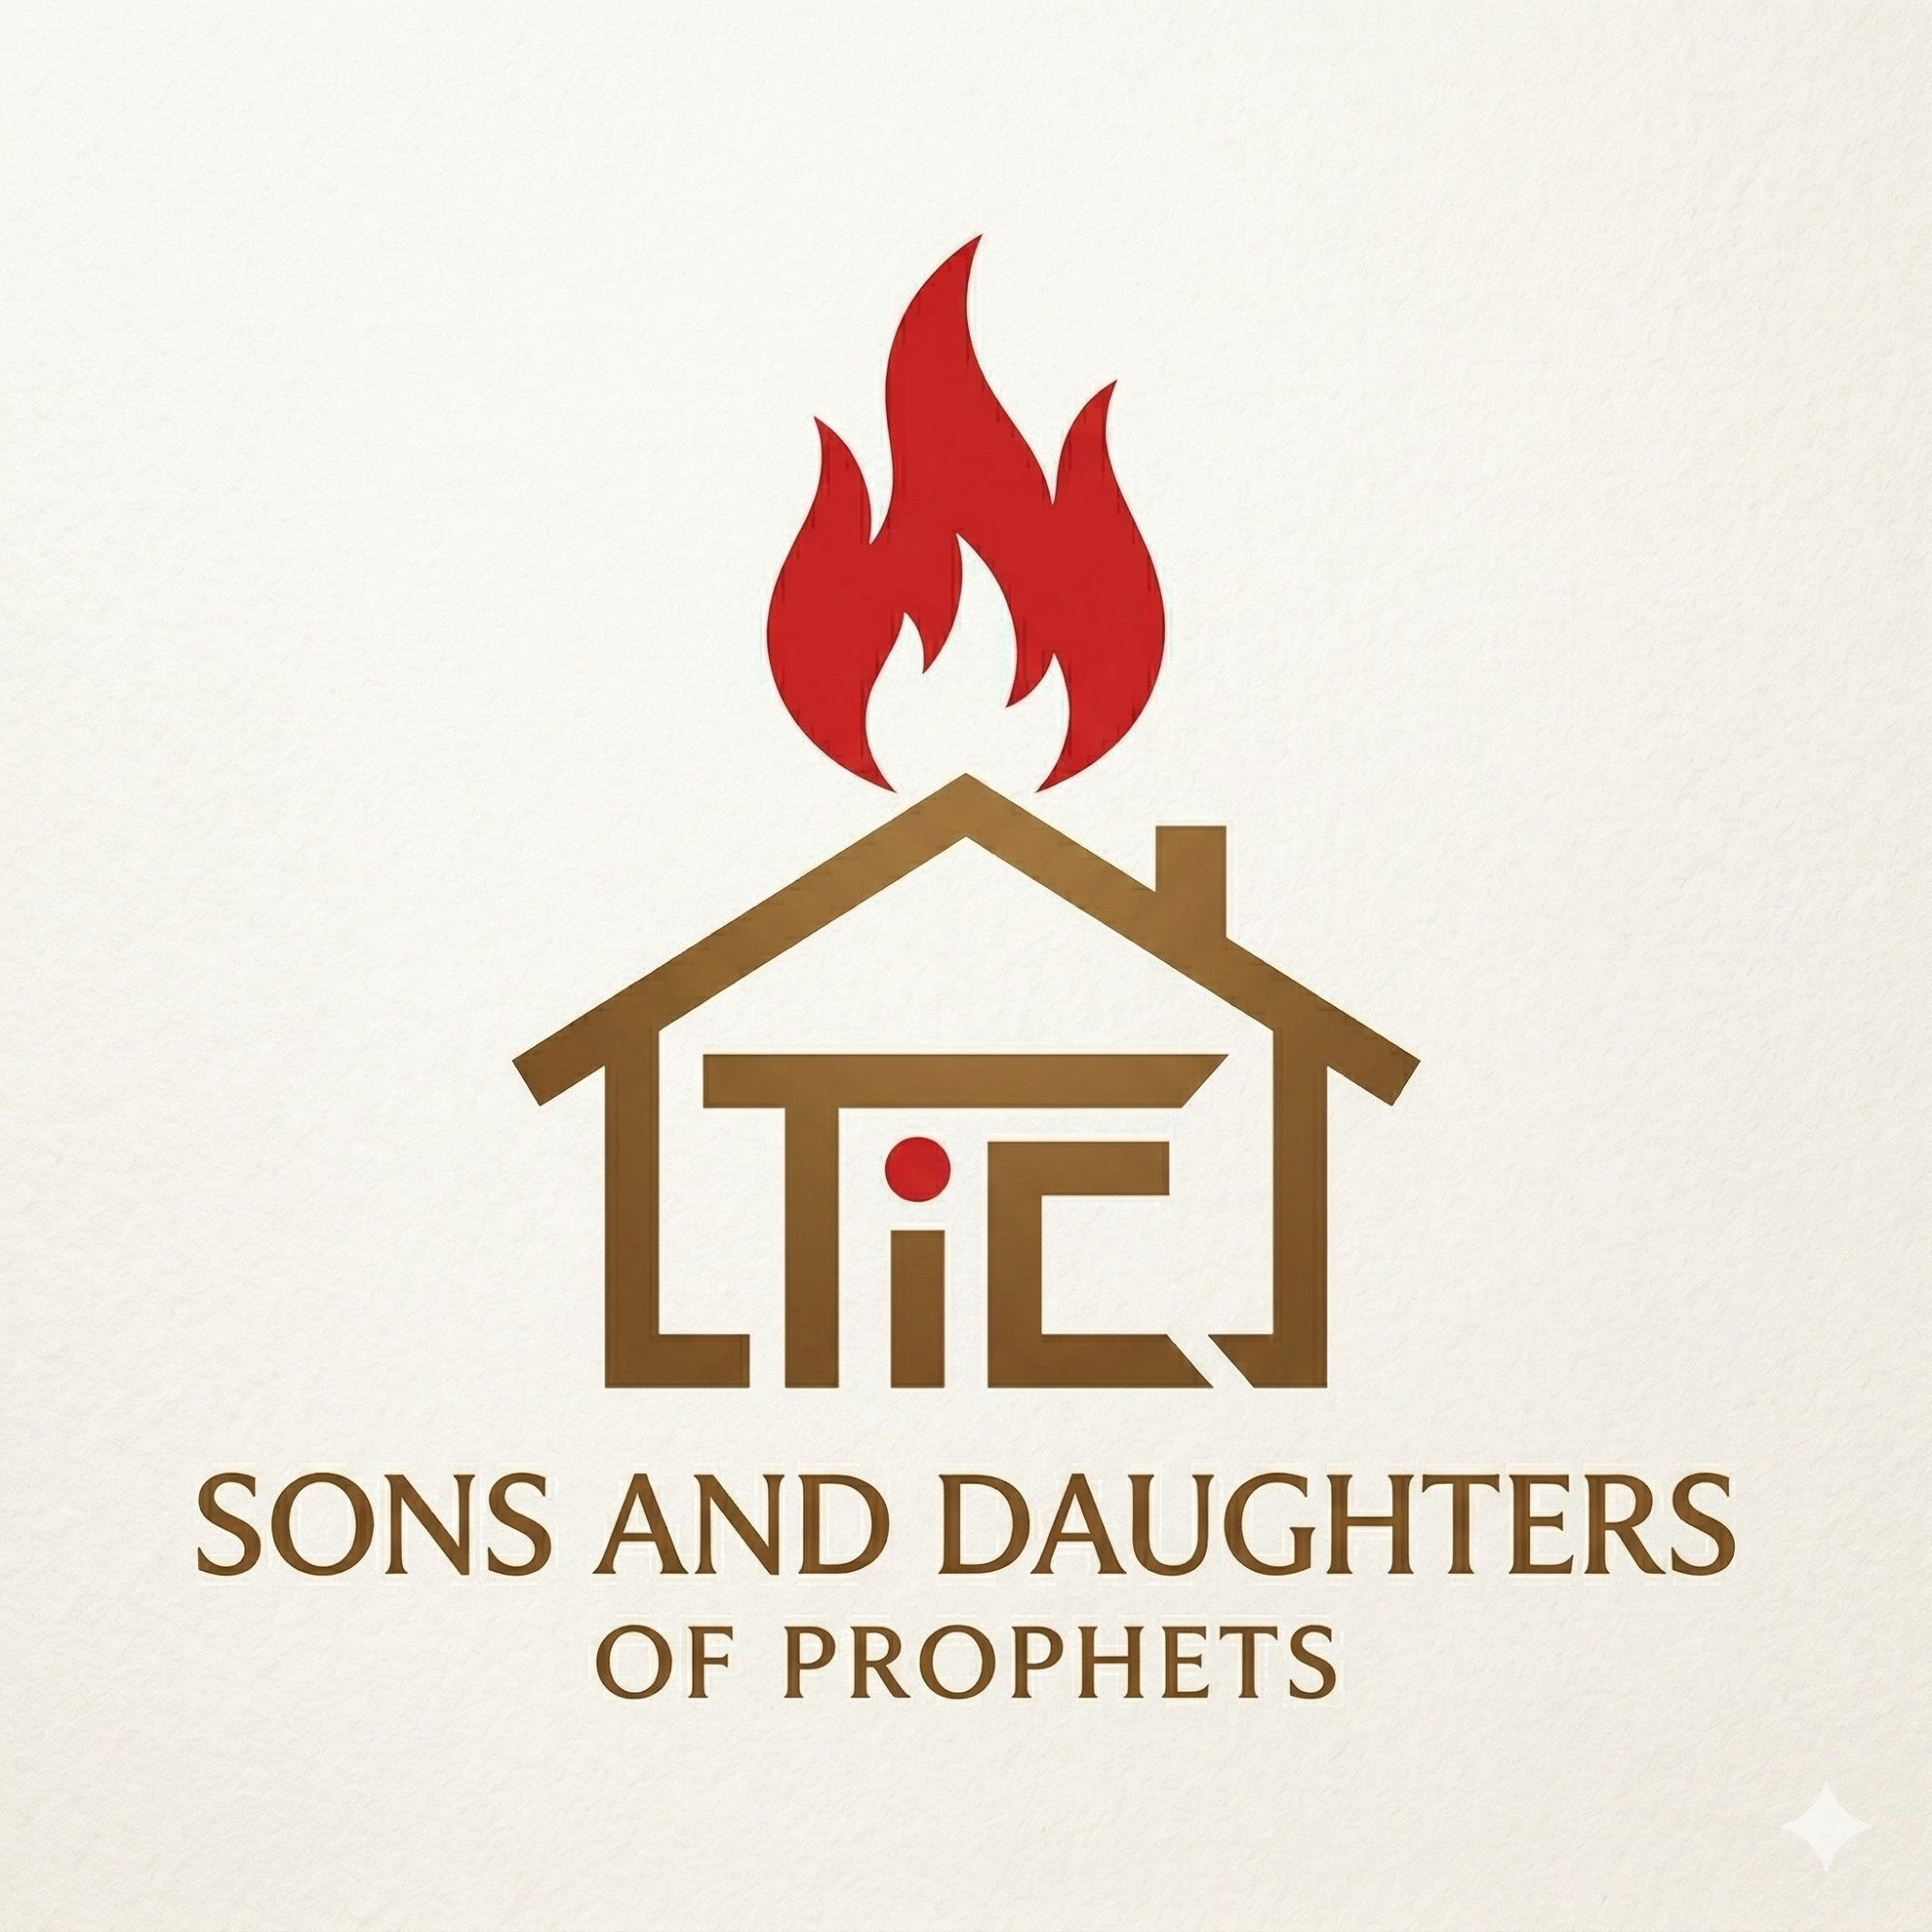
SONS AND DAUGHTERS OF PROPHETS
Prophetic Training School
Treasures in Clay Ministries
RAISING NEW TESTAMENT PROPHETS
FOR THIS GENERATION

"But the one who prophesies speaks to people for their strengthening, encouraging and comfort."
— 1 Corinthians 14:3

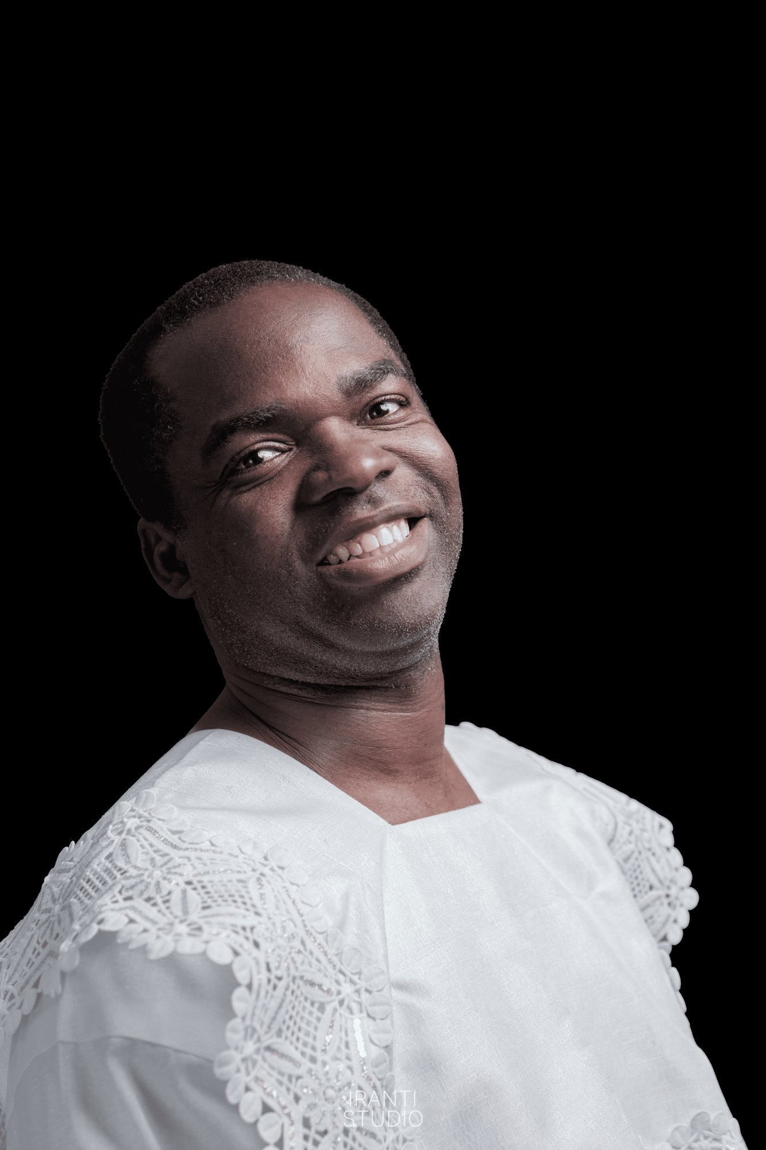
Prophet Abiodun Sule
Founder & Dean

About the School
The Sons and Daughters of Prophets Prophetic Training School is a two-year online school established by Prophet Abiodun Sule under the authority of Treasures in Clay Ministries. It was founded with one conviction: the church needs prophets who are not merely gifted, but biblically grounded, spiritually discerning, and deeply accountable.

The school is completely free of charge. Tuition will never be charged to any student, in any cohort, at any level. Your calling is the only requirement for enrolment.

Our Mission
To raise a generation of New Testament prophets who are rooted in the Word, led by the Spirit, and accountable to the Body of Christ.

Our Vision
A church in which every believer understands, weighs, and walks in the prophetic gifts freely given by the Holy Spirit — in orderly, loving, and fruit-bearing prophetic community.

Why This School?
Prophetic ministry is one of the most misunderstood and misused gifts in the church today. Too many believers have been hurt by prophetic error, manipulation, and presumption. Too many genuine prophetic gifts have remained undeveloped for lack of training, accountability, and a biblical framework.

This school exists to correct that. We believe you can be trained — not just talented. We believe that prophecy can be both genuinely supernatural and properly tested. We believe that the same Spirit who moves in power also calls His people to humility, accuracy, and love.

Our Four Foundations

01. Scripture-Anchored  Every course is rooted in the Word — not tradition, emotion, or personal preference. | 02. Discernment First  Students learn to test every spirit before they minister. Accuracy matters.
03. Character Over Gift  Holiness and integrity are prerequisites to prophetic ministry, never afterthoughts. | 04. Activation-Based  Prophetic exercises in every lesson — not just theory. You learn by doing.

Year 1 Curriculum — Certificate in Prophetic Ministry
Year 1 consists of six courses worth 15 credits. All courses are included in your free enrolment.

# | Opens | Course Title | Credits
01 | 10 May | Introduction to New Testament Prophecy | 3
02 | 24 May | The Person & Work of the Holy Spirit | 3
03 | 7 Jun | Biblical Hermeneutics | 3
04 | 21 Jun | Spirituality vs Spiritism | 2
05 | 5 Jul | Prayer & Intimacy with God | 2
06 | 19 Jul | Character & Ethics in Ministry | 2

Year 2 — Diploma in New Testament Prophecy
Year 2 opens upon successful completion of Year 1. It consists of five advanced courses worth 13 credits.

07. Advanced Prophetic Ministry 3 credits
08. Discernment & Deliverance 3 credits
09. Theology of the New Covenant 3 credits
10. Leadership in Prophetic Ministry 2 credits
11. Prophetic Evangelism 2 credits

How to Join

Admission Requirements
There are no academic prerequisites. The only requirements are: (1) You are a believer in Jesus Christ. (2) You have a genuine interest in the prophetic gift. (3) You are willing to be taught, corrected, and held accountable. Tuition is completely free.

HOW TO APPLY
1. Visit sandd.abiodunsule.uk and click 'Apply'
2. Fill in your name, email, phone, church and city
3. Create a password for your student portal
4. Your account is immediately activated — no waiting period
5. Join the Telegram community: t.me/+zoXkAa9bjCtmZmY8
6. Log in to your portal and access your courses

School Leadership

  Prophet Abiodun Sule  Founder & Dean  www.abiodunsule.uk |   John Ayomide Akinola  Registrar  sandd@abiodunsule.uk

Contact & Community

Student Portal: sandd.abiodunsule.uk
Email (Registrar): sandd@abiodunsule.uk
Telegram Community: t.me/+zoXkAa9bjCtmZmY8
Instagram: @tic.ministries
Ministry Website: www.abiodunsule.uk

"Eagerly desire gifts of the Spirit, especially prophecy." — 1 Corinthians 14:1
S&D Prophetic Training School | Treasures in Clay Ministries | 2026

