**PRJ301 Assignment**

**Project name: Website Kinh Doanh Linh Kiện Máy Tính**

**(Computer Parts Shop)**

**Group 7**

**Team members:**

Hoàng Minh Tiến – SE62418

Bùi Thị Thùy Linh - SE141167

**Summer 2021**

1. **CASE STUDY**

In a fast-paced life like now, especially when the Covid-19 epidemic is making the world wobble. Instead of having to "walk" to gaming gear stores like before. You just sit at home and choose the best equipment to build a perfect gaming computer to relax when you have to stay at home due to social distancing.

1. **DATABASE DESIGN**

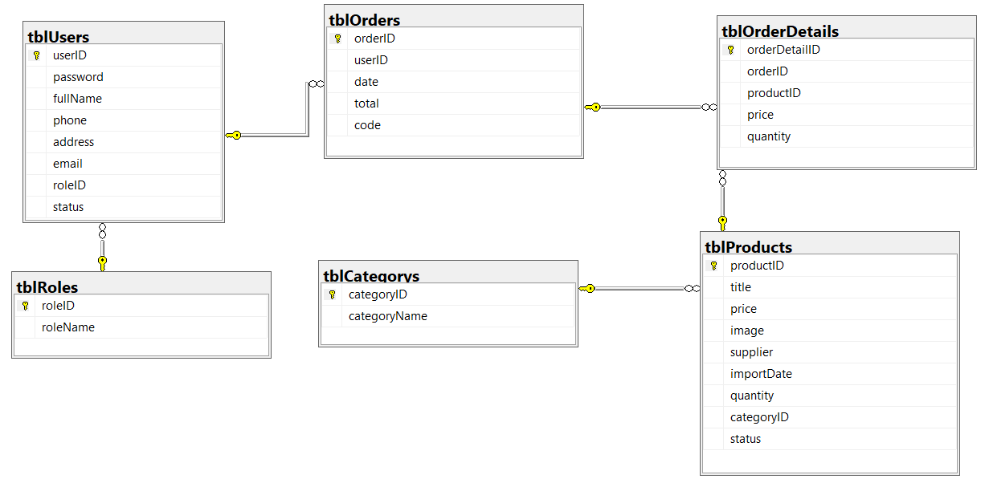

1. **SYSTEM DESIGN**

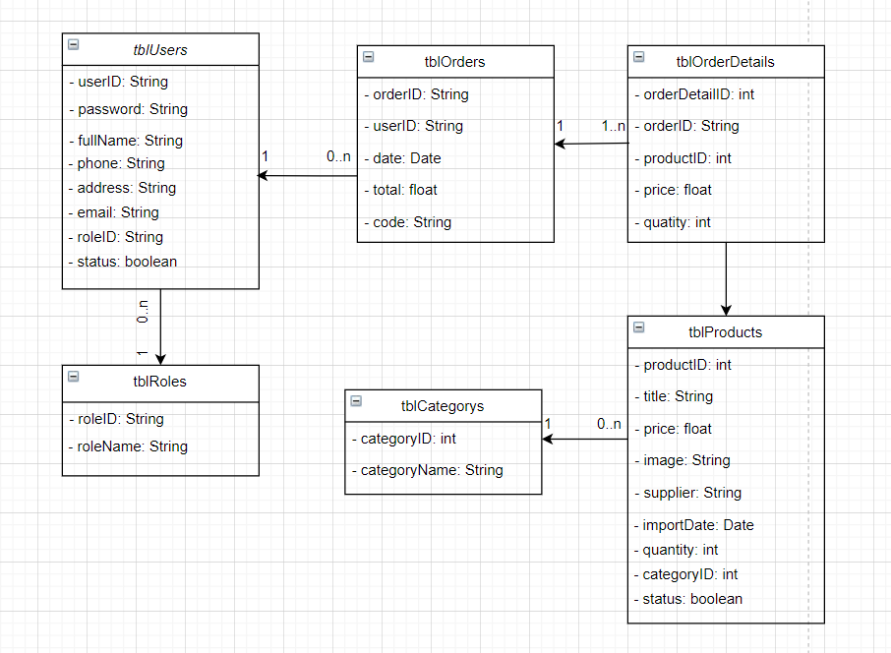

**Login:**

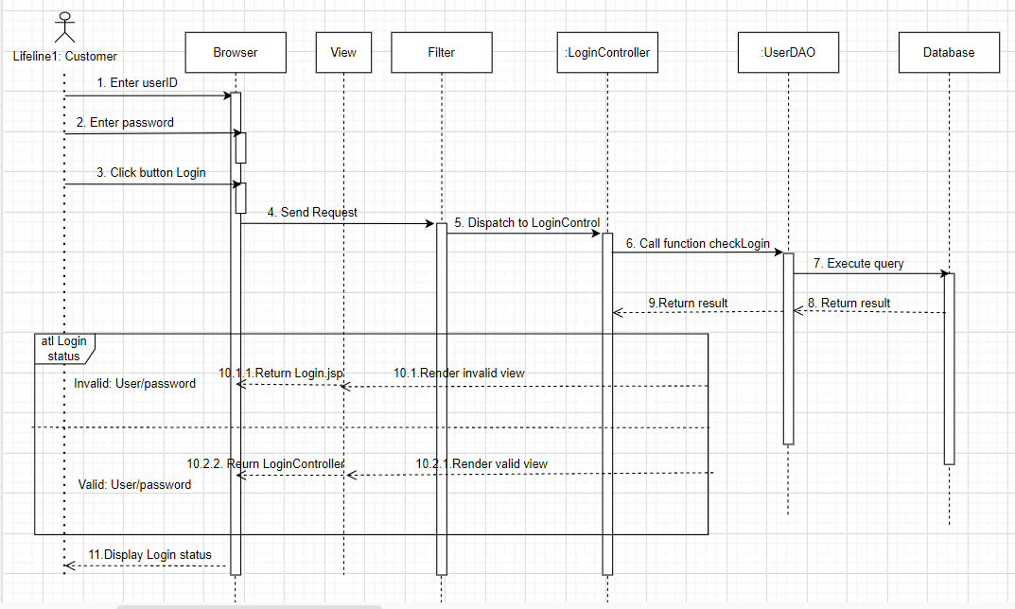

**Register**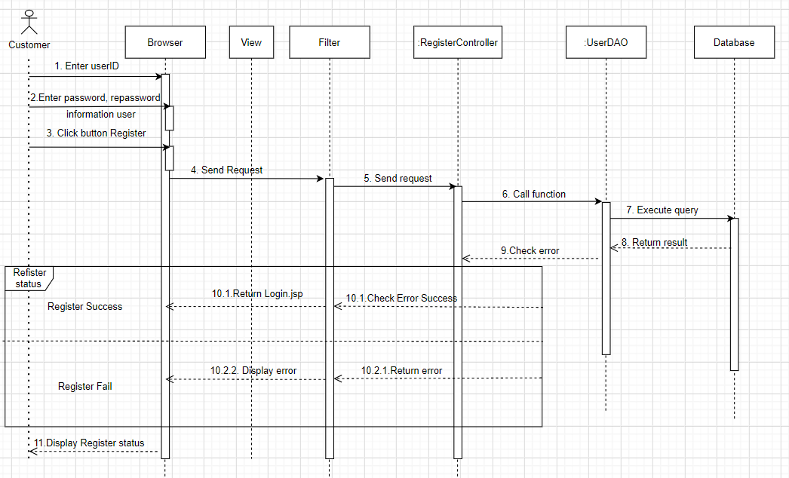

**Detail Product**

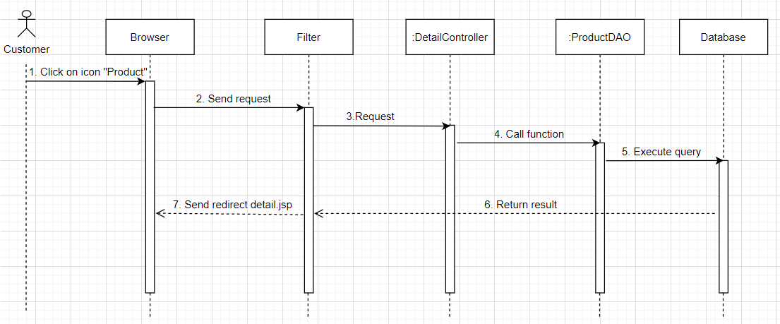

**Search product**

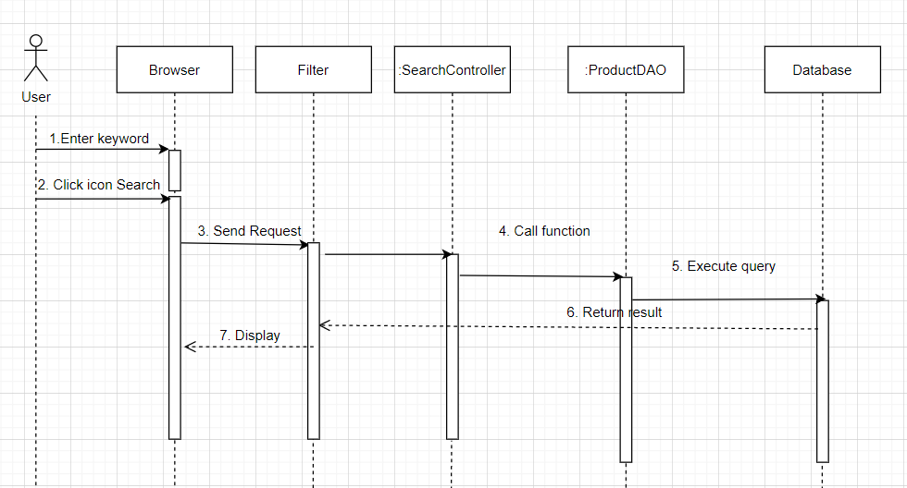

**Add To Cart and Delete**

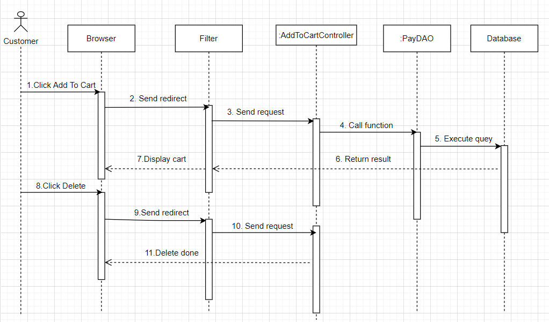

**Add Product**

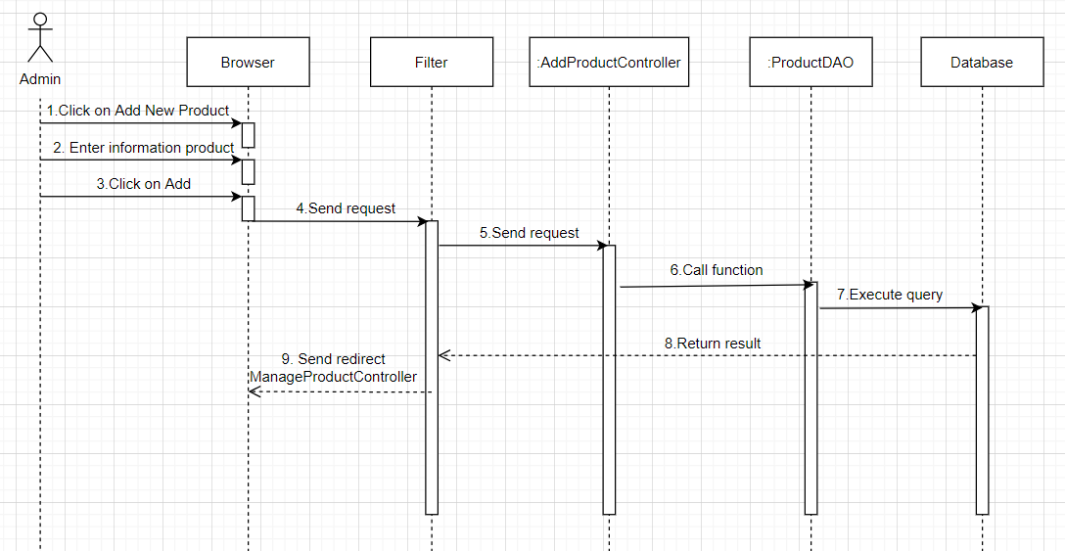

**Update Product**

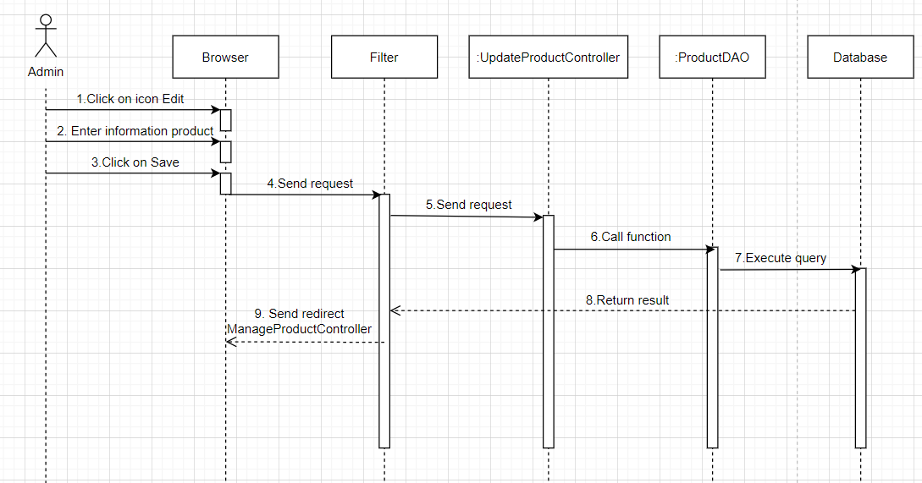

**Delete product**

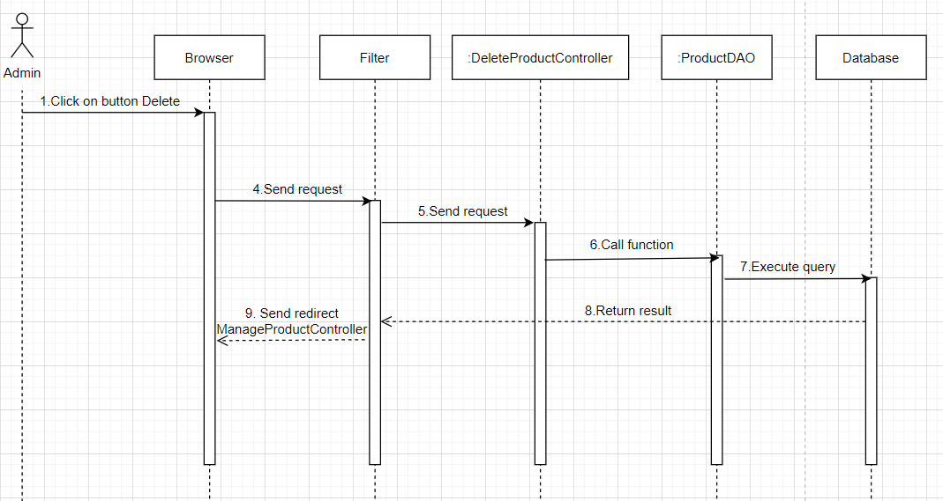

**Logout**

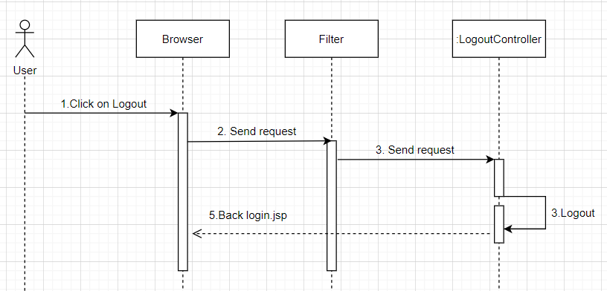

1. **IMPLEMENTATION**

Sign in:

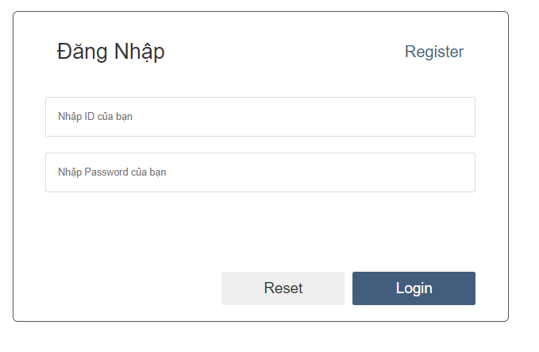

Register

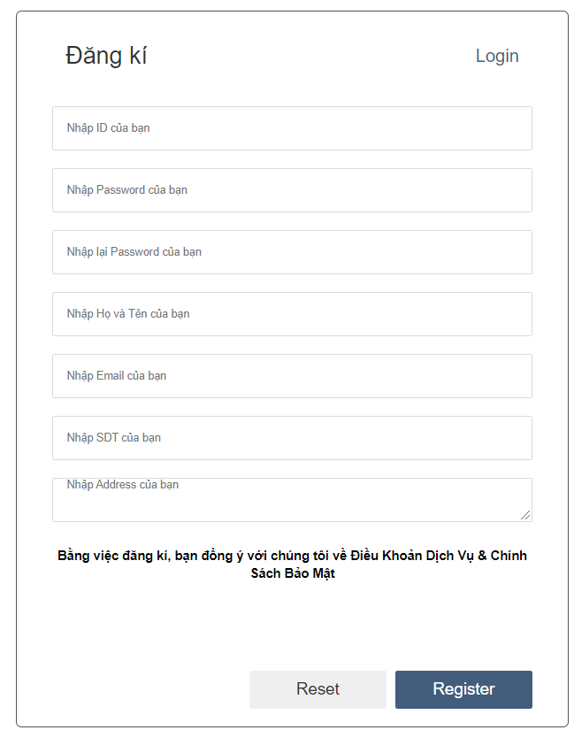

List product in customer’s view

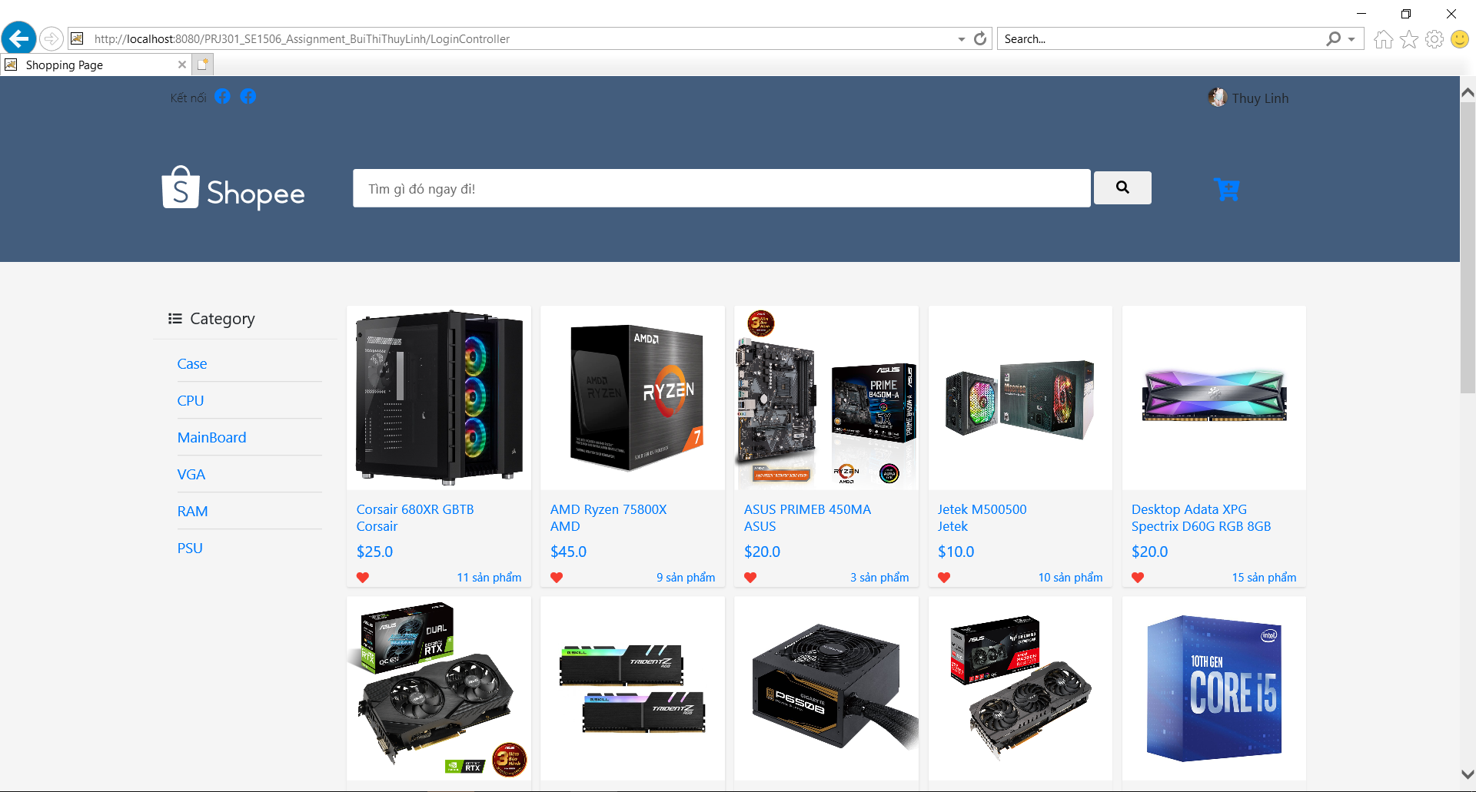

Search:

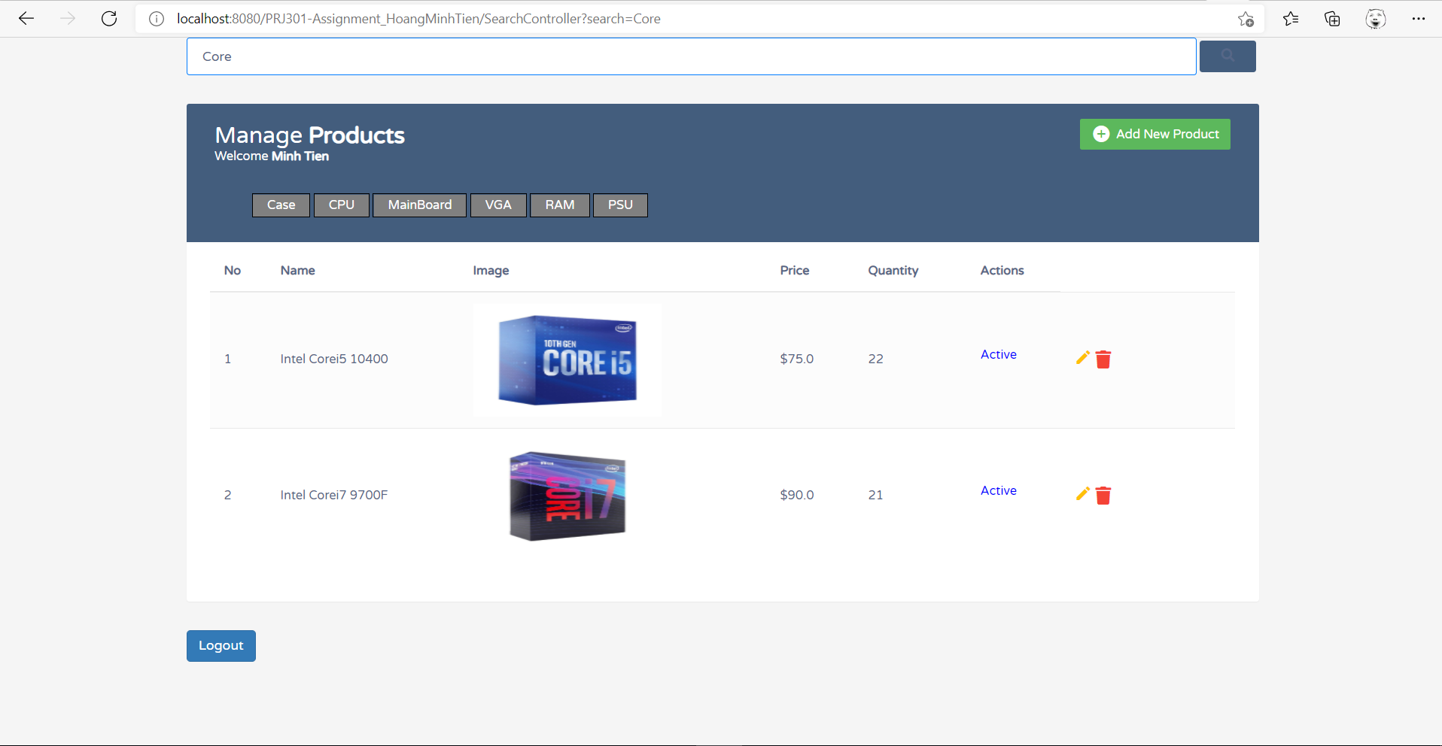

Detail Product:

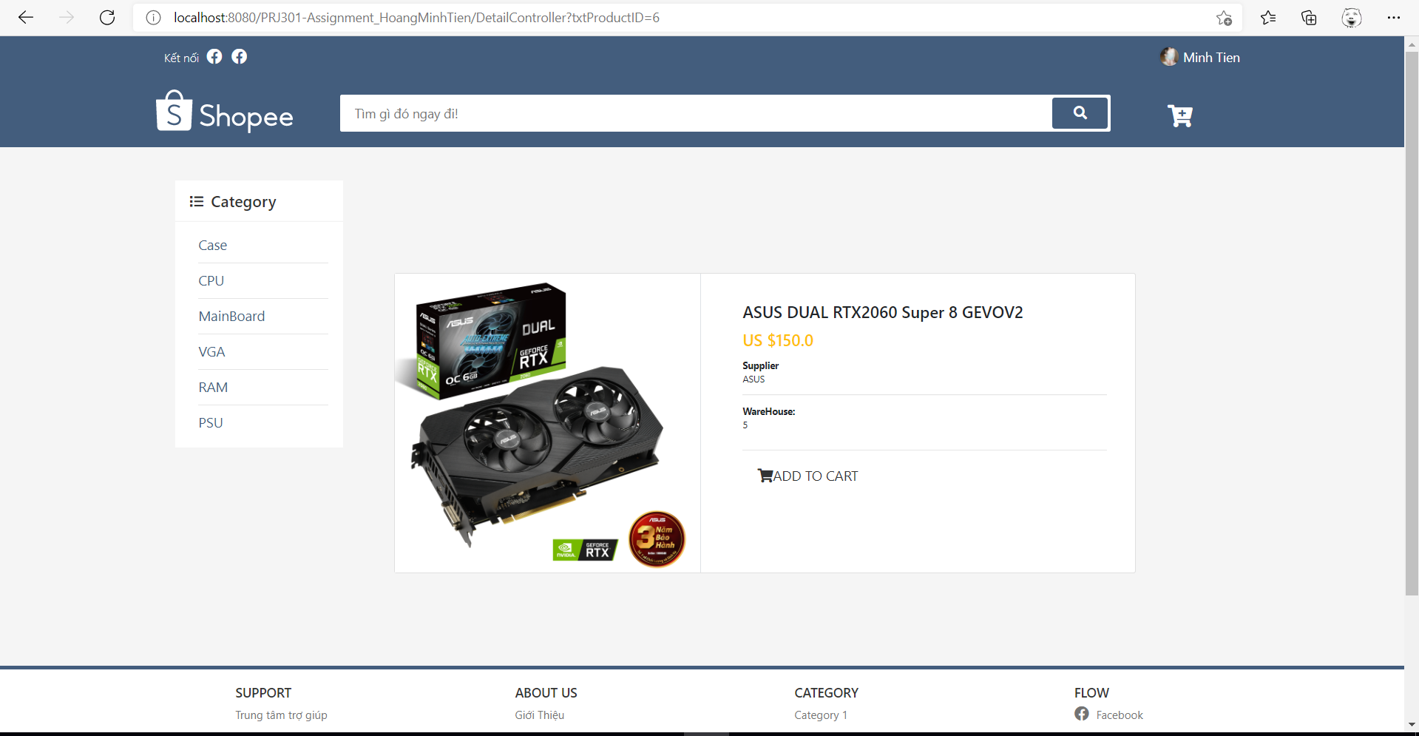

Add to cart:

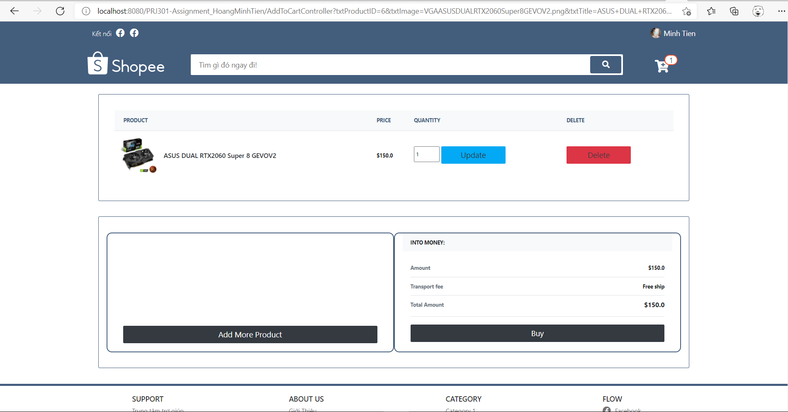

Increase the number of products in the cart

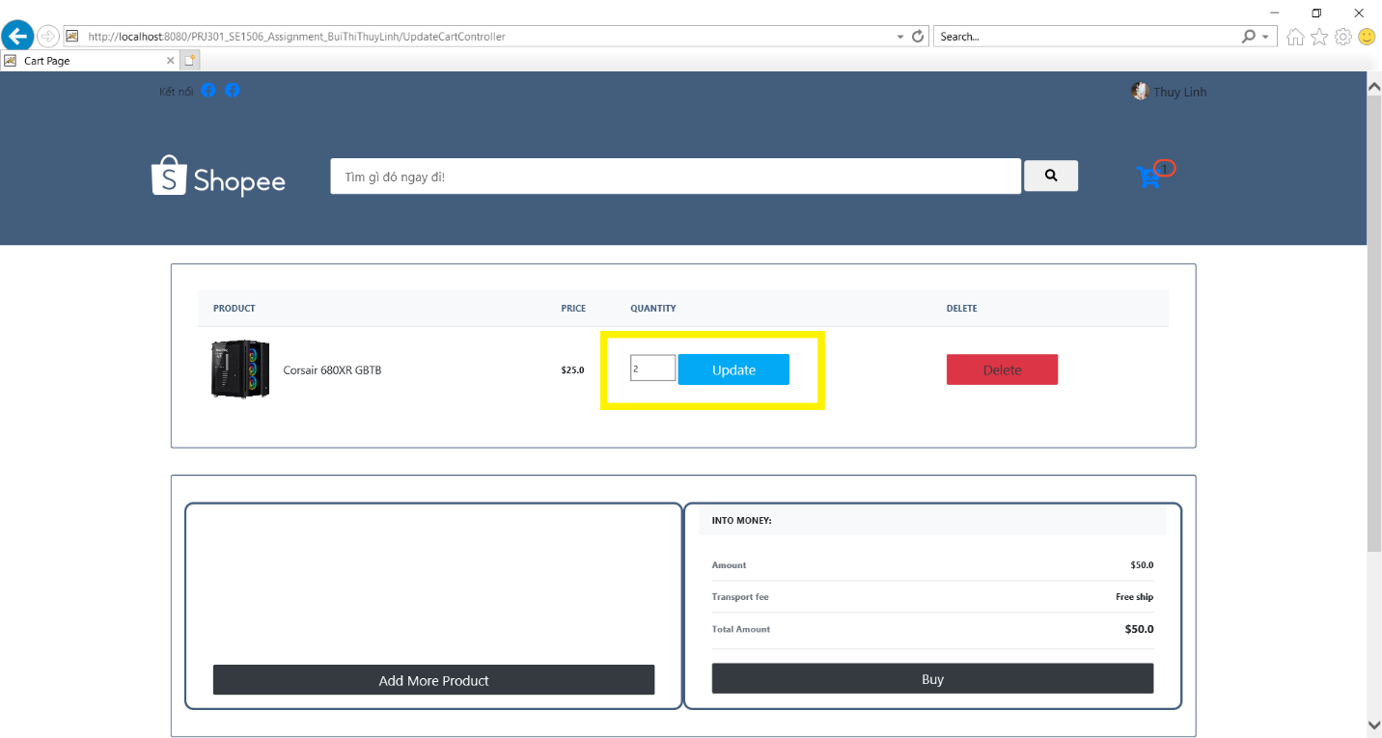

Remove product from cart:

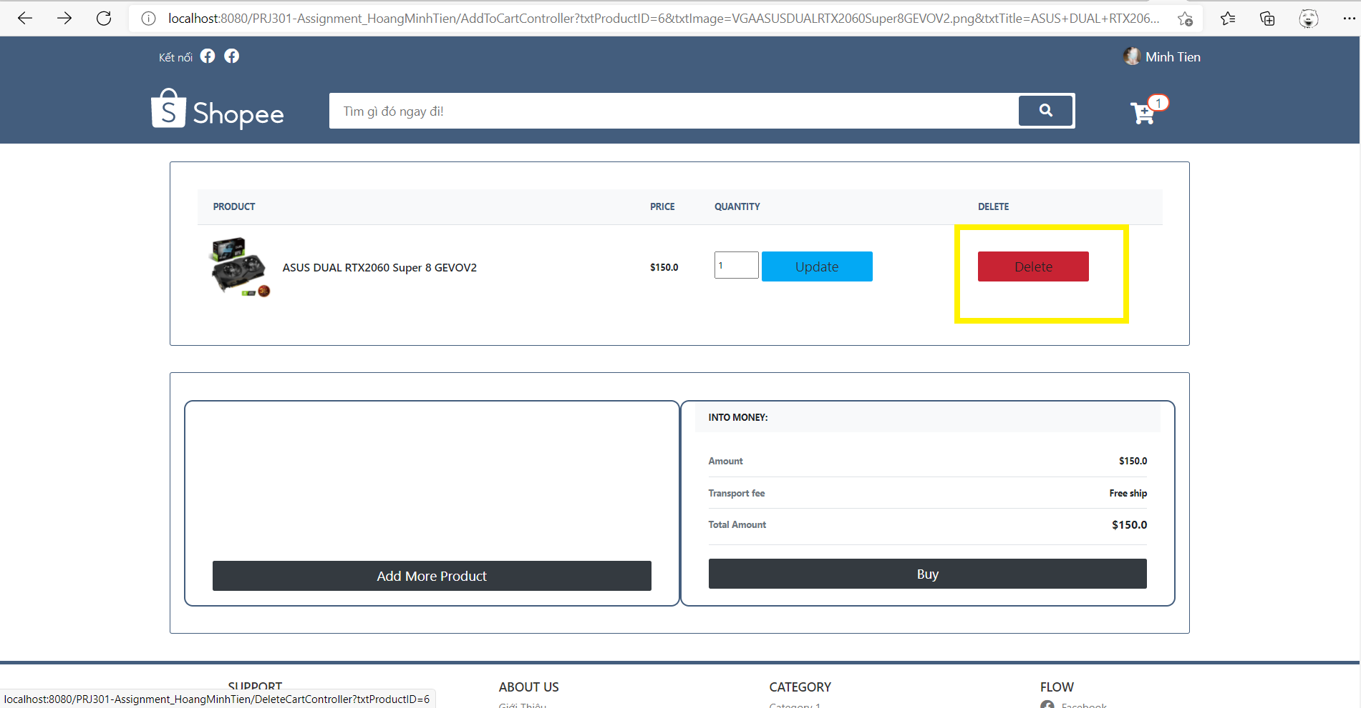

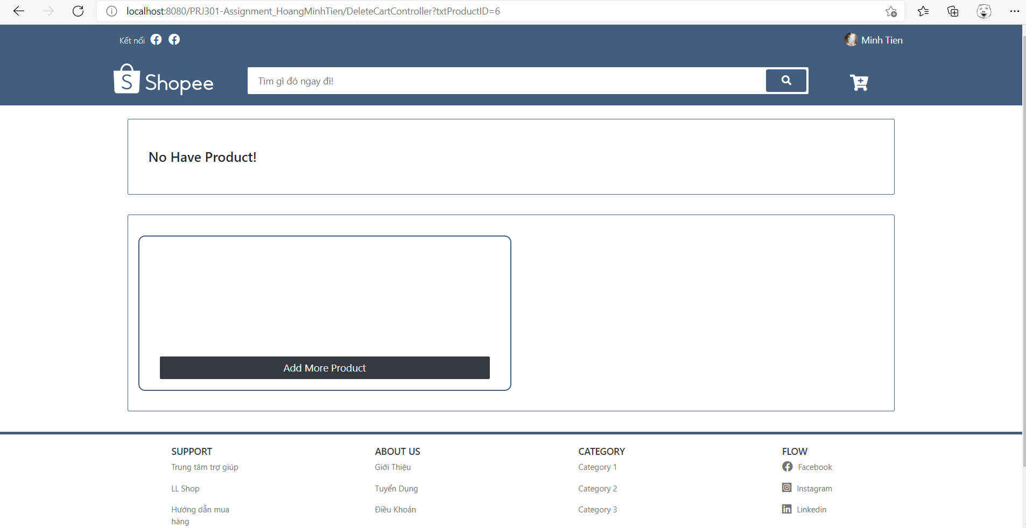

Log Out:

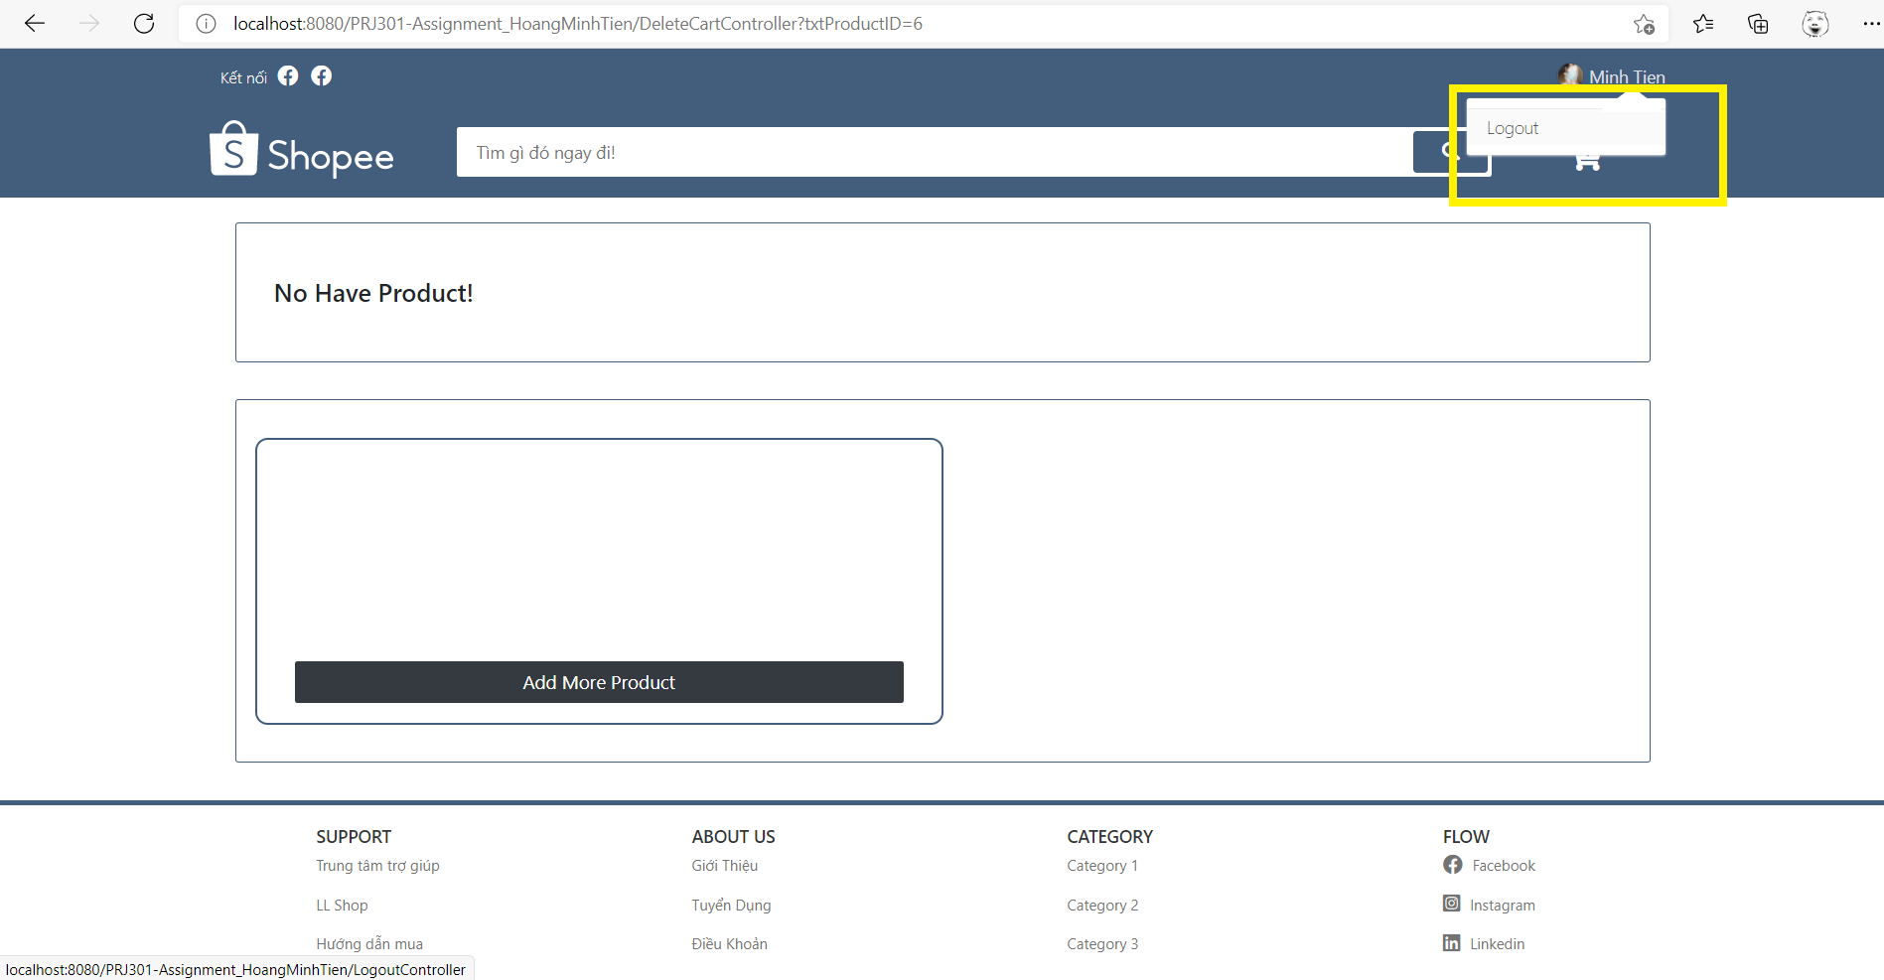

List product in admin’s view:

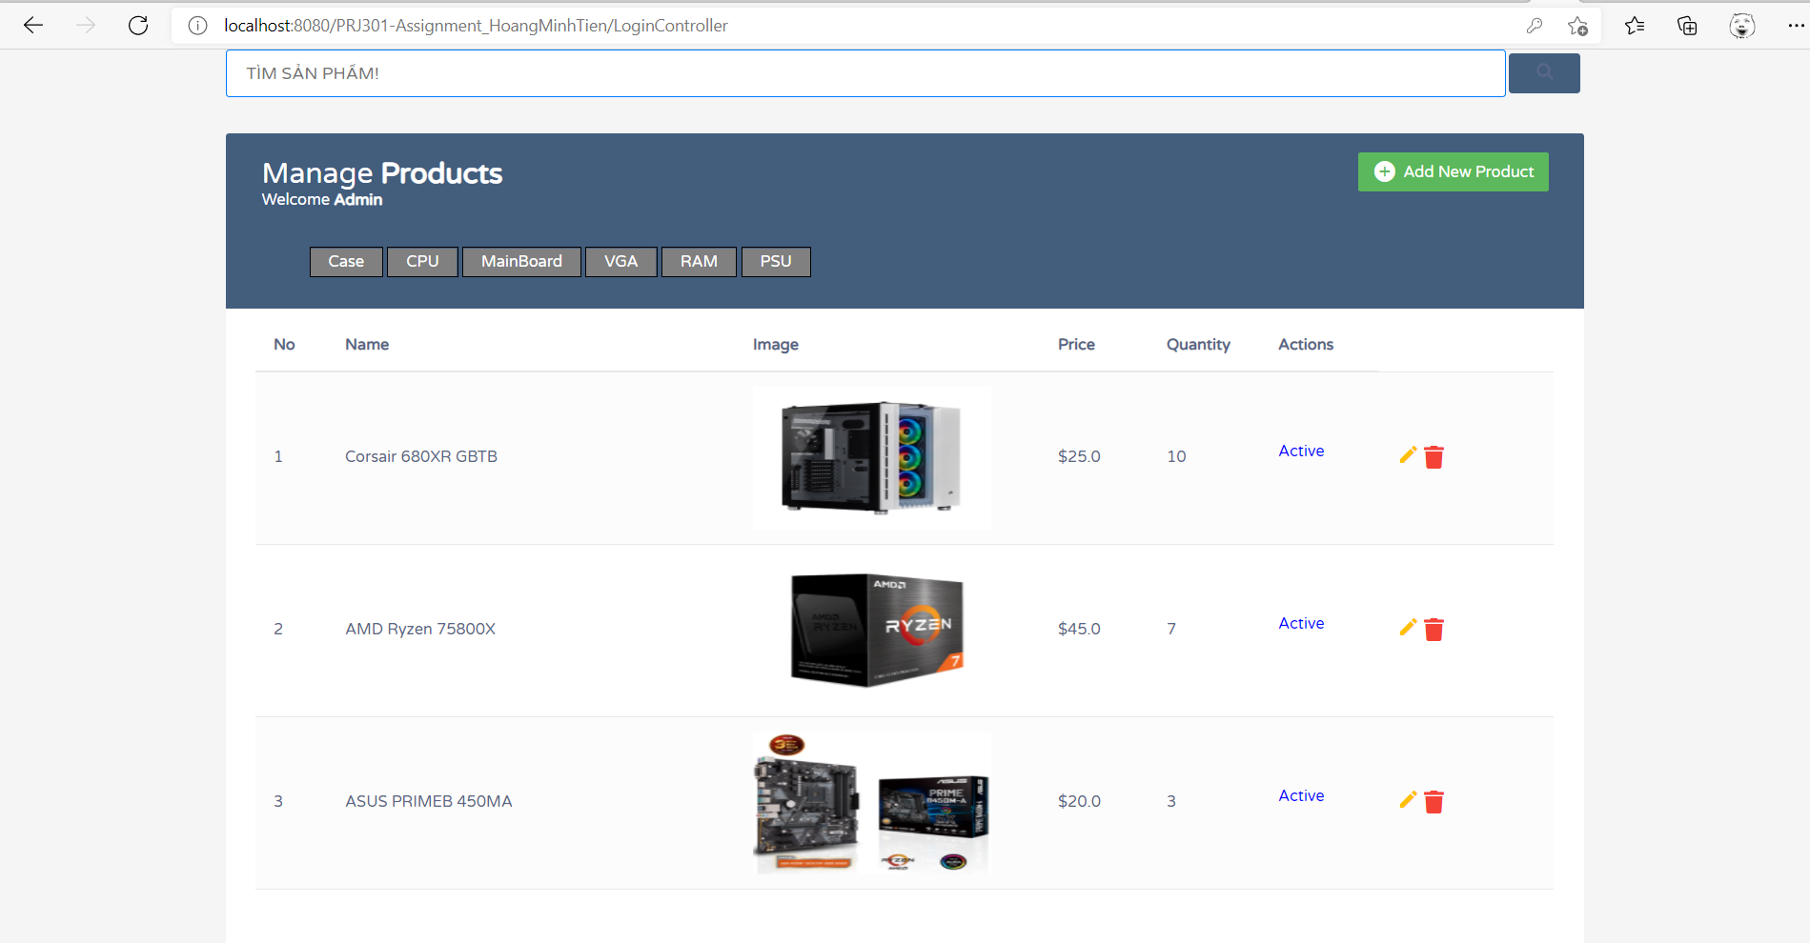

Add product:

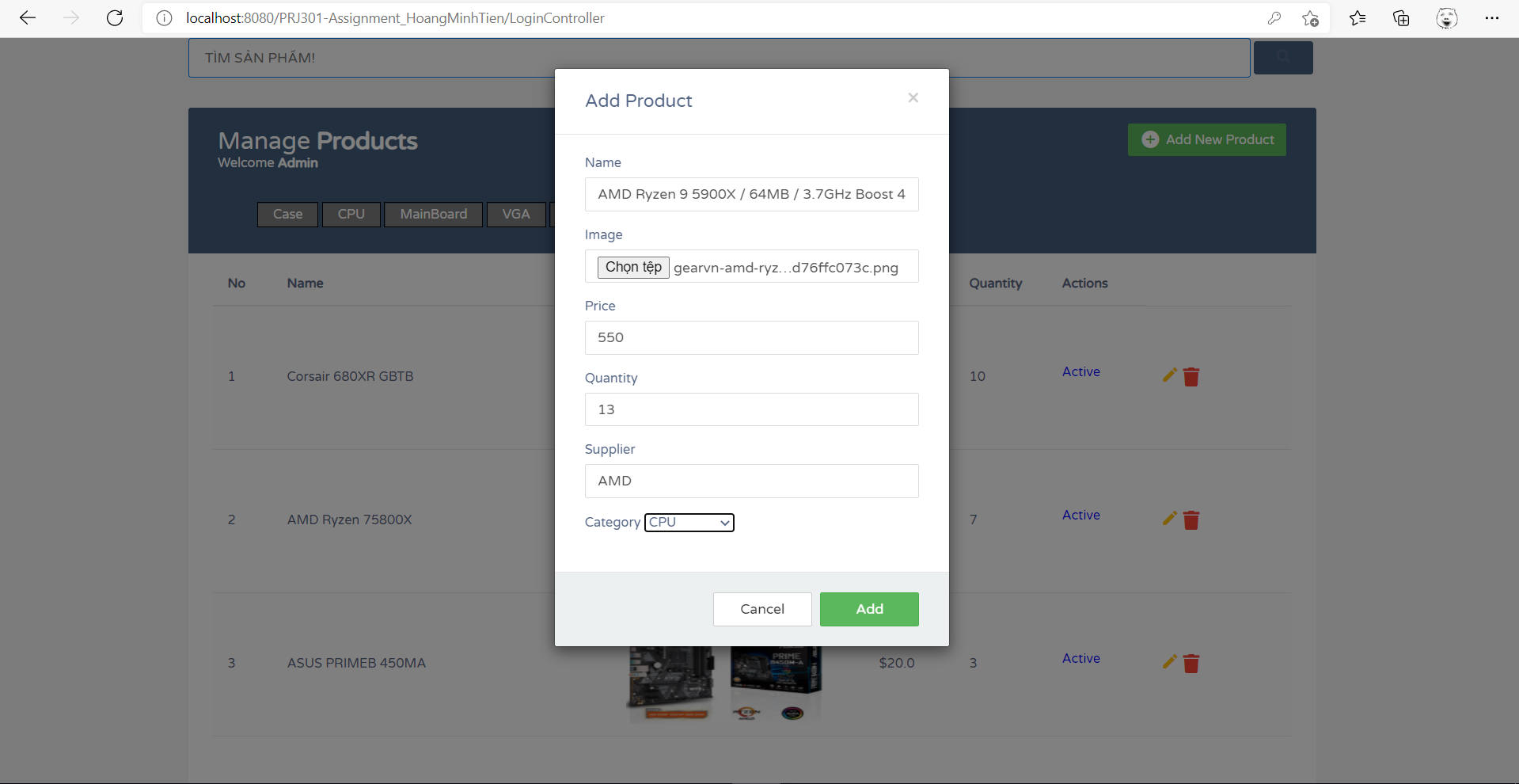

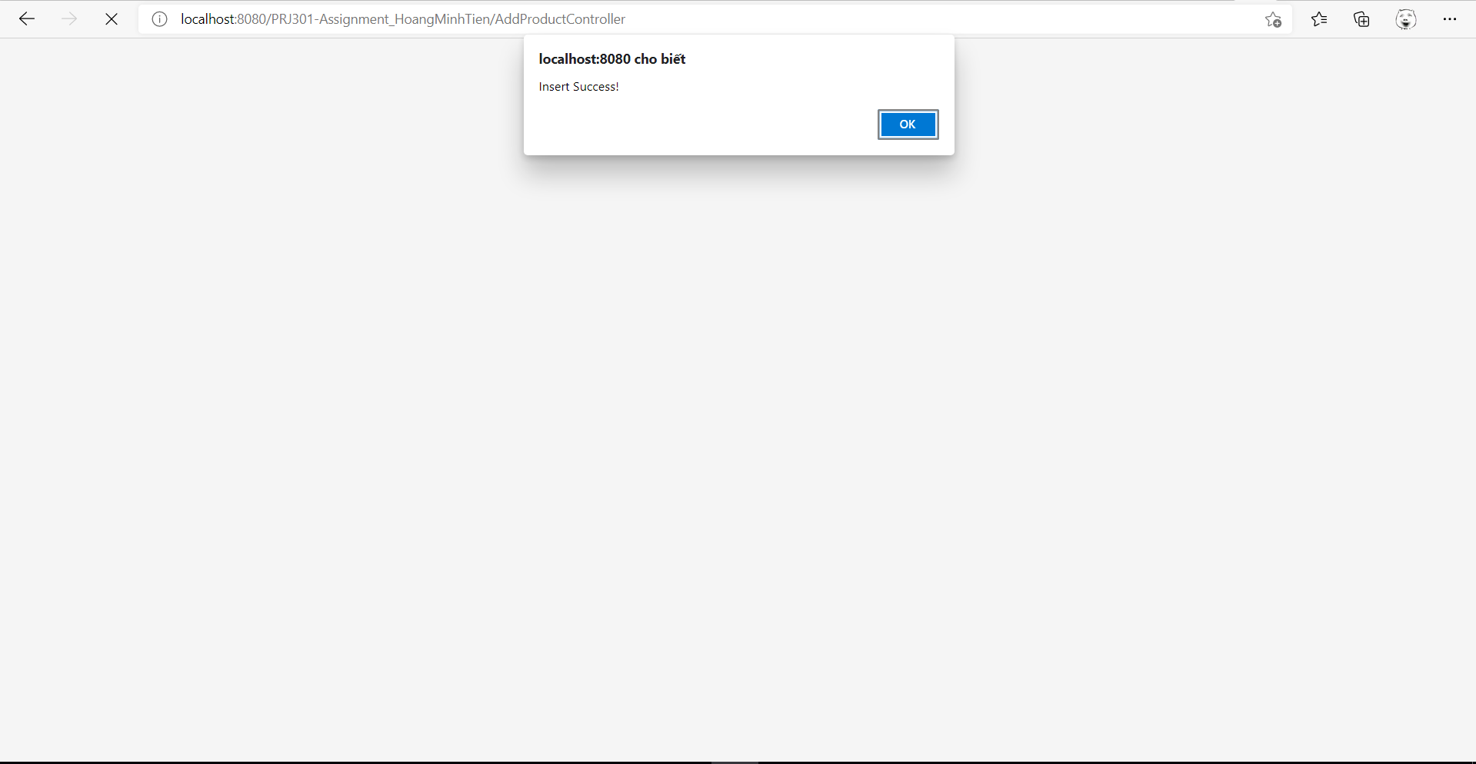

Edit product:

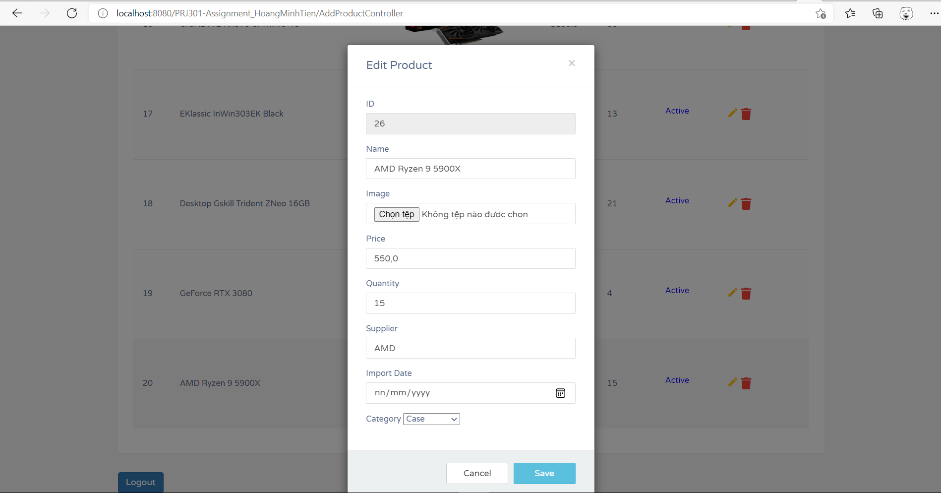

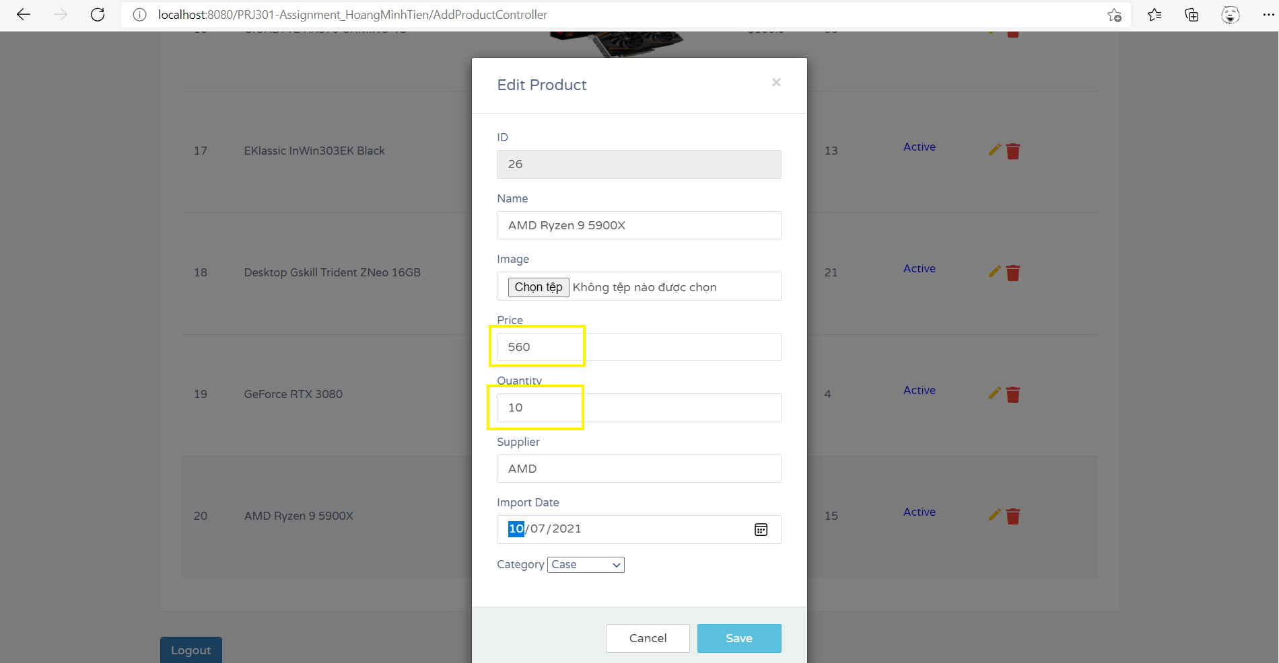

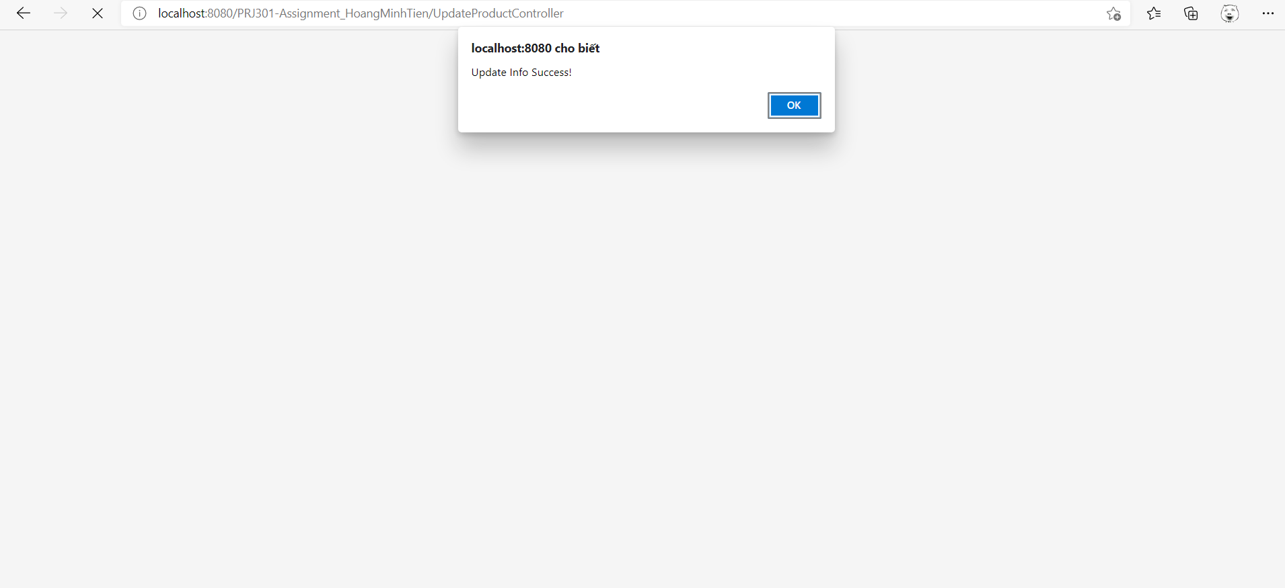

Delete product:

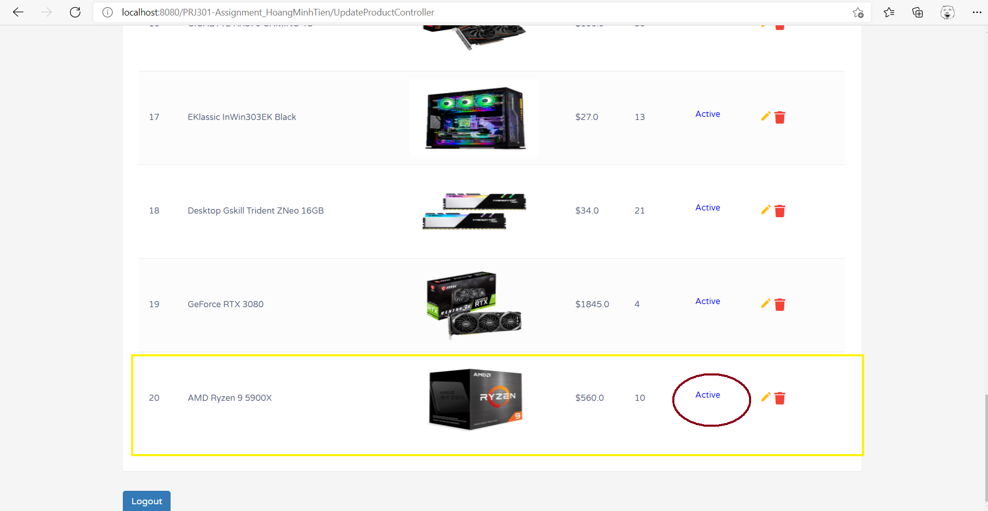

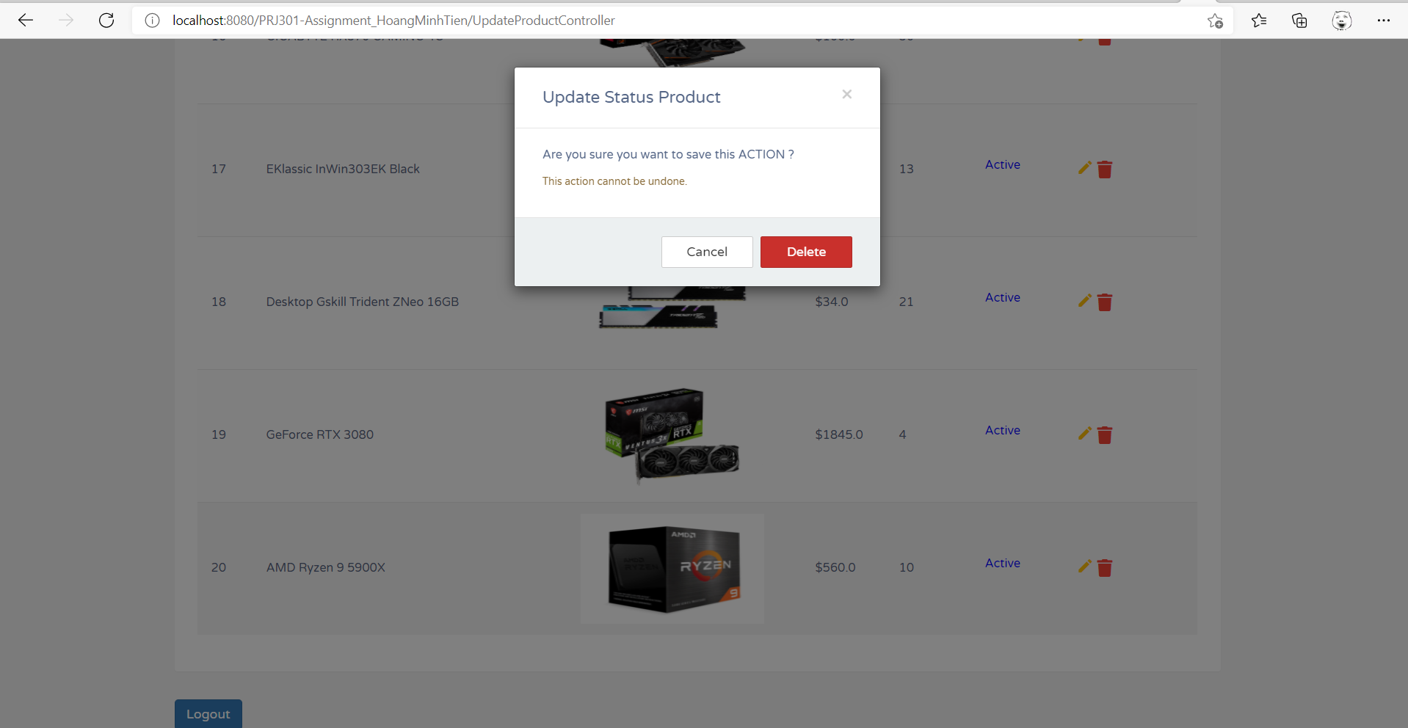

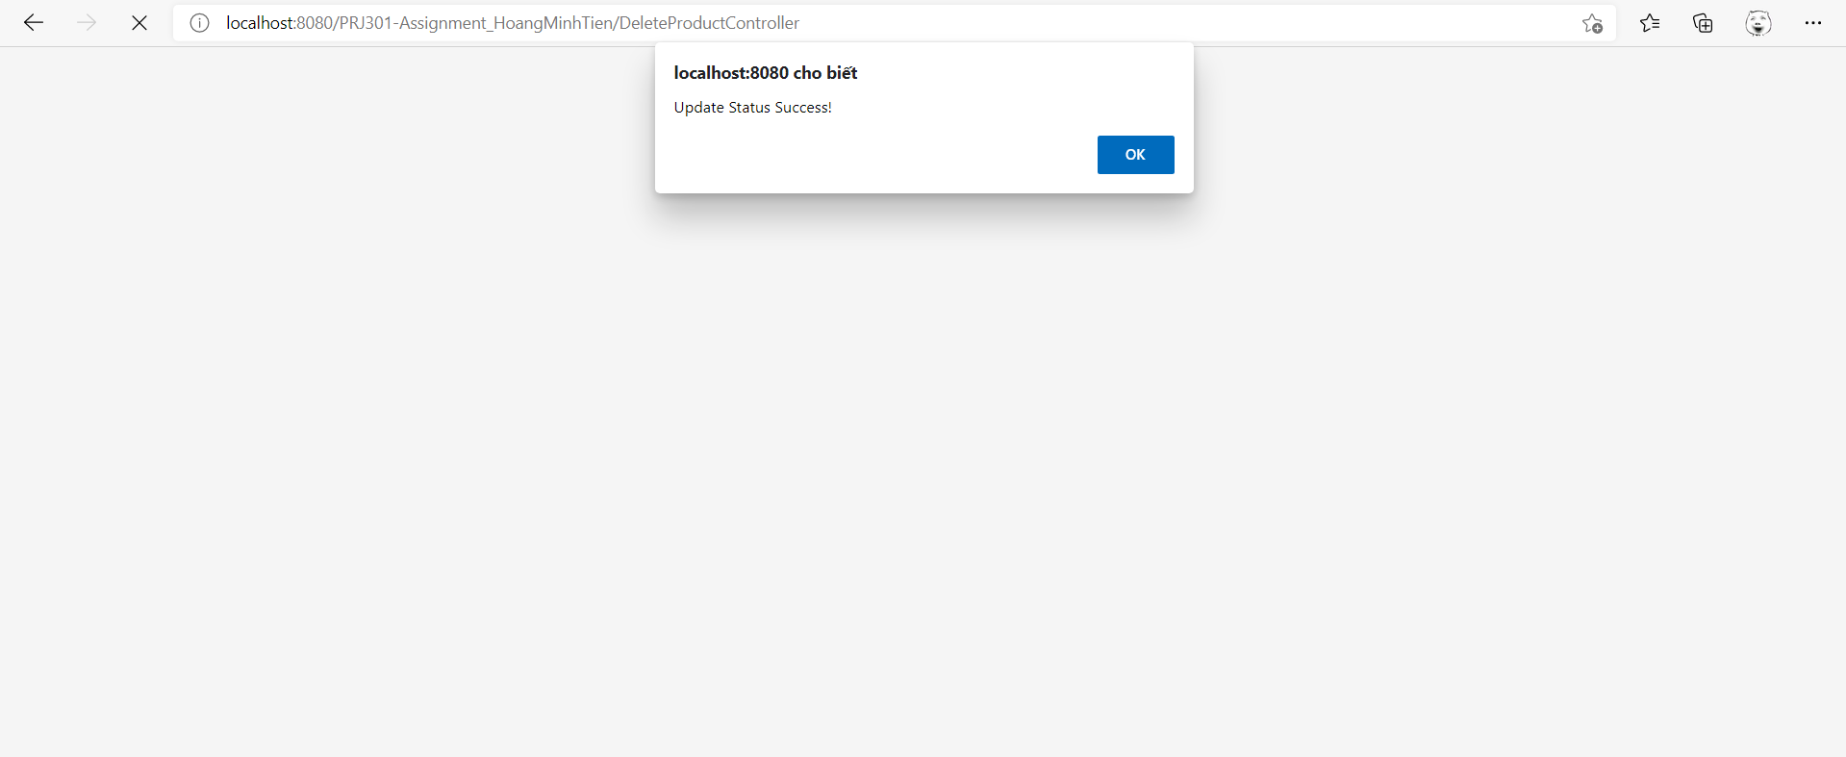

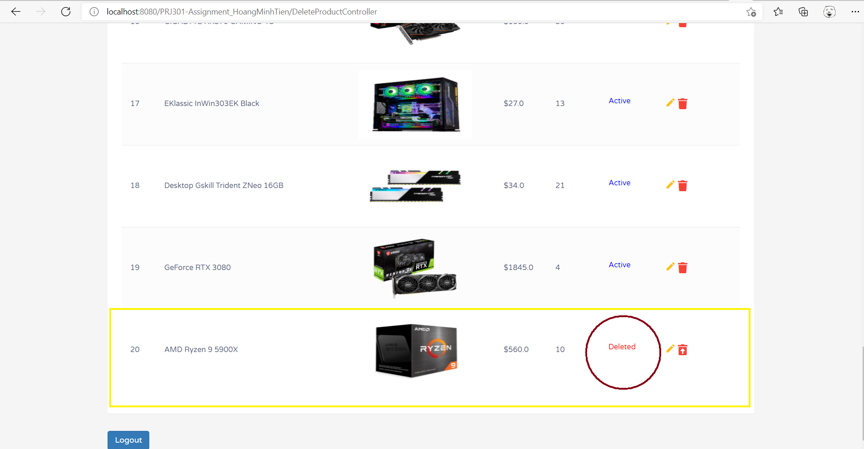

1. **CONCLUSION**

- Our website helps users have the best experience to buy products as simply as possible.

- Although we had a lot of difficulties in completing this website (especially the shopping cart part) but our team tried our best to complete this website in the best way.