Group Project   
Subject: Basic Cross-Platform Application Programming With .NET

*STUDENT MANAGEMENT*

Prepared by Group 7

Nguyễn Khánh Linh SE140459

Bùi Thị Thùy Linh SE141167

Trần Khắc Đại SE150681

Nguyễn Ngọc Ước SE140739

November, 2021

Table of Contents

Table of Contents ii

Revision History ii

1. Case Study 1

2. Database Design 1

3. System Architecture 1

4. Implementation 2

Revision History

|  |  |  |  |
| --- | --- | --- | --- |
| **Name** | **Date** | **Reason For Changes** | **Version** |
| *Thùy Linh, Khắc Đại, Ngọc Ước, Khánh Linh* | *16/9/2021* | *Initial draft, choose a topic, discuss and present the business function of winform* | *1.0 draft 1* |
| *Thùy Linh,*  *Khắc Đại, Ngọc Ước, Khánh Linh* | *18/9/2021* | *Draw ERD, class diagram and write database* | *1.0 draft 2* |
| *Thùy Linh*  *Khắc Đại*  *Ngọc Ước*  *Khánh Linh* | *19/9 – 3/10* | *Code function mark management*  *Function student management and login*  *Function course and major management*  *Function subject management* | *2.0 stage 1* |
| *Thùy Linh*  *Khắc Đại*  *Ngọc Ước*  *Khánh Linh* | *4/10 – 17/10* | *Design UI Home*  *Put parts together*  *Fix bug* | *2.0 stage 2* |
| *Thùy Linh*  *Khắc Đại*  *Ngọc Ước*  *Khánh Linh* | *18/10 – 30/10* | *Fix bug and Complete features* | *2.0 stage 3* |
| *Thùy Linh*  *Khắc Đại*  *Ngọc Ước*  *Khánh Linh* | *31/10 – 3/11* | *Write report* | *2.0 stage 4* |

# Case Study

**Purpose of the topic**

If the number of students is very large, manual management by bookkeeping is very difficult. Therefore, the student management winform software helps the process of storing students' scores and infor efficiently, conveniently and saving time. In addition, it also helps keep students' information secure.

**Software requirements**

* The interface and components are arranged reasonably and clearly to create convenience for managers.
* The manager can easily search, add, delete, edit student information, subjects, mark, course, major just by clicking.
* The software allows to host a large number of students.

**User role:**

Admin : - Login, Logout

* Read, Create, Update, Delete, Search infor Students, Mark, Subject, Course, Major

# Database Design

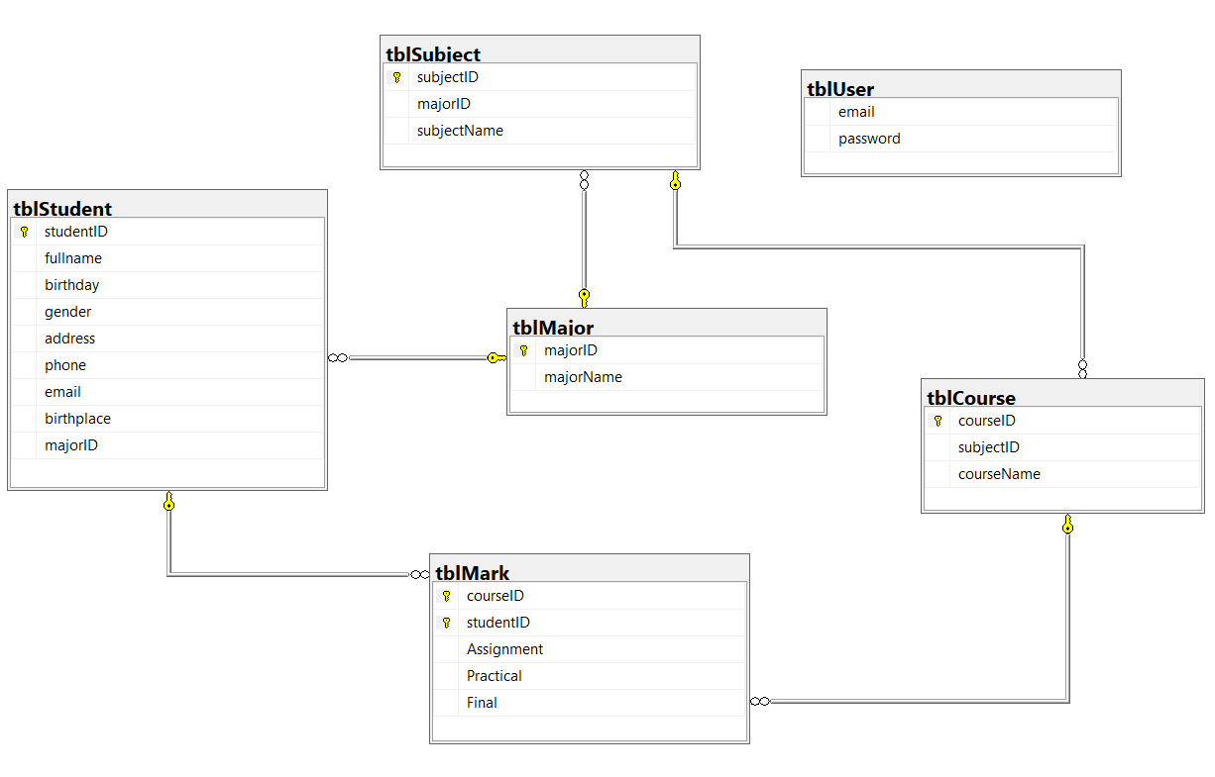

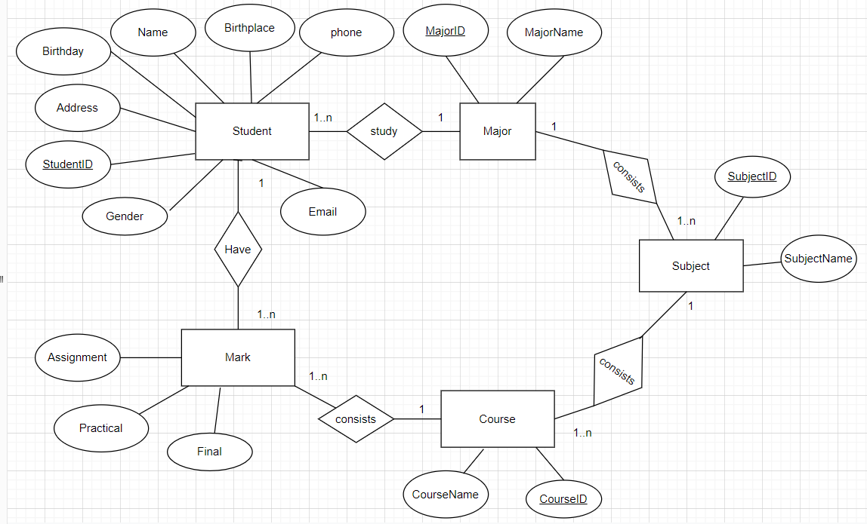

# System Architecture

In this project, we use 3 layers architecture to develop an application and Apply MPV (Model-Presenter-View) pattern in WinForms application. The system operating the software should have .NET Core 5.0 of higher installed.

**Class diagram**

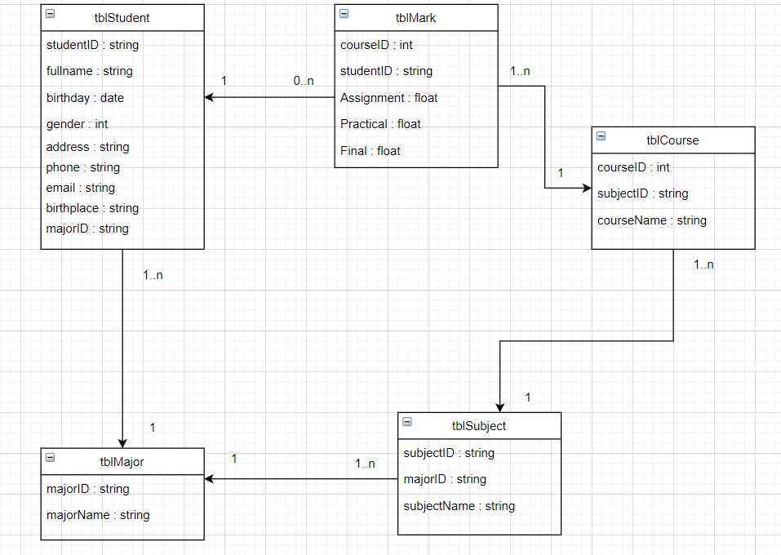

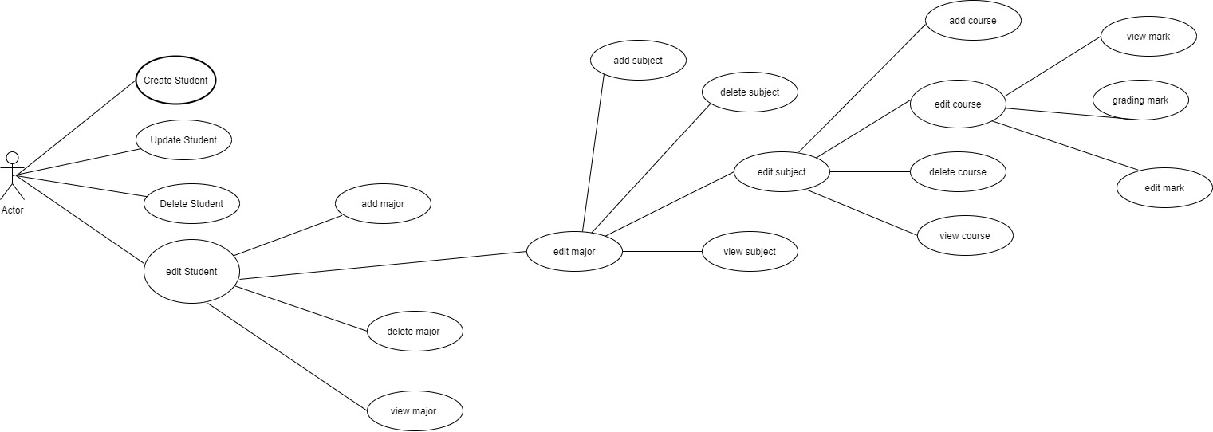

# Implementation

**Login**

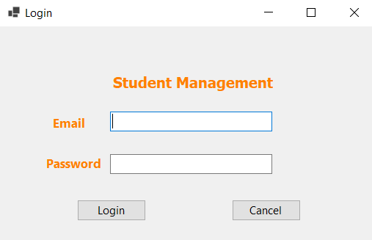

**Home View**

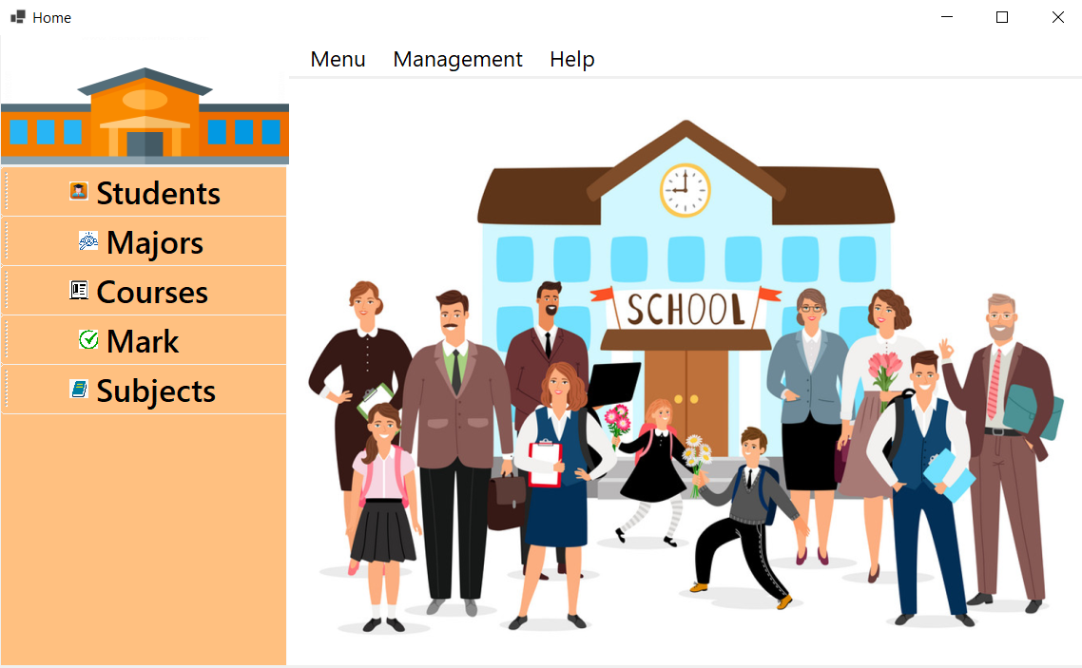

**Menu**

Click on Exit to exit the app

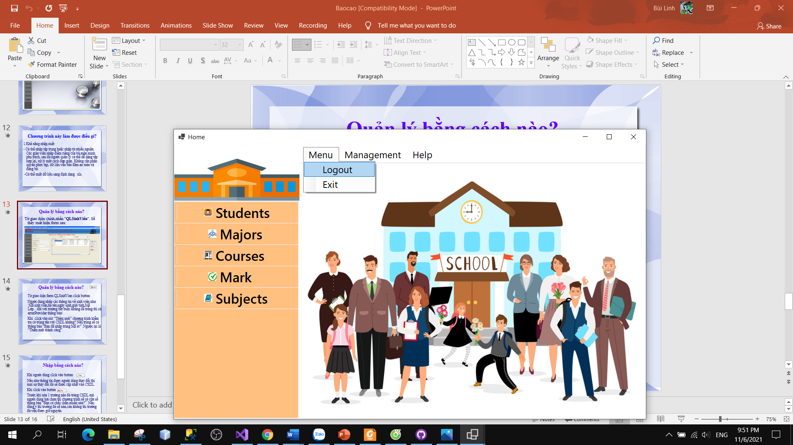

**Logout**

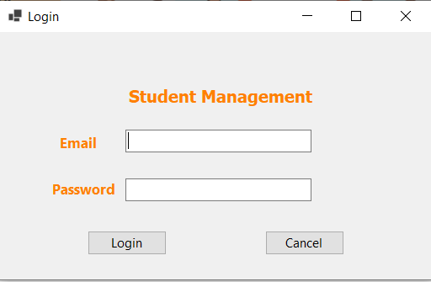

**Management**

Clicking on Students will take you to the Student form

Clicking on Majors will take you to the Major form

Clicking on Subject will take you to the Subject form

Clicking on Courses will take you to the Course form

Clicking on Mark will take you to the Mark form

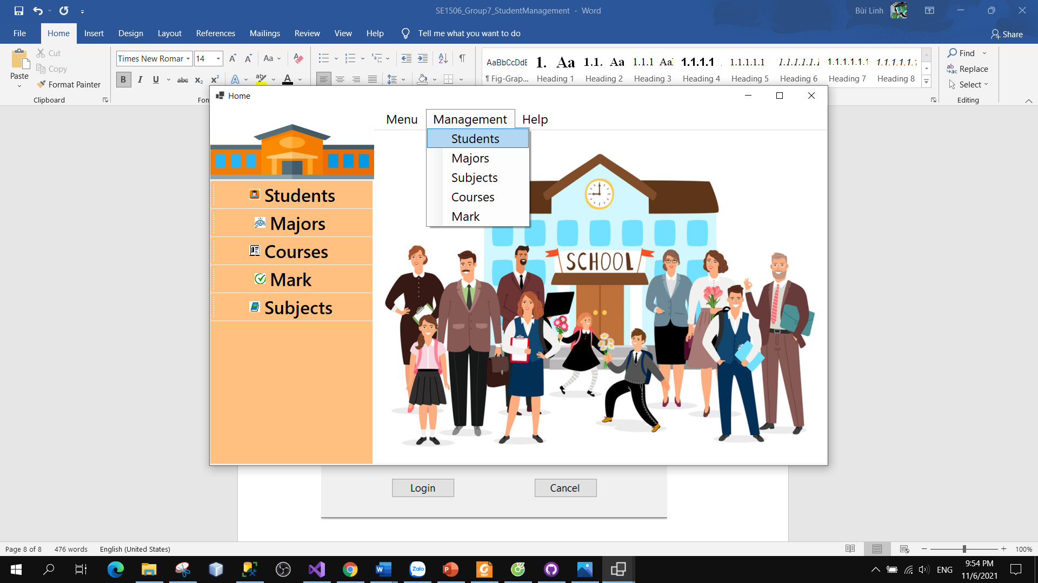

**Button**

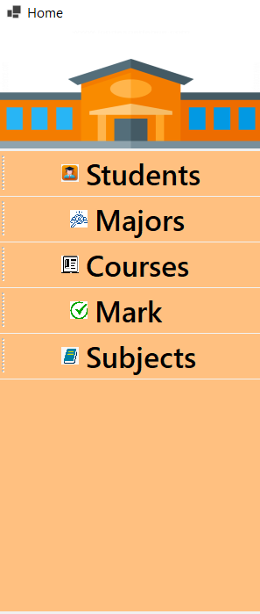

**Form Students**

**Load**

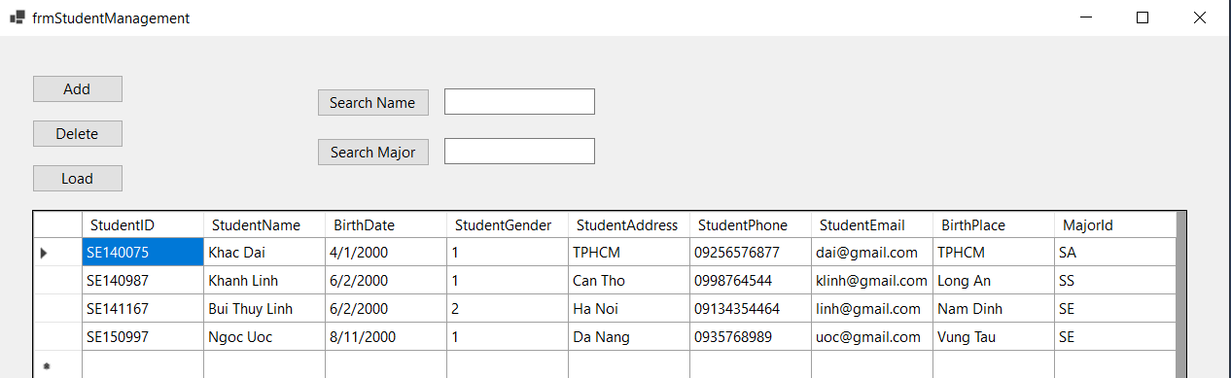

**Add**

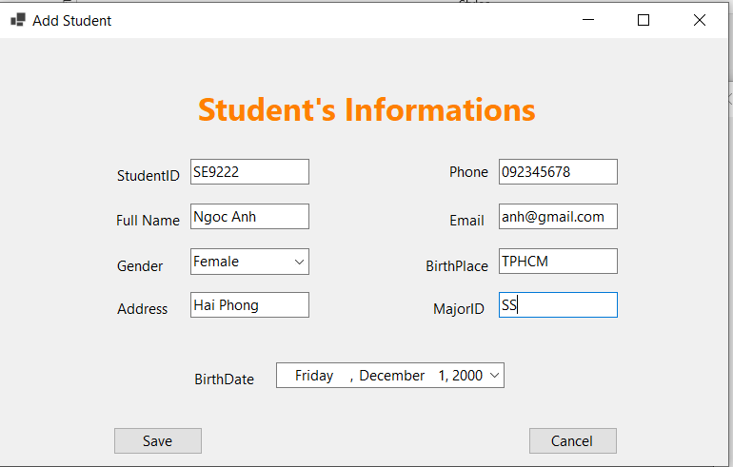

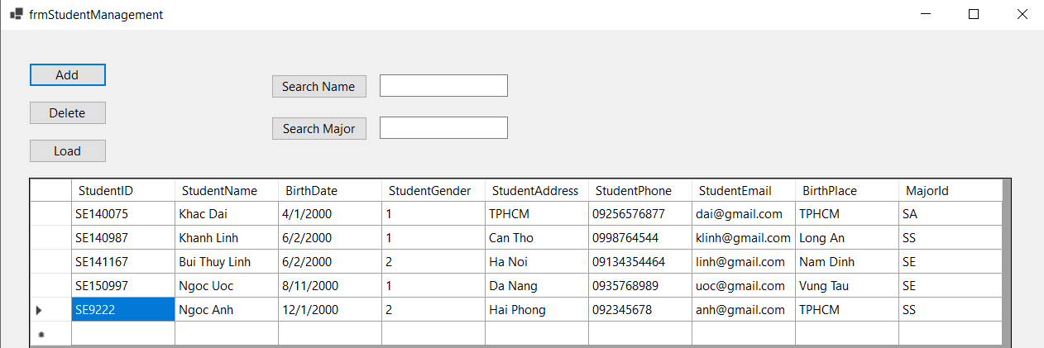

**Delete**

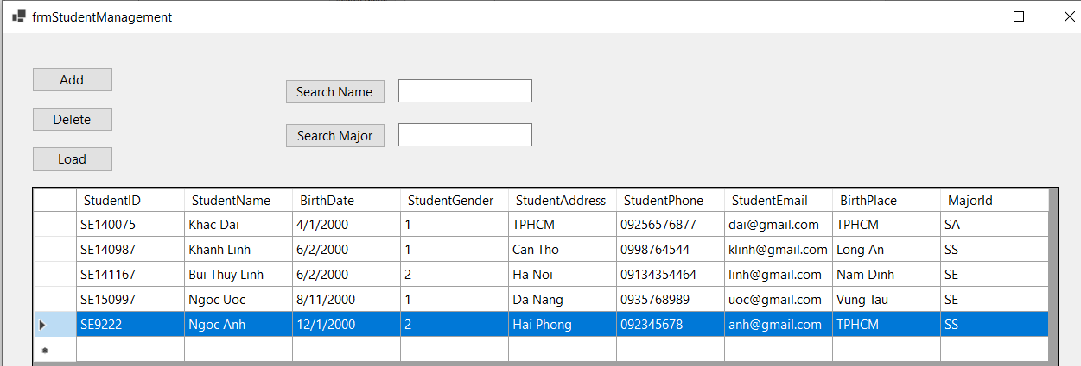

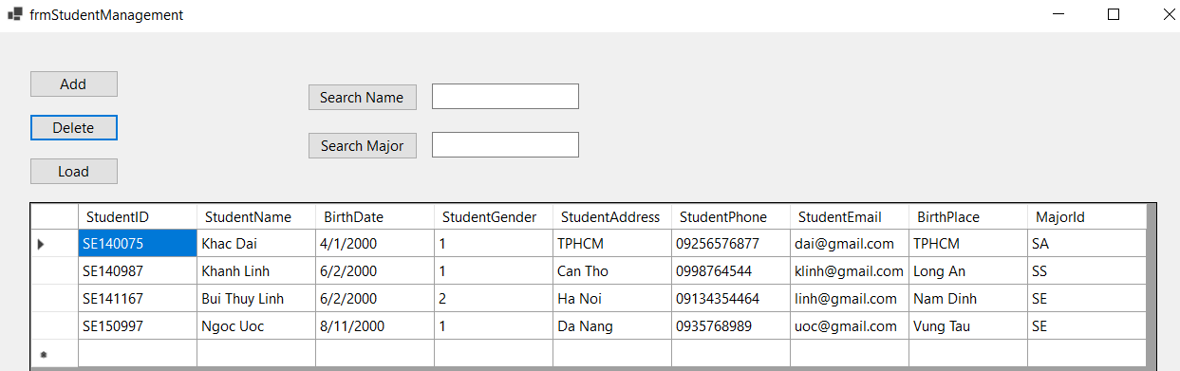

**Update**

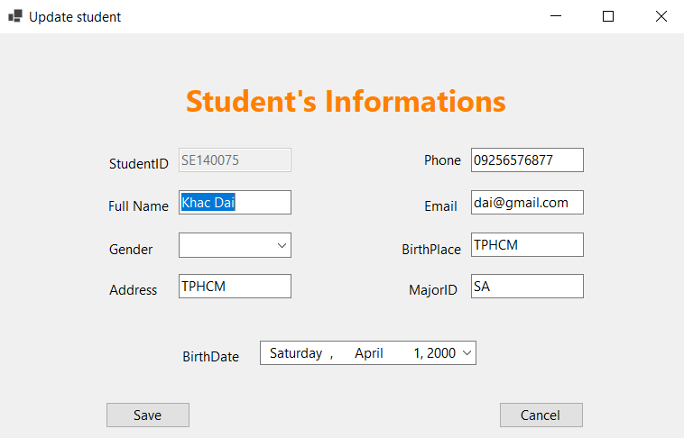

**Search**

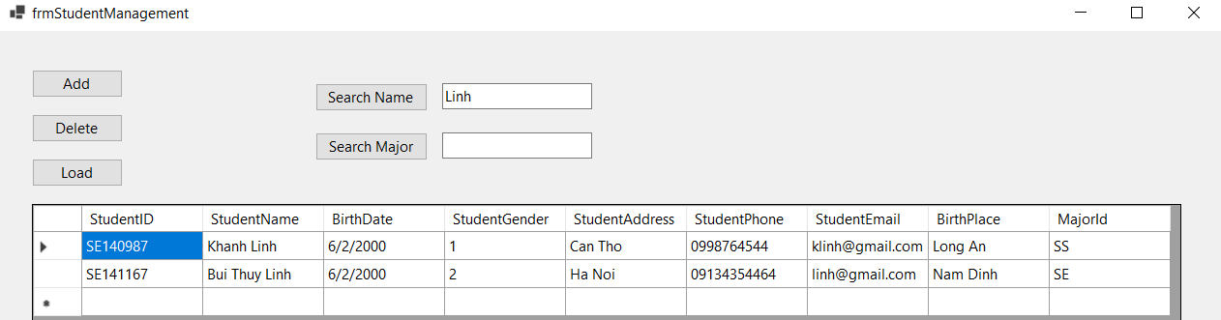

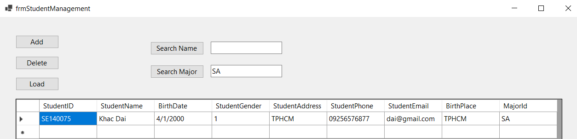

**Majors**

**Load**

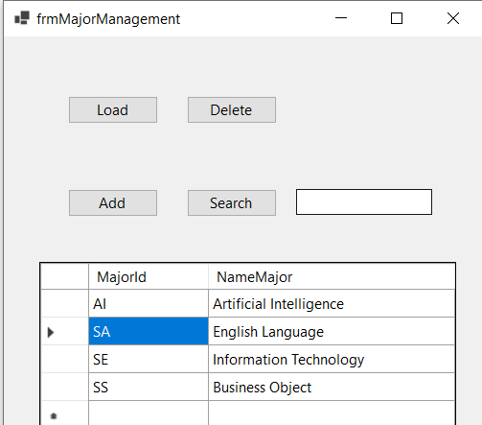

**Add**

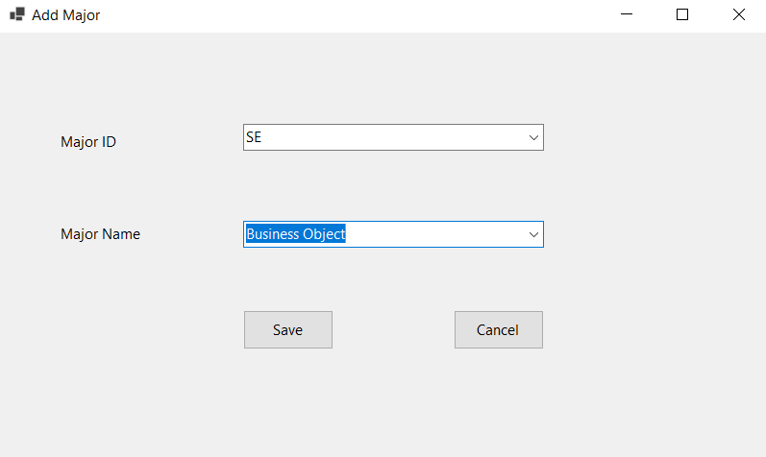

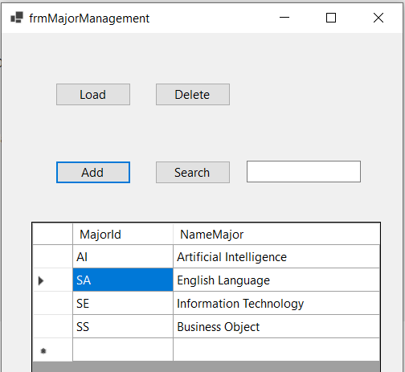

**Update**

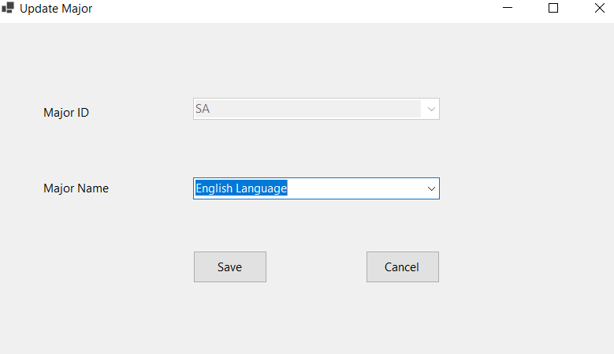

**Delete**

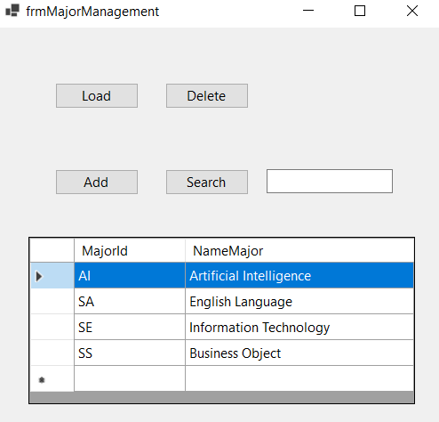

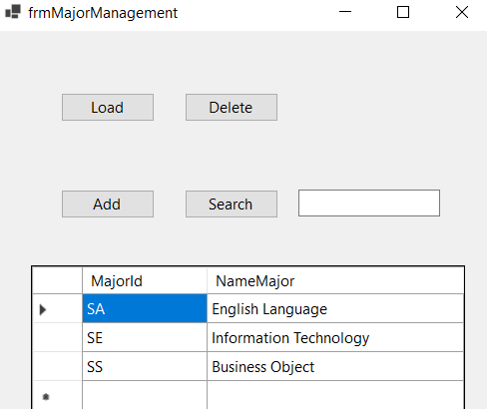

**Search**

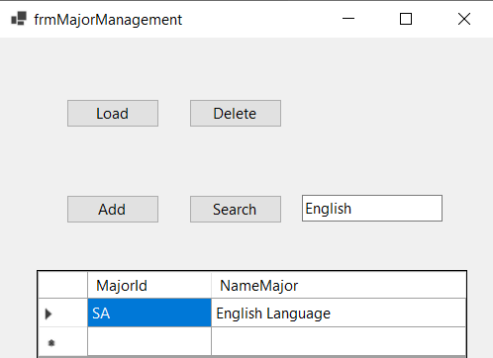

**Couser**

**Load**

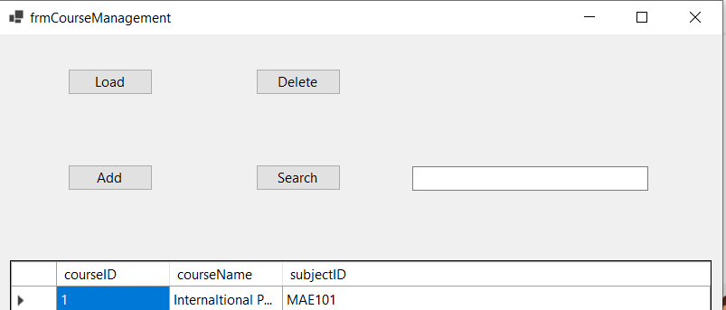

**Add**

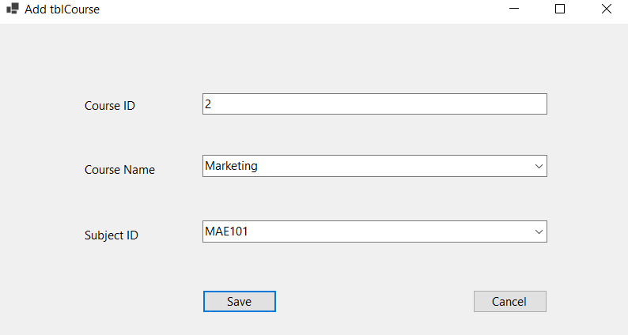

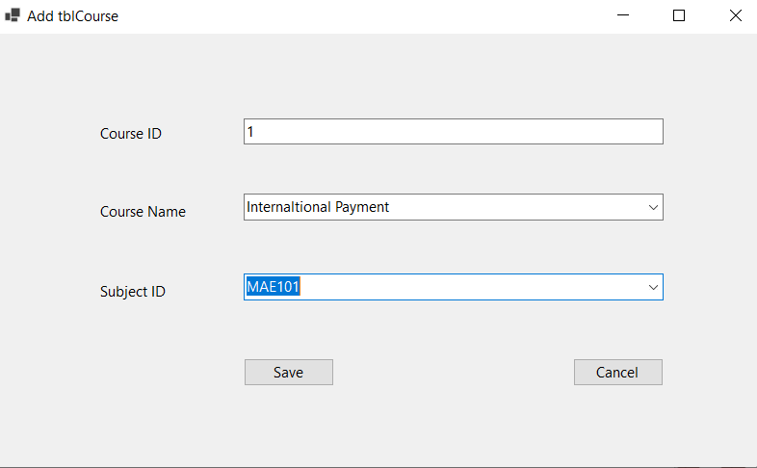

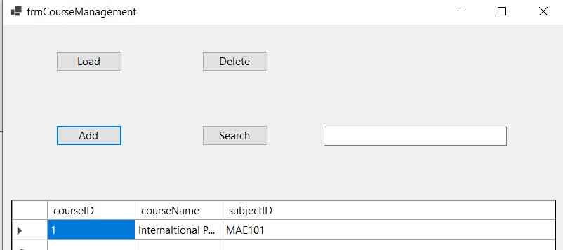

**Search**

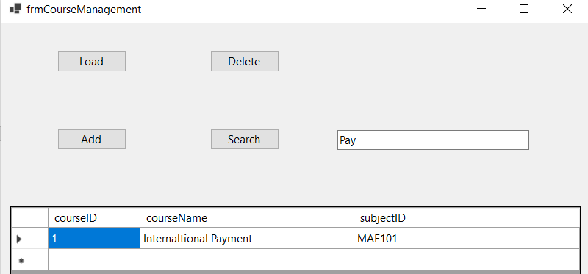

**Mark**

**Load**

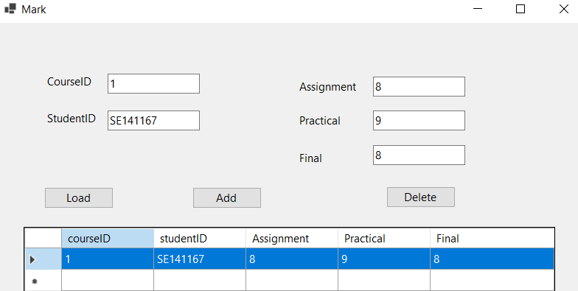

**Add**

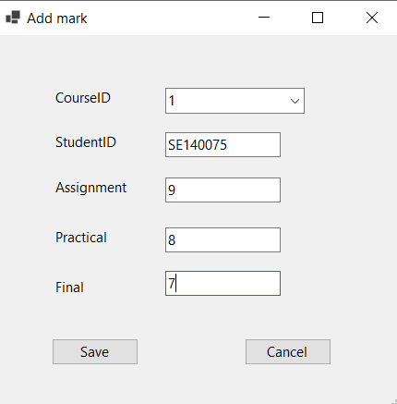

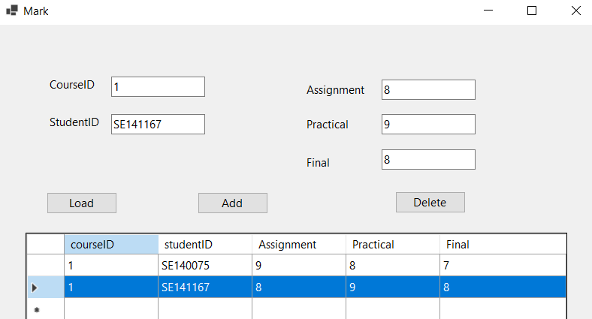

**Delete**

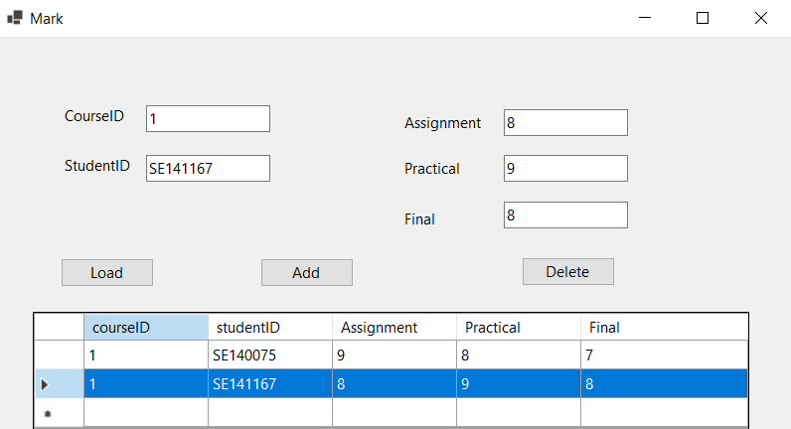

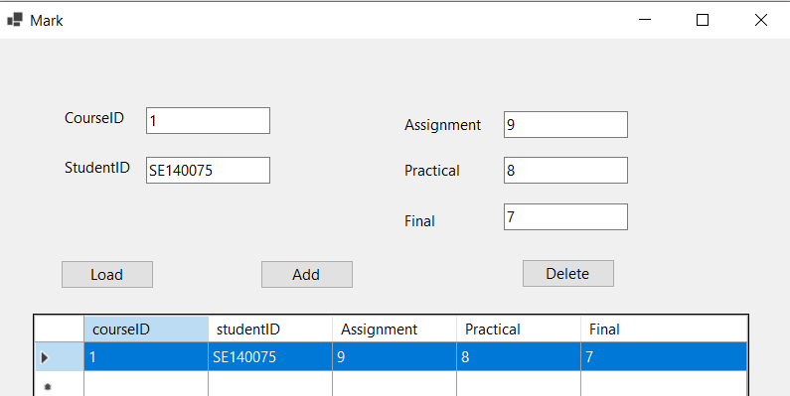

**Update**

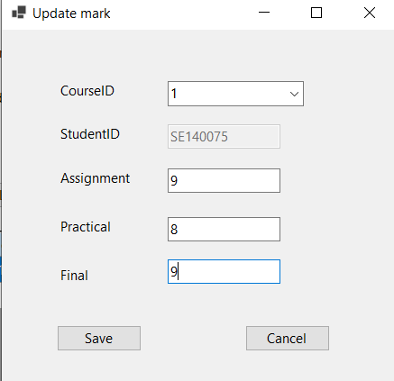

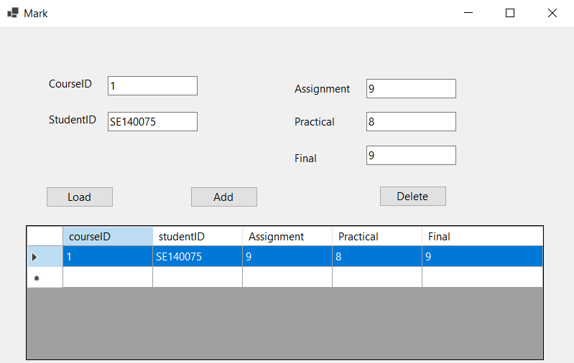

**Subject**

**Load**

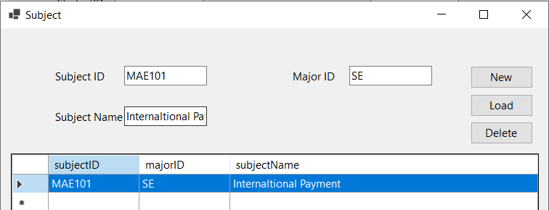

**New**

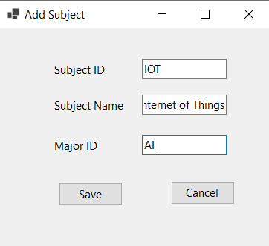

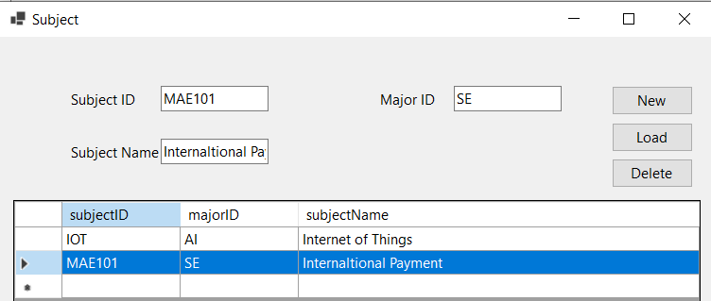

**Delete**





**Update**

