- Intro
- SQL
  - 2020
  - pipeline
  - sets
  - code
  - image
  - was it nails?
- ed
  - Intro

Markus: For our next hammer, we chose emacs, one of the most amazing (blah blah blah)

Matt (puts up slide of “swiss army knife” with a jack hammer, chain saw, etc.)
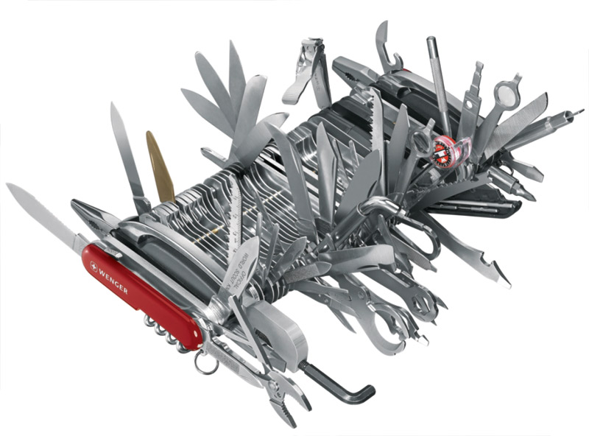
Markus (blather about emacs)

Matt (pondering slide) (interrupts): I don't think that's a hammer.

Markus: huh?

Matt (to audience): What do you think? Does that look like a hammer?

(chatter)

Markus: Ok, VIM then.

Matt (puts up slide with an “apartment tool kit”)

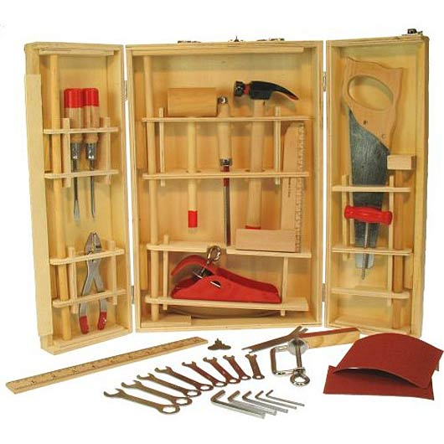
(Same pattern)

Markus: (exasperated) What should we use then?

Matt: ed

Markus: ed?

Matt puts up a slide of a balloon hammer: Now that's a hammer.

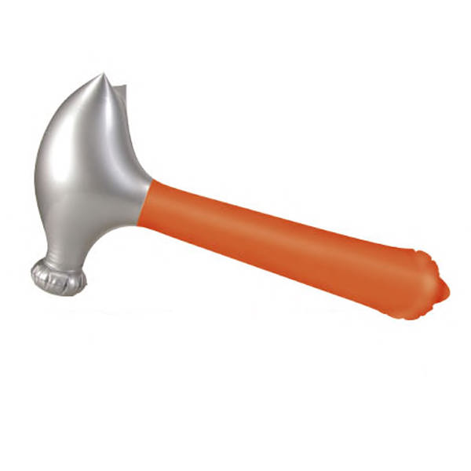
Markus (sighing): Ok, ed it is then.

  - Vim / Emacs wars left no survivors, ditto c / pascal and tastes great / less filling
  - semantics of ed; regex limited, g supresses errors
  - directory structure; code, data, assignment, loader
  - code
  - nails!
- M4 to write config files
  - In ed we were using regular expressions to implement macros? Why not just use a macro processor?
  - Replacement engines are turing complete
- Constraints (one armed man making breakfast)
- Harmonic computing
  - Accordian quote
  - Alternate reality
  - Heterodyne
  - Jello

- Conclusion

In the fib-ed example, we initially thought that everything “looked like text in a file” and, at some level, that was true. But at another level—the level we were really working at—it was far from true.

Yes, our numeric variable files were just text in a buffer, but only in the sense that (insert dramatic jpg here) this image is “just a bunch of ones and zeros”

More pointedly, at some stage in the process we stopped looking at our files as text (even if they were) and started thinking of them as “code” and “data” with specific syntax and semantics, and concerning ourselves with with that level and ignoring their nail-ness.

Likewise with the sql image....

...etc.

In hindsight, this should have been obvious.

At one point, “the only tool you have is a hammer” was literally true.

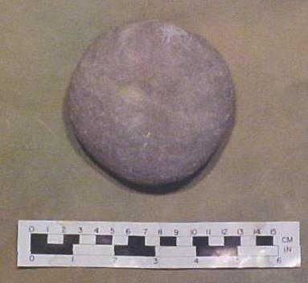

And the people who faced this situation used their hammers....

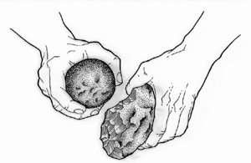

...to make an axe:

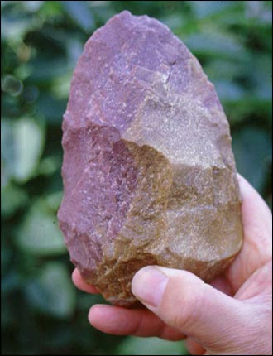

...and some arrows. And awls. And adzes. And chisels. And so on.

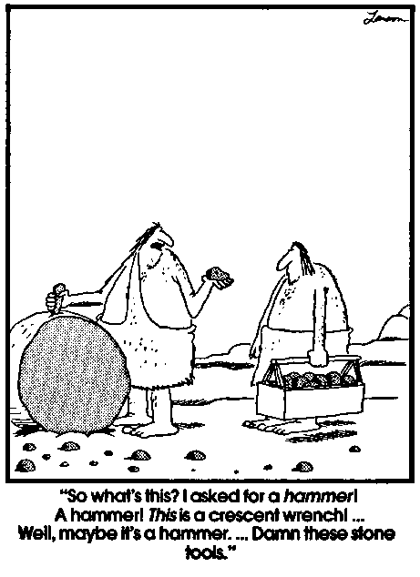
And thus, because people are never entirely satisfied with their tools, we embarked on a centuries-long process of tool building and tool improvement to this very day.

When the only tool you have is a hammer, everything looks like raw materials to make better tools with.

