When the Test Environment Changes
  - ANLY 735 Research Seminar in Predictive AI
Hemendra Gummadi
2026-10-25

Study
Article: WILDS: A Benchmark of in-the-Wild Distribution Shifts
Authors: Pang Wei Koh, Shiori Sagawa, Henrik Marklund, and colleagues
DOI/URL: https://proceedings.mlr.press/v139/koh21a.html
Replication Type: Partial replication using Camelyon17-WILDS
Computational Environment: Python 3.12.14 on Linux x86_64; Quarto 1.10.19
Primary Packages: NumPy 2.3.5, pandas 2.2.3, scikit-learn 1.8.0, SciPy 1.17.0, Matplotlib 3.10.8, Pillow 12.3.0, PyArrow 26.0.0, and fsspec 2026.9.0
Random Seeds: Image sampling 735; patient bootstrap 8735. The classifier uses a deterministic solver.
Repository: https://github.com/builtbyhem/anly735-lab03-builtbyhem

1 Research Claim

What result are you attempting to reproduce
Replication question: When the fitted model and prediction task remain fixed, how much does performance change between familiar hospitals and a hospital outside development?
This laboratory examines the claim that strong in-distribution performance can overstate performance in a meaningfully different environment. The prediction task is binary classification of tumor presence in tissue-image patches. Accuracy is the primary outcome so that the direction of the result can be compared with Camelyon17-WILDS (Koh et al., 2021b). Balanced accuracy, ROC AUC, and Brier score assess class-specific performance, ranking, and probabilistic prediction quality.
The substantive question concerns whether the evidence travels across environments. It does not require a new model for each test condition. One fitted pipeline is evaluated unchanged on both conditions, using a fixed classification threshold of 0.5.

2 Replication Strategy

How will you investigate the claim
This is a partial replication: it retains the Camelyon17-WILDS task and hospital-based split definitions but uses a sampled dataset and a simpler classifier. A pinned public mirror supplies PNG patches and source metadata because the official CodaLab download returned an error. The mirror is not an official Stanford-hosted distribution; its provenance is a limitation, not something assumed away.
The published neural-network baseline is replaced by logistic regression on fixed image statistics so that the analysis can run on a CPU. Therefore, numerical agreement with the original model is not expected, and no claim is made to reproduce its architecture, training procedure, or robustness-algorithm comparisons. The retained comparison is narrower: familiar versus unfamiliar hospitals for the same fitted predictor.
The configuration recorded the sample-selection rule, classifier settings, metrics, threshold, and subgroup analyses before this model’s test results were examined. This is a local decision record, not a formal preregistration. No hyperparameter search, threshold search, or model selection used either evaluation set.

3 Data
The original benchmark adapts the CAMELYON17 challenge data (Bandi et al., 2019). It uses 96-by-96 tissue patches, with a binary label describing tumor presence in the central 32-by-32 region. Its hospital split provides 302,436 training patches, 33,560 ID validation patches, 34,904 OOD validation patches, and 85,054 OOD test patches. ID validation comes from the same 30 slides as training; the OOD test comes from 10 slides in a different hospital (Koh et al., 2021a).
The implementation follows the official zero-indexed hospital codes: 0, 3, and 4 are development hospitals, 1 is OOD validation, and 2 is OOD testing (WILDS contributors, n.d.). The mirror combines both validation conditions in one directory. Hospital metadata separates the ID observations from OOD validation, which is excluded from this fixed-model experiment.
Environment | Patches | Hospitals | Patients | Slides | Tumor (%)
ID | 1500 | 0,3,4 | 26 | 30 | 50.8
OOD | 3164 | 2 | 9 | 10 | 50.6
train | 11200 | 0,3,4 | 26 | 30 | 49.0
Patient and slide identifiers are dataset metadata. Tumor percentages use the recorded sampling weights. “ID” is a held-out evaluation use of the original id_val condition; it is not an official ID test split.
The sample contains 11,200 training patches, 1,500 ID patches, and 3,164 OOD patches. All three source hospitals and all 30 source slides are represented. The shifted sample contains 9 patients and all 10 target slides. ID and training share 26 patients and 30 slides by design, but no sampled image coordinates or exact image hashes overlap across splits. Target patients and slides are absent from development.

Sampling and provenance
The PNG mirror is pinned to revision d784d5344ba6c967f83f9f3d9b2f1e2a4d6eb78f (wltjr1007, n.d.). Its complete shard counts match the documented training, combined-validation, and test counts. Every processed image was checked for PNG encoding and 96-by-96 dimensions. These checks establish consistency; they do not establish bitwise equivalence to the unavailable official archive.
To limit downloading, entire Parquet row groups were sampled uniformly without replacement within every shard: 8 per training shard, 12 per combined-validation shard, and 8 per test shard. Selection used seed 735 and deterministic file-specific seeds before inspecting labels. Each row group contains at most 100 patches. There are 14 training, 3 combined-validation, and 4 test shards; all were included in the sampling frame.
The realized sample is a cluster sample, not a simple random sample of patches. Its manifest records selected groups, source-row locations, and inclusion probabilities. Weights are inverse inclusion probabilities. Within each evaluation environment these probabilities are constant, so weighting leaves the displayed evaluation averages unchanged. The sample was not adjusted after seeing performance.

4 Method
The pipeline extracts 88 fixed image features from the whole patch and central 32-by-32 region. For each region, each RGB channel contributes mean, standard deviation, 10th/50th/90th percentiles, and an eight-bin histogram. Grayscale horizontal and vertical gradients and three dark-pixel fractions complete the feature set. Pixels are scaled by the fixed constant 255; no per-image stain normalization is applied.
StandardScaler is fitted only on training features. Logistic regression uses C=1, the lbfgs solver, a maximum of 2,000 iterations, and inverse sampling weights in its fitting objective. It converged after 330 iterations. The fitted scaler, coefficients, and 0.5 decision threshold are reused unchanged for both evaluation sets. Hospital, patient, slide, coordinates, identifiers, and labels are excluded from the predictors.
Accuracy measures the fraction of correctly classified patches. Balanced accuracy averages sensitivity and specificity, helping distinguish a class-mixture effect from class-specific errors. ROC AUC measures ranking over thresholds. Brier score is mean squared probability error; lower is better. It reflects overall probability quality and does not isolate calibration from discrimination.
The accompanying project contains the feature snapshot, source-row manifest, per-image hashes, executable preparation and analysis scripts, exact dependencies, raw predictions, and input/code hashes. Analytical reproduction works offline from the snapshot. Regenerating image features requires access to the pinned mirror.

5 Results
Measure | ID | OOD | Change (OOD minus ID)
Accuracy | 87.67% | 61.88% | -25.78 pp
Balanced accuracy | 87.72% | 61.61% | -26.12 pp
ROC AUC | 0.952 | 0.467 | -0.484
Brier score | 0.090 | 0.344 | +0.254
Changes in accuracy and balanced accuracy are percentage points, not relative percentages. AUC and Brier changes are on their original scales.
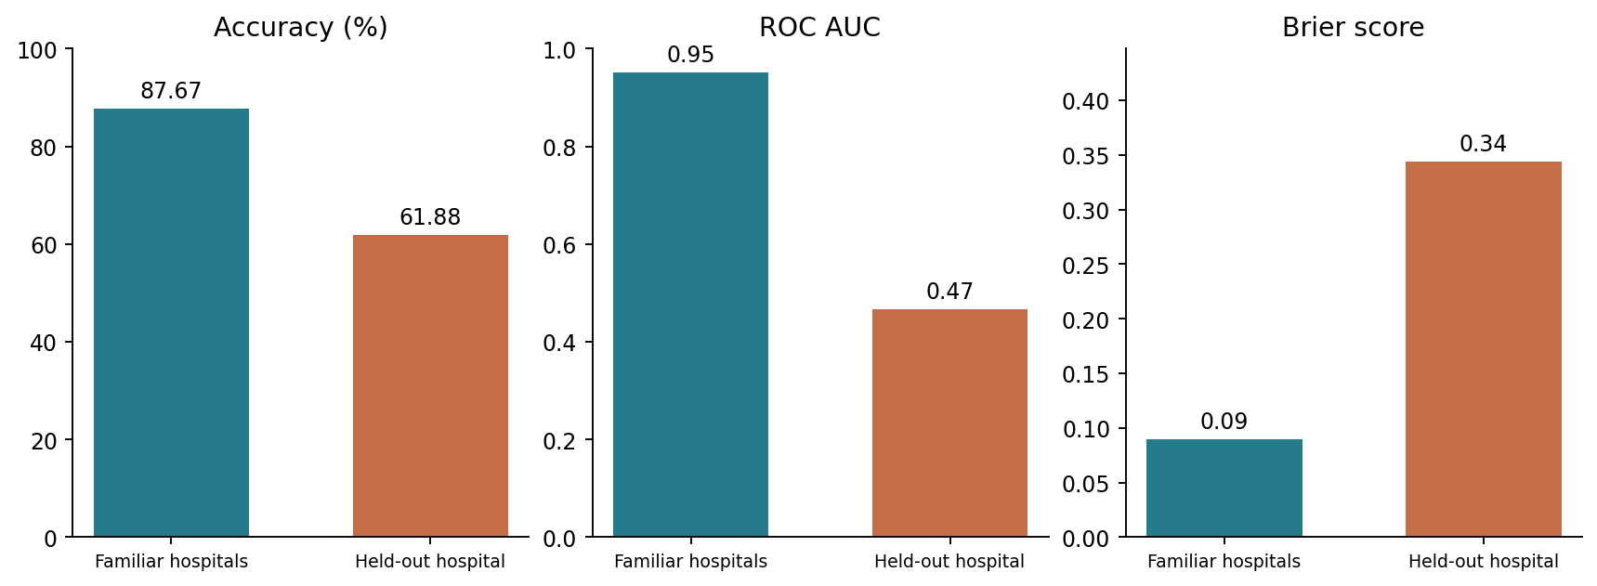
Figure 1: One fitted classifier evaluated on familiar hospitals and the held-out hospital. Higher accuracy and AUC are better; lower Brier score is better.
Accuracy changed from 87.67% to 61.88%, a difference of -25.78 percentage points. Balanced accuracy changed by -26.12 points, ROC AUC by -0.484, and Brier score by +0.254. Higher accuracy, balanced accuracy, and AUC are better; lower Brier score is better.
The average accuracy decrease is 25.78 percentage points. The AUC point estimate falls close to chance, while probability error also increases substantially. Comparing the raw magnitudes of these differently scaled metrics would be misleading. The most pronounced interpretable class-level change is the loss of specificity, shown below.

Class-specific errors and local performance
Class / measure | ID patches | ID performance | OOD patches | OOD performance | Change
Non-tumor / specificity | 738 | 91.19% | 1563 | 38.52% | -52.68 pp
Tumor / sensitivity | 762 | 84.25% | 1601 | 84.70% | +0.45 pp
Tumor sensitivity changes by less than one percentage point, while specificity falls by 52.68 points. The false-positive rate consequently rises from approximately 8.81% to 61.48%. The shifted classifier therefore makes many more false tumor classifications among non-tumor patches. An aggregate accuracy number alone would obscure that asymmetry. These are patch-level errors; they cannot be translated directly into patient-level diagnoses or clinical consequences.
Environment | Slides | Minimum slide accuracy | Median slide accuracy | Maximum slide accuracy
ID | 30 | 45.1% | 91.5% | 100.0%
OOD | 10 | 13.9% | 48.3% | 82.2%

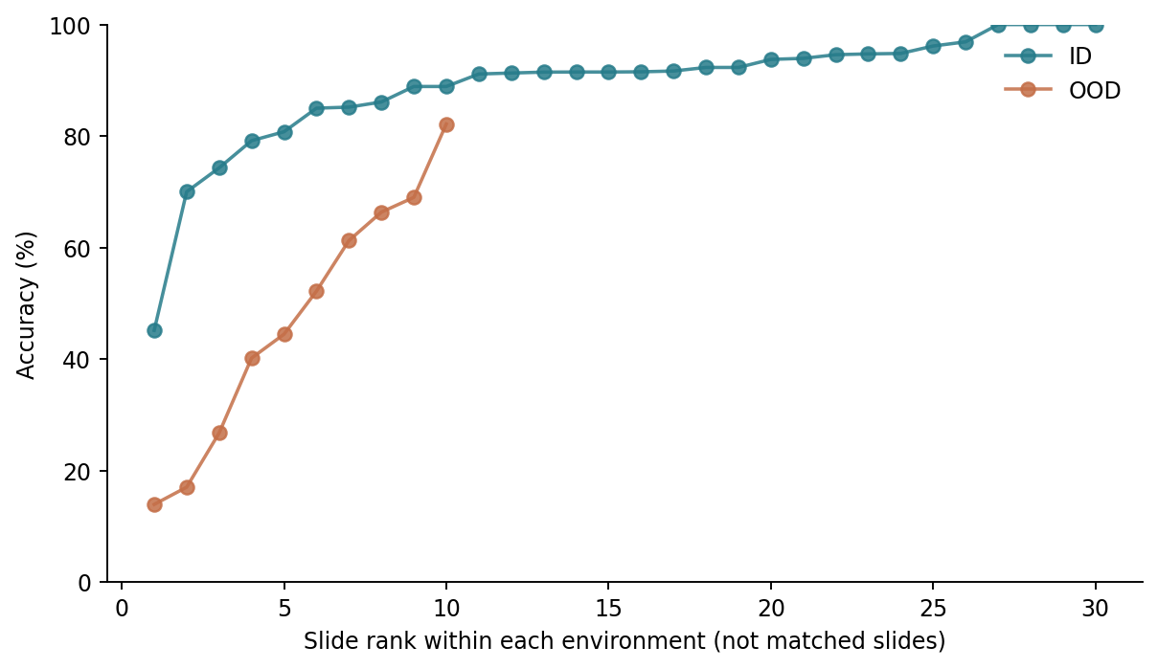
Figure 2: Accuracy across sampled slides, ordered separately within each environment. The ranked positions do not pair corresponding slides across hospitals.
The aggregate also hides substantial variation across slides. ID slide sample sizes range down to five patches, whereas every sampled OOD slide has at least 100 patches. Some local estimates are therefore much less stable than others. Minimum, median, and maximum slide accuracies are descriptive summaries, not evidence that a particular slide or patient characteristic caused the difference. Complete slide counts and results are retained in the CSV output.

Uncertainty
Measure | ID 95% interval | OOD 95% interval | Difference 95% interval
Accuracy | [80.27, 92.97]% | [36.34, 74.81]% | [-52.37, -11.36] pp
Balanced accuracy | [78.51, 92.90]% | [49.60, 68.38]% | [-38.55, -14.19] pp
Brier | [0.05, 0.14] | [0.22, 0.61] | [0.12, 0.52]
Intervals use 1,000 percentile-bootstrap resamples of patients separately within each environment, with seed 8735. All sampled patches belonging to a resampled patient stay together. This avoids treating neighboring patches as independent observations. The accuracy-difference interval is approximately −52.37 to −11.36 percentage points.
Eight OOD bootstrap resamples contain only one class; balanced accuracy is undefined for those resamples. Its OOD and difference intervals therefore use 992 valid replicates, while all accuracy and Brier intervals use 1,000. The exact counts are recorded. These approximate intervals condition on the fitted model and sampled images; they do not represent uncertainty across possible target hospitals or training datasets. With only nine sampled target patients, their precision is limited.

Diagnosis before intervention
The outcome proportions are nearly equal: approximately 50.8% tumor in ID and 50.6% in OOD. Balanced accuracy also declines substantially, and the class-specific table localizes the problem to non-tumor patches. A different tumor proportion is therefore not an adequate explanation for the observed accuracy loss.
Center-patch feature | ID mean | OOD mean | Difference / training SD
center_r_mean | 0.747 | 0.671 | -0.65
center_g_mean | 0.587 | 0.474 | -0.78
center_b_mean | 0.722 | 0.735 | +0.10
RGB means are on a 0–1 scale. Standardized differences compare OOD with ID using the training-feature standard deviation.
The target patches have lower mean red and green intensities in their central regions. The green-channel difference is about 0.78 training standard deviations. Across all 88 features, the largest absolute standardized difference is in the whole-patch fraction of red-channel pixels between 0.125 and 0.25: it increases from 0.66% to 4.18%, or 1.31 training standard deviations. The complete feature audit is retained in feature_shift.csv.
These measured differences make color-sensitive representation a plausible vulnerability of this particular classifier. They do not demonstrate that staining caused the errors. Scanner characteristics, tissue composition, sampling, and relationships between features and labels can also contribute.
The provided fields and image dimensions are consistent across environments, and no feature values are missing. Consistent encoding does not prove equivalent acquisition or measurement practices. This design cannot isolate covariate shift from a changed feature-outcome relationship, and a low OOD AUC alone does not identify the causal mechanism. Retraining, recalibration, and changing the threshold are deliberately deferred until after diagnosis.

6 Compare

How closely did your results align with the original study
Evidence | Original study | This replication
ID accuracy | 93.2% | 87.67%
OOD accuracy | 70.3% | 61.88%
OOD minus ID | -22.9 pp | -25.78 pp
Model | DenseNet 121 | Image features and logistic regression
Koh et al. (2021b) report Camelyon17 ERM accuracy of 93.2% ID and 70.3% OOD, a 22.9-point decrease. The present classifier also deteriorates across hospitals, but its 25.78-point gap is not a numerical replication of that result. A different representation, fitting objective, and sampled cohort can change both performance levels and the gap.
The original baseline uses a DenseNet-121 trained from scratch and aggregates results across 10 seeds (Koh et al., 2021a). Our experiment uses one deterministic feature-based classifier. Its patient-bootstrap intervals and the paper’s between-seed standard deviations quantify different sources of variation and should not be treated as interchangeable.
The benchmark deliberately includes consequential shifts, and this target hospital was selected for visually distinctive patches (Koh et al., 2021a). The result consequently supports a claim about this defined hospital contrast, not an estimate of how often an arbitrary deployment shift will cause failure.

Deployment judgment and claim boundaries
Judgment: Revalidate before deployment in the shifted environment.
The unchanged classifier’s loss of specificity, weakened ranking, and increased probability error make its ID performance an inadequate basis for transport. The evidence does not support autonomous use in the target environment. Because this is a research classifier evaluated on selected patches, it also does not establish that the ID performance would have justified clinical deployment in the source hospitals.
Additional evidence should include an agreed use case and acceptable false-positive/false-negative tradeoff, independent slides and patients from additional hospitals, representative prevalence, patient- or slide-level evaluation, measurement checks, and an external evaluation of any revised pipeline. Threshold changes or recalibration would require separate development data and a subsequent untouched evaluation. No clinical cost or safety threshold was supplied, so no such threshold is invented here.
Supported claim: for this fixed sampled-image pipeline, performance is substantially worse at the specified held-out hospital, with degradation concentrated in specificity.
Unsupported claims: staining is the proven cause; all unseen hospitals would fail similarly; the published DenseNet result has been numerically reproduced; or these patch-level results establish patient-level performance, fairness across demographic groups, or deployment safety.

7 Reproducibility Check
- Data source documented
- Code runs from beginning to end
- Computational environment identified
- Software and packages documented
- Package versions documented
- Random seeds documented
- Key preprocessing steps documented
- Evaluation procedure documented
- Repository README provides reproduction instructions
What was the greatest reproducibility challenge you encountered?
The main challenge was preserving the hospital comparison when the official download was unavailable. I used a pinned PNG mirror, checked full split counts and hospital metadata, recorded image hashes and sampled row locations, and retained a feature snapshot for offline reproduction. A second run produced identical predictions, and raw-prediction arithmetic independently matched accuracy and Brier scores. These checks verify this analysis without proving equivalence to the unavailable archive. The simpler classifier is another explicit departure; its results are not presented as the paper’s neural-network baseline.

Limitations of the evidence
Several limitations matter to the interpretation. First, the mirror preserves useful metadata and lossless PNG encoding, but no official archive checksum was available for comparison. Pinning its revision and retaining image hashes makes our input reproducible without proving its equivalence to every original patch.
Second, row-group sampling can retain correlated or locally ordered observations and alter the realized mixture of tissue patterns. The known sampling probabilities support weighted summaries, but the patient bootstrap is not a complete design-based variance estimate for the row-group sampling process. A different sampled set could yield a different gap. Small ID slide samples also limit claims about local failures.
Third, ID patches come from the same slides and patients as training. This follows the benchmark’s familiar-environment comparison, but it can make ID performance favorable relative to testing new slides even within the same hospitals. The hospital contrast therefore combines changes in institution with a change from familiar slides to entirely new slides and patients.
Fourth, the 88-feature representation is intentionally limited. It can rely strongly on color and simple texture while missing morphology available to a convolutional model. Its failure cannot establish the cause or extent of failure in DenseNet or in clinical pathology systems. Likewise, one target hospital cannot characterize transportability across all institutions. Brier scores on roughly class-balanced research samples should not be interpreted as field calibration under a different prevalence.
Reproduce and render:
python code/run_analysis.py
quarto render replication-lab.qmd --to html
quarto render replication-lab.qmd --to docx
python code/format_report.py replication-lab.docx
The feature snapshot supports offline analytical reproduction. Rebuilding it requires python code/prepare_data.py and network access. Package versions, raw predictions, hashes, and a complete session record are retained in the repository. AI assistance supported implementation, checking, and drafting; the author remains responsible for reviewing and defending the analysis.

8 Extend

What did the replication reveal that you would investigate next
I would conduct leave-one-source-hospital-out evaluation across hospitals 0, 3, and 4. At each of three rotations, fit the same fixed feature pipeline on two hospitals and evaluate the third without tuning its threshold. Prespecify specificity loss as the main diagnostic outcome, with balanced accuracy as a companion measure. This would test whether the observed false-positive problem recurs across other hospital changes or is concentrated in the selected target contrast. It would add evidence about cross-hospital variability without searching for a more favorable model. This extension is proposed, not executed.

Replication Verdict
- Reproduced The central result was substantially reproduced.
- Partially Reproduced Some findings were reproduced, but meaningful differences remain.
- Not Reproduced The central result was not reproduced.
- Not Directly Comparable Numerical comparison is not appropriate for a proxy replication.
The same fitted model performs worse at the specified held-out hospital, with degradation concentrated in specificity. The sampled mirror data and simpler classifier do not reproduce the original architecture, full-data analysis, or multi-seed results, so the verdict is partial. This verdict concerns alignment with the research claim; the deployment judgment concerns whether there is enough relevant evidence for use.

References
Bandi, P., Geessink, O., Manson, Q., Van Dijk, M., Balkenhol, M., Hermsen, M., Bejnordi, B. E., Lee, B., Paeng, K., Zhong, A., et al. (2019). From detection of individual metastases to classification of lymph node status at the patient level: The CAMELYON17 challenge. IEEE Transactions on Medical Imaging, 38(2), 550–560.
Koh, P. W., Sagawa, S., Marklund, H., Xie, S. M., Zhang, M., Balsubramani, A., Hu, W., Yasunaga, M., Phillips, R. L., Gao, I., Lee, T., David, E., Stavness, I., Guo, W., Earnshaw, B., Haque, I., Beery, S. M., Leskovec, J., Kundaje, A., … Liang, P. (2021a). Supplementary material: WILDS: A benchmark of in-the-wild distribution shifts. https://proceedings.mlr.press/v139/koh21a/koh21a-supp.pdf
Koh, P. W., Sagawa, S., Marklund, H., Xie, S. M., Zhang, M., Balsubramani, A., Hu, W., Yasunaga, M., Phillips, R. L., Gao, I., Lee, T., David, E., Stavness, I., Guo, W., Earnshaw, B., Haque, I., Beery, S. M., Leskovec, J., Kundaje, A., … Liang, P. (2021b). WILDS: A benchmark of in-the-wild distribution shifts. Proceedings of the 38th International Conference on Machine Learning, Proceedings of Machine Learning Research, 139, 5637–5664. https://proceedings.mlr.press/v139/koh21a.html
WILDS contributors. (n.d.). WILDS dataset implementation: Camelyon17. Retrieved https://github.com/p-lambda/wilds/blob/main/wilds/datasets/camelyon17_dataset.py
wltjr1007. (n.d.). Camelyon17-WILDS: PNG and metadata mirror. Retrieved https://huggingface.co/datasets/wltjr1007/Camelyon17-WILDS

