**C++ CLOCK_REALTIME vs. CLOCK_MONOTONIC in Overlay implementation**

**1 - Situation:**

Our project supports one interesting feature called Overlay – 5 types of which are demonstrate in the higher layers than screen layer in z-axis order. They are Pop-up, Notification, Important Notification, QSP, Quick note.

Flow design: Producer – consumer; Thread pool pattern

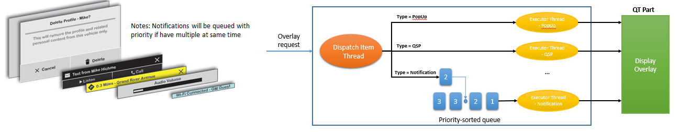

One of the most essential characteristics of Overlay is “existing duration”. For example, the Audio Volume qsp will automatically hide after 1 second if user do not touch on it.

Currently, we are using time functions supported by C++ to control the waiting time.

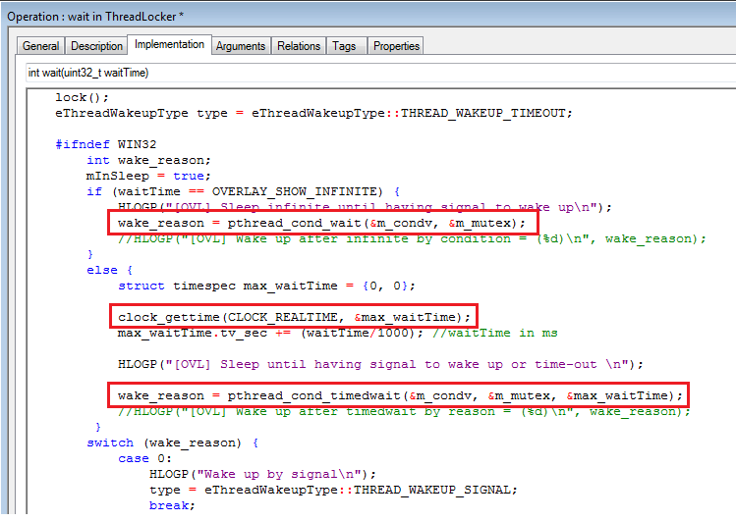

The bug is discovered as below reproduction route:

1. Set system time is 10a.m
2. Display an overlay which has shown duration is 60 seconds
3. Adjust system time to 11a.m => overlay timed-out immediately => bug
4. Adjust system time to 9a.m => overlay does not hide after 60s, the actual hidden time is 1 hour and 1 minutes => bug

**2 - Analysis:**

In function clock_gettime(), clock_id = CLOCK_REALTIME is being used.

http://www.qnx.com/developers/docs/6.5.0/index.jsp?topic=%2Fcom.qnx.doc.neutrino_lib_ref%2Fc%2Fclock_gettime.html

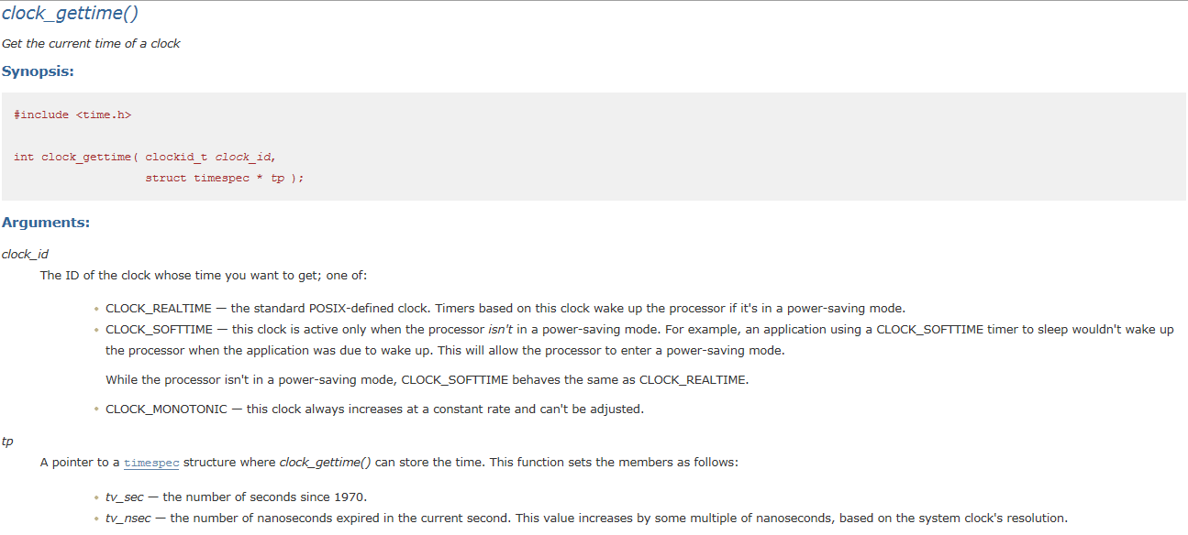



Obviously, while using this clock_id, the system time affects wake-condition of function pthread_cond_wait(). It looks like if overlay appears at 10:00 then it will disappear at exactly 10:01.

**3 - Solution:**

Use clock_id = CLOCK_MONOTONIC

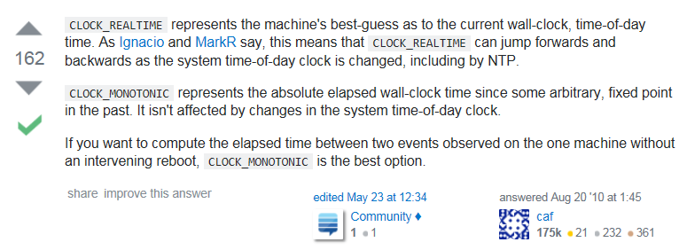

https://stackoverflow.com/questions/3523442/difference-between-clock-realtime-and-clock-monotonic

Why? Change the attribute in function pthread_cond_init() from *NULL* to *&attr*.

