**How to commit project after long time of modification on local workspace**

Pre-condition:

+ 10 days ago, I pulled the I3L-project code to my local workspace (D:\GIT\I3L_Modeling)

+ During that time, I added the state charts for Safety App (VPM, RVC, APA) without updating the code daily.

+ Today, when I intend to commit my modifications to master branch, a big issue occurs – I cannot resolve conflict while pull the latest code from remote repository. There are too many modifications during 10 days, despite resolving many time, build errors happen.

Here are my steps:

**Step 1: Create code reservation.**

First, I make a copy of I3L_Modeling local workspace (let’s call A) to another directory (called B).

**Step 2: I delete my commits on local repository (commits of Safety App modifications)**

<https://ncona.com/2011/07/how-to-delete-a-commit-in-git-local-and-remote/>

Before,

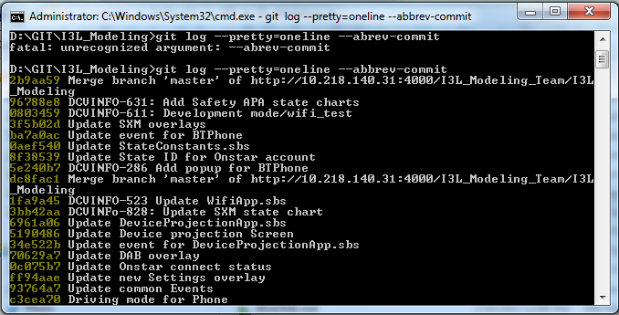

After, git reset --hard HEAD~2

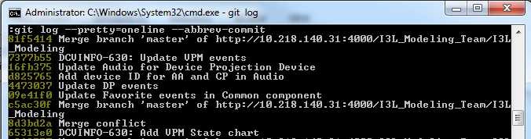

Result:

+ 2 latest commits 96788e8 and 2b9aa59 disappear.

+ The I3L project code in my workspace is back to 10 days ago. My modifications has gone.

**Step 3: Pull the latest code from remote repository to local workspace then re-build project.**

TortoiseGit > Pull

Delete folder libHMI\QNX_ARM before rebuild.

After building success, we are ready to merger code from B directory

**Step 4. Merge code.**

+ **SafetyApp.sbs**

Copy SafetyApp.sbs from (B) to (A)

Rebuild 1st, error:

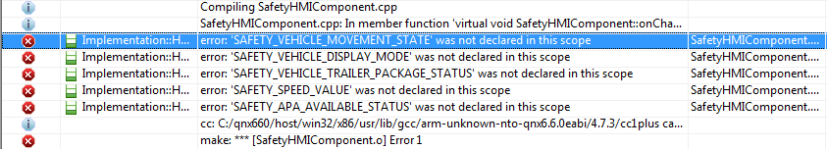

+ Update **eSafetyStateIDs** (in Package Model_IPC_Interface/StateContants)

Also copy from (B). This constant variable contains all key value of Safety App.

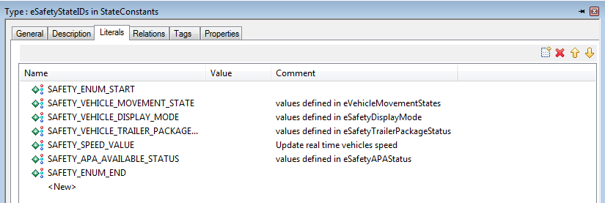

Rebuild 2nd, success – but not enough.

+ Add events list to **HMIEventFactory** class (in package HMIComponent)

Attribute: mSafetyEventMap

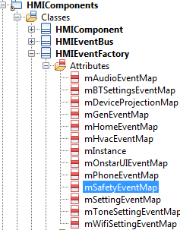

Operations:

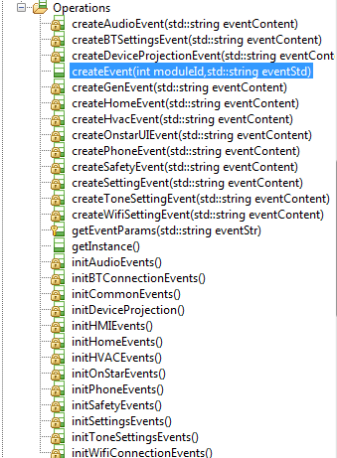

Copy the operation implementations from (B) to (A)

Library: HMIEventFactory > Properties > In CPP_CG > ImpIncludes

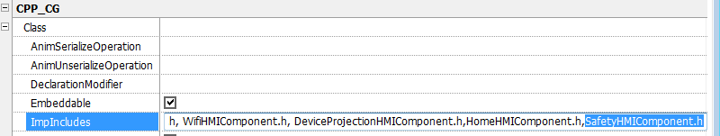

Rebuild 3rd, success

I try to commit to master, there are only 3 modified files. That is heaven compared to the previous effort.

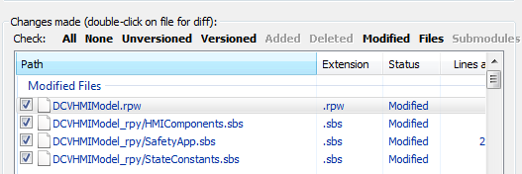

**!!! Not urgent but important**

+ Animation code in **main.cpp** (I3L_Modeling/Test/HMIModelVerification)

Add the code for Safety animation:

