How to create a new git branch

**1. Pre-condition**

Master: <http://10.218.140.31:4000/I3L_Modeling_Team/Lib.git>

We are going to create new git branch “safety_under_testing” for safety app development.

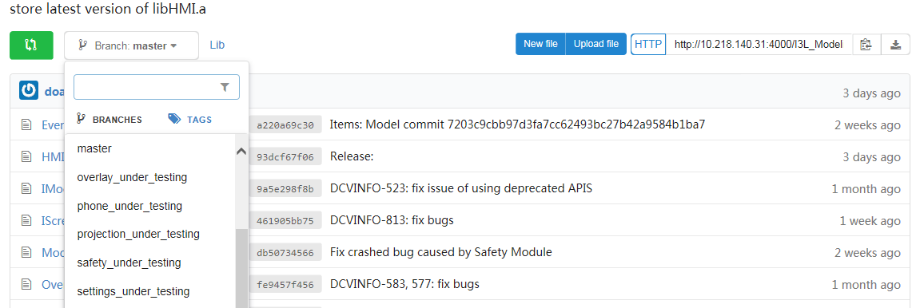

**2. Steps**

Step 1. Pull master to local workspace

E.g. Libs

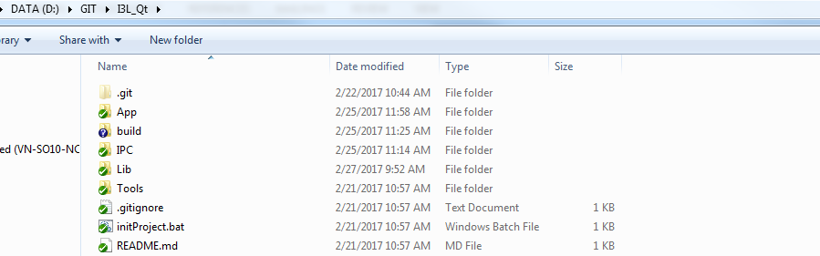

Step 2. Create new branch

Right click on folder Lib > TortoiseGit > Create Branch…

> Fill out the new branch name.

> Input the user name and password

=> New branch will be created on local repository.

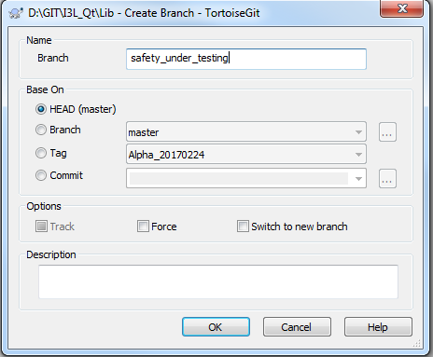

Step 3. Switch to new branch

Right click on folder Lib > TortoiseGit > Switch/check out

> Change from ‘master’ to ‘safety_under_testing’

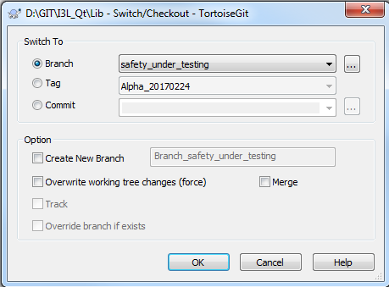

Now we can see the difference when Git Commit. Not commit to ‘master’ anymore.

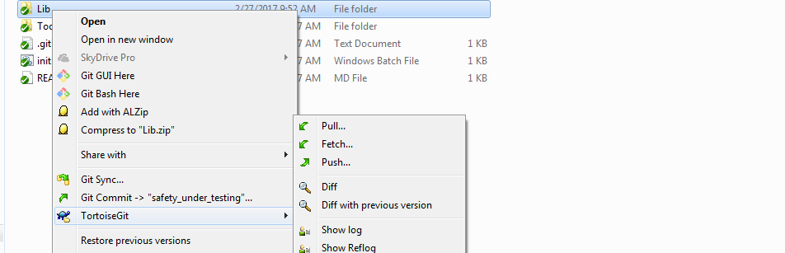

Step 4. Push to remote repository

The new branch is now residing on local repository. We push it to remote repository.

Git push --set-upstream origin safety_under_testing

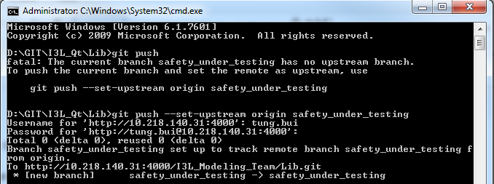

We’ve completed creating new git branch.

**Appendix. Get Model, IPC, Qt version while updating JIRA ticket**

When creating JIRA ticket, we need to provide what version of Model/IPC/Qt is used.

E.g.

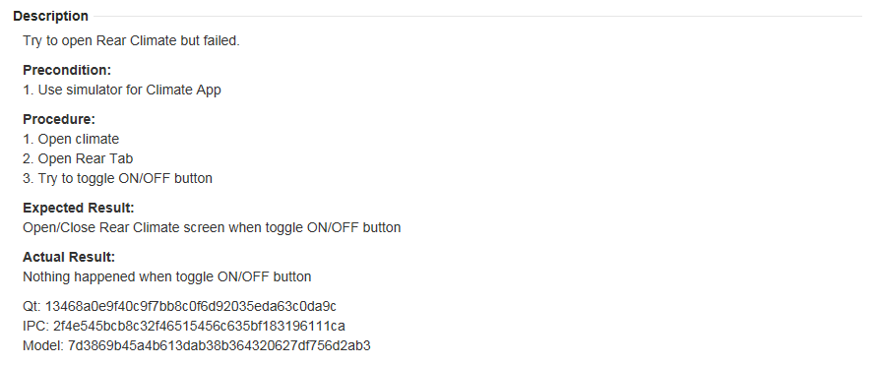

Answer: Enter git on local workspace and check latest git log.

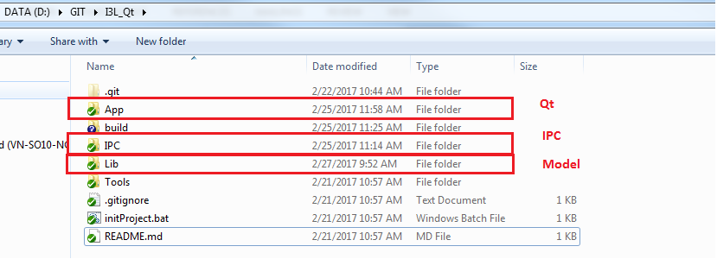

TortoiseGit > Show log… > See the SHA-1 number

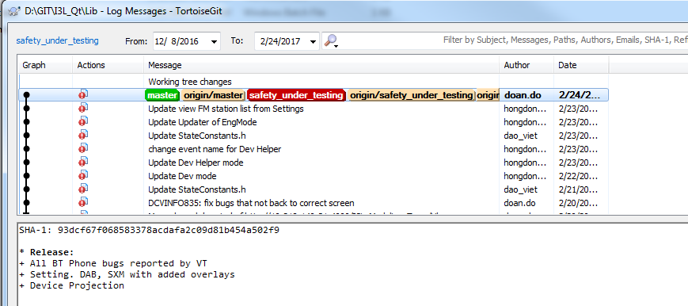

It is easy to get but hard to trace. ☺