How to diff between 2 revisions of a file

Purpose:

How to compare the same file between two different commits (not contiguous) on the same branch.

For example, on repo <http://10.218.140.31:4000/hongdong.nguyen/Lib.git>, file StateConstants.h has several revisions.



How to see the difference of StateConstants between 2 marked commits in the figure?

Method 1: Using git bash command

|  |
| --- |
| $ git diff <revision_1>:<file_1> <revision_2>:<file_2>  e.g.  $ git diff f892d72e29:Lib/StateConstants.h e604e3517d:Lib/StateConstants.h  Or  $ git diff HEAD~2 HEAD -- StateConstants.h |

For example:

git diff f892d72e29:StateConstant.h e604e3517d:StateConstant.h

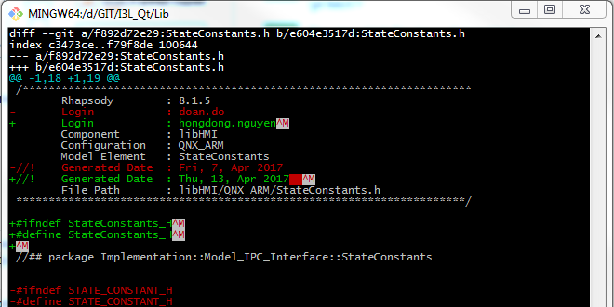

If file a not in current directory, we has to guide:

git diff f892d72e29:Lib/StateConstants.h e604e3517d:Lib/StateConstants.h

or we can use the commit Id from git log (so we can compare file between our local commit and remote repo)

**git log StateConstants.h**

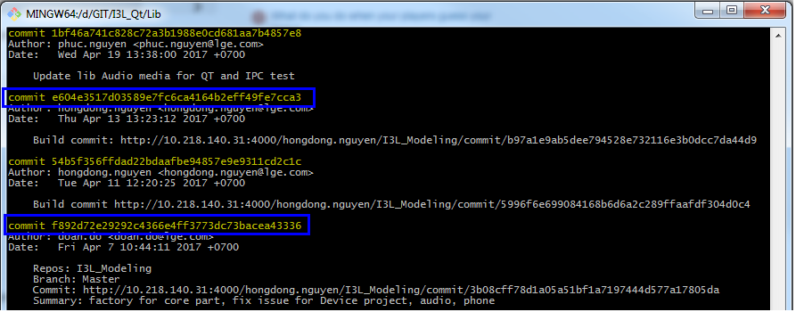

**git diff f892d72e29292c4366e4ff3773dc73bacea43336:StateConstants.h e604e3517d03589e7fc6ca4164b2eff49fe7cca3:StateConstants.h**

Moreover, we can use specific command to see the difference for a file between now and 2 commits back,

git diff HEAD~2 HEAD -- StateConstants.h

Method 2: Using Tortoise git difftool

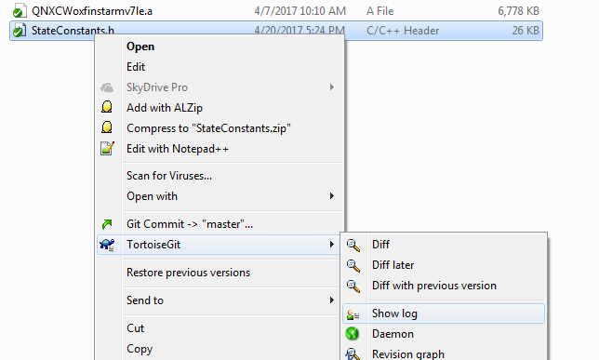

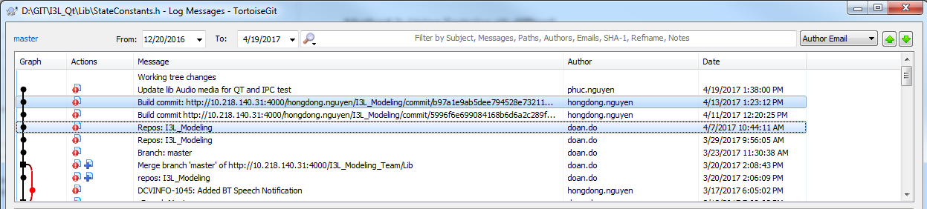

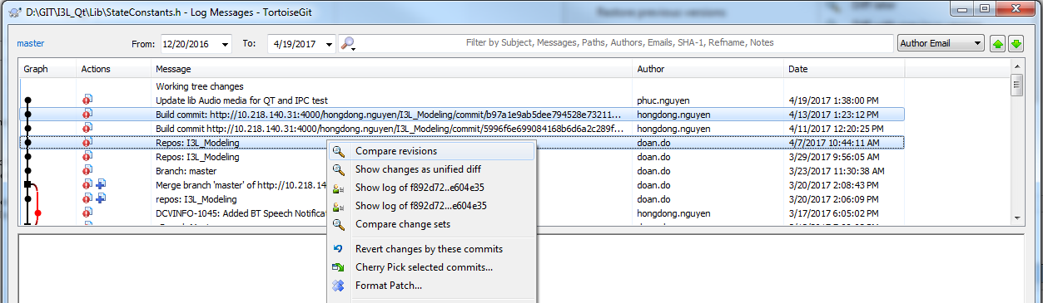

Result

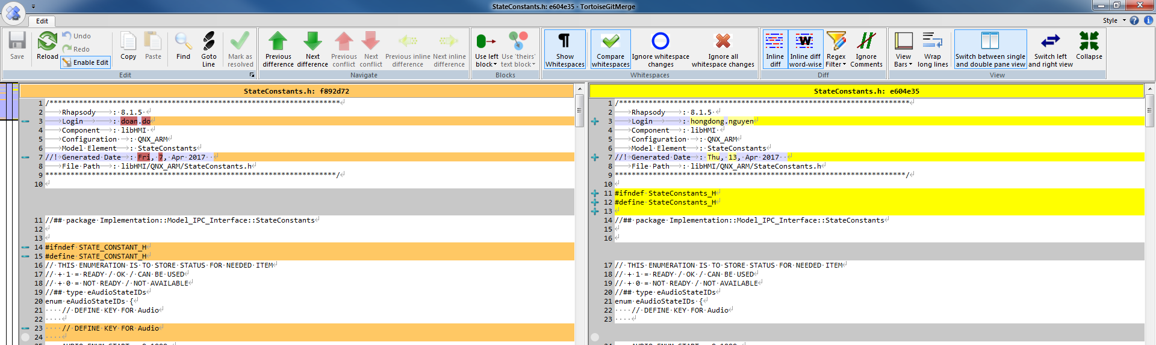

Source:

<http://stackoverflow.com/questions/3338126/how-to-diff-the-same-file-between-two-different-commits-on-the-same-branch>

<https://tortoisegit.org/docs/tortoisegit/tgit-dug-diff.html>