How to amend patch set #2

Purpose: Modify a “pushed” but “not merged” yet commit. And keep the previous review link

For example:

http://mod.lge.com/ivi/#/c/439407/

Patch set 1 – Add some logs

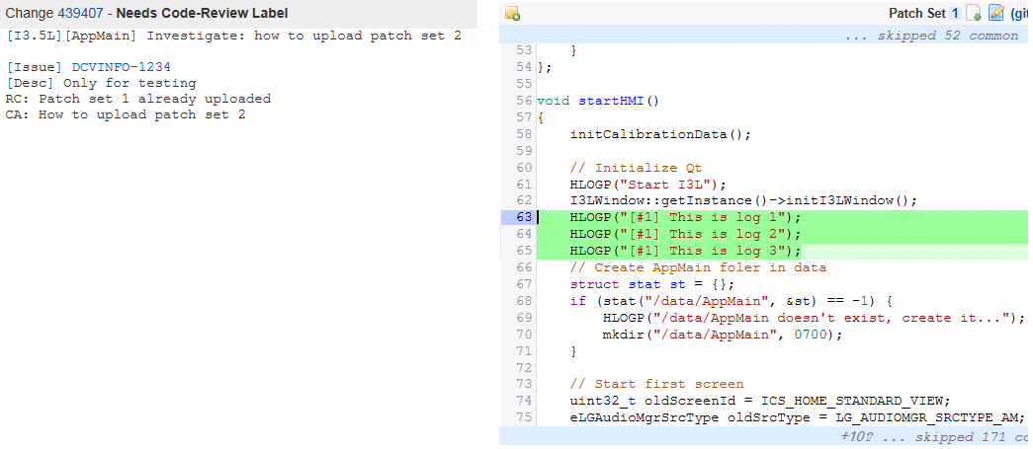

Now we want to add some more log for patch set 2. How?

|  |
| --- |
| $ git add *  $ git commit --amend –m “New and correct message”  $ git push origin HEAD:refs/changes/CHANGE_ID (which is 439407, the number of gerrit link) |

Result:

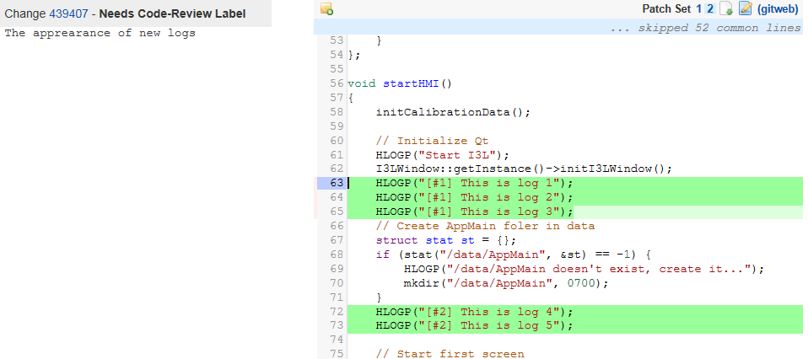

Source:

http://10.218.140.31:4000/Documents/MasterWiki/src/master/git.md