**What is the difference between cookie, cache and session?**

**SESSION INFORMATION RESIDES ON THE WEB SERVER**

[1] Sessions – are created & managed by the Web server (e.g. Apache) – and these sessions are used to identify and manage valid User Sessions (usually via a cookie containing an id code).

Once you login to any web application, and the given credentials (user id and password) are validated by the application, the associated Web Server starts a unique session exclusively for you. And this is how server keeps recognizing you one after another HTTP requests you send to the web server.

Finally, either the Sessions are timed-out after a pre-set duration (e.g. 30 minutes) or they are programmed to expire – after a certain period of activities or eventually an active session is terminated once you explicitly logout or close the browser.

**A COOKIE RESIDES ON THE USER’S COMPUTER**

[2] Cookies are something – that are small piece of information which is store on the browsers of client’s machine (computer) and are sent back to the web servers by browsers with every request. Cookies comprise of small set data / files for shorter periods (or until it is deleted by the user).

The cookies are used for various purposes. Common uses for cookies include authentication, storage of site preferences and shopping cart items. The problem with cookies is that anyone can block or delete them at any time. If, for example, a website’s shopping cart utilizes cookies, shoppers who block cookies in their browsers can’t shop at that website.

Like sessions, cookies can also be programmed to expire after a certain duration or under certain circumstances. All the server side programming languages (e.g. PHP) provides the infrastructure to manage the life cycle of cookies and sessions.

For example, cookies on Opera browser

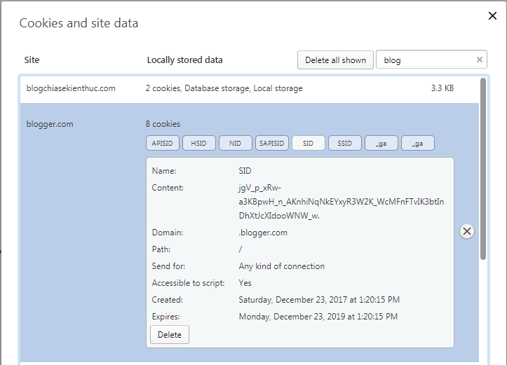

If you have a site requiring a login, that information is better served as a cookie, or the user would be forced to login every time he visits. If you prefer tighter security and the ability to control the data and when it expires, sessions work best.

**CACHE RESIDES ON CLIENT’S MACHINE**

Cache is a temporary storage of web page resources stored on client’s machine for quicker loading of the web pages. The browser stores the web site contents like the images, videos, audio, text, etc. on our computer so the next time when we load the same website we will find it loading faster.

The page elements are downloaded when we visit a website and the browser check its cache folder for copies when we browse the website. If a copy exists, then the browser doesn’t download the same file again, thus significantly speeding up web browsing speeds.

Cache will remain until they are removed manually by the user.

**Example of Cookies:** If we open any e-commerce site then purchase few items then those items are stored in cookies. Any time if we again go to that site and log in then it will show our username and those items will be shown in that site’s cart. Moreover, when you open other websites that support ads, those ads will show the list of items which you have surfed in the past. That is what cookies do.

**Example of Sessions:** When we login as a member in any website it creates sessions until we log out of the website.

**Example of Caches:** Cache storages images of items that you opened. If you closed and then open an item’s sale page again, the images will be loaded faster.