**Chapter 7 Making Control Flow Easy To Read**

* Guideline in conditional statements:

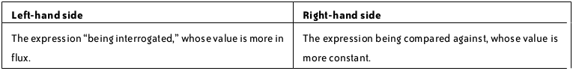

* Switching the order of arguments or YODA Notation is not helpful and make the code a bit unnatural to read.
* In creating if/else statement
  + Prefer dealing with the positive case first instead of the negative.
  + Prefer dealing with the simpler case first to get it out of the way.
* Pay attention to factors and cases where your if/else is in an awkward order.
* Conditional Expression a.k.a Ternary Operator
* Not at all times using Ternary Operator as a way of squeezing your code is not helpful, sometimes it just makes your code more complicated and confusing.
* Ternary operators should be used for simple cases.
* Most do/while loops could have been written as while loops, and is more recommended to use while loops.

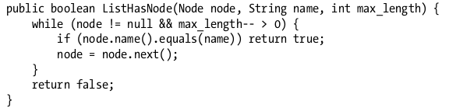

* Another reason to avoid do/while is that continue statement can be confusing inside it.
* Returning early from a function is desirable. Good example:



* Ways to achieve this guarantee:

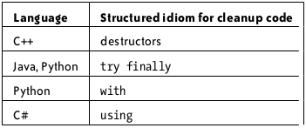

* Go to statement should be avoided.
* Nested code is hard to understand and you should always try to minimize nesting.
* Nested code can be avoided by returning early.
* Example:

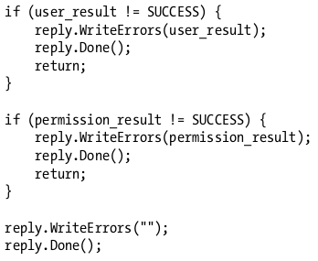

* Continue statement can be used to remove nesting inside loops.

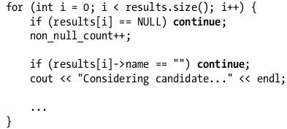

* Think of the flow your code in high level.
* Start with main method and step through the code.
* Some codes and libraries that run behind the scenes that make it difficult to follow.

