**Chapter 8 Breaking Down Giant Expressions**

* Simplest way to break down an expression is to introduce an extra variable that captures a smaller subexpression. Sometimes called an “explaining variable”.
* Using a variable to hold an expression and use it to make simpler if/else statement:



* Summary variables is like explaining variable but with this one there is a process or condition and the result of that will be set to the summary variable.

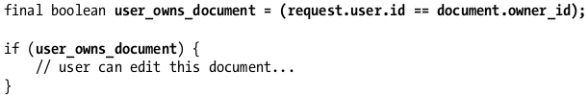

* The value of this variables may also be helpful in other functions that needs it.
* When the logic becomes too complicated find another approach that will make it look easier.
* One technique is to see if you can solve the problem in opposite way.

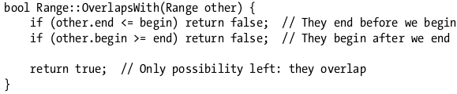

* Individual Expression aren’t big but when when placed all together forms a giant statement.

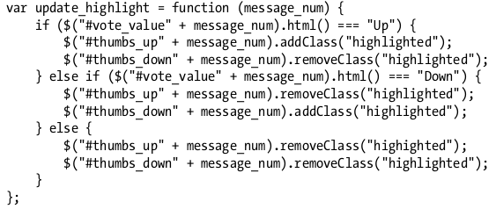

* Solution is to create a variable that will hold the expression and condition.

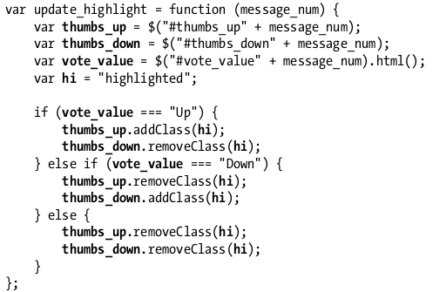

* Another way is to use MACRO in C.