**Chapter 9 Variables and Readability**

* Useless temporary variables are variables that is not breaking a complex expression, doesn’t add clarification, and used only once.
* Intermediate results can be eliminated by handling the result early and return early.
* Control flow variable can be eliminated by making better use of structured programming.

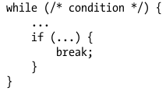

* Avoid using global variable, it is better to keep the scope of variable small.
* A way to restrict access to class members is to make static method or breaking classes to smaller class.
* Creating Private Variables packing a function in one variable, now the reader doesn’t have to wonder where else the function is used.
* When the keyword var is removed from variable declaration the variable becomes global in javascript so anyone can access it.
* It helps if variable changes in fewer places.
* Needs improvement:

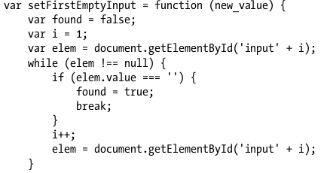

* Improved:

