**Chapter 11 One Task at a Time**

* code that does multiple things at once is harder to understand.

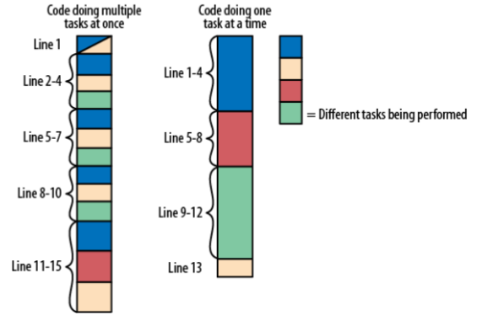

Defragmenting Code

Making code do one task at a time:

* List out all tasks your code is doing.
* Separate those tasks as much as you can into different functions or at least different sections of code.

Tasks can be Small

* defragmenting your code is simplifying your code.

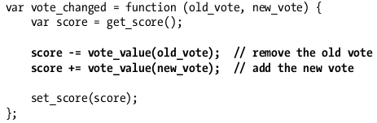

Applying “One Task at a Time”

* instead of testing all objects if they exist you can just contain them in few variables and make the least decision that you can do. That way, the job is done and the code is readable.

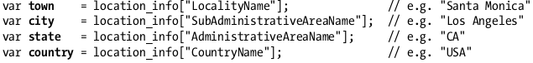

* What’s good in these isolated code, while reading one region, you don’t need to think about the other regions.
* You can also separate them into functions e.g:

