**Chapter 12 Turning Thoughts into Code**

* Process that can help you make code more clearly:
  + Describe what code needs to do, in plain English.
  + Pay attention to the keywords and phrases used in this description.
  + Make your code to match this description.
* To turn your thoughts into code you must be able to explain first your goals in plain english.
* Example:

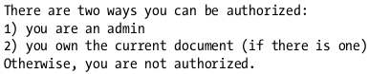

Translated to Code:

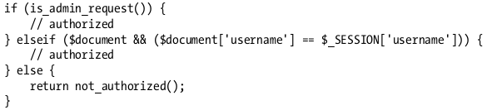

* Built-in libraries will help you in writing code more simple.
* Describing program in plain English helps you write more natural code.
* Rubber ducking is a technique in debugging a program or a problem by explaining to a dedicated teddy bear in corner of the room. Just by describing the problem aloud can help you to figure out a solution.
* If you can’t describe the problem or your design in words, something is probably missing or undefined.