Group 4: ER Diagram for Library system

**ER diagram before normalization**



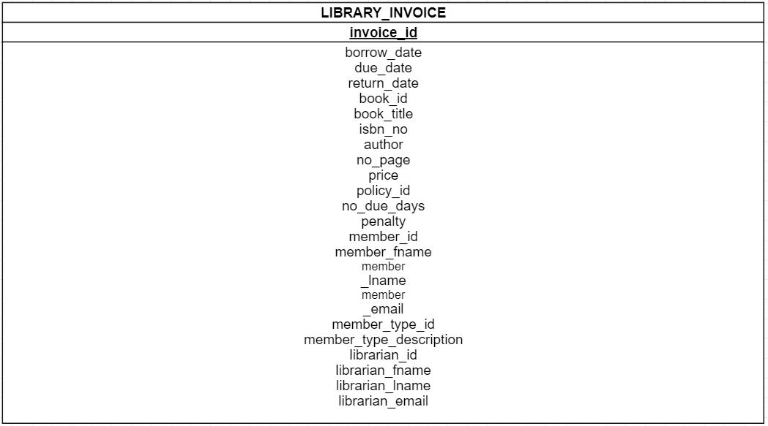

**ER diagram after normalization**

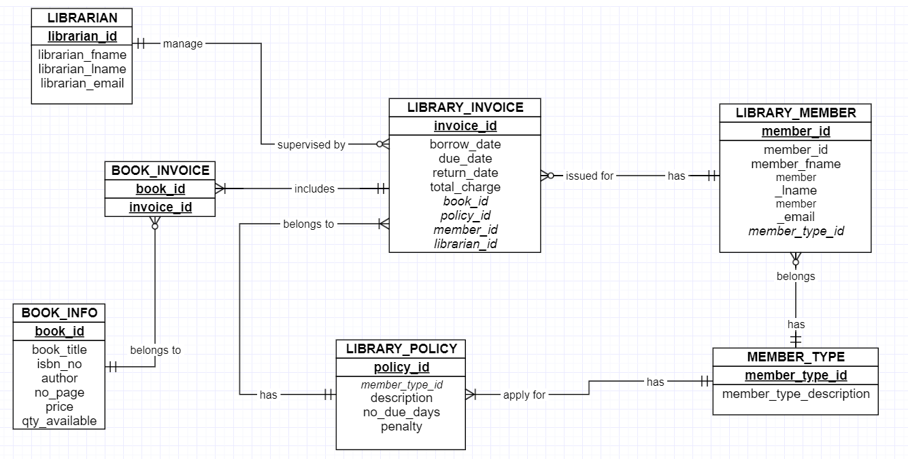

|  |  |  |  |  |  |
| --- | --- | --- | --- | --- | --- |
| **LIBRARY_INVOICE** | | | | | |
| **invoice_id** | borrow_date | return_date | ***book_id*** | *member_id* | *librarian_id* |
| inv_001 | 1/20/2019 | 1/27/2019 | bk_001 | 1 | 1 |
| inv_001 | 1/20/2019 | 1/27/2019 | bk_002 | 2 | 1 |
| inv_002 | 3/2/2019 | 3/30/2019 | bk_003 | 2 | 1 |
| inv_003 | 1/20/2019 | 1/28/2019 | bk_004 | 3 | 1 |

|  |  |  |  |  |  |  |
| --- | --- | --- | --- | --- | --- | --- |
| **BOOK_INFO** | | | | | | |
| **book_id** | book_title | isbn_no | author | no_page | price | Qty_available |
| Bk_001 | Big Data Fundamental | Isbn_0001 | ABC_0001 | 123 | $85 | 4 |
| Bk_002 | Relational Database | Isbn_0001 | ABC_0002 | 181 | $125 | 3 |
| Bk_003 | Cloud Computing Administration Guide | Isbn_0001 | ABC_0003 | 256 | $200 | 2 |
| Bk_004 | Hyper-V Virtualization | Isbn_0001 | ABC_0004 | 198 | $155 | 5 |

|  |  |
| --- | --- |
| BOOK_INVOICE | |
| book_id | invoice_id |
|  |  |
|  |  |
|  |  |

|  |  |  |  |
| --- | --- | --- | --- |
| **LIBRARY_CARD** | | | |
| **card_type_id** | description | no_due_days | penalty/over-due day |
| 1 | Student | 7 | $5 |
| 2 | Instructor | 90 | $2 |
| 3 | Others | 5 | $7 |

|  |  |  |  |  |
| --- | --- | --- | --- | --- |
| **CARD_MEMBER_INFO** | | | | |
| **member_id** | member_fname | member_fname | email | *card_type_id* |
| C0770339 | Cuong | Bui | C0770339@mylambton.ca | 1 |
| C0769944 | Chiranjeev | Singh | [C0760944@mylambton.ca](mailto:C0760944@mylambton.ca) | 1 |
| C0765460 | Shanel | Pinto | [C0765460@mylambton.ca](mailto:C0765460@mylambton.ca) | 1 |
| T0434343 | Asem | Omari | Asem.omari@cestarcollege.com | 2 |

|  |  |  |  |
| --- | --- | --- | --- |
| LIBRARRIAN | | | |
| **librarian_id** | librarian_fname | librarian_lname | librarian_email |
| lib_001 | Alice | Tuhn | Alice.tuhn@librarycollege.ca |
| lib_002 | Tom | Cruze | Tom.cruze@librarycollege.ca |
| lib_003 | John | Walker | John.walker @librarycollege.ca |
| lib_004 | Rick | David | Rick.david @librarycollege.ca |