Assignment 2 - Unsupervised learning (Python / R code submission link )
Apply K-means clustering ( or any other clustering algorithm ) on any dataset of your interest from the UCI Machine Learning Repository which could be access through this link:
https://archive.ics.uci.edu/ml/index.php
//It is expected that different groups work on different datasets.//
Use Python or R.
Please submit a report in PDF format which is no more than 10 pages explaining:
- Which dataset you’re using
- Specification of your dataset
- Pre-processing
- How K-means / other clustering algorithm work
- Result of implementation
- Conclusion
Also make sure your input file as well as .py file is submitted.

Introduction
In this exercise #2, k-means targets to resolve problem to clustering for wine datasets from UCI Machine learning repository
https://archive.ics.uci.edu/ml/datasets/Wine.

Wine dataset specification
Wine dataset with 13 attributes (integer & real) and 178 instances are the outcomes of analyzing chemical of wines sourced from differein the same area of Italy.
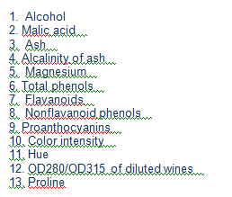

Pre-processing
Load wine data and omit NA and scale data excluding wine type
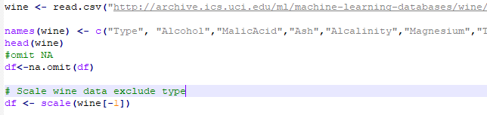

K-means clustering algorithm

Clustering is one algorithm of Unsupervised learning in which interfere datasets using only independent input without dependent data or labels to try to combine different data records into different groups with similar characteristics. K-means algorithm identifies k number of centroids, and then assign each data record to the closest cluster. K-means uses the average of data for identifying centroid. Similar measurement such as Euclidean-based distance or correlation-based distance.
K-means algorithm’s objective is to separate clusters as far distance as possible and keep data records are as small distance with centroids as possible by below iteration steps.
- Identify k as number of clusters of data set.
- Initialize centroids by first shuffling the dataset and then randomly selecting K data points for the centroids without replacement.
- Continue iterating until the centroids get stabilized based on measurements.
  - Compute the sum of the squared distance between data points and all centroids.
  - Assign each data record to the closest centroid.
  - Get the means of data record as centroids for the clusters.
Since clustering algorithms including kmeans use distance-based measurements to determine the similarity between data points, it’s recommended to standardize the data to have a mean of zero and a standard deviation of one since almost always the features in any dataset would have different units of measurements such as age vs income.

Clustering Evaluation with silhouette coefficient
three most popular methods for determining the optimal clusters, which includes:
- Elbow method
- Silhouette method
- Gap statistic

Elbow Method
https://uc-r.github.io/kmeans_clustering
library(cluster)
library(factoextra)
sil <- silhouette(clustering$cluster, dist(input))
fviz_silhouette(sil)

library(GGally)
library(plotly)
all.mammals.milk.1956$cluster <- as.factor(clustering$cluster)
p <- ggparcoord(data = all.mammals.milk.1956, columns = c(2:6), groupColumn = "cluster", scale = "std") + labs(x = "milk constituent", y = "value (in standard-deviation units)", title = "Clustering")
ggplotly(p)

