TRƯỜNG ĐẠI HỌC FPT — FPT UNIVERSITY
Requirement & Design Specification
Classroom Asset Management System (F-CAMS Simple)
Version: 1.0
Course: PRJ301 (Java Web Application)
Group: Group 1 (Sample)
Authors: HE190001 – Nguyen Van A (40%) | HE190002 – Tran Van B (30%) | HE190003 – Le Van C (30%)
Date: October 2026
――――――――――――――――――――――――――――――――――――――――――――――――――――――――――
Table of Contents
I. Overview
1. User Requirements (Actors, Use Cases, Diagram)
2. Overall Functionalities (Screens Flow, Descriptions, Authorization)
3. Database Design (Schema, Table Descriptions)
II. Design Specifications
1. Login Screen
2. Dashboard Screen
3. Asset Management Screen
4. Room Management Screen
5. Room Detail Screen
III. Technology Stack & Verification

I. Overview
The Classroom Asset Management System (F-CAMS Simple) is a specialized web application developed for FPT University campus operations. It provides comprehensive facility management, equipment inventory tracking, seat capacity planning, and lifecycle maintenance for all lecture halls, computer labs, and seminar rooms across campus buildings (Alpha, Beta, Delta, Epsilon, Gamma).
The application strictly adheres to the Model-View-Controller (MVC) architectural pattern, utilizing Jakarta EE Servlet 6.0, JSP/JSTL, Custom Taglib, AuthFilter, and Microsoft SQL Server via JDBC driver.
1. User Requirements
1.1 Actors
# | Actor | Description
1 | Admin | Full administrative control over campus data. Authorized to view Dashboard, perform full CRUD on assets, and execute sensitive/destructive operations (Add classroom, Edit classroom specs, Delete classroom, Delete asset).
2 | Staff / IT Staff | Operational and IT personnel responsible for routine equipment inspections. Authorized to view Dashboard, view/filter/add/edit assets, transfer assets between classrooms, and inspect room details. Blocked from deleting records or altering room catalogs.
1.2 Use Cases

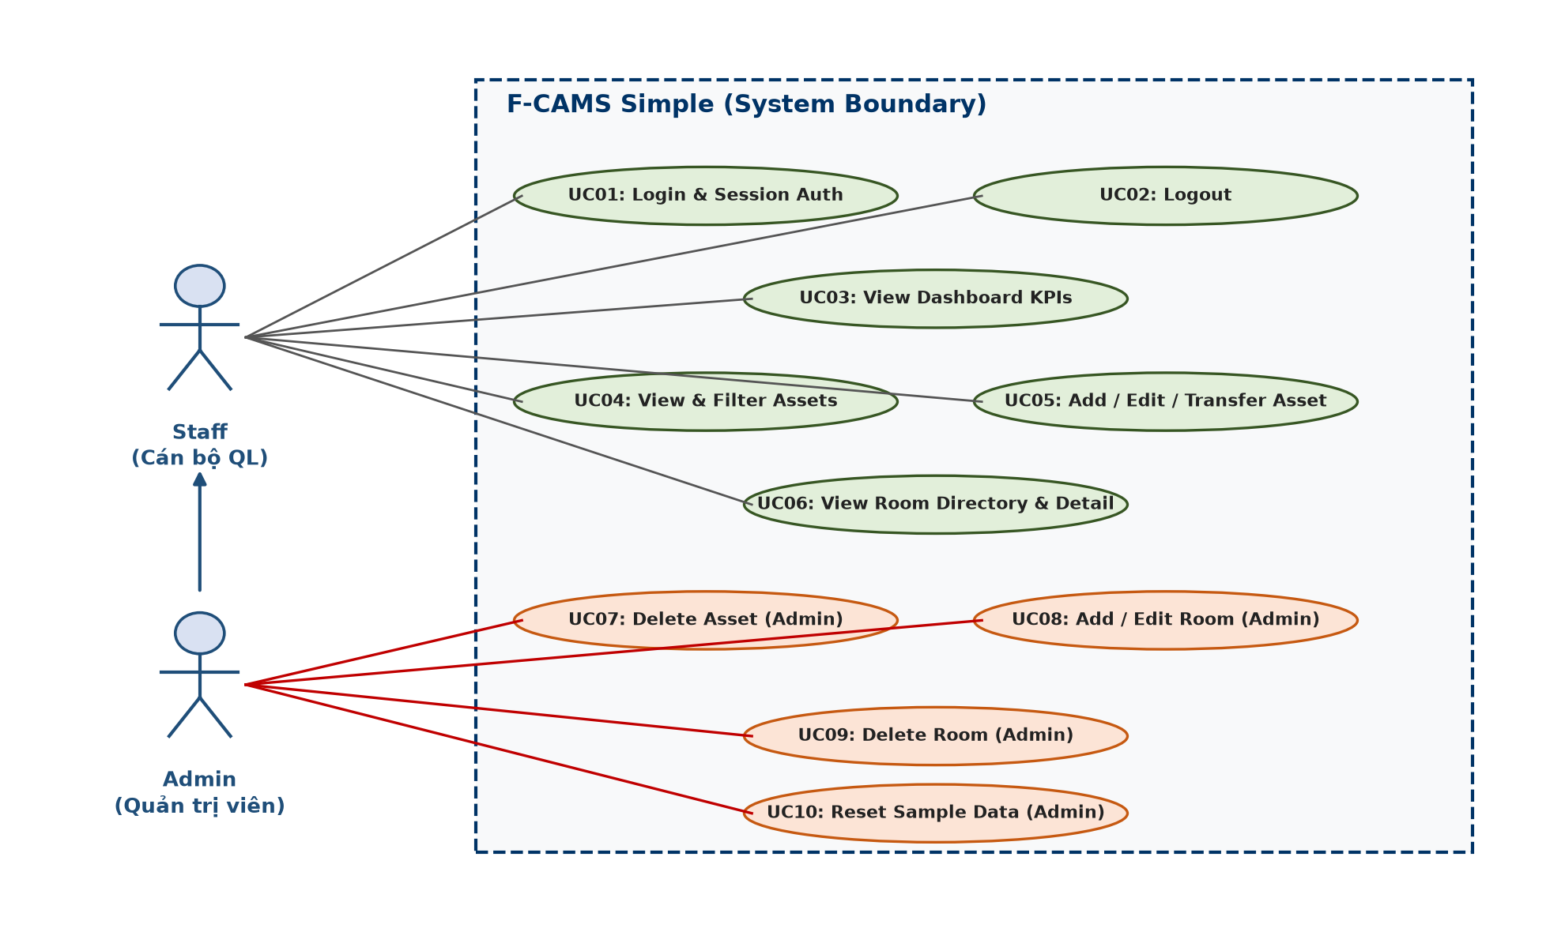
Figure 1.1: Use Case Diagram for F-CAMS Simple
ID | Feature | Use Case | Use Case Description
01 | Authentication | Login / Logout | Authenticate username and password via UserDAO. Establish session with role metadata or destroy session on logout.
02 | Dashboard | View KPIs & Ratios | Monitor total assets, total rooms, estimated campus inventory value, condition ratios, urgent maintenance alerts, and recent assets.
03 | Asset Management | View & Filter Assets | Browse and filter inventory by classroom, category, status (ACTIVE, REPAIRING, FAULTY), or keyword.
04 | Asset Management | Add / Edit Asset | Register new assets with serial, date, price, and status, or modify existing asset information.
05 | Asset Management | Transfer Asset | Relocate an asset from one classroom to another with atomic room reassignment.
06 | Asset Management | Delete Asset | Permanently remove an asset from the system (Restricted to Admin).
07 | Room Management | View & Filter Rooms | Browse room catalog with chair metric badges (Deficit / Normal / Surplus), building filter, and status filter.
08 | Room Management | View Room Detail | Inspect visual room blueprint (Stage bar, student seat grid) and full equipment roster (Projector, ACs, TV).
09 | Room Management | Add / Edit / Delete Room | Maintain campus rooms with validation: ID format [A-Z]{2}-\d{3}, floor 1-10, seat limits (Admin only).
10 | System Maintenance | Reset Sample Data | Execute stored procedure sp_ResetFcamsData to revert system to standard benchmark data.
2. Overall Functionalities
2.1 Screens Flow

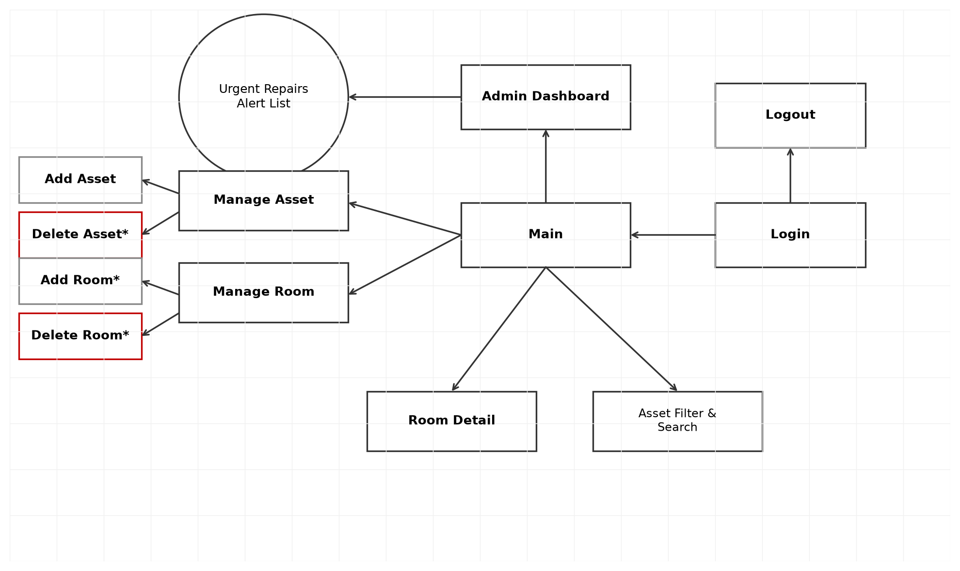
Figure 2.1: Navigation and Screen Flow Diagram
2.2 Screen Descriptions
# | Feature | Screen | Description
1 | Authentication | Login (/login) | Centered FPT-branded card for entering credentials. Includes validation error handling.
2 | Executive Monitoring | Dashboard (/dashboard) | Visual overview with 3 KPI metric cards, condition breakdown table, recently added assets, and urgent items.
3 | Asset Inventory | Asset Management (/assets) | Searchable and filterable asset table, Add form, Edit form, and Transfer form.
4 | Facility Directory | Room Management (/rooms) | Catalogue of campus classrooms with seat status tags, equipment summaries, and Admin CRUD controls.
5 | Classroom Inspection | Room Detail (/room-detail) | Auditing workbench with Stage Bar, interactive chair grid (Missing/Surplus), and device list.
2.3 Screen Authorization (RBAC Matrix)
# | Screen / Action | Admin | Staff / IT Staff
1 | Login Screen (/login) | X | X
2 | Dashboard (/dashboard) | X | X
3 | Asset Management — View, Filter & Search | X | X
4 | Asset Management — Add, Edit & Transfer Asset | X | X
5 | Asset Management — DELETE Asset | X | (Blocked by AuthFilter)
6 | Room Management — View, Filter & Search | X | X
7 | Room Management — ADD, EDIT, DELETE Room | X | (Blocked by AuthFilter)
8 | Room Detail Inspection (/room-detail) | X | X
9 | Database Reset (sp_ResetFcamsData) | X | X

2.4 Database Design
a. Database Schema (ERD)

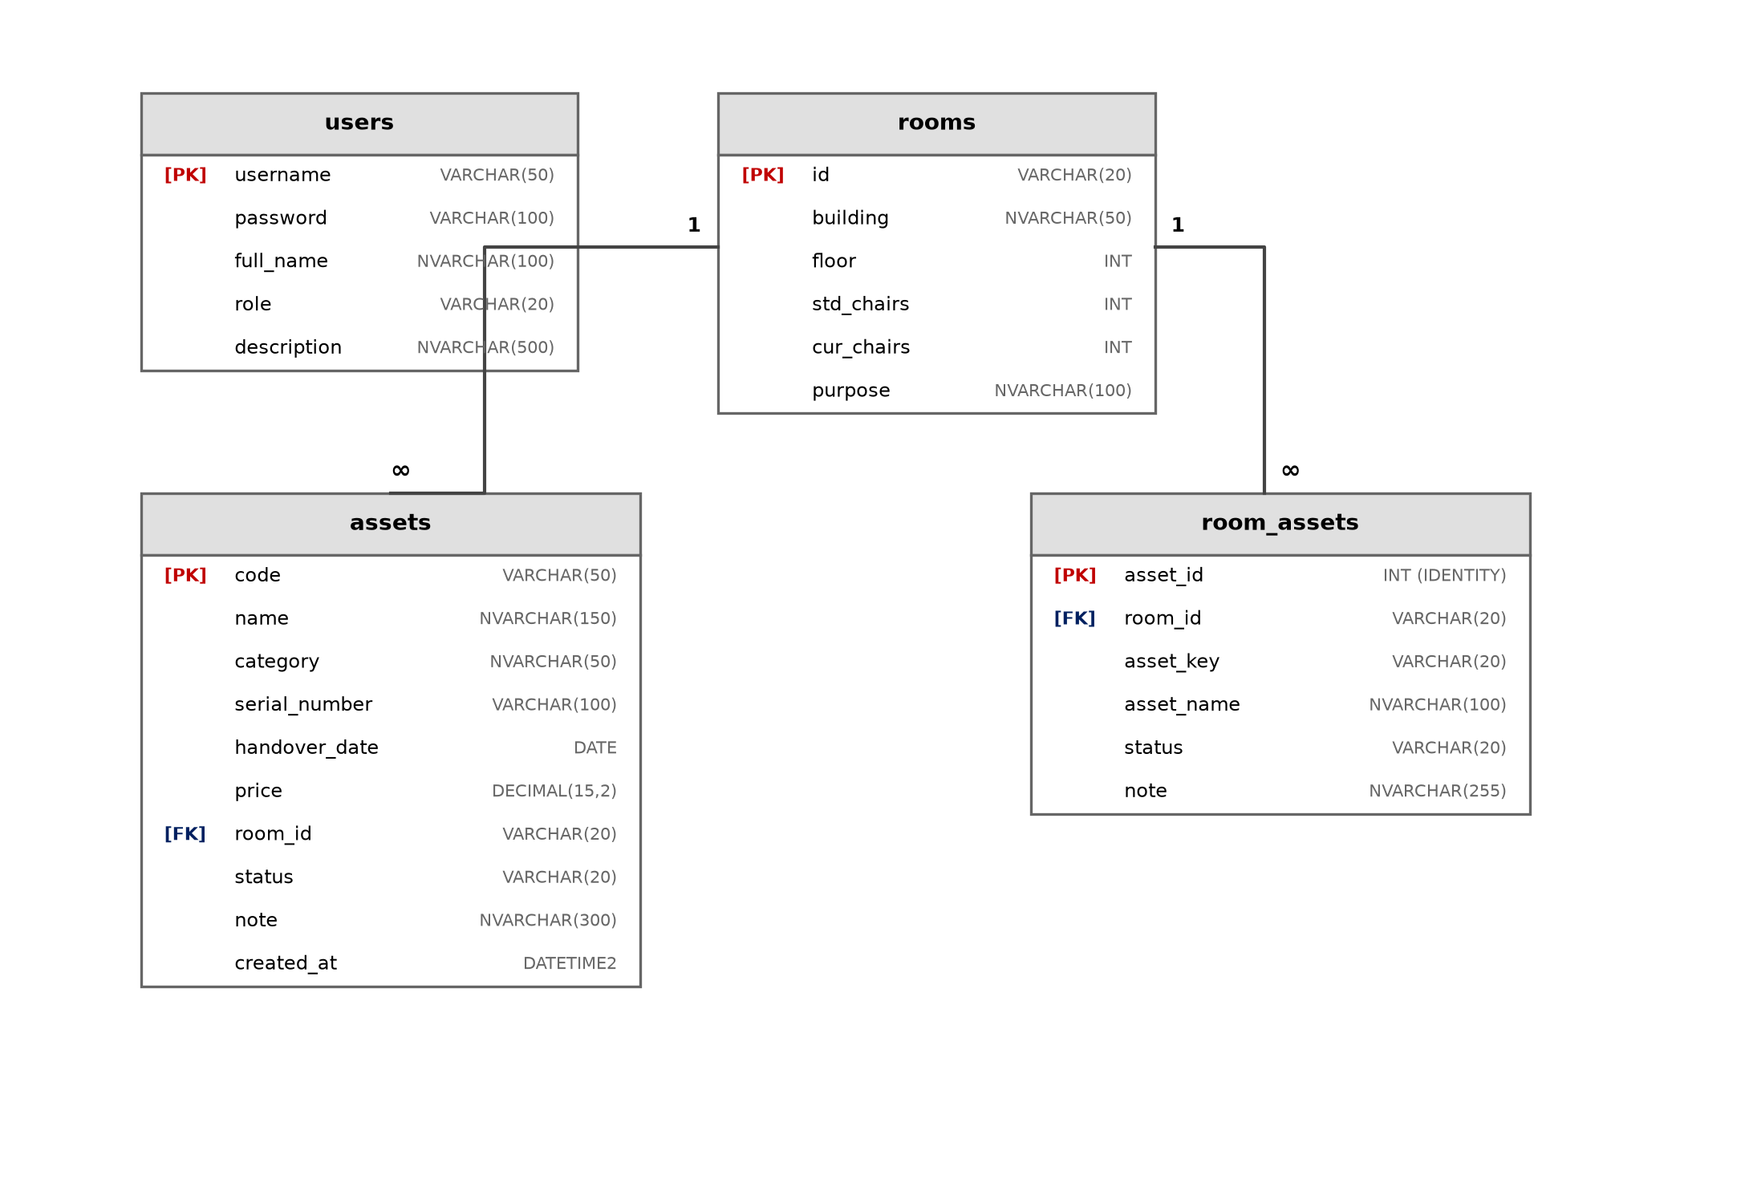
Figure 2.2: Entity-Relationship Diagram (SQL Server)
b. Table Descriptions
No | Table | Description
01 | users | Stores system user credentials and role definitions (ADMIN, STAFF, IT_STAFF, LECTURER). Enforces min 3-char username.  • Primary Key: username
02 | rooms | Manages physical classrooms across buildings (Alpha, Beta, Delta, Epsilon, Gamma), floor (1-10), standard/current chair count, and purpose.  • Primary Key: id (Format: [A-Z]{2}-\d{3})
03 | assets | Maintains equipment inventory items with category, serial number, handover date, price (VND), status (ACTIVE, REPAIRING, FAULTY), and room assignment.  • Primary Key: code  • Foreign Key: room_id -> rooms(id) ON DELETE CASCADE
04 | room_assets | Tracks core fixed classroom appliances (projector, acLeft, acRight, tv) with operational condition and technician notes.  • Primary Key: asset_id  • Foreign Key: room_id -> rooms(id) ON DELETE CASCADE  • Unique: (room_id, asset_key)
II. Design Specifications
1. Login Screen (/login)
Users authenticate with designated username and password. Features modern FPT orange accent and responsive container.

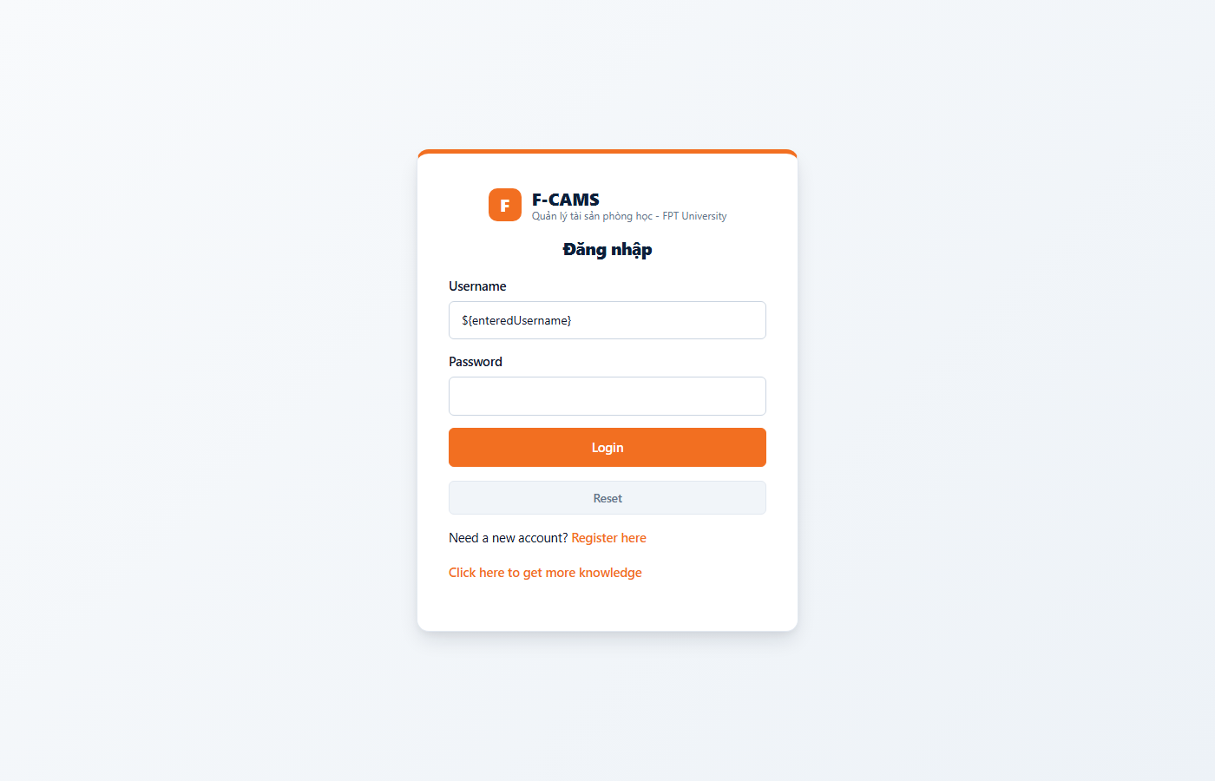
Screenshot: 1. Login Screen (/login)
Field / Component | Type | Description
Username | Text Box | Accepts account username (e.g., admin, it_beta). Autofocused on load.
Password | Password Box | Masked input for account password.
Login | Submit Button | Sends POST request to LoginServlet for credential verification.
Reset | Reset Button | Clears all input fields back to blank.
2. Dashboard Screen (/dashboard)
Executive summary monitoring all university classroom assets, failure rates, and maintenance queues.

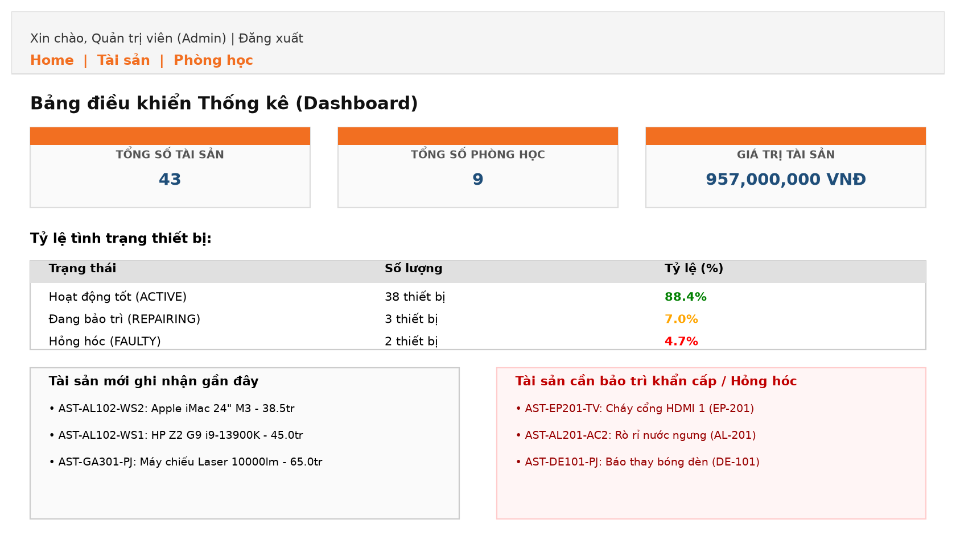
Screenshot: 2. Dashboard Screen (/dashboard)
Field / Component | Type | Description
Total Assets Card | KPI Card | Displays aggregate count of all campus assets.
Total Rooms Card | KPI Card | Displays aggregate count of classrooms across all buildings.
Total Value Card | KPI Card | Displays total inventory acquisition cost formatted in VNĐ.
Condition Table | Data Table | Summarizes percentages of Good, In-Repair, and Broken devices.
Urgent Assets Table | Data Table | High-priority table listing equipment needing immediate repair.
3. Asset Management Screen (/assets)
Inventory control console supporting multi-criteria filtering, search, add, update, and transfer workflows.

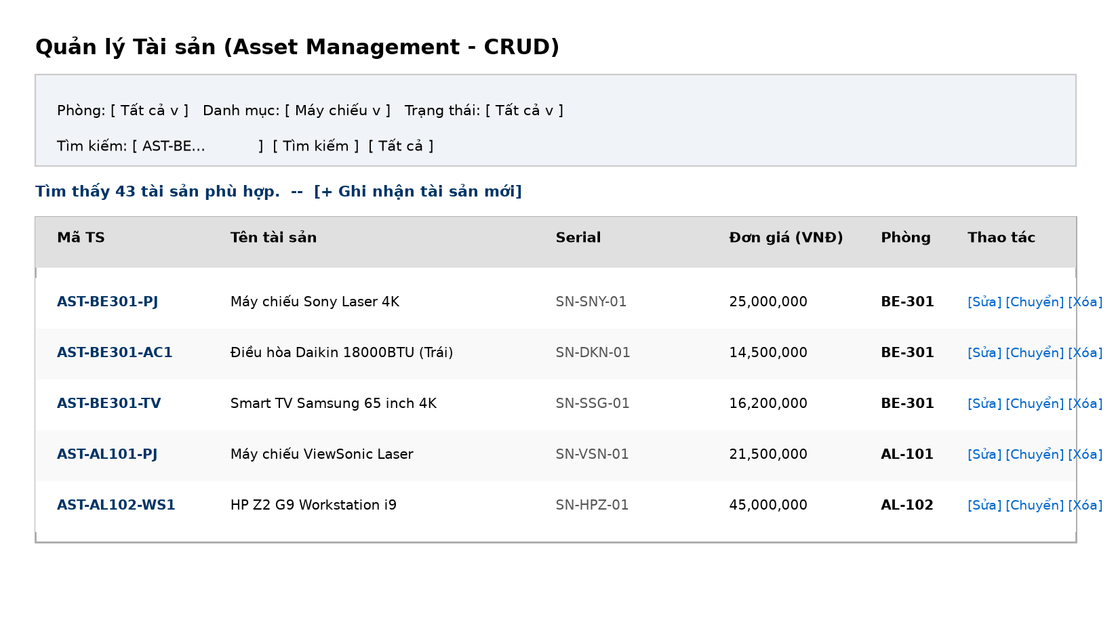
Screenshot: 3. Asset Management Screen (/assets)
Field / Component | Type | Description
Room Filter | Dropdown | Filters assets by designated classroom ID.
Category Filter | Dropdown | Filters assets by category (Computer, Projector, AC, etc.).
Status Filter | Dropdown | Filters assets by ACTIVE, REPAIRING, or FAULTY.
Search Keyword | Text Input | Matches code, name, or serial number.
Add / Edit Form | Fieldset Form | Captures Asset Code, Name, Category, Serial, Date, Price, and Room.
Delete Action | Button | Allows Admin to remove an asset record with confirmation prompt.
4. Room Management Screen (/rooms)
Classroom directory with capacity indicators, equipment status, and Admin management controls.

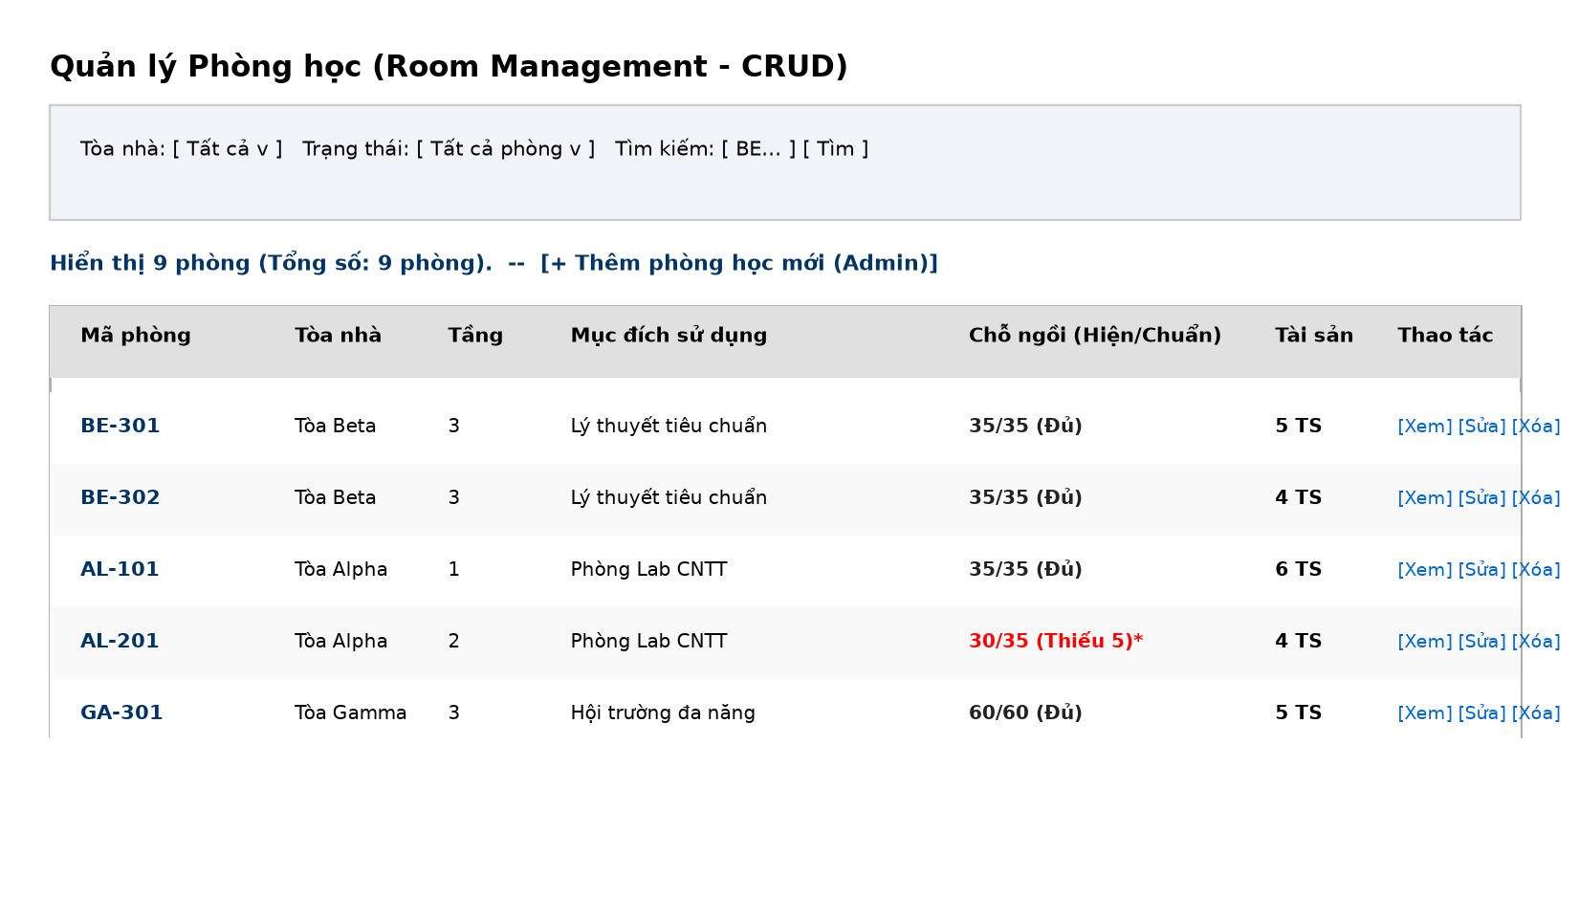
Screenshot: 4. Room Management Screen (/rooms)
Field / Component | Type | Description
Building Filter | Dropdown | Select between Alpha, Beta, Delta, Epsilon, and Gamma buildings.
Status Filter | Dropdown | Filters rooms having issues (deficit chairs / broken devices).
Add Room Form | Fieldset Form | Admin form for creating room with automated equipment generation.
Seat Metric Badge | Custom Tag | Displays Current/Standard chairs with deficit/surplus alerts.
5. Room Detail Screen (/room-detail)
Comprehensive room auditing page with visual Stage Bar, student seat grid, and equipment list.

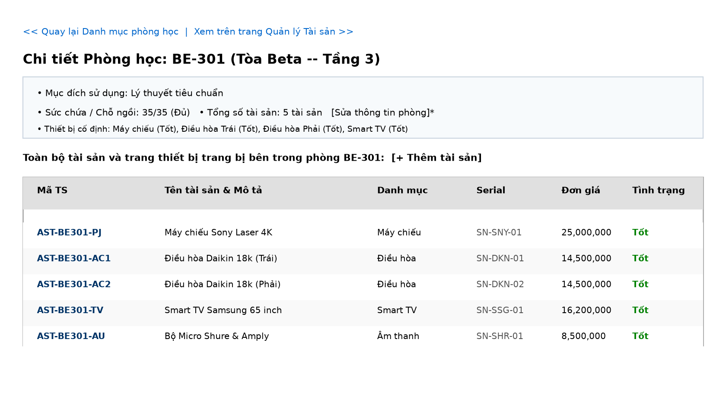
Screenshot: 5. Room Detail Screen (/room-detail)
Field / Component | Type | Description
Stage Bar | Visual Element | Navy-styled podium/projector position marker.
Seat Grid | Dynamic Matrix | Visual representation of student chairs with condition styling.
Equipment Roster | Data Table | Detailed inventory table of all hardware inside the room.

