TRƯỜNG ĐẠI HỌC FPT - FPT UNIVERSITY
DEPARTMENT OF INFORMATION TECHNOLOGY
COURSE: PRJ301 - JAVA WEB APPLICATION DEVELOPMENT
Requirement & Design Specification
FPT Classroom Asset Management System (F-CAMS Simple)
Version: 1.0
Group: FCAMS Project Team - Group 6
Class: PRJ301 - SE / IA
Date: October 2026
No | Student ID | Full Name | Contribution (%)
1 | HE190001 | Trần Văn Tuấn | 40%
2 | HE190002 | Nguyễn Quốc Hùng | 30%
3 | HE190003 | Lê Hoàng Nam | 30%

Table of content
Table of content ........................................................... 2
I. Overview ................................................................ 3
1. User Requirements ..................................................... 3
1.1 Actors ............................................................. 3
1.2 Use Cases .......................................................... 3
a. Diagram(s) ........................................................ 3
b. Descriptions ...................................................... 4
2. Overall Functionalities ............................................... 4
2.1 Screens Flow ....................................................... 4
2.2 Screen Descriptions ................................................ 5
2.3 Screen Authorization ............................................... 5
2.4 Database Design .................................................... 6
a. Database Schema ................................................... 6
b. Table Descriptions ................................................ 7
II. Design Specifications .................................................. 8
1. Login Screen .......................................................... 8
2. Dashboard Screen ...................................................... 9
3. Asset Management Screen ............................................... 10
4. Room Management Screen ................................................ 12
5. Room Detail Screen .................................................... 13

I. Overview
The FPT Classroom Asset Management System (F-CAMS Simple) is a specialized Java Web application designed for managing classroom facilities, inventory equipment, and room assets across the FPT University Hoa Lac campus. The project is developed using Java 17 LTS, Jakarta EE 10 (Servlet 6.0, JSP, JSTL 2.0, Custom JSP Tag Library), running on Apache Tomcat 10.1 web container, with data persistence managed by Microsoft SQL Server 2022 via Microsoft JDBC Driver.
The primary objective of F-CAMS Simple is to streamline the operations of campus administrators and IT facility officers in monitoring classroom capacity, tracking asset lifecycle (projectors, air conditioners, Smart TVs, sound equipment, lab workstations), overseeing maintenance status, and preventing asset loss during room reallocations across campus blocks (Alpha, Beta, Delta, Epsilon, Gamma).

1. User Requirements

1.1 Actors
# | Actor | Description
1 | Admin | System Administrator possessing full management authority across the entire platform. Has complete CRUD privileges on assets (Add, Edit, Relocate, and DELETE), full management privileges on rooms (Add room with default assets, Edit specifications, and DELETE room), dashboard statistical viewing, and system data reset authority.
2 | Staff | Operational Staff / IT Support Officer responsible for daily classroom inspection and equipment handling. Has permissions to view Dashboard KPIs, manage assets (search, filter, add new asset, edit asset info, transfer assets between rooms), and inspect detailed room equipment catalogs. Explicitly RESTRICTED from dangerous operations (cannot delete assets, cannot add, edit, or delete classroom profiles).

1.2 Use Cases
a. Diagram(s)

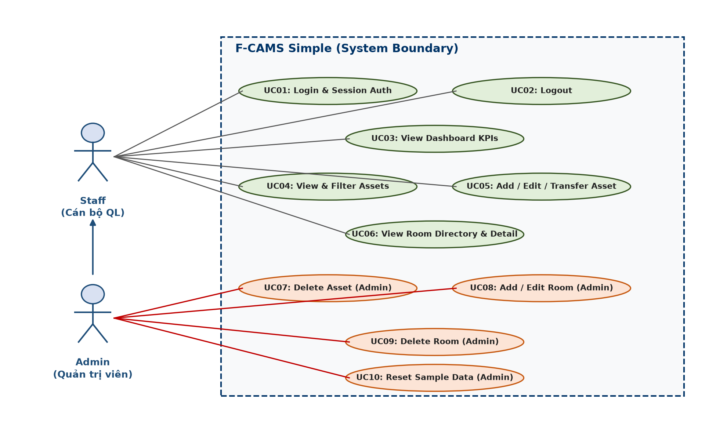
Figure 1.1: Use Case Diagram for F-CAMS Simple
b. Descriptions
ID | Feature | Use Case | Use Case Description
01 | Authentication | Login | Users provide username and password to authenticate; stores User in HttpSession.
02 | Authentication | Logout | Clears the active HttpSession and redirects user back to the login screen.
03 | Dashboard | View Overall KPIs | Displays summary KPI metric cards: Total Assets, Total Rooms, and Total Estimated Inventory Valuation.
04 | Dashboard | View Status Distribution | Analyzes operational proportion of assets (Active, Maintenance/Repairing, Faulty/Broken).
05 | Asset Management | Search & Filter Assets | Multi-criteria asset filtering by Room, Category, Status, and keyword search.
06 | Asset Management | Add & Edit Asset | Registers new asset or updates specifications, serial, unit price, status, notes.
07 | Asset Management | Transfer Asset | Relocates asset to another classroom and automatically records historical movement notes.
08 | Asset Management | Delete Asset | Permanently deletes an asset record from database (Admin only; enforced by AuthFilter).
09 | Room Management | View & Filter Rooms | Lists campus rooms with building filter, chair variance/issue filter, and search.
10 | Room Management | Add / Edit / Delete Room | Admin manages room specs (floor, seats, purpose) and associated assets.

2. Overall Functionalities

2.1 Screens Flow

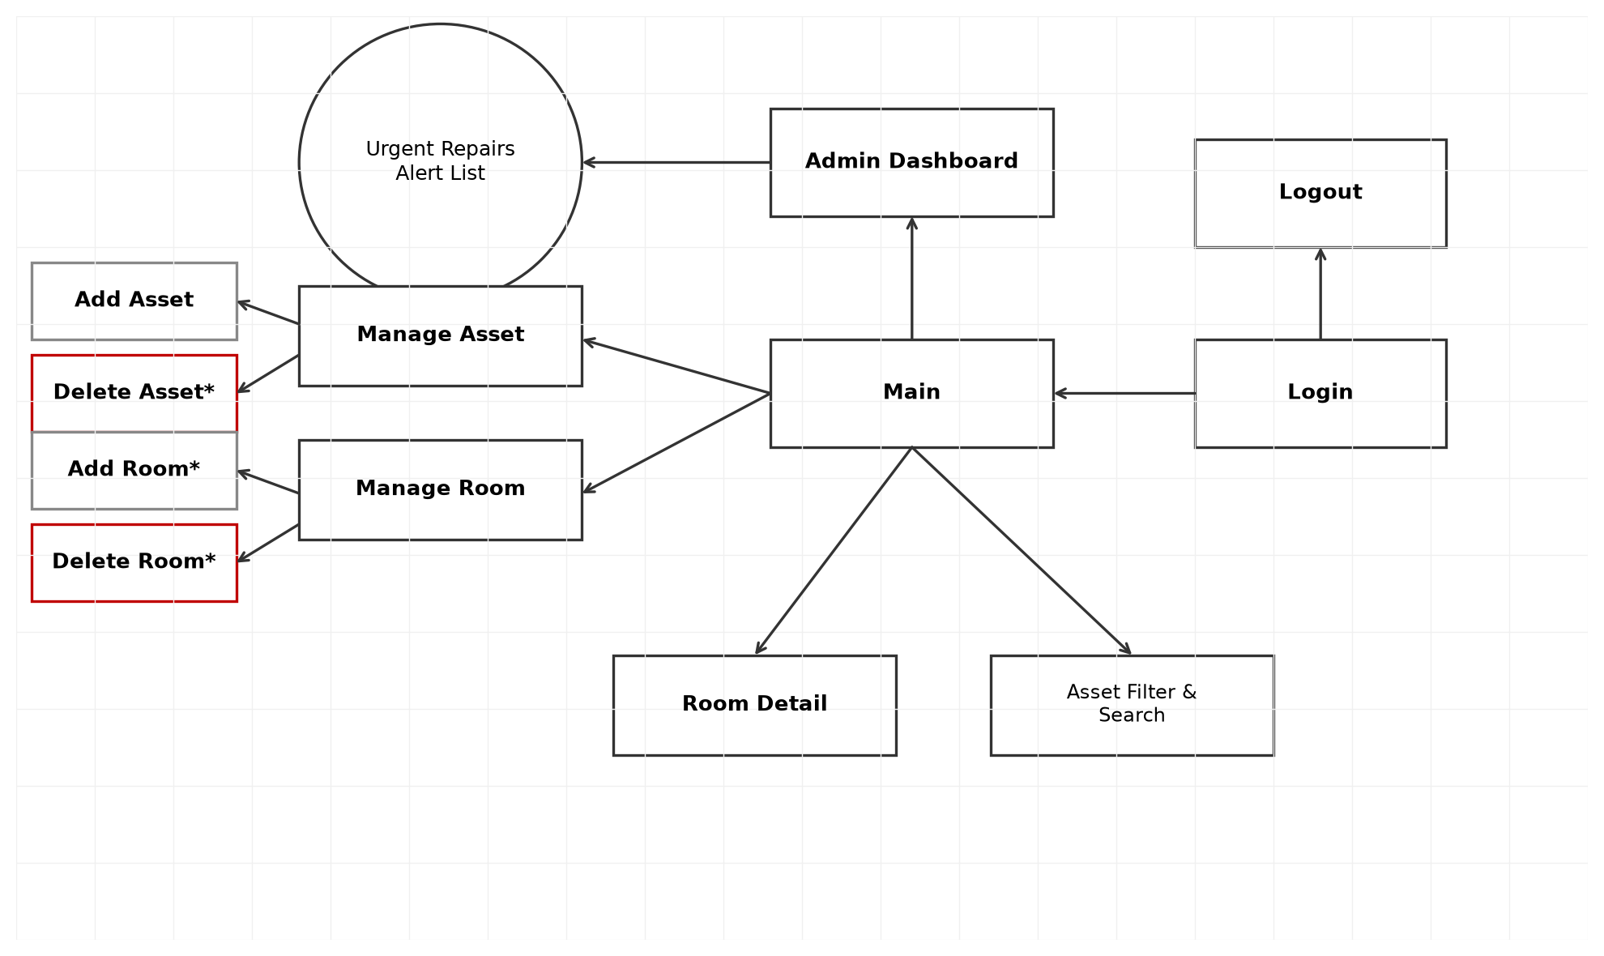
Figure 2.1: Screens Flow Diagram

2.2 Screen Descriptions
# | Feature | Screen | Description
1 | Authentication | Login Screen | Provides username and password entry form with validation alerts and role authentication.
2 | Common UI | Header Navigation | Displays current user credentials, RoleName custom tag, global navbar tabs, and alert message banners.
3 | Dashboard | Dashboard Screen | Presents overall KPI cards (assets, rooms, valuation), asset operational health distribution table, recent additions, and urgent maintenance lists.
4 | Asset Management | Asset Management Screen | Centralized inventory control screen with multi-select filter toolbar, search bar, Add/Edit/Transfer forms, and tabular asset data.
5 | Room Management | Room Management Screen | Classroom directory showing building, floor, chair variance (ChairStatus custom tag), core equipment indicators, and Add/Edit/Delete room controls.
6 | Room Detail | Room Detail Screen | Detailed classroom profile showing capacity specs, educational purpose, and complete listing of all physical assets stationed in the room.

2.3 Screen Authorization
# | Screen / Action | Admin | Staff
1 | Login Screen (/login) | X | X
2 | Logout (/logout) | X | X
3 | Dashboard Screen (/dashboard) | X | X
4 | Asset Management - View & Filter (/assets) | X | X
5 | Asset Management - Add / Edit / Transfer Asset | X | X
6 | Asset Management - DELETE Asset (Dangerous) | X
7 | Room Management - View & Filter Rooms (/rooms) | X | X
8 | Room Management - Add / Edit / DELETE Room (Dangerous) | X
9 | Room Detail Screen (/room-detail) | X | X

2.4 Database Design

a. Database Schema

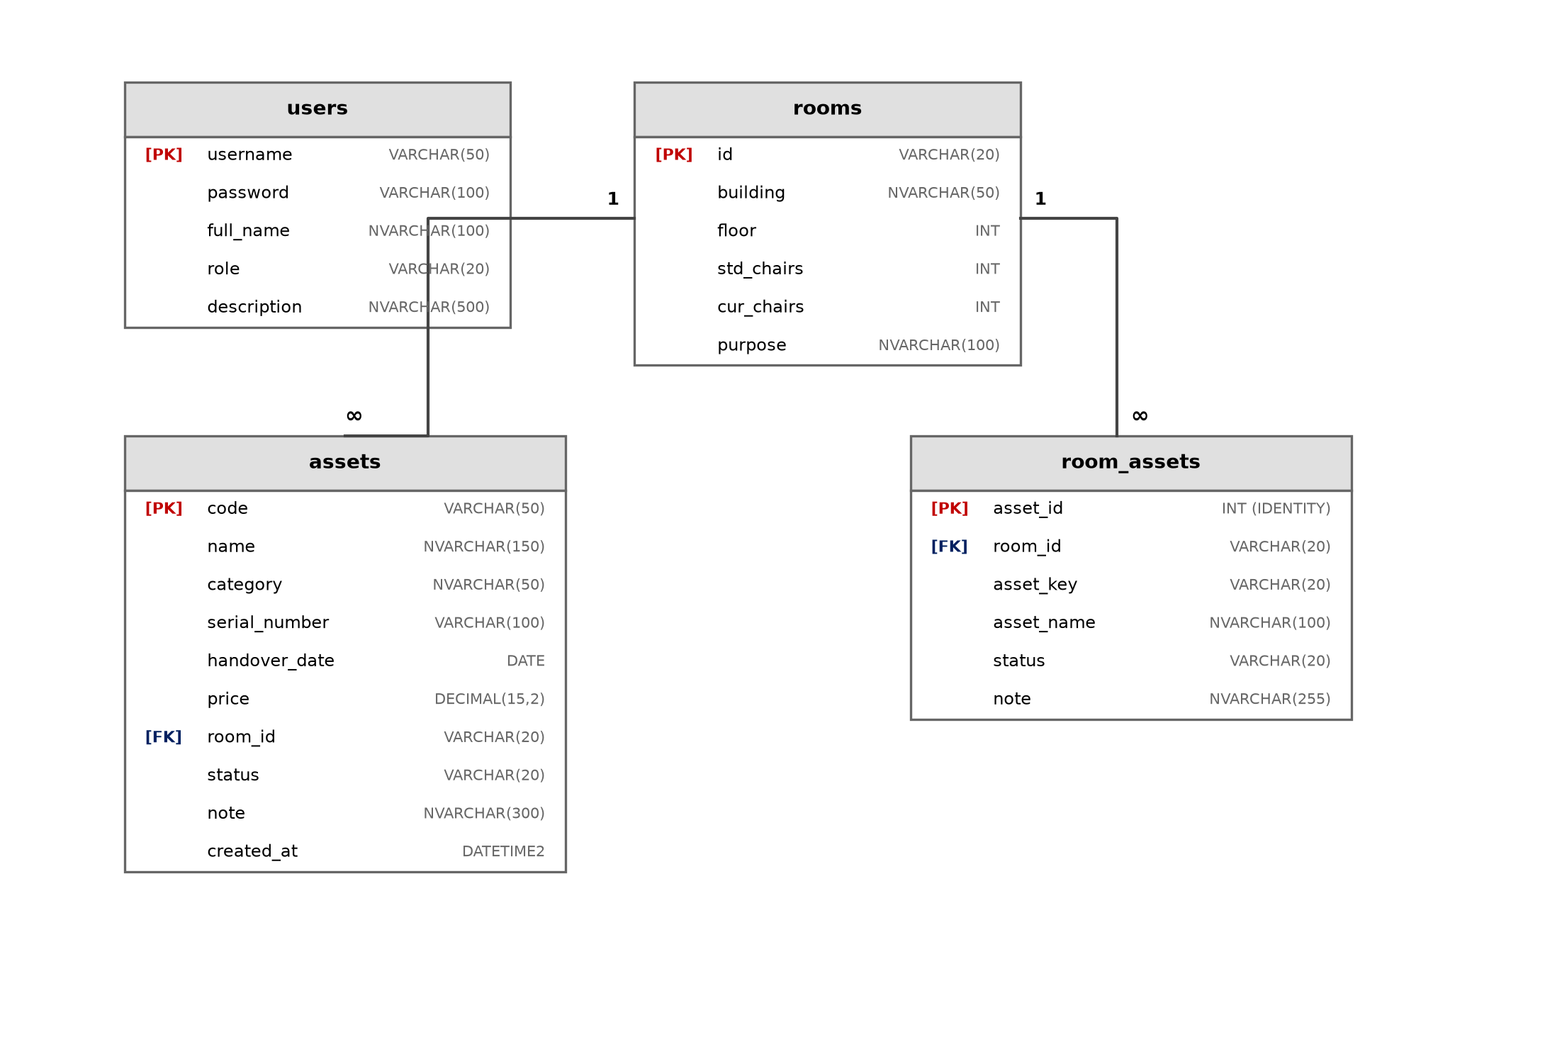
Figure 2.2: Entity Relationship Diagram (ERD) - FCAMS_DB

b. Table Descriptions
No | Table | Description | Keys & Constraints
01 | users | Stores system account credentials, full names, authorization roles (ADMIN, STAFF, IT_STAFF, LECTURER), and role descriptions. | Primary Key: username  Check: role IN ('ADMIN', 'STAFF', 'IT_STAFF', 'LECTURER')
02 | rooms | Manages campus classroom spaces, physical building locations, floor numbers, standard seat quotas, current seats, and intended educational purposes. | Primary Key: id  Check: building IN ('Alpha', 'Beta', 'Delta', 'Epsilon', 'Gamma'), floor 1..10, std_chairs 10..100
03 | assets | Comprehensive inventory registry holding all physical classroom assets, categories, manufacturer serial numbers, acquisition date, unit price, assigned room, and health status. | Primary Key: code  Foreign Key: room_id REFERENCES rooms(id) ON DELETE CASCADE  Check: status IN ('ACTIVE', 'MAINTENANCE', 'BROKEN', 'REPAIRING', 'FAULTY'), price >= 0
04 | room_assets | Tracks 4 fixed core technical installations per classroom (projector, acLeft, acRight, tv) for quick facility health monitoring. | Primary Key: asset_id  Foreign Key: room_id REFERENCES rooms(id) ON DELETE CASCADE  Unique: (room_id, asset_key)

II. Design Specifications

1. Login Screen
Staff and Administrator log in with their designated credentials to access the management portal.

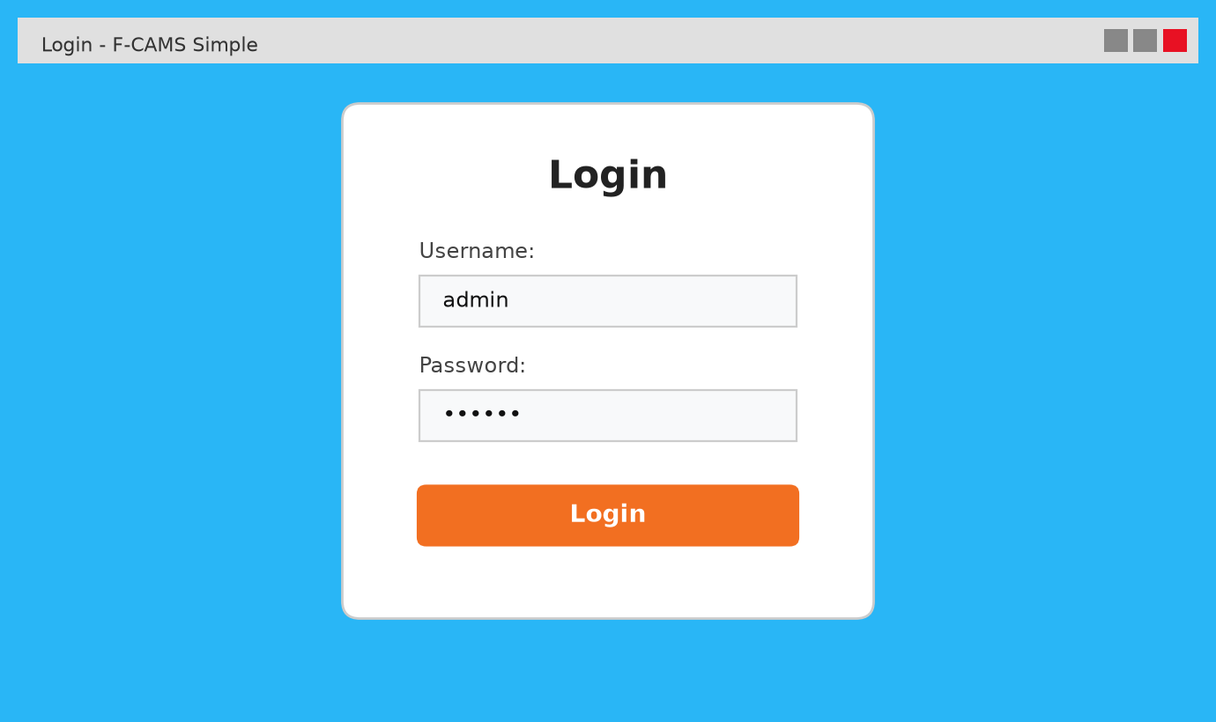
Figure 3.1: Login Screen Interface
Field Name | Field Type | Description
Username | Text Box (Required) | User enters their account username (min 3 characters, e.g. admin, it_beta, hungnq).
Password | Password Box (Required) | User enters their secret authentication password (e.g. 123).
Login | Submit Button | Sends HTTP POST request to /login to authenticate credentials against dbo.users.
Reset | Reset Button | Clears all currently entered values in username and password input fields.

2. Dashboard Screen (Bảng điều khiển Thống kê)
Displays comprehensive high-level system indicators, asset operational health ratios, recently added equipment, and urgent maintenance alerts.

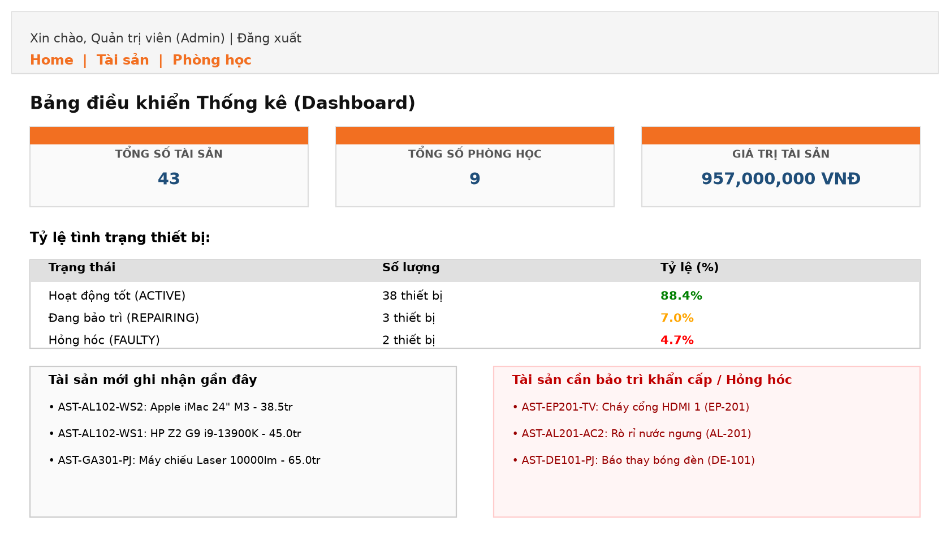
Figure 3.2: Dashboard Interface with KPI Metric Cards
Element / Field Name | Element Type | Description
Total Assets Card | Metric Box (Read-only) | Displays total count of all inventory assets recorded in database.
Total Rooms Card | Metric Box (Read-only) | Displays total number of active classrooms across all campus buildings.
Estimated Value Card | Metric Box (Read-only) | Displays total procurement price sum of all assets, formatted in VND (###,###,### VNĐ).
Asset Health Table | Data Table | Breaks down assets into Active, Repairing, and Faulty counts with calculated percentage ratios.
Recent Assets & Urgent Lists | Data Tables | Displays two responsive tables highlighting newly registered items and urgent maintenance tickets.

3. Asset Management Screen (Quản lý Tài sản - CRUD)
Central management portal for classroom inventory: multi-criteria search and filter, asset registration, asset detail update, inter-room transfer, and deletion.

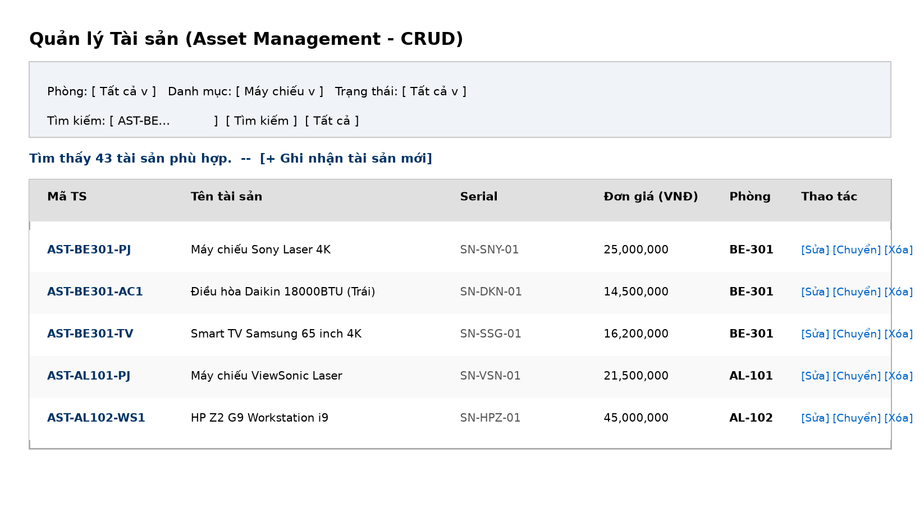
Figure 3.3: Asset Management Screen with Multi-Criteria Filter Bar
Field Name | Field Type | Description
Room Filter | Dropdown List | Filters asset records by assigned classroom (or ALL).
Category Filter | Dropdown List | Filters assets by equipment type (Máy chiếu, Điều hòa, Smart TV, Âm thanh, Thiết bị Lab, Bàn ghế, Khác).
Status Filter | Dropdown List | Filters assets by operational health: ACTIVE (Tốt), REPAIRING (Bảo trì), FAULTY (Hỏng).
Keyword Input | Text Box | Searches matches in asset code, asset name, or manufacturer serial number.
Mã tài sản (code) | Text Box (Required) | Unique asset code identifier (min 3 characters, e.g. AST-BE301-PJ). Primary key.
Tên tài sản (name) | Text Box (Required) | Descriptive asset name including brand and specifications.
Thao tác (Actions) | Buttons / Links | [Sửa] opens inline edit form; [Chuyển phòng] opens relocation form; [Xóa] triggers deletion (Admin only).

4. Room Management Screen (Quản lý Phòng học - CRUD)
Directory of campus classrooms with capacity tracking, chair discrepancy detection via custom tag, and complete room management.

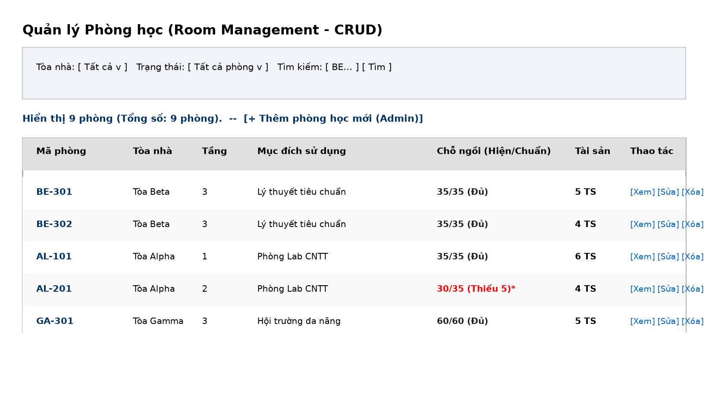
Figure 3.4: Room Management Screen with Chair Quota Variance Tag
Field Name | Field Type | Description
Building Filter | Dropdown List | Filters rooms by campus block (Alpha, Beta, Delta, Epsilon, Gamma, or ALL).
Status Filter | Dropdown List | Filters rooms by condition: ISSUES (seat shortage or broken gear) or OK.
Mã phòng (id) | Text Box (Required) | Room code formatted strictly to regex ^[A-Z]{2}-\d{3}$ (e.g. BE-303, AL-101).
Tầng (floor) | Number Box (1 - 10) | Floor level in building where the classroom is situated.
Ghế (std / cur) | Number Boxes | Standard seating capacity and current physical chair count (triggers chairStatus custom tag).

5. Room Detail Screen (Chi tiết Phòng học & Thiết bị)
Dedicated room inspection screen displaying complete room specifications, seating quota status, and a full catalog of all assets deployed in the room.

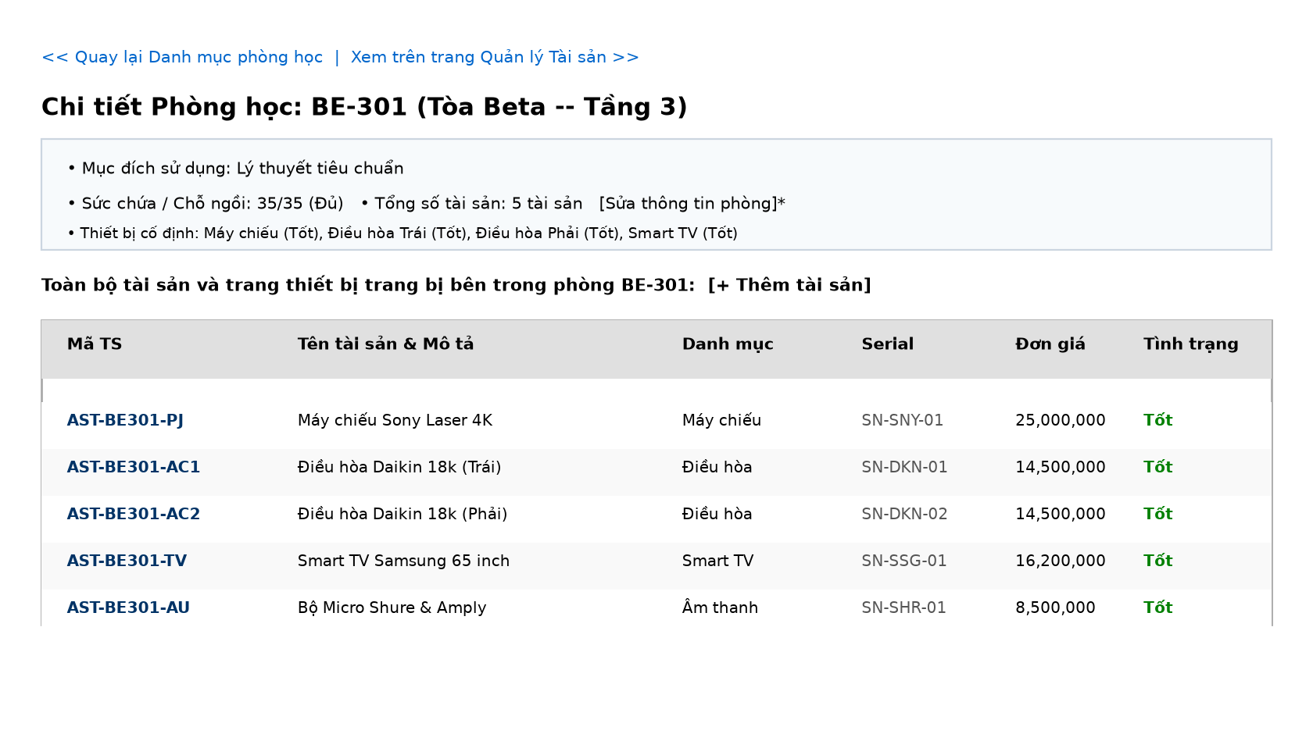
Figure 3.5: Room Detail Screen with Equipped Assets Catalog
Element / Field Name | Element Type | Description
Room Profile Summary Card | Information Card | Displays Room ID, Building, Floor, Educational Purpose, and Chair Variance indicator.
Equipped Asset Catalog Table | Data Table | Renders tabular list of all assets deployed in this room, complete with code, name, category, serial, price, status, and notes.
Link: Add Asset to Room | Hyperlink | Navigates directly to /assets?roomId=... with target room pre-selected in registration form.
Item Actions | Action Links / Buttons | Allows inline editing [Sửa], transfer to another room [Chuyển], or deletion [Xóa] (Admin only).

