|  |
| --- |
| Team Report  Living History - A Mobile App to explore preserved historic buildings and locations in the city of Zurich  **Authors:**  Julia Burgermeister  Charalampos Gkonos  Rebecca Ilehag  December 2015 |
| Institute of Cartography and Geoinformation |

Content

1 Idea and Goals 3

1.1 Theme of the Application 3

1.2 Vision and Project-Goals 3

2 Planning and Organization 3

2.1 Schedule 3

2.2 Responsibilities 4

3 Data 4

3.1 Open Data Zürich 4

3.1.1 Historic Point and Polygon data 4

3.1.2 Historic Base maps 5

3.2 Other data 5

3.2.1 Tour Geometry and Information 5

4 Application 5

4.1 Functionality 5

4.2 Implementation 6

4.2.1 Creating the Map View and adding the Base maps and Layers 6

4.2.2 Filter Function 6

4.2.3 Tour Function 6

4.2.4 License the App with ArcGIS online 7

5 Discussion 7

5.1 Major Challenges 7

5.1.1 Code Repositories 7

5.1.2 ArcGIS for Android SDK 7

5.1.3 Unimplemented functionalities 7

5.2 Outlook and future functionalities 8

5.2.1 Tours 8

# Idea and Goals

## Theme of the Application

The inspiration for this project came from the fact that there are over 8000 historic preserved objects and buildings (Denkmalschutzobjekte) in the city of Zurich and no one really knows where they’re located.

Therefore, the theme for our application is the exploration of historic Zurich, mainly focusing on the preserved sites and gardens and also providing historic maps to the user. The target user group was narrowed down to people with an interest of historic preservation, more specifically Swiss tourists or inhabitants of Zurich under the assumption that these two groups are mainly those interested in historical preservation. Therefore, the language used in the app was chosen to be German.

## Vision and Project-Goals

The visions and the goals of the project were the following points.

* Let users experience historic preserved Zurich
  + Highlight preserved, historic objects
  + Locate and guide the user through history
  + Provide thematic tours to explore
  + Make it user-friendly

# Planning and Organization

## Schedule

To plan the project, we divided the work into tasks and subtasks. The tasks where assigned to a group member which then was responsible for it, but the subtasks still being executed by other members of the group. The first draft of the schedule can be seen in Figure 1.

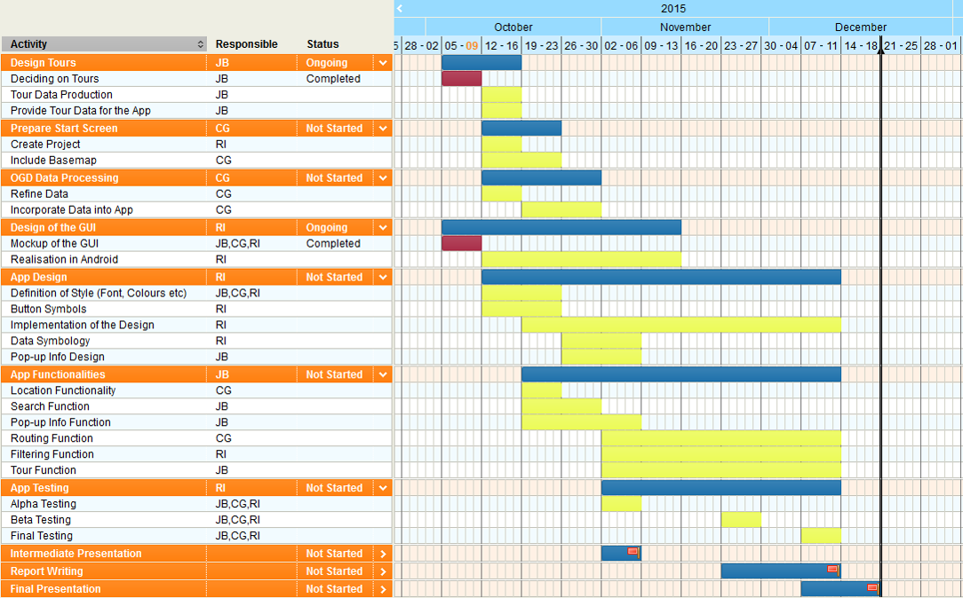

Figure 1: First draft of the schedule

The initial plan was to have all base tasks, the less code demanding functionalities, done by the intermediate presentation in order to have time for the more time consuming functionalities. However, certain functionalities took more time than expected to finish due to various factors. Some of the tasks scheduled in the later part of the project were never completed due to lack of time and uncompleted related tasks, such as the filtering functionality. //Move this to discussion and update the schedule online so we can show the true schedule?

## Responsibilities

Each student was assigned two main responsibilities and several subtasks which can be seen in Figure 1. The student responsible for a task is represented by the student’s initials. The initial assignments of the tasks were not completely followed, since it happened occasionally that two students helped each other when one got stuck or lacked the time to finish the task. Hence, the true division of the tasks can be seen in Table 1. There are comments in the code as well, pinpointing to who wrote this parts.

Table 1: The distribution of the responsibilities

|  |  |  |  |
| --- | --- | --- | --- |
| Julia Burgermeister | Charalampos Gkonos | Rebecca Ilehag | Everyone |
| Digitize the tours | Location | Initial Code with empty methods and constructors | Touren-Menu with Buttons and showing the geometry |
| Tours and OGC data on ArcGIS Online (with symbolization) | Routing | Filter-Menu | Showing different layers and basemaps |
| Colors |  | Layouts |  |
| Popup-Window |  | Layer-order |  |

# Data

## Open Data Zürich

### Historic Point and Polygon data

Two layers containing preserved objects were available as WMS on Open Data Zürich, one containing historical and preserved objects as points (“Denkmalschutzobjekte”) and the other contained preserved gardens as polygons (“Gartendenkmalschutzobjekte”). A layer containing viewing points were chosen as well (“Aussichtspunkte”) as an additional layer. The initial plan was to include a layer with wells and fountains as well, however the dataset only contained the coordinates of the objects and was therefore considered not suitable for the project.

### Historic Base maps

The historic base maps, city maps, were all available on Open Data Zürich as WMS. Four historical maps were used as base maps and are dated from the years 1793, 1860, 1900 and 1970. The reasoning behind picking these years was to have several base maps over a large time epoch. Since the city of Zurich has grown during these years, the maps are covering different areas. The default base map is the current city plan map, which is dated from 2014.

## Other data

### Tour Geometry and Information

As one of the many services the city of Zurich provides its residents and visitors, there are 20 city walks created to explore the city. The walks are called “Züri z’Fuess” and can be found online[1]. They’re available as PDF-plans with additional information concerning the theme and the stops as well as their duration.

As this project should provide some tours to explore historic Zurich and most of the “Züri z’Fuess” walks also incorporate historic sites, the tours where digitized in ArcMap based on the PDF plans. Afterwards, the tour geometries including styling and labelling where published to ArcGIS Online as a Feature Service and a Tiled Map Service.

# Application

## Functionality

The original planned functionalities were the following, shown in the order of the scheduled implementation with a small description of what each functionality should be like.

1. Map view – the default map one would see in the start window
2. Location – the user location tracking
3. Layer Filtering – choosing which layer that should be displayed
4. Search-function (closest / radius) – filter out objects and display those within the chosen radius
5. Search-function (by name or subcategory, autofill) – filter out objects by either using the name or a defined subcategory with autofill
6. Routing – using the user’s location and find the shortest route to a chosen location
7. Info window – a pop-up window that would display information about the object of interest
8. List view (show search results in a list) – display the search results in a list
9. Language Selection – being able to swap the app language between German and English

## Implementation

### Creating the Map View and adding the Base maps and Layers

#### User’s location

//Charis

#### Base map option

If the user would press the button called “Karten”, a group of radio buttons would be displayed making it possible to pick from the various historical base maps. Only one base map can be displayed, and hence if the user picks another base map and first one gets hidden. The base map is always placed as the bottom layer.

#### Layer option

If the user would press the button called “Ebenen”, a group of check boxes would be displayed making it possible to show or hide the layers “Denkmalpflege”,”Gartendenkmal” or “Aussichtspunkte”. The drawing order of the layers would be the points on the top and polygon underneath.

#### Filter and tour buttons

If the user either pressed the filter or the tour button, a new intent would be created and the user would be a new window would appear. Either the uncompleted filter menu or the tour menu would then be displayed.

#### Pop-up window

//Julia

#### Routing

//Charis

### Filter Function

The planned filtering was never completed due to lack of time since more crucial tasks need to be implemented. However, the mockup of the menu was implemented and the explanation of the reasoning behind the unimplemented functions can be read below.

#### Filtering based on search distance

The user would be able to write a distance that would work as a buffer, hence the objects outside this distance would not be displayed in the map.

#### Filtering based on subcategory

The user would be able to pick which subcategory of the gardens that should be displayed. The subcategories of the gardens are already defined in the dataset, which was not the case for the historical preserved objects. Hence, categorizing roughly 7000 points manually would require a lot of work and therefore, this option would only be available for the gardens.

#### Filtering based on year

The user would be able to filter the historical preserved objects based on the year they were built. A number of historical objects didn’t contain a building date and were deleted from the dataset.

### Tour Function

#### Tour Activity

Only one of the tours was implemented, however the principle would be the same for any tour. By picking a tour from the list of the tours, the tour’s corresponding button would be adding results to an intent which would transfer data to the main activity. The tour activity would end once the button is pressed, returning the user to the main menu.

#### Display Tour on Map

The tour chosen in the previous window would now be displayed, in addition to the already chosen base map and layers. A button making it possible to remove the tour from the map would now be visible.

#### Stop viewing the Tour

If the user pressed on the button to stop the tour, the tour would be removed from the map by calling the deselect method.

### License the App with ArcGIS online

To make sure the app can be used by everyone and to remove the watermark on the map, the app needs to be licensed[2]. Providing and ArcGIS-Online account, the app can be registered on the ArcGIS for Developers platform. By doing so, you’ll get a unique client ID with a corresponding “Client Secret”, a password-like information that should be stored in a secure location.

Using those credentials, the app is allowed to use different services provided by ArcGIS, for example the Routing service.

# Discussion

## Major Challenges

### Code Repositories

To share the code and merge it after working on the app separately, GitExtensions and BitBucket where used. The pull request wasn’t pulling the current version from BitBucket and Commit and Push didn’t work all the time. Also, the merge software K3diff didn’t working properly, it wasn’t possible to save the solved conflicts and therefore the merged file resulted in being corrupt and the merge needed to be cleaned up by hand.

To avoid these problems, the Server provided by IKG was used to exchange the current project folder, copy it to the Git-folder and then work on with that version. Nevertheless, this procedure took a lot of time and didn’t prove to be useful for bigger projects.

### ArcGIS for Android SDK

The online help and

### Unimplemented functionalities

#### Search functionality

//Julia

## Outlook and future functionalities

### Tours

More tours could be implemented

Addition of sound, by adding the stories to be found on this website:

<https://www.stadt-zuerich.ch/ted/de/index/stadtverkehr2025/zu-fuss/hoerspiele.html>

1. <https://www.stadt-zuerich.ch/ted/de/index/stadtverkehr2025/zu-fuss/routen.html>
2. <https://developers.arcgis.com/android/guide/license-your-app.htm>