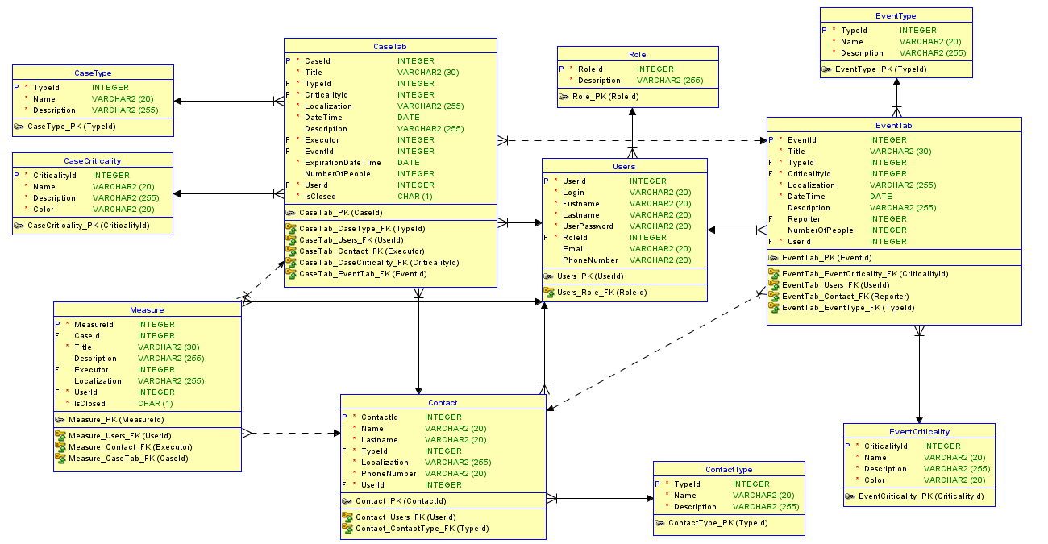

|  |  |  |  |  |  |  |
| --- | --- | --- | --- | --- | --- | --- |
| **TABELA** | **KOLUMNA** | **TYP DANYCH** | **WARTOŚĆ DOMYŚLNA** | **Może być NULL** | **Obowiązkowa?** | **Referencja - tablica(kolumna)** |
| Users | UserId | INTEGER |  |  | V |  |
| Users | Login | VARCHAR2(20) |  |  | V |  |
| Users | Firstname | VARCHAR2(20) |  |  | V |  |
| Users | Lastname | VARCHAR2(20) |  |  | V |  |
| Users | UserPassword | VARCHAR2(20) |  |  | V |  |
| Users | RoleId | INTEGER |  |  | V | Role(RoleId) |
| Users | Email | VARCHAR2(20) | NULL | V |  |  |
| Users | PhoneNumber | VARCHAR2(20) | NULL | V |  |  |
| Role | RoleId | INTEGER |  |  | V |  |
| Role | Description | VARCHAR2(255) |  |  | V |  |
| Contact | ContactId | INTEGER |  |  | V |  |
| Contact | Name | VARCHAR2(20) |  |  | V |  |
| Contact | Lastname | VARCHAR2(20) |  |  | V |  |
| Contact | TypeId | INTEGER |  |  | V | ContactType(TypeId) |
| Contact | Localization | VARCHAR2(255) |  |  | V |  |
| Contact | PhoneNumber | VARCHAR2(20) |  |  | V |  |
| Contact | UserId | INTEGER |  |  | V | Users(UserId) |
| ContactType | TypeId | INTEGER |  |  | V |  |
| ContactType | Name | VARCHAR2(20) |  |  | V |  |
| ContactType | Description | VARCHAR2(255) |  |  | V |  |
| Event | EventId | INTEGER |  |  | V |  |
| Event | Title | VARCHAR2(30) |  |  | V |  |
| Event | TypeId | INTEGER |  |  | V | EventType(TypeId) |
| Event | CriticalityId | INTEGER |  |  | V | EventCriticality(CriticalityId) |
| Event | Localization | VARCHAR2(255) |  |  | V |  |
| Event | DateTime | DATE |  |  | V |  |
| Event | Description | VARCHAR2(255) | NULL | V |  |  |
| Event | Reporter | INTEGER | NULL | V |  | Contact(ContactId) |
| Event | NumberOfPeople | INTEGER | NULL | V |  |  |
| Event | UserId | INTEGER |  |  | V | Users(UserId) |
| EventType | TypeId | INTEGER |  |  | V |  |
| EventType | Name | VARCHAR2(20) |  |  | V |  |
| EventType | Description | VARCHAR2(255) |  |  | V |  |
| EventCriticality | CriticalityId | INTEGER |  |  | V |  |
| EventCriticality | Name | VARCHAR2(20) |  |  | V |  |
| EventCriticality | Description | VARCHAR2(255) |  |  | V |  |
| EventCriticality | Color | VARCHAR2(20) | WHITE |  | V |  |
| Case | CaseId | INTEGER |  |  | V |  |
| Case | Title | VARCHAR2(30) |  |  | V |  |
| Case | TypeId | INTEGER |  |  | V | CaseType(TypeId) |
| Case | CriticalityId | INTEGER |  |  | V | CaseCriticality(CriticalityId) |
| Case | Localization | VARCHAR2(255) |  |  | V |  |
| Case | DateTime | DATE |  |  | V |  |
| Case | Description | VARCHAR2(255) | NULL | V |  |  |
| Case | Executor | INTEGER |  |  | V | Contact(ContactId) |
| Case | EventId | INTEGER | NULL | V |  | Event(EventId) |
| Case | ExpirationDateTime | DATE |  |  | V |  |
| Case | NumberOfPeople | INTEGER | NULL | V |  |  |
| Case | UserId | INTEGER |  |  | V | Users(UserId) |
| Case | IsClosed | BOOLEAN |  |  | V |  |
| CaseType | TypeId | INTEGER |  |  | V |  |
| CaseType | Name | VARCHAR2(20) |  |  | V |  |
| CaseType | Description | VARCHAR2(255) |  |  | V |  |
| CaseCriticality | CriticalityId | VARCHAR2(20) |  |  | V |  |
| CaseCriticality | Name | VARCHAR2(20) |  |  | V |  |
| CaseCriticality | Description | VARCHAR2(255) |  |  | V |  |
| CaseCriticality | Color | VARCHAR2(20) | WHITE |  | V |  |
| Measure | MeasureId | INTEGER |  |  | V |  |
| Measure | CaseId | INTEGER | NULL | V |  | Case(CaseId) |
| Measure | Title | VARCHAR2(30) |  |  | V |  |
| Measure | Description | VARCHAR2(255) | NULL | V |  |  |
| Measure | Executor | INTEGER | NULL | V |  | Contact(ContactId) |
| Measure | Localization | VARCHAR2(255) | NULL | V |  |  |
| Measure | UserId | INTEGER |  |  | V |  |