This project is also a presentation to your set. It will be presented in your lab period on the final day of the iOS course (along with your iOS project)

It is worth 30% of your overall grade, so please start early and work hard on it.

Requirements:

* index.html: Create an HTML page named “index.html” to show off and combine what we have covered during this whole course.
* When the user visits your page, they will be shown a single textbox and a button. When the user clicks the button, the following things must happen:
* storage.html: If the text in the textbox has the word “storage” in it, then a hyperlink is created using document.createElement and appended to the body. Its href attribute value will be “storage.html” which is another web page that you have written too. storage.html is an HTML page that uses your own words and or images to explain how window.localStorage works. You will be teaching me (your instructor) how it works. There are lots of tutorials out there, but you must use your own words and your own demonstrations. The clearer your tutorial is, and the better your demonstration is, the higher your mark will be. So, give a short write up with explanations and examples of localStorage, plus a demo on this page.
* If the text in the textbox has the word “alien” in it, then an alien image is created and appended to the body of index.html. The alien stays on the document from this point on. If the user types “walk” in the textbox and presses the button after the alien has been created, the alien will pace back and forth at 1px every 100ms. If the user types “run” in the textbox and presses the button after the alien has been created, the alien will pace back and forth at 1px every 10ms. If the user types “stop” in the textbox and presses the button after the alien has been created, the alien will stop moving. If the user types “bye” in the textbox and presses the button after the alien has been created, the alien will be removed from the document (display:none).
* If the text in the textbox has the word “jquery” in it, then use plain-old JavaScript to create four images on index.html. Then use jQuery to do the following: all images must get an HTML width attribute of 200; when the second image gets clicked, it gets a big fat red border.
* plugin.html: if the text in the textbox has the word “plugin” in it, then a hyperlink is created using document.createElement and appended to the body. Its href attribute value will be “plugin.html” which is another web page that you have written too. Here you will show off any jquery plugin you want. There are some awesome and useful jquery plugins, and you can choose any one. Clearly, the more “wow” it has, the better it is.
* if the text in the textbox has the word “ajax” in it, then create an XMLHttpRequest object right away and open an asynchronous GET request to read data from a text file named “advice.txt”. Whatever is written in advice.txt should be displayed in a new h1 object (use document.createElement and document.body.appendChild) in UPPERCASE. advice.txt should be one piece of genuine advice that you would like to give people. NOTE: the advice in advice.txt is actually an array of words in JSON format.
* alphabet.html: if the text in the textbox has the word “alphabet” in it then loop through the letters backwards from z to a and append images of the letters to the document; each letter must be 40px wide. Whenever a letter is clicked, all the images on the document get that letter’s src.

Upload your four files (index.html, storage.html, plugin.html, advice.txt) before Sunday November 28 at 11:59pm to your learning hub’s “Project” dropbox.

We will present our work to one another in that week’s lab on zoom. Your presentation with your partner should take about 5-8 minutes.

Work with one partner. In a comment inside index.html, specify who your partner is and what parts each of you worked on.

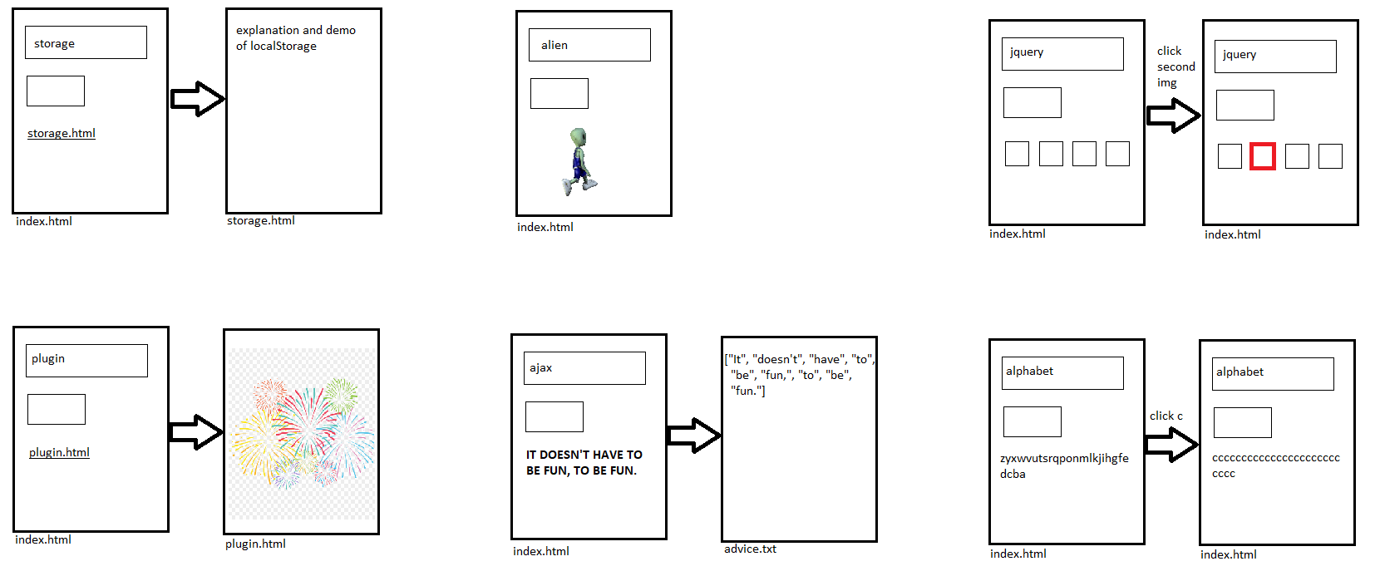

Marking guide:

|  |  |  |  |
| --- | --- | --- | --- |
| **Requirement** | **Max Score** | **Your Score** | **Comments** |
| storage.html hyperlink appears when **storage** typed into textbox and button clicked | 2 |  |  |
| storage.html has a clear explanation in your own words, how localStorage works | 5 |  |  |
| storage.html has a clear, simple, functional demonstration, showing a working localStorage app | 10 |  |  |
|  |  |  |  |
| index.html has comments about what each partner did | 2 |  |  |
| Alien appears when **alien** typed into textbox and button clicked | 5 |  |  |
| Alien walks when **walk** typed into textbox and button clicked | 3 |  |  |
| Alien runs when **run** typed into textbox and button clicked | 3 |  |  |
| Alien stops when **stop** typed into textbox and button clicked | 3 |  |  |
| Alien disappears when **bye** typed into textbox and button clicked | 3 |  |  |
|  |  |  |  |
| Four images get created when **jquery** typed into textbox and button clicked | 5 |  |  |
| jquery is used to resize html width attribute of all images | 3 |  |  |
| jquery is used to change css border of second image when it is clicked | 5 |  |  |
|  |  |  |  |
| plugin.html hyperlink appears when **plugin** typed into textbox and button clicked | 2 |  |  |
| plugin.html shows an interesting jquery plugin working fine…something that would be difficult for us to do ourselves | 15 |  |  |
|  |  |  |  |
| advice.txt has a json array of words | 5 |  |  |
| advice.txt json becomes a JavaScript array in index.html when **ajax** typed into textbox and button clicked | 2 |  |  |
| The json array is printed as a text node inside a new <h1> element on index.html when **ajax** typed into textbox and button clicked | 10 |  |  |
| The text is uppercased in the h1 (but not in the advice.txt file) | 2 |  |  |
|  |  |  |  |
| When **alphabet** is typed into the textbox and the button is clicked, 26 images of the letters of the alphabet are placed onto index.html | 5 |  |  |
| The letters are in reverse alphabetical order, from z to a | 5 |  |  |
| Whenever a letter is clicked, all 26 letters get that letter’s src | 5 |  |  |
|  |  |  |  |
| Total | 100 |  |  |