# CSE 222 HOMEWORK 8:

# Graphs Social Network System

Gebze Technical University Computer Engineering Department

Project Report

Buket Gençer

210104004298

Introduction

The aim of this project is to develop a social network analysis system using graph data structures and algorithms. The goal is to simulate a social network where each person is represented by a node, and each friendship is represented by an edge. The system allows users to add and remove people, create and delete friendships, find the shortest path between two people, suggest friends based on mutual friends and common hobbies, and count clusters of connected people. This project helps in understanding the structure and dynamics of social networks through practical implementation and analysis.

Test and Results

1. Add Person

The new person is then added to the people map, using a unique key combining their name and timestamp to ensure uniqueness. Additionally, an empty list is initialized for the person's friendships in the friendships map.

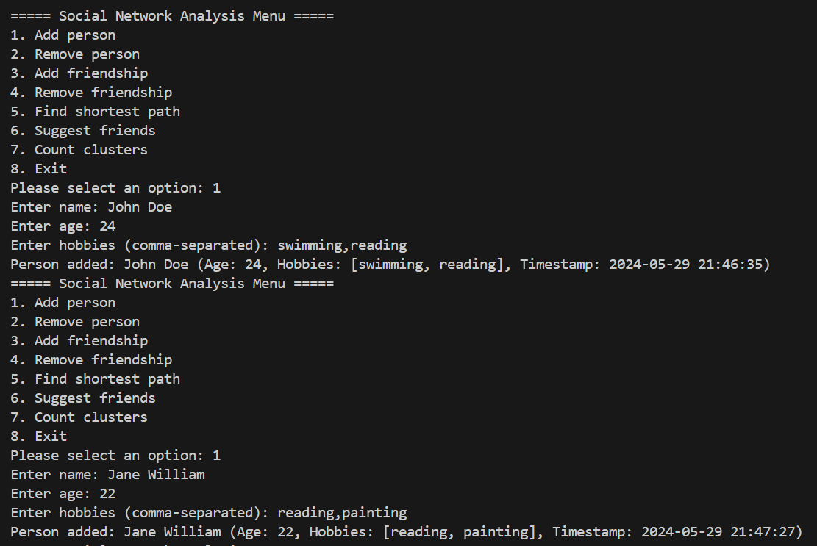

When enter invalid input:  
metin, ekran görüntüsü, yazı tipi içeren bir resim

Açıklama otomatik olarak oluşturuldu

2.Remove Person

This option lets you remove a person from the social network. You need to provide the person's name and the exact timestamp when they joined. The person and their friendships will be removed, and a confirmation message will be shown.

metin, ekran görüntüsü, yazı tipi içeren bir resim

Açıklama otomatik olarak oluşturuldu

After removing Jane William is gone in Clusters

metin, ekran görüntüsü, menü, yazı tipi içeren bir resim

Açıklama otomatik olarak oluşturuldu

metin, ekran görüntüsü, yazı tipi içeren bir resim

Açıklama otomatik olarak oluşturuldu

Result of invalid input

3.Add Friendships

With this option, you can create a friendship between two people in the network. You need to enter the names and timestamps of both individuals.

metin, ekran görüntüsü, yazı tipi içeren bir resim

Açıklama otomatik olarak oluşturuldu

When people have a friendship they ara in the same cluster.

4.Remove Friendship

This option triggers the removeFriendship method in the SocialNetworkGraph class. It requires the names and timestamps of the two people whose friendship you want to remove. The friendship is deleted from the network, and a confirmation message is printed.

metin, ekran görüntüsü, menü, yazı tipi içeren bir resim

Açıklama otomatik olarak oluşturuldu

We can see in cluster result of removing friendships.

5.Shortest Path

This option invokes the findShortestPath method in the SocialNetworkGraph class. You need to input the names and timestamps of the start and end persons. The method uses breadth-first search (BFS) to find and display the shortest path between them.

Before Paul White and Emily Davis friendship:  
metin, ekran görüntüsü, yazı tipi içeren bir resim

Açıklama otomatik olarak oluşturuldu  
After Paul White and Emily Davis friendships:  
metin, ekran görüntüsü, yazı tipi içeren bir resim

Açıklama otomatik olarak oluşturuldu

6.Suggest Friends

This option calls the suggestFriends method in the SocialNetworkGraph class. You provide the person's name, timestamp, and the maximum number of suggestions you want. The system calculates scores based on mutual friends and common hobbies and prints a list of suggested friends.

metin, ekran görüntüsü, yazı tipi içeren bir resim

Açıklama otomatik olarak oluşturuldu

metin, ekran görüntüsü, yazı tipi, tasarım içeren bir resim

Açıklama otomatik olarak oluşturuldu

metin, ekran görüntüsü, yazı tipi, tasarım içeren bir resim

Açıklama otomatik olarak oluşturuldu

7. Count Clusters:  
his option uses the countClusters method in the SocialNetworkGraph class. It counts the number of clusters in the network, where a cluster is a group of interconnected people. The method prints the number of clusters and lists the members of each cluster.

metin, ekran görüntüsü, yazı tipi içeren bir resim

Açıklama otomatik olarak oluşturuldu