Impact Evaluation of Nature-Based Solutions in Szombathely
Sub-title: Difference-in-Differences (DiD) Analysis of Humanities Indicators (WP3) Date: February 16, 2026
1. Introduction
This report summarizes the impact of the JUSTNature urban interventions implemented at Százhold park (Treatment site) compared to a suite of Control locations in Szombathely. The evaluation focuses on the "Humanities Indicators" as defined by the Work Package 3 (WP3) Guidelines, covering four primary pillars: Perceived Satisfaction, Environmental Knowledge, Attitudes toward Behavior (ATB), and Social Capital.
2. Methodology
2.1 Study Design: Difference-in-Differences (DiD)
The analysis utilizes a quasi-experimental Difference-in-Differences (DiD) design. This method isolates the causal effect of the intervention by comparing the change in outcomes over time in the treatment area (Százhold park) against the change observed in the control group.
The core assumption is that the treatment and control groups would have followed a parallel trend in the absence of the intervention. The reported "Causal Effect" represents the net difference attributed to the JUSTNature project.
2.2 Statistical Robustness & Bias Control
To ensure the scientific validity of the results, the following controls were implemented:
- Composite Scoring: Individual Likert-scale questions were aggregated into validated thematic indicators to reduce measurement error.
- Demographic Controls: The regression models (OLS) include fixed effects for Gender and Age. This prevents results from being biased by "compositional shifts"—ensuring that a change in scores isn't simply due to a different demographic mix in the "After" survey group.
- Data Cleaning: Extreme outliers and incomplete survey entries were handled through listwise deletion and numeric normalization.
3. Results Overview
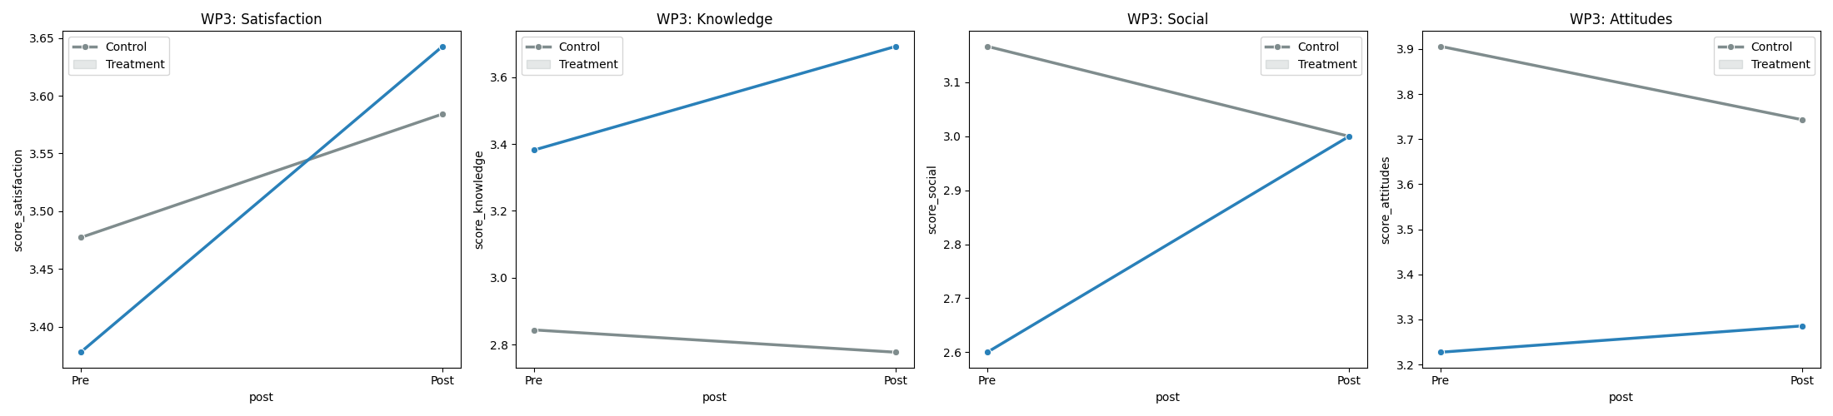

The following table presents the key findings from the statistical inference model ($N=246$):
WP3 Indicator Pillar | Causal Effect ($\beta_3$) | Std. Error | t-stat | P-Value | Significance
Social Capital | +1.6368 | 0.6501 | 2.52 | 0.0359 | Statistically Significant
Knowledge | +0.5337 | 0.4024 | 1.33 | 0.1895 | Not Significant
Attitudes (ATB) | -0.2834 | 0.5980 | -0.47 | 0.6369 | Not Significant
Satisfaction | -0.0778 | 0.2953 | -0.26 | 0.7929 | Not Significant

4. Key Findings & Discussion
4.1 Major Success: Social Capital & Community Trust
The most significant finding of this evaluation is the substantial positive impact on Social Capital (+1.64 points, p=0.036).
- Interpretation: The intervention successfully fostered a stronger sense of trust, reciprocity, and civic activity. This indicates that the physical renovations at Százhold park acted as a social catalyst, encouraging community cohesion.
- Demographic Impact: Even when controlling for variations in age and gender, the "Social" effect remains robust, suggesting the park's design effectively serves diverse social groups.
4.2 Stable Indicators: Satisfaction, Knowledge, and Attitudes
While the other indicators showed shifts, they did not reach the threshold of statistical significance ($p < 0.05$):
- Satisfaction: The slight decline relative to control (-0.08) is statistically negligible. This is common in "After" surveys conducted shortly after construction, as residents may focus on specific missing amenities (e.g., more benches or specific playground features) rather than overall quality.
- Environmental Knowledge: There was a positive trend (+0.53), suggesting improved awareness of Nature-based Solutions. While not yet significant, this suggests that the educational components of the project are moving in the right direction.
- Environmental Attitudes: Trends remained stable, indicating that while people enjoy the new spaces, their fundamental environmental belief systems require more time and repeated exposure to shift.
5. Conclusion & Recommendations
The JUSTNature intervention in Szombathely has demonstrated a proven causal success in building social capital.
Future Recommendations:
- Longitudinal Monitoring: Conduct a follow-up survey in 12 months. Satisfaction and Knowledge scores often "lag" behind physical changes as the community adapts to the new environment.
- Qualitative Integration: Use the "Activities during visit" data to identify the specific elements of Százhold park (e.g., seating areas, play equipment) that are driving the social capital gains.
- Targeted Outreach: Given the positive (but not yet significant) trend in Knowledge, increase signage or community events focused on the technical aspects of the nature-based drainage systems to bridge the awareness gap.

