DEBRODER
COMMERCE
EXPERIENCE
BLUEPRINT
Nike-inspired discipline. DEBRODER-owned commerce.
VERSION 1.0 / FROZEN
PROJECT
DEBRODER Apparel & Printing Platform
STATUS
Approved public commerce architecture - do not alter without explicit decision
SCOPE
Category experiences, catalog, product detail, cart, checkout and customer journey
DATE
13 July 2026

DOCUMENT CONTROL
Blueprint Status
FROZEN DECISION
Dokumen ini adalah sumber kebenaran resmi untuk pengalaman commerce publik DEBRODER setelah pelanggan meninggalkan landing page. Dokumen ini melengkapi, tidak menggantikan, Landing Page Blueprint v1.0 dan Product, Ordering, Production & Inventory Blueprint Suite v1.0-v1.3 yang telah dibekukan.

Field | Value
Document | DEBRODER Commerce Experience Blueprint
Version | 1.0
Status | Frozen / Approved
Design direction | Nike-inspired commerce discipline; DEBRODER-owned identity and business logic
Primary brand color | #063D24 - Dark Forest Green
Platform | Next.js + Vercel + Supabase
Primary scope | Public category, catalog, product, custom, cart, checkout, payment and post-purchase experience
Canonical product route | /produk/[slug]
Change rule | No structural change without explicit owner approval, a new version or an approved addendum

Contents
01 Vision, Scope & Non-Negotiables | 02 Experience Architecture & Canonical Routes | 03 Universal Commerce Rules
04 Collection Browsing Experience | 05 Category Experience Templates | 06 Product Listing & Product Detail
07 Cart, Checkout, Fulfillment & Payment | 08 Account, Tracking, Approval & Repeat Order | 09 CMS, PIM & Admin Ownership
10 Responsive, Accessibility & UI States | 11 Security, Privacy & Data Integrity | 12 Service Recovery, Returns & Complaints
13 Search, SEO, Trust & Analytics | 14 Performance, Reliability & CMS Governance | 15 Quality Gate, Implementation & Change Control
01
VISION, SCOPE & NON-NEGOTIABLES
Commerce harus terasa premium karena alurnya jelas, stabil, jujur, mudah dipahami, dan benar-benar menyelesaikan transaksi dalam sistem DEBRODER.

CORE VISION
“Nike membantu pelanggan menemukan dan membeli produk. DEBRODER membantu pelanggan menemukan, menyesuaikan, menyetujui, membayar, memantau, menyelesaikan masalah, dan memesan ulang apparel dalam satu sistem.”
Commerce Experience memakai disiplin navigasi, white space, katalog, filter, product detail, cart, dan checkout dari pengalaman commerce premium. Seluruh identitas, layanan custom, aturan pembayaran, produksi, dan data pelanggan tetap milik DEBRODER.
Fifteen Non-Negotiable Principles
Principle A | Principle B | Principle C
01 - System Purchase First  Tambah ke Keranjang, Beli Sekarang, Checkout, dan Minta Penawaran adalah jalur transaksi resmi. | 02 - WhatsApp Is Secondary  WhatsApp hanya untuk bantuan, konsultasi, pengiriman link dan notifikasi. | 03 - One Product Truth  Nama, harga, foto, SKU, varian, ukuran dan stok hanya berasal dari PIM.
04 - Ready Stock + Custom  Semua kategori mendukung dua jalur; Admin dapat mengaktifkan salah satu atau keduanya. | 05 - One Canonical Product URL  Seluruh detail produk menggunakan /produk/[slug]; category experience tidak membuat URL detail duplikat. | 06 - Jersey Configurator Exception  Custom jersey selalu memakai Jersey Configurator, bukan form custom generik.
07 - CMS Controls Editorial  Hero, poster, CTA, navbar kategori, urutan section dan portfolio dikelola CMS. | 08 - Order Before Payment  Order dibuat dan masuk Admin sebelum pembayaran dimulai. | 09 - Payment Updates Same Order  Full payment atau DP memperbarui order yang sama.
10 - Statuses Stay Separate  Order, payment, quotation, mockup, production dan fulfillment status tidak dicampur. | 11 - No Silent Data Change  Perubahan harga, stok, scope atau biaya harus diketahui pelanggan sebelum komitmen. | 12 - Recoverable by Design  Jaringan putus, pembayaran gagal atau upload gagal tidak boleh menghilangkan order/configuration.
13 - Mobile Is Composed  Mobile dirancang khusus, bukan sekadar desktop yang dikecilkan. | 14 - Private by Default  File pelanggan, bukti pembayaran, PO dan desain tidak boleh menjadi public asset. | 15 - No Visual Copy  Nike menjadi referensi disiplin pengalaman, bukan desain yang disalin mentah.

Scope Boundary
Included | Excluded from this document
Collection, search, category experience, filtered catalog and universal product detail | Detailed internal Operations Console layouts
Jersey, Kaos Polos, Jaket & Hoodie, Headwear, Sablon DTF and Cetak Sublim public experiences | v1.3 inventory, procurement and production-planning implementation
Ready Stock, generic Custom, Jersey Configurator entry and service request flows | Changes to the frozen homepage architecture
Cart, checkout, fulfillment choice, payment/DP, quotation, mockup approval and post-purchase experience | Rewriting business rules already frozen in Product Suite
CMS/PIM ownership, search/SEO, trust, analytics, accessibility, security and recovery | Accounting ledger, payroll, native app, AI recommendation and marketplace integration

BOUNDARY RULE
Landing Page Blueprint tetap mengatur homepage. Product Suite tetap mengatur domain bisnis. Dokumen ini hanya mengatur bagaimana pelanggan menggunakan domain tersebut melalui route commerce publik.

02
EXPERIENCE ARCHITECTURE & CANONICAL ROUTES
Every public route has one clear role: inspire, browse, decide, configure, buy, pay, approve, track, resolve, or repeat.

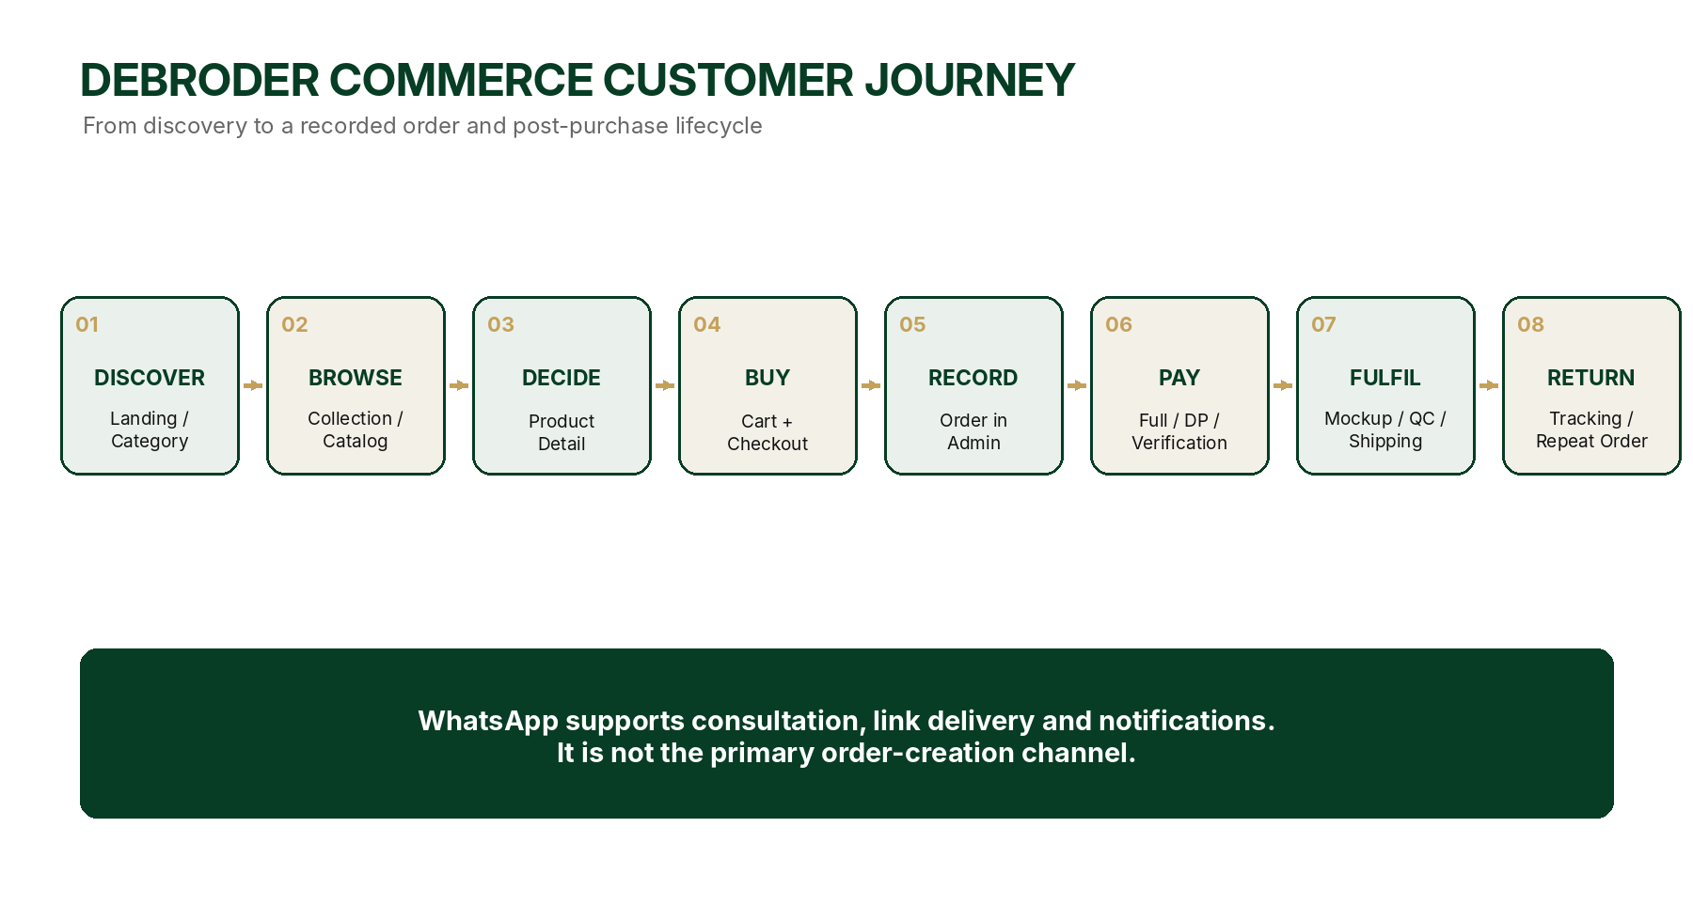
Source Hierarchy and Conflict Rule
Document | Authority
DEBRODER Landing Page Blueprint v1.0 - FROZEN | Homepage architecture, section order, media ratio, CMS/PIM ownership, scroll and responsive behavior.
DEBRODER Product, Ordering, Production & Inventory Blueprint Suite v1.0-v1.3 - FROZEN | Business rules, product data, cart, quotation, order, payment, production and inventory domain.
DEBRODER Commerce Experience Blueprint v1.0 - FROZEN | Public commerce routes, UI roles, customer flow, recovery, search, trust and quality gates.

CONFLICT RESOLUTION
Aturan bisnis mengikuti Product Suite. Struktur homepage mengikuti Landing Page Blueprint. Pola UI dan customer journey pada route commerce mengikuti dokumen ini. Route baru tidak boleh membuat sumber data, produk, kategori, order atau status kedua.

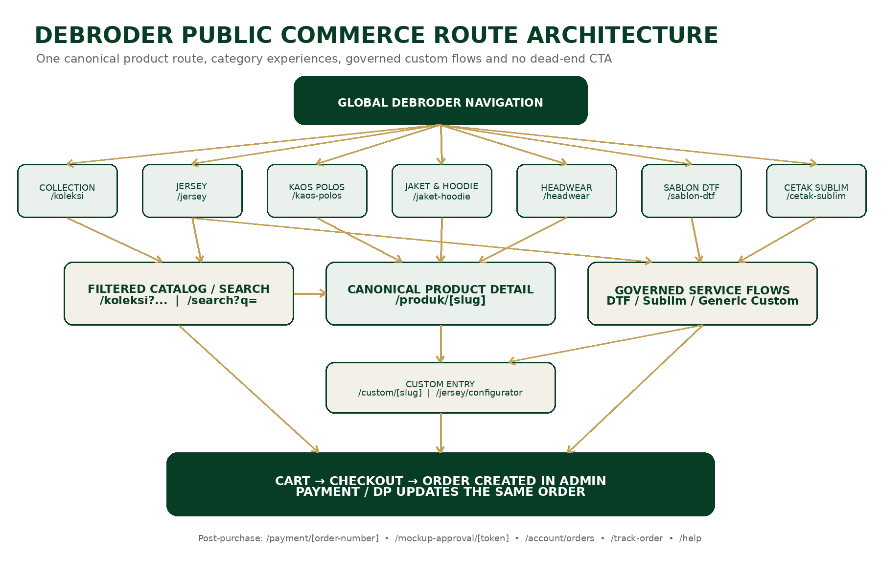
Canonical Public Routes
Route | Role | Primary owner
/koleksi | All-product collection; filters, sorting and product comparison | PIM + commerce UI
/search?q= | Search products, categories, services, guides and relevant campaigns | Search index + PIM/CMS
/produk/[slug] | Single canonical product-detail route for every category | PIM + commerce UI
/custom/[slug] | Generic custom flow for non-jersey products | Custom service system
/jersey | Jersey editorial mini landing | CMS
/jersey/shop | Jersey catalog; product cards link to /produk/[slug] | PIM + commerce UI
/jersey/configurator?product=[slug] | Dedicated custom jersey configuration | Jersey Configurator
/kaos-polos | Kaos Polos category mini landing | CMS + selected PIM products
/jaket-hoodie | Jaket & Hoodie category mini landing | CMS + selected PIM products
/headwear | Headwear category mini landing | CMS + selected PIM products
/sablon-dtf | DTF portfolio and service experience | CMS + service system
/sablon-dtf/order | DTF request, upload, estimate/quotation or checkout | Service system
/cetak-sublim | Sublimation portfolio and service experience | CMS + service system
/cetak-sublim/order | Sublimation request, upload, estimate/quotation or checkout | Service system
/cart | Mixed Ready Stock and final-price Custom cart | Transaction system
/checkout | Guest/member checkout and fulfillment/payment selection | Transaction system
/quotation/[token] | Secure customer review/approval of the latest quotation version | Quotation system
/mockup-approval/[token] | Secure approval or revision request without mandatory login | Mockup system
/payment/[order-number] | Pay full/DP for an existing order | Payment system
/payment/[order-number]/retry | Recover and retry a failed/expired payment attempt | Payment system
/order-confirmation/[number] | Order number, payment state and next action | Order Management
/account/orders | Member order history | Order Management
/account/orders/[number] | Order detail, timeline, files, documents and actions | Order Management
/account/quotations | Member quotation history | Quotation system
/account/drafts | Saved custom configurations and drafts | Configuration system
/track-order | Guest lookup using verified order/contact/token | Order Management
/account/orders/[number]/complaint | Complaint/service recovery request | Customer service system
/help | Help center index | CMS + customer service
/help/order | /help/payment | /help/custom | /help/returns-complaints | Published policy and help routes | CMS + customer service

Route and Redirect Rules
- Product cards from any category always open /produk/[slug].
- Category CTA uses /koleksi query parameters or a dedicated service/configurator route; it must not point to a missing page.
- Legacy product URLs permanently redirect to the canonical /produk/[slug] route.
- Public links, canonical metadata, approval links and WhatsApp payloads use NEXT_PUBLIC_SITE_URL.
- A CMS CTA cannot be published when the target route is empty, invalid, archived or outside the permitted route set.
03
UNIVERSAL COMMERCE RULES
All categories share one commerce foundation while preserving category-specific custom logic and operational truth.

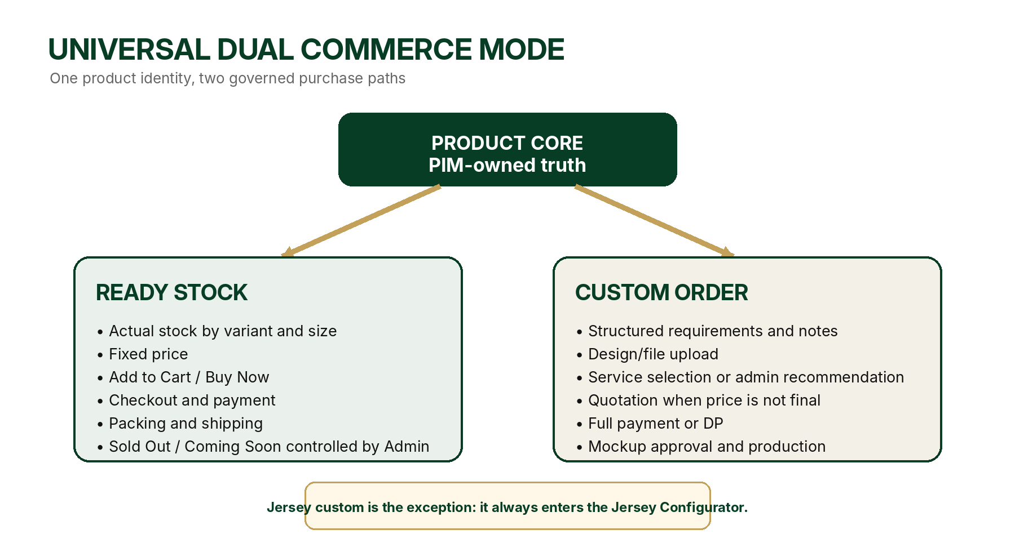
Universal Product Capability
Setiap produk DEBRODER memiliki kemampuan Ready Stock dan Custom. Admin dapat mengaktifkan salah satu atau keduanya tanpa membuat produk duplikat. Produk tetap memiliki satu identitas, satu URL canonical dan satu sumber data PIM.
Mode | Public behavior | Transaction path
ready_stock_only | Harga pasti, varian, ukuran, stok, Add to Cart dan Buy Now. | Cart -> checkout -> order -> payment -> packing/shipping
custom_only | CTA custom terpisah; tidak menampilkan blok Ready Stock palsu. | Configuration/request -> quotation or checkout -> payment/DP -> mockup -> production
hybrid | Ready Stock purchase area first; Custom CTA appears as a separate editorial block. | Customer chooses direct purchase or governed custom flow

Persistent Purchase CTA and Sale Status
Status | Public label | CTA behavior
Available | Ready Stock / Tersedia | Tambah ke Keranjang and Beli Sekarang active
Low Stock | Stok Terbatas / Sisa X | CTA active; warning visible
Sold Out | Sold Out | Purchase CTA remains visible but disabled
Coming Soon | Segera Tersedia | CTA visible but disabled
Archived | Not shown publicly | No public CTA

LAUNCH DEFAULT
Low-stock threshold default is 5 sellable units with per-product override. Sold Out products remain visible by default with disabled CTA; Admin may hide them from collection without deleting history.

Custom Pricing Rule
Condition | Public price | Primary action
Price can be calculated now | Fixed total | Add to Cart / Buy Now
Only starting price is known | Mulai Rp... | Configure / Request Quote
Design or method requires review | Menunggu Konfirmasi | Minta Penawaran
Customer does not know the method | No forced technical choice | Rekomendasikan metode terbaik + note/upload

Custom CTA Positioning
Ready Stock dan Custom tidak ditampilkan sebagai toggle kecil yang berdampingan. Blok pembelian Ready Stock fokus pada harga, varian, ukuran, quantity dan CTA. Custom muncul setelahnya sebagai promo CTA menarik tetapi lebih kecil dari hero.
READY STOCK PURCHASE AREA -> SEPARATE CUSTOM PROMO CTA -> DETAILS / GUIDE / FAQ

Commitment and Approval Rule
- Harga pasti, layanan final, minimum quantity and lead time must be visible before customer commitment.
- Jika Admin mengubah harga atau scope setelah customer approval, system creates a new version or requests explicit re-approval.
- Produksi tidak boleh dimulai sebelum syarat pembayaran, file, data dan mockup approval yang diwajibkan terpenuhi.
04
COLLECTION BROWSING EXPERIENCE
Collection is a high-density product-comparison mode with a clean three-column grid and a sticky browsing toolbar.

Desktop Layout
State | Layout rule
Initial | Global header + title/count + left filter sidebar + toolbar + three product cards per row.
Scrolled | Global header moves out naturally. Collection toolbar remains sticky with Show/Hide Filters and Sort By.
Filters shown | Sidebar 240-280 px; grid uses remaining width; still three cards per row.
Filters hidden | Sidebar disappears; three cards expand proportionally; image ratio remains 4:5.

Sort Menu
Required options | Optional DEBRODER options
Unggulan | Paling Banyak Dipesan
Terbaru | Ready Stock Dahulu
Harga: Tertinggi-Terendah | Custom Available Dahulu
Harga: Terendah-Tertinggi | Stok Terbatas Dahulu

Universal Filters
- Kategori
- Ready Stock
- Bisa Custom
- Ukuran
- Warna
- Rentang Harga
- Ketersediaan
- Terbaru / Featured
Mobile Collection
- Filter sidebar becomes a drawer or bottom sheet.
- Filter and Sort toolbar remains sticky and easy to reach.
- Two product cards per row.
- No horizontal page overflow.
- Active filter count is visible and state is reflected in the URL.
COLLECTION ACCEPTANCE
Hide/show filter does not change the desktop grid from three to four columns. Cards only resize within the available width and all product images remain 4:5 without distortion.

Filter, URL and SEO Rules
- Active filter, sorting and category state are reflected in query parameters.
- Refresh and shared links preserve the same collection view.
- Reset Filters is always available when filters are active.
- Core category pages may be indexed; arbitrary multi-filter combinations are noindex with canonical pointing to the relevant base collection/category.
- Changing filters must not move the user to an unrelated route or reset scroll unexpectedly.
Collection Quality Checks
- No duplicate product cards.
- Draft and archived products never appear publicly.
- Sold Out visibility follows Admin configuration.
- Loading skeleton reserves the final 4:5 image space.
- Filter sidebar and sticky toolbar do not cover content.
05
CATEGORY EXPERIENCE TEMPLATES
Category pages use CMS-controlled editorial mini landings and guide customers into PIM catalogs or governed service flows.

5.1 Jersey Experience - Frozen
Jersey memakai pengalaman kategori paling ekspresif: tema gelap, identity bar, contextual sub-navigation, poster editorial, CTA katalog, Ready Stock support and a separate Jersey Configurator path.
Layer | Frozen behavior
Global Navbar | DEBRODER navigation; visible at first load and moves out naturally while scrolling.
Jersey Identity Bar | DEBRODER JERSEY identity; dark background; category-specific visual tone.
Jersey Subnav | Sticky: Home, Football, Futsal, Esports, Custom, Paket Tim, Shop All.
Content | CMS posters, wide campaigns, team/order stories; no prices on mini landing.
Shop CTA | Routes to /jersey/shop or /koleksi?category=jersey.
Product click | Routes to /produk/[slug].
Custom CTA | Separate editorial CTA to /jersey/configurator?product=[slug].

JERSEY EXCEPTION
Ready Stock jersey is officially supported and controlled by PIM. Custom jersey always uses Jersey Configurator because material, model, collar, sleeve, print, team size, player data, logo, sponsor, name and number require a dedicated model.

Jersey Mini-Landing Sequence
1. Hero campaign
2. Split campaign posters
3. Team/style carousel
4. Wide editorial campaign
5. Custom Jersey CTA
6. Paket Tim campaign
7. Cara Order
8. Closing campaign
5.2 Kaos Polos Experience - Frozen
LOCKED CONTEXTUAL NAV
KAOS POLOS | Home | T-Shirt | Polo | Anak | NSA Collection | Custom | Shop All

Kaos Polos menggunakan tema putih/off-white dan pola mini landing seperti landing utama, tetapi seluruh campaign, produk pilihan, panduan dan CTA hanya berkaitan dengan Kaos Polos.
Section | Source / role
Hero Slider | CMS; desktop/mobile media; Belanja Sekarang and Mulai Custom.
Featured | CMS editorial posters for T-Shirt, Polo, Anak, NSA or material stories.
Wide Editorial Campaign | CMS material, use-case or collection story.
Shop by Type | CMS cards linking to /koleksi with category/type filters.
Produk Pilihan | PIM-selected products; price and stock remain PIM-owned.
Custom Campaign | Separate CTA for DTF, embroidery, logo or other custom needs.
Shop by Need | Harian, Tim, Perusahaan, Event, Anak or Brand.
Guides | Material thickness, size, care, minimum custom order and lead time.
Closing Campaign | CMS; Shop All and Mulai Custom.

5.3 Jaket & Hoodie - Inherits Kaos Polos Template
LOCKED CONTEXTUAL NAV
JAKET & HOODIE | Home | Jaket | Hoodie | Bomber | Sweater | Custom | Shop All

Struktur sama dengan Kaos Polos, tetapi content and filters menyesuaikan model, material, lining, zipper/pullover, thickness, fit, size and custom placement.
- Featured: Bomber, Hoodie, Jaket Tim
- Custom services: bordir, DTF, patch, logo, packaging
- Shop by Need: komunitas, perusahaan, sekolah, event, merchandise
- Guides: material, thickness, fit, care and lead time
5.4 Headwear - Inherits Kaos Polos Template
LOCKED CONTEXTUAL NAV
HEADWEAR | Home | Topi | Snapback | Trucker | Bucket Hat | Custom | Shop All

Struktur tetap terang dan editorial, tetapi sizing and fit do not copy apparel sizing. Product data supports adjustable/fixed size and placement-specific services.
- Types: topi, snapback, trucker and bucket hat
- Custom positions and methods: front/side/back, embroidery, DTF or patch
- Guide: fit, closure, material and logo area
5.5 Sablon DTF - CMS Portfolio Experience
Sablon DTF adalah layanan visual, bukan katalog produk biasa. Halaman menggunakan carousel bergaya Instagram yang medianya dikelola CMS, bukan embed Instagram sebagai sumber utama.
Section | Frozen rule
Hero | Short proposition and clear Mulai Pesanan DTF CTA.
Portfolio Carousel | CMS image/video, title, caption, service tag, CTA, sort order and publish state.
Proof Detail | Material, position, size, quantity, method and CTA Buat Seperti Ini.
Service Choice | Buy apparel from DEBRODER or bring customer-owned apparel.
Request Form | Quantity, position, design size, sides, file upload and notes.
Pricing | Fixed estimate if possible; otherwise quotation.
Instagram | Optional external link only; page works without API/embed.

PORTFOLIO -> MULAI PESANAN DTF -> UPLOAD / REQUIREMENTS -> QUOTATION OR CHECKOUT -> ORDER IN ADMIN

5.6 Cetak Sublim - Service Experience
Cetak Sublim tidak boleh menjadi CTA mati dari homepage. Route /cetak-sublim menggunakan service template yang sama prinsipnya dengan DTF, tetapi field dan panduan menyesuaikan bahan, ukuran media, jumlah, warna, sisi, file, finishing dan kebutuhan produksi sublimasi.
Layer | Frozen rule
CMS Portfolio | Image/video projects, caption, tags, CTA and order.
Service Request | Product/material, quantity, size, side, finishing, upload and note.
Pricing | Fixed estimate when rules are complete; quotation when review is required.
Primary CTA | Mulai Pesanan Sublim; not WhatsApp.
Fallback | If service is temporarily inactive, page remains published with Coming Soon/help copy; CTA cannot point to a 404.

06
PRODUCT LISTING & PRODUCT DETAIL
Product cards stay concise; product detail reveals Ready Stock and Custom without mixing their roles or creating duplicate URLs.

Product Card Specification
Element | Rule
Image | 4:5 master, no distortion, primary PIM image.
Badge | Ready Stock, Custom Available, Ready Stock + Custom, Low Stock, Sold Out, Coming Soon, New.
Name | Short official product name from PIM.
Detail | One concise line: material, audience, model or number of colors.
Price | Fixed price for Ready Stock; Mulai Rp... for custom starting price.
Click target | Image and product information open /produk/[slug].
CMS rule | CMS may select placement but cannot rewrite product truth.

Universal Product Detail Anatomy
Order | Section
01 | Breadcrumb and category context
02 | 4:5 gallery: front, back, detail, lifestyle/side
03 | Product name, badge, description and price
04 | Ready Stock selection: color/design, size, quantity, stock
05 | Persistent Add to Cart and Buy Now CTA
06 | Delivery/pickup information
07 | Separate Custom promotional CTA
08 | Material, specifications and care
09 | Size guide
10 | Custom process / production lead time
11 | FAQ, trust proof and related products

Desktop and Mobile
Desktop | Mobile
Two-column layout: gallery left, purchase panel right. Panel may be sticky without colliding with footer. | Swipe gallery with indicator; information below; reachable CTA.
Gallery can use two columns for four images. | One image per sequence; no horizontal page overflow.
Contextual category nav remains compact. | Contextual nav uses native horizontal scroll.

Custom CTA Copy Pattern
RECOMMENDED COPY
Buat Produk Ini Sesuai Identitas Anda
Tambahkan logo, desain, nama, nomor, sablon, bordir, atau detail khusus untuk tim, komunitas, perusahaan, dan acara.
Primary CTA: Mulai Pesanan Custom
Secondary text link: Butuh bantuan? Konsultasi dengan Admin

Generic Custom Flow
PRODUCT BASE -> COLOR / SIZE / QTY -> SERVICE REQUEST -> FILE + NOTES -> QUOTATION OR CART -> CHECKOUT

- Customer may select known services such as DTF, embroidery, logo, name, number or packaging.
- Customer may select “Saya belum tahu - rekomendasikan metode terbaik.”
- Customer notes and files are stored and visible to Admin.
- Admin may finalize method and price; changes affecting price/scope require history and customer approval.
- Generic custom flow uses /custom/[slug]; Jersey uses the dedicated configurator.
Jersey Product Detail Exception
Ready Stock jersey uses the universal purchase area. The separate Custom CTA says “Mulai Konfigurasi Jersey” and routes to /jersey/configurator?product=[slug]. Ready Stock and Custom are never a small side-by-side toggle.
Trust and Proof on Product Detail
- Verified material/specification information
- Real production examples with customer permission
- Clear starting-price/final-price labels
- Published lead-time conditions
- Visible policy links for sizing, custom approval and complaints
Product Detail Acceptance Gate
Area | Pass condition
Routing | All cards resolve to /produk/[slug]; no duplicate detail URL.
Ready Stock | Price, variant, size, stock and purchase CTA match PIM.
Custom | Separate CTA opens the correct generic flow or Jersey Configurator.
Trust | Lead time, price type, policy links and consent-based proof are visible.
Mobile | Gallery, selection, CTA and errors work without overflow.
SEO | Canonical, metadata, breadcrumb and structured data are correct.

07
CART, CHECKOUT, FULFILLMENT & PAYMENT
The cart stays visually calm while preserving complex configurations. Checkout creates a recoverable order before payment begins.

Cart Layout
Desktop | Mobile
Left item list; right sticky order summary; no heavy cards or excessive borders. | Single-column list followed by summary; total and CTA may be sticky.
Item shows image, product, color, size, quantity, price and concise actions. | Image left, details right; custom details collapse.
Custom item shows concise summary and Lihat Konfigurasi/Edit. | Do not print every player/service line by default.

Cart Item Types
Type | Summary behavior
Ready Stock | Variant, size, quantity, stock and fixed price.
Custom - final price | Quantity, size distribution, services, file count, lead time and final total.
Custom - quotation required | Clearly separated; not included in payable total until approved.

MIXED CART RULE
Ready Stock and custom items with final prices may checkout together. Items waiting for quotation are separated and cannot silently enter the payable total.

Mixed Fulfillment Rule
Choice | Frozen behavior
Kirim Bersamaan - default | All eligible items ship after the latest item is ready. One combined estimate is shown.
Kirim Terpisah - optional | Ready Stock may ship earlier when eligible. Additional shipping cost and separate estimates are shown before payment.
Pickup | Each ready group shows pickup readiness; Ready Stock and Custom may be collected at different times.
Admin confirmation required | If a method/carrier/production dependency is uncertain, checkout records preference and Admin confirms before final commitment.

Checkout Experience
Area | Fields / behavior
Contact | Email, full name, WhatsApp number. Guest checkout allowed.
Fulfillment | Delivery or pickup. Address appears only for delivery.
Pickup stores | Pettarani, Tello, Landak, Parepare; Admin can activate/deactivate.
Payment plan | Bayar Penuh or Bayar DP when permitted.
Payment method | Only methods activated in Admin are displayed; no hard-coded unavailable provider.
Order Summary | Products, services, discount, shipping, total, payment today and balance.
Primary CTA | Buat Pesanan & Lanjut Pembayaran.

Canonical Transaction Sequence
CHECKOUT CONFIRMED -> ORDER CREATED -> ORDER APPEARS IN ADMIN AS UNPAID -> CUSTOMER PAYS FULL OR DP -> SAME ORDER IS UPDATED

Order and Payment Status Separation
Order status | Payment status / attempt outcome
draft | unpaid
pending_payment | pending_verification
confirmed | partially_paid
in_process | paid
completed | failed attempt / refund states
cancelled / expired | partially_refunded / refunded

Expiry and Reservation Defaults
Item | Frozen default
Unpaid order/payment window | 24 hours; Admin configurable within a governed setting.
Quotation validity | 7 calendar days unless the quotation states another expiry.
Approval/share token | Time-limited and revocable; replacement link preserves history.
Ready Stock reservation before v1.3 | Order record does not promise permanent stock reservation unless an explicit reservation rule is active. Stock is revalidated before successful payment/confirmation.
Expired data | Order/quotation is not deleted; status changes to expired/cancelled and customer can restart/retry where allowed.

Payment Safety
- Payment never creates a second order.
- Manual evidence attaches to the existing order.
- Gateway webhook is validated and idempotent.
- Repeated callback/upload/click cannot duplicate payment.
- Failed payment keeps the order recoverable.
- Production eligibility depends on configured DP/full-payment and approval requirements.
08
ACCOUNT, TRACKING, APPROVAL & REPEAT ORDER
Post-purchase experience remains understandable without exposing every internal status, while preserving quotation and approval actions.

Guest and Member Experience
Guest | Member
Checkout without account | Saved addresses and contacts
Order confirmation via secure link | Order, quotation and payment history
Track with number + verified contact/token | Saved designs and draft configurations
Secure quotation/mockup links | Repeat order and documents
Can create account after purchase | Complaints and service-recovery history

Customer-Facing Status
Customer status | Internal mapping examples
Pesanan Dikonfirmasi | confirmed, payment condition met
Persiapan Desain | mockup in progress / awaiting approval
Sedang Diproduksi | released, in_progress or production stages
Quality Control | awaiting_qc / QC in progress
Siap | ready_to_ship or pickup ready
Dikirim | shipped with tracking
Selesai | completed / received

Order Detail for Customer
- Order number/date and items
- Custom configuration summary
- Payment history, DP and balance
- Quotation and mockup approval actions
- Production timeline and required customer action
- Shipping/pickup details and tracking
- Documents: order summary, invoice, receipt and delivery note
- Complaint and Repeat Order actions
Quotation and Mockup Approval
- Only the latest quotation version can be approved.
- Ready for Review mockup must generate a secure share link without login.
- Approval or revision request changes canonical status and writes activity history.
- An approved mockup cannot remain labeled Ready for Review.
- Expired/revoked links show a clear replacement flow, never a generic 404.
Repeat Order
REPEAT ORDER RULE
Repeat Order creates a new order with a new number and a stored link to the source order. Product, variant, quantity, service, design, position and notes may be copied, but current price, stock, service availability and policy are revalidated. The source order never changes.

- Allow full-copy repeat order.
- Allow “Tambah anggota baru saja” or partial-line repeat when business rules permit.
- Copied customer files remain private and auditable.
- A change in product/service requires explicit resolution, not silent substitution.
09
CMS, PIM & ADMIN OWNERSHIP
Editorial freedom and product integrity coexist: CMS controls storytelling, PIM controls product truth, and transaction modules control lifecycle state.

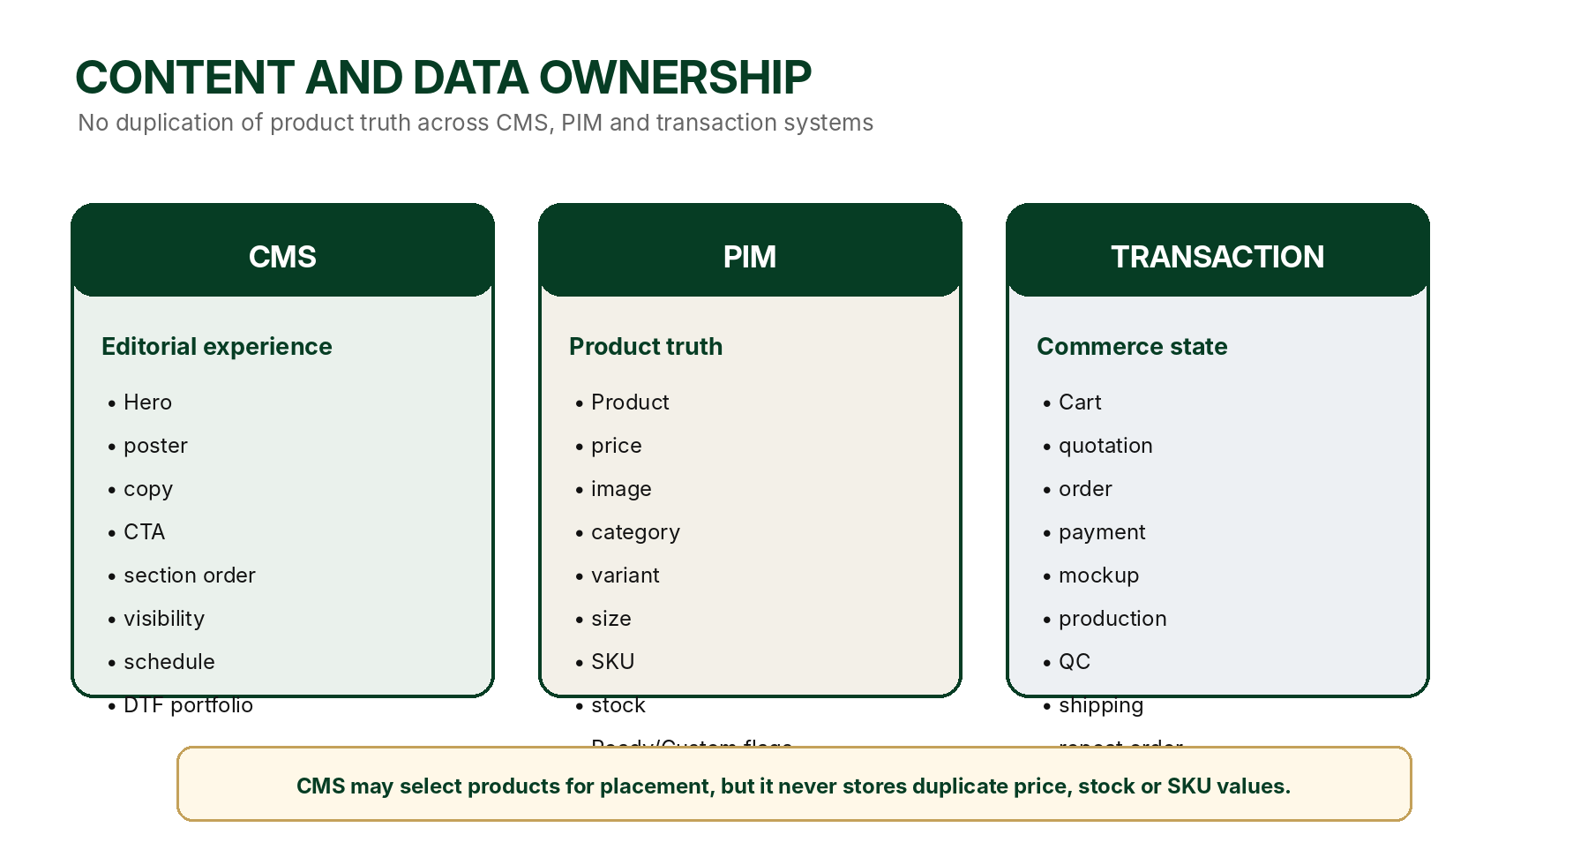
CMS Menu Structure - Frozen
Admin path | Scope
CMS > Landing Page | Existing frozen homepage only.
CMS > Commerce Experiences > Jersey | Identity, subnav, campaigns and CTA.
CMS > Commerce Experiences > Kaos Polos | Category mini landing and guides.
CMS > Commerce Experiences > Jaket & Hoodie | Inherited template and category-specific media.
CMS > Commerce Experiences > Headwear | Inherited template and headwear-specific media.
CMS > Commerce Experiences > Sablon DTF | Portfolio and service storytelling.
CMS > Commerce Experiences > Cetak Sublim | Portfolio and service storytelling.
CMS > Help & Policies | Help, payment, custom, return and complaint policy content.

Minimum CMS Fields
Field group | Fields
Identity | page_key, section_type, internal_name
Copy | eyebrow, headline, description, alt_text
Media | desktop_media, mobile_media, media_type, thumbnail
CTA | primary_label/url, secondary_label/url
Presentation | text_position, text_theme, layout_variant
Publishing | sort_order, visibility, draft/published/scheduled/archived, published_at
SEO | seo_title, seo_description, social_image, canonical_target
Product placement | selected_product_ids only; product values are not copied
Portfolio consent | customer_permission_reference when customer work is displayed

PIM Product Configuration
Configuration | Examples
Universal | name, slug, category, images, price, description, status
Ready Stock | enabled, sale status, variants, sizes, SKU, stock, shipping estimate
Custom | enabled, starting price, MOQ, services, file/quotation/mockup requirements, lead time
Jersey | ready stock fields + jersey_configurator_id and configurator flags
Badge | available, low stock, sold out, coming soon, custom available, hybrid
Visibility | show/hide Sold Out in collection; archive preserves history

Admin Commerce Controls
- Activate/deactivate Ready Stock and Custom independently.
- Set sale status, low-stock threshold and Sold Out visibility.
- Select products for CMS sections without copying price/stock.
- Configure DP minimum, unpaid expiry and production eligibility.
- Activate payment methods and pickup stores.
- Review notes/files and finalize method/price.
- Maintain history for customer-impacting changes.
10
RESPONSIVE, ACCESSIBILITY & UI STATES
The experience is complete only when every major route works at real desktop and mobile sizes with accessible interaction and clear states.

Responsive Rules
Pattern | Desktop | Mobile
Contextual category nav | Horizontal row; sticky after global header exits. | Native horizontal scroll; labels readable.
Hero/campaign | Separate desktop artwork where needed. | Separate mobile composition; no careless crop.
Collection | Three cards per row; optional sidebar. | Two cards per row; filter drawer.
Editorial carousel | Three full items plus teaser when specified. | About 1.3 cards; native scroll.
Product detail | Gallery left; sticky purchase panel right. | Swipe gallery; information below; reachable CTA.
Cart/checkout | Two columns. | Single column; sticky total/CTA where helpful.

Accessibility Requirements
- Semantic headings and landmarks.
- Keyboard access for nav, filters, carousel, modal and checkout.
- Visible focus styles.
- Alt text for campaign and product media.
- Sufficient contrast for copy, CTA and disabled states.
- Appropriate mobile touch targets.
- Errors explain how to fix input.
- Do not rely on color alone for status.
- Reduced-motion preference is respected.
Required UI States
State | Expected behavior
Loading | Reserve final media ratio and use calm skeletons.
Empty collection | Explain no results and provide filter reset.
Product unavailable | Keep context; disable purchase; offer custom/related path if permitted.
Price changed | Show old/new price; require acknowledgment.
Stock changed | Show current availability and require cart correction.
Upload failed | Keep other inputs; explain type/size and retry.
Payment failed | Order remains; provide retry and support.
Order success | Show order number, payment state and next action.
Network interruption | Prevent duplicate submit and recover latest state.
Expired link | Explain expiry and provide replacement/retry path.

State Copy Examples
Situation | Recommended copy
Sold Out | Produk ini sedang habis. Anda tetap dapat melihat detail atau memulai pesanan custom jika tersedia.
Price changed | Harga berubah dari RpX menjadi RpY. Tinjau perubahan sebelum melanjutkan.
Stock reduced | Stok ukuran M hanya tersisa X pcs. Sesuaikan jumlah pesanan.
Payment failed | Pembayaran belum berhasil. Pesanan Anda tetap tersimpan dan dapat dibayar ulang.
Link expired | Tautan ini sudah kedaluwarsa. Minta tautan baru tanpa kehilangan riwayat sebelumnya.

11
SECURITY, PRIVACY & DATA INTEGRITY
A polished interface is not trustworthy if orders, payments, permissions or customer files can be duplicated, lost or accessed incorrectly.

Integrity Rules
- Checkout submit is idempotent.
- Payment callback is idempotent.
- Order-to-Job conversion is idempotent.
- Repeat Order never changes source order.
- Configurations/files stay linked to the correct line.
- Stock/price revalidate at add-to-cart, cart open and pre-checkout.
- UI status matches canonical database state.
- Applied migrations are never edited; corrections use new migrations.
Permission Model
Actor | Minimum permission rule
Guest customer | Only access own session/order through secure token or verified lookup.
Member customer | Only access own account, orders, files and approvals.
Sales/Admin Order | Manage order/customer workflow within role scope.
Designer | Manage mockup/design; no unauthorized payment/role changes.
Finance | Manage payment verification and financial documents.
Production / QC / Store | Only operational data required for assigned work.
Super Admin | Full governed access including restricted delete and audit.

Customer File Governance
Rule | Frozen decision
Storage | Private by default; access through signed/authorized URL.
Rights declaration | Customer confirms they have permission to use uploaded logo/design.
Portfolio permission | Separate explicit opt-in; never bundled with upload rights.
Retention | Default 24 months after order completion for reusable design/configuration files; configurable. Legal/financial records follow applicable retention requirements.
Deletion request | Allowed when not blocked by legal, accounting, fraud or audit obligations.
Access log | Sensitive file views/downloads are auditable for authorized roles.
Cross-order isolation | Files cannot be exposed to another customer/order.

SEPARATE CONSENT
“Saya memiliki izin menggunakan desain/logo ini” and “Saya mengizinkan hasil produksi digunakan sebagai portfolio DEBRODER” are separate consent records. Portfolio content cannot be published without the second consent.

Risk Scenarios and Controls
Risk | Required control
Double checkout click | Idempotency key and pending-submit lock.
Repeated webhook | Provider event ID uniqueness and transaction lock.
Expired approval link | Expiry, revocation and replacement flow.
Unauthorized API access | Server authorization + RLS; not hidden buttons only.
Price changed after approval | New version or customer re-approval.
Deleted source data | Archive/soft-delete; preserve historical references.
Customer file used in marketing | Require portfolio consent and CMS reference.

Audit Events and Retention
- Quantity/price/scope changes
- Quotation and mockup decisions
- Payment submission and verification
- Order/Job/Work Item creation
- Shipping and completion
- Role/permission changes
- Portfolio consent and file access
- Complaint resolution and permanent deletion
Audit records preserve actor, role, timestamp, action, entity, before/after values and reason. Permanent-delete audit cannot be removed through normal operational screens.
12
SERVICE RECOVERY, RETURNS & COMPLAINTS
Commerce is not complete until customers can understand what happens when an order is wrong, delayed, cancelled, damaged or disputed.

Policy Separation
Ready Stock | Custom Order
Return/exchange eligibility is based on published product condition, use, packaging, size and defect policy. | Custom items are governed by approved data, mockup, production stage and responsibility for the error.
Wrong item, shortage, visible defect and shipping damage have documented evidence flow. | DEBRODER production error leads to rework/remake or approved remedy without charging the customer for the same scope.
Change-of-mind policy is published and may differ by product. | Customer-approved wrong data/design may require a new paid change or new work order.

Cancellation Rules
Stage | Frozen behavior
Unpaid order | Customer may cancel; order remains recorded as cancelled.
Paid/DP before review or production | Admin calculates refundable amount using published policy and actual committed cost.
After quotation/mockup approval | Scope changes require a new version, price or schedule confirmation.
After production begins | Cancellation may be limited; completed/committed work and material cost are recorded.
Provider/payment failure | Order remains recoverable; no duplicate order is created.

Complaint Flow
CUSTOMER OPENS COMPLAINT -> SELECTS ISSUE -> UPLOADS EVIDENCE -> ADMIN TRIAGE -> REMEDY / REWORK / REFUND -> CLOSURE + AUDIT

Issue | Possible governed outcome
DEBRODER production defect | Rework, remake, partial remedy or refund according to approved resolution.
Quantity shortage / wrong item | Replacement, completion shipment or refund.
Customer-approved data error | Paid revision/new work unless owner grants exception.
Delivery damage | Carrier/customer-service investigation and remedy.
Late production | Updated estimate, escalation and compensation only if an active policy grants it.

Published Policy Requirements
- Claim windows, evidence requirements, item condition and shipping responsibility are CMS-configurable policy values and must be published before launch.
- Policy changes are versioned and do not silently rewrite the terms attached to an existing order.
- Customer can see complaint status, requested evidence, resolution and refund/rework history.
- Custom color/size tolerances and screen-to-material color differences are explained before approval.
13
SEARCH, SEO, TRUST & ANALYTICS
Customers must find the right solution, trust what they see, and generate measurable signals without sacrificing privacy or performance.

Search Experience
Search source | Examples
Products | Kaos Cotton Combed 24s, Jersey Match Pro
Categories | Kaos Polos, Jaket & Hoodie, Headwear
Services | Sablon DTF, Bordir, Cetak Sublim
Guides | 20s vs 24s vs 30s, panduan ukuran, DTF vs bordir
Intent phrases | kaos untuk event 50 orang, jersey futsal custom, topi bordir perusahaan

- Search results never invent price/stock outside PIM.
- Unavailable results show their state and a relevant alternative.
- No-result state suggests categories, services, guides and custom assistance.
- Search query is shareable through /search?q=.
SEO Governance
- /produk/[slug] is the only canonical product detail URL.
- NEXT_PUBLIC_SITE_URL is used for canonical, metadata, public share and structured-data URLs.
- Product, category and service pages have unique title, description, social image and breadcrumb.
- Product structured data reflects actual price/availability; do not mark Custom starting price as a guaranteed fixed offer.
- Arbitrary filter combinations are noindex; canonical points to relevant base route.
- Sitemap excludes draft, archived, private token, cart, checkout and account routes.
- Legacy slugs use permanent redirects and do not create duplicate indexable pages.
Trust & Proof System
Content type | Minimum data
Case study | Customer type, product/service, quantity, method, lead time and approved media.
Verified review | Linked order/customer verification and moderation state.
Before/after | Approved media, explanation and CTA Buat Seperti Ini.
Production proof | Material/method close-up, QC or process proof without exposing private data.
Guide comparison | Use case, characteristics, limitations and relevant CTA.

Analytics Event Contract
Funnel stage | Required events
Discovery | category_view, campaign_click, search_submitted
Browse | collection_view, filter_used, sort_changed, product_view
Custom | custom_cta_click, configurator_started, configurator_completed, quotation_submitted
Purchase | add_to_cart, buy_now, checkout_started, order_created
Payment | payment_started, payment_completed, payment_failed
Approval | quotation_approved, mockup_approved, revision_requested
Post-purchase | tracking_viewed, complaint_created, repeat_order_created

ANALYTICS PRIVACY
Analytics payload may include anonymous/session ID and entity IDs, but never customer design content, payment evidence, full address, sensitive notes or private file URLs. Analytics failure cannot block checkout.

14
PERFORMANCE, RELIABILITY & CMS GOVERNANCE
Premium commerce must remain fast, recoverable and safe to operate even when media, network, providers or CMS edits fail.

Performance Budget - Launch Gate
Metric / asset | Target
LCP on key public routes | <= 2.5 seconds at p75 mobile under representative conditions
CLS | <= 0.10
INP | <= 200 ms at p75
Optimized hero image | Target <= 500 KB desktop and <= 350 KB mobile; preserve approved visual quality
Optimized product image | Target <= 250 KB per displayed asset; lazy-load below fold
Page-specific JS | Keep route-specific client JavaScript minimal; no unnecessary library on cart/checkout
Order creation response | UI acknowledges submit immediately; server target p95 <= 3 seconds excluding external payment redirect
Third-party scripts | Non-essential scripts deferred and limited on product/cart/checkout

Reliability and Recovery
Failure | Required behavior
Network drops during checkout | Idempotent retry retrieves/creates the same order.
Payment succeeds but return page fails | Webhook updates the existing order; customer can reopen confirmation.
Upload interrupted | Resume/retry without losing completed form fields.
Provider unavailable | Show unavailable state; preserve order and allow later retry/alternative method.
CMS media missing | Section validation blocks publish or safe fallback prevents broken layout.
Search/index unavailable | Core category and product browsing remains usable.

CMS Governance
- Desktop/mobile preview before publish.
- Staging preview with protected URL.
- Draft, publish, schedule, archive, revision history and rollback.
- Section clone with new internal ID; no accidental shared reference.
- CTA validation and broken-link scan before publish.
- Media dimension, file-size and alt-text validation.
- Role separation for edit and publish where configured.
- Before/after audit for copy, media, CTA, order and visibility.
- Orphan media reporting and safe cleanup.
- Customer portfolio media requires stored consent reference.
Monitoring and Operational Signals
- Vercel/runtime errors for key routes
- Supabase/API failures
- Payment webhook failures and replay count
- Checkout/order idempotency conflicts
- Broken CMS links/media
- Search no-result rate
- Core Web Vitals by route
- Cart/checkout abandonment and configuration completion rate
15
QUALITY GATE, IMPLEMENTATION & CHANGE CONTROL
The blueprint is frozen, but implementation is complete only after each stage passes measurable functional, data, responsive and production gates.

Frozen Decisions
- Canonical product route is /produk/[slug].
- Collection route is /koleksi; category filters use query parameters.
- Jersey, Kaos Polos, Jaket & Hoodie, Headwear, Sablon DTF and Cetak Sublim have defined public experiences.
- All products support Ready Stock and Custom capability; Admin controls active mode.
- Jersey Custom uses Jersey Configurator.
- Buy Now and Add to Cart remain visible/disabled according to PIM sale status.
- Order is created before payment and appears in Admin as unpaid.
- Full payment or DP updates the same order.
- Mixed fulfillment defaults to ship together; separate shipping is explicit and priced.
- CMS owns editorial content; PIM owns product truth; transaction systems own lifecycle state.
- WhatsApp is secondary and cannot be the only order path.
Implementation Sequence
Stage | Deliverable | Gate
1 | Route map, redirects, navigation and CMS schema | No dead CTA; no impact on frozen homepage
2 | Collection, search and filtered catalogs | Three-column desktop grid and URL state verified
3 | Category mini landings and service pages | CMS management, Sublim route and responsive acceptance
4 | Universal /produk/[slug] detail + Ready Stock CTA | PIM price/stock/Sold Out and SEO verified
5 | Generic Custom request flow | Notes/files/services reach Admin correctly
6 | Jersey Configurator context handoff | No configuration data loss
7 | Cart, fulfillment and checkout | Mixed cart, delivery grouping, guest checkout and idempotency
8 | Quotation, payment/DP and approval links | Same order updated; secure links; no duplicate payment
9 | Account, tracking, complaint and repeat order | Customer permissions and price/stock revalidation
10 | CMS governance, analytics and performance | Preview/rollback/event contract/budgets pass
11 | Deep regression and v1.2 stabilization | Typecheck, lint, tests, build and end-to-end UAT pass

Minimum UAT Journeys
1. Ready Stock retail: category -> product -> cart -> checkout -> unpaid order in Admin -> full payment.
2. Ready Stock Sold Out/Low Stock and price/stock change acknowledgement.
3. Generic custom apparel: product -> custom CTA -> services/files/notes -> quotation or checkout.
4. Jersey custom: jersey mini landing -> product -> configurator -> quotation/order -> DP -> mockup approval.
5. Mixed cart: Ready Stock + final-price Custom with together/separate fulfillment.
6. DTF and Sublim service: portfolio -> request -> upload -> quotation/checkout.
7. Guest checkout, failed payment retry and order tracking.
8. Quotation revision and expired/replaced mockup link.
9. Complaint: evidence -> admin resolution -> rework/refund history.
10. Repeat Order with current price, stock, service and availability validation.
11. CMS preview/publish/rollback and broken CTA prevention.
12. Search, canonical URL, noindex filters and structured data verification.
GO / NO-GO Criteria
GO | NO-GO
No blocker or integrity defect | Order, payment, configuration or approval duplication
Direct purchase works without WhatsApp | WhatsApp remains the only order path
Order appears in Admin before payment | Order is only created after payment
Full/DP update the same order | Payment creates another order
No dead route or invalid CMS CTA | Category/CTA opens 404 or ambiguous page
CMS/PIM ownership respected | Campaign duplicates product truth
Private files and consent protected | Customer work is public without permission
Search/SEO canonical rules pass | Duplicate indexable product pages
Performance budgets pass or approved exception recorded | Critical route is slow/unstable without accepted mitigation
Typecheck, tests and production build pass | Unresolved production/build error

Change Control
AFTER FREEZE
Any structural change requires a new Commerce Experience version or an explicitly approved addendum. Bug fixes may preserve architecture, but new routes, section roles, transaction rules, ownership rules, policy models or canonical URL changes cannot be introduced silently.

Implementation Handoff Requirements
- AGENTS.md points to all frozen blueprints and prohibits silent scope expansion.
- docs/DEBRODER_MASTER_STATE.md records the current deployed version and frozen architecture.
- docs/CURRENT_PHASE_HANDOFF.md records completed, pending, migrations, errors and next action.
- A route manifest, CMS field manifest and UAT checklist accompany implementation.
- Every delivery ends with changed files, migration status, test/build results and residual risks.
A
APPENDIX - LOCKED NAVIGATION, ROUTES & LAUNCH DEFAULTS
These defaults remove ambiguity and may only be changed through governed Admin settings or an approved blueprint revision.

Experience | Locked contextual navigation / route intent
Jersey | DEBRODER JERSEY + Home | Football | Futsal | Esports | Custom | Paket Tim | Shop All
Kaos Polos | KAOS POLOS | Home | T-Shirt | Polo | Anak | NSA Collection | Custom | Shop All
Jaket & Hoodie | JAKET & HOODIE | Home | Jaket | Hoodie | Bomber | Sweater | Custom | Shop All
Headwear | HEADWEAR | Home | Topi | Snapback | Trucker | Bucket Hat | Custom | Shop All
Collection | No category subnav; sticky Show/Hide Filters + Sort By toolbar.
Sablon DTF | Portfolio + Mulai Pesanan DTF; Instagram is optional external link.
Cetak Sublim | Portfolio + Mulai Pesanan Sublim; never a dead homepage CTA.

Launch Defaults
Setting | Frozen default / governance
Collection canonical route | /koleksi
Product canonical route | /produk/[slug]
Low-stock threshold | 5 units; per-product override
Sold Out visibility | Visible + disabled CTA; Admin may hide
Unpaid order expiry | 24 hours; governed Admin setting
Quotation validity | 7 calendar days unless quotation specifies otherwise
Pickup stores | Pettarani, Tello, Landak, Parepare; Admin controls visibility
Payment methods | Show active Admin-configured methods only
Mixed fulfillment | Together default; separate optional with explicit cost
CMS menu | CMS > Commerce Experiences

B
APPENDIX - CMS SECTION TYPES & DEFERRED v1.1
The v1.0 section library is complete enough for launch; advanced growth features remain intentionally deferred.

CMS Section Types
section_type | Typical use
hero | Category hero / slider
split_campaign | Two large campaign items
poster_carousel | Editorial or portfolio carousel
wide_campaign | Full-width campaign
shop_by_type | Category navigation cards
selected_products | PIM-selected product carousel/grid
custom_cta | Separate Custom promotional block
shop_by_need | Use-case navigation
guide_links | Material/size/care guides
case_study | Real project proof with permission
verified_review | Order-linked moderated review
before_after | Approved proof comparison
production_proof | Process/QC evidence
closing_campaign | Final category CTA
dtf_portfolio | DTF image/video work portfolio
sublim_portfolio | Sublimation image/video portfolio

Deferred to Commerce Experience v1.1
- Advanced Project Builder based on budget and use case
- AI recommendation or semantic search
- Wishlist, loyalty, referral and complex promotion engine
- Abandoned-cart automation and marketing journeys
- Multilingual/personalized category experience
- Advanced B2B multi-user approval, marketplace and native app
FINAL
FROZEN DECISION
DEBRODER Commerce Experience Blueprint v1.0 is the approved public-commerce source of truth and is ready for implementation.
IMPLEMENTATION STATUS
This blueprint defines what must be built and how the public experience must behave. It does not declare any route, feature, phase or version technically implemented until code, database, tests, build, deployment and UAT pass.

Required Companion Documents
- DEBRODER Landing Page Blueprint v1.0 - FROZEN
- DEBRODER Product, Ordering, Production & Inventory Blueprint Suite v1.0-v1.3 - FROZEN
- AGENTS.md, DEBRODER_MASTER_STATE.md and CURRENT_PHASE_HANDOFF.md in the repository
Owner Change Rule
Any future structural revision must be approved explicitly and issued as Commerce Experience v1.1+ or a named addendum. Silent route, ownership, transaction, policy or canonical-URL changes are prohibited.

