DEBRODER
LANDING PAGE
BLUEPRINT
Nike-inspired structure. DEBRODER-owned identity.
VERSION 1.0 / FROZEN
PROJECT
DEBRODER Apparel & Printing Platform
STATUS
Approved architecture — do not alter without explicit decision
DATE
10 July 2026

DOCUMENT CONTROL

Blueprint Status
FROZEN DECISION
This document is the single source of truth for the DEBRODER landing page. The architecture, section roles, scroll behavior, media ratios, CMS/PIM ownership, and responsive rules are locked. Any revision must be explicitly approved by the project owner.

Field | Value
Document | DEBRODER Landing Page Blueprint
Version | 1.0
Status | Frozen / Approved
Design direction | Nike-inspired interaction and editorial discipline; not a visual copy
Primary brand color | #063D24 — Dark Forest Green
Platform | Next.js + Vercel + Supabase
Change rule | No structural change without explicit owner approval

Contents
01 | Vision & Non-Negotiables
02 | Final Landing Architecture
03 | Global Visual System
04 | Section Specifications
05 | CMS & PIM Ownership
06 | Responsive & Scroll Experience
07 | Implementation Roadmap
08 | Quality Gate & Change Control
01
VISION & NON-NEGOTIABLES
The landing page must feel premium because it is disciplined, stable, editorial, and effortless to use — not because it contains many effects.

CORE VISION
“The structure and comfort of Nike, with the identity, services, and business logic of DEBRODER.”
DEBRODER will not become a copy of Nike. It will adopt the same discipline: strong imagery, concise language, native scrolling, clear section roles, predictable navigation, generous white space, and content that stops moving when the user stops interacting.

Seven Non-Negotiable Principles
01 — Image First  Photography and campaign artwork carry the emotion. UI decoration stays neutral and minimal. | 02 — Native Scroll  No global smooth-scroll library, no wheel interception, no residual movement after input stops. | 03 — One Role per Section  Editorial cards tell stories; product carousels sell products; category carousels navigate.
04 — Calm Interface  No heavy shadows, oversized rounded cards, parallax, or looping animations. | 05 — Short Copy  Headlines are direct; subheadlines are one sentence; CTAs are one or two words where possible. | 06 — Mobile Is Composed  Desktop and mobile hero/banner artwork are separate assets, not careless crops.
07 — Admin Controlled
Campaign content can be changed from CMS; product content remains governed by PIM.

02
FINAL LANDING ARCHITECTURE
The order below is frozen. Each block has a distinct purpose in the customer journey.

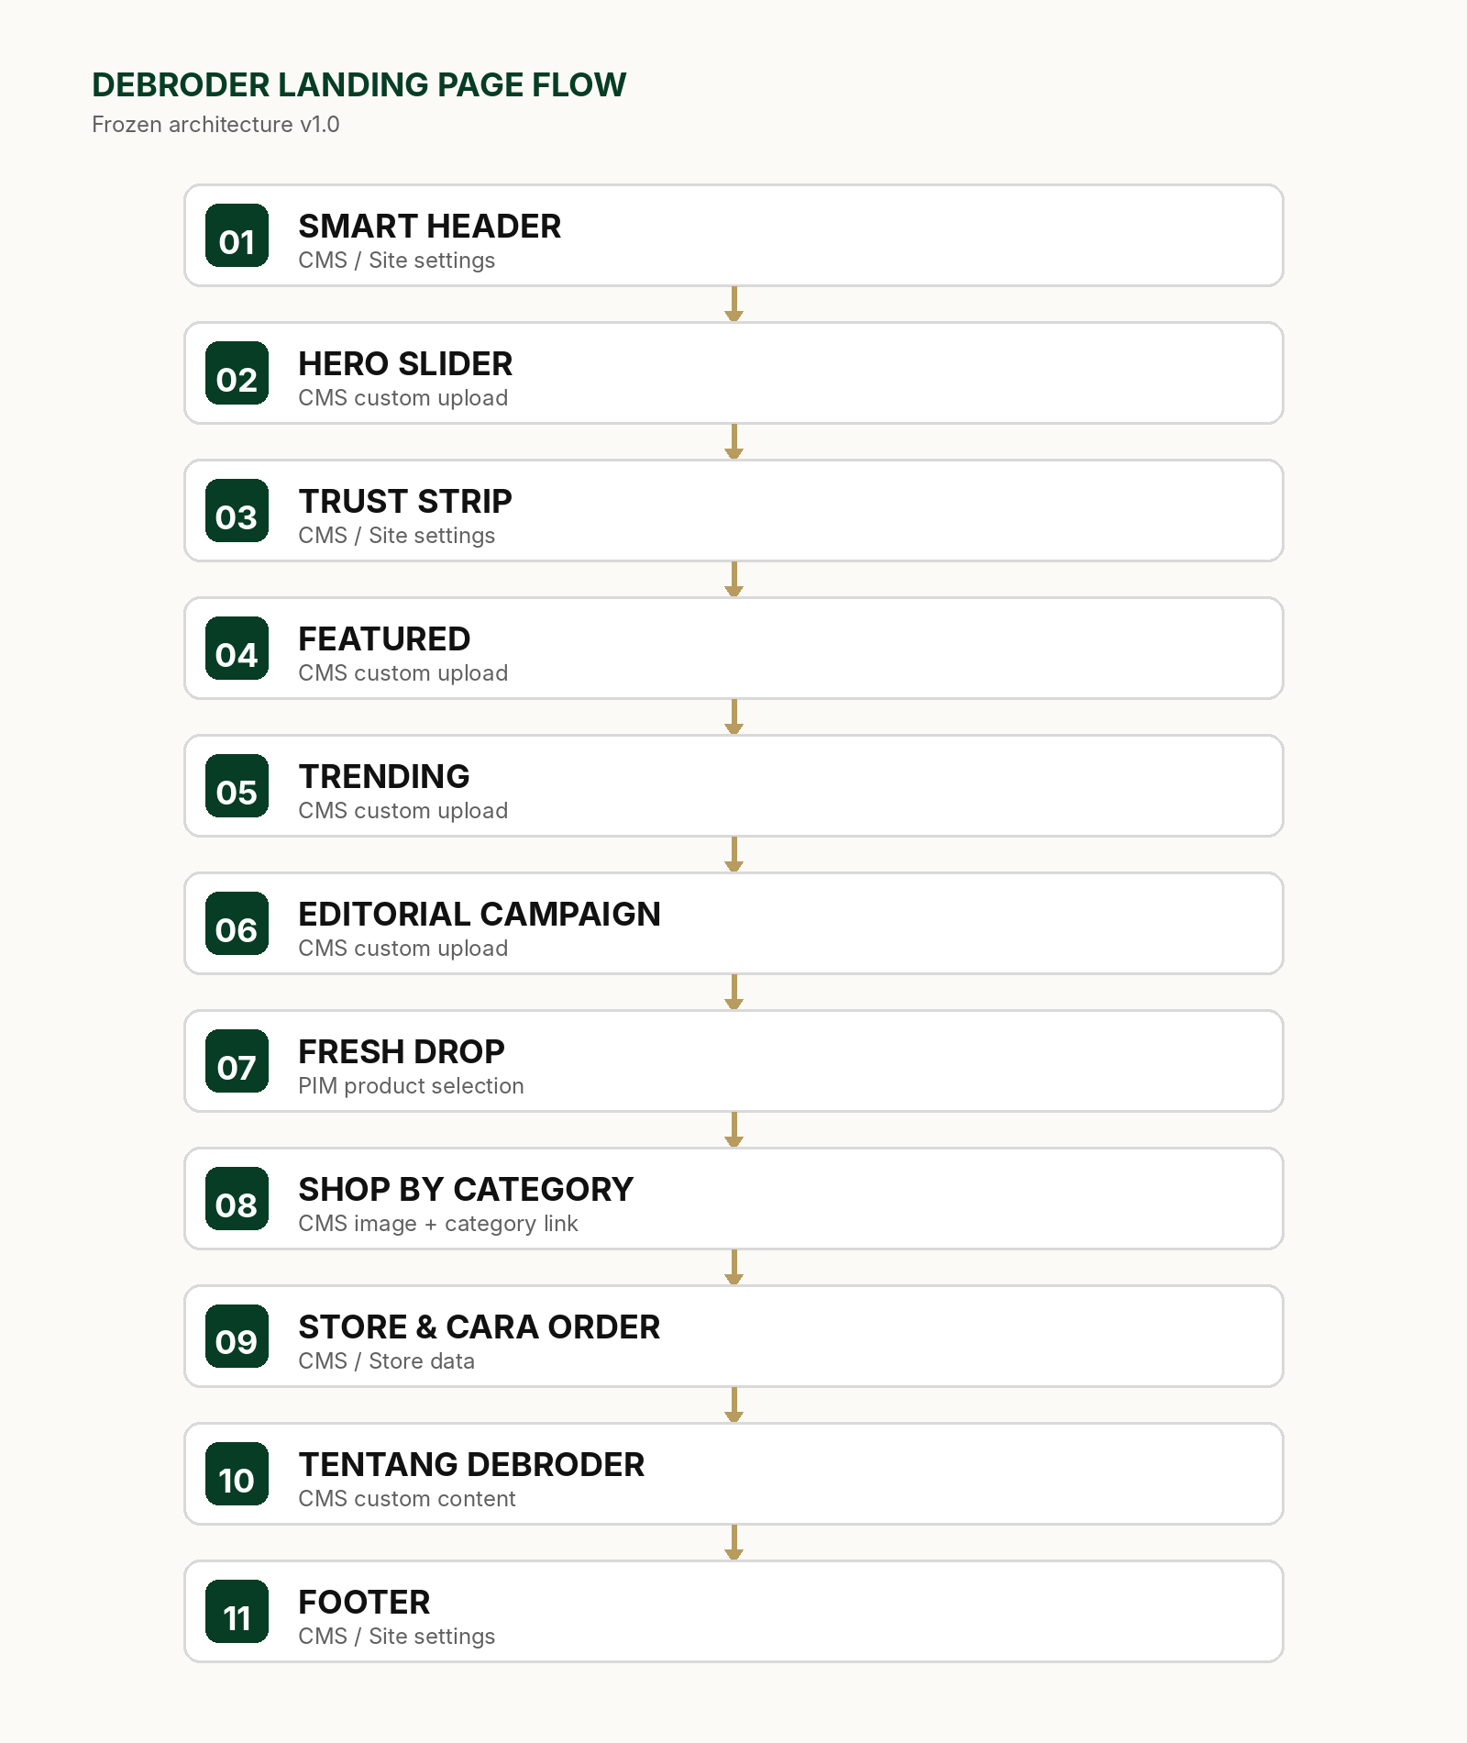
The journey moves from emotion to confidence, then discovery, product selection, category navigation, store/order support, brand context, and finally utility information.

Customer Journey Logic
Stage | Purpose
1. Capture | Hero establishes the campaign and brand mood.
2. Reassure | Trust Strip removes initial doubt without interrupting the visual flow.
3. Inspire | Featured, Trending, and Editorial Campaign create desire through stories.
4. Convert | Fresh Drop presents real products with names, details, and prices.
5. Navigate | Shop by Category helps users move to the most relevant catalog path.
6. Support | Store, Cara Order, About, and Footer answer practical questions.

03
GLOBAL VISUAL SYSTEM
A restrained visual language keeps every campaign flexible while preserving a recognizable DEBRODER experience.

Brand Foundation
System | Locked Direction
Primary color | Dark Forest Green #063D24
UI neutrals | White, black, warm off-white, light gray
Body type | Inter or approved equivalent
Display type | Approved condensed extra-bold display face; used selectively for major campaign headlines
Grid | 12-column desktop grid; 8px spacing system
Card style | Flat, edge-to-edge, no heavy border, no shadow, no large radius
Image language | Editorial, authentic, product-centered, consistent crop and lighting

Spacing & Layout Rules
Section spacing  Desktop: generous vertical rhythm. Mobile: reduced but never cramped. | Outer margins  Desktop content typically begins around 48–64px from the viewport edge; adapt responsively.
Internal gaps  Editorial and category cards: approximately 12–16px, unless artwork is intentionally full-bleed. | Text hierarchy  Section titles remain moderate. Campaign headlines can be dramatic. Body copy stays quiet.
Alignment  Left-align navigation and section titles; center-align major campaign copy when visually appropriate. | Motion  Only animate state changes. Avoid continuously mapping transforms to scroll position.

Media Master Specifications
Asset | Desktop Master | Mobile Master | Usage
Hero | 1920 × 900 px | 1080 × 1350 px | Separate composition per breakpoint
Editorial Campaign | 1920 × 900 px | 1080 × 1350 px | Single artwork, copy managed separately
Featured | 2000 × 2500 px (4:5) | Same 4:5 asset where suitable | Two large campaign items
Trending | 2000 × 2500 px (4:5) | Same 4:5 asset | Editorial cards
Category | 2000 × 2500 px (4:5) | Same 4:5 asset | Lifestyle navigation image
Product | 2000 × 2500 px (4:5) | Same 4:5 asset | Catalog and product carousel

File delivery
Maintain high-resolution source files. Publish optimized WebP/AVIF variants through the application pipeline. Every media element must reserve its final aspect ratio before loading to prevent layout shift.

04
SECTION SPECIFICATIONS
Every landing section is defined by purpose, content source, desktop behavior, mobile behavior, and acceptance criteria.

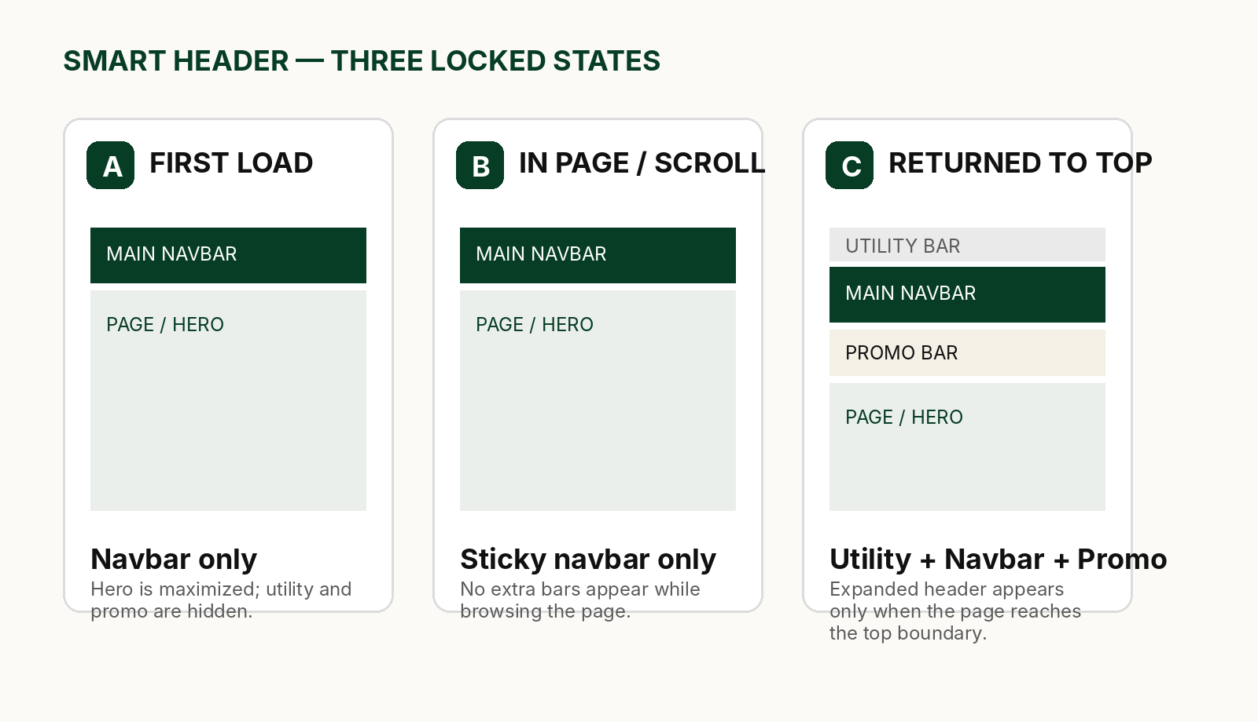

4.1 Smart Header
The main navbar remains the stable navigation anchor. Utility and promo bars appear only at the top boundary after the user has interacted with the page.
State | Utility Bar | Main Navbar | Promo Bar | Trigger
First load | Hidden | Visible | Hidden | Initial page render at top
Browsing / any scroll position | Hidden | Sticky / visible | Hidden | scrollY > top threshold
Returned to absolute top | Visible | Visible | Visible | User has scrolled before and scrollY reaches top boundary
Scroll down again | Hidden | Sticky / visible | Hidden | Leaves the top boundary

- Utility content: Store, Cara Order, Bantuan.
- Promo content: one concise message, such as free design consultation or active service benefit.
- Do not make the entire header chase scroll direction. Returning upward in the middle of the page must not reveal extra bars.
- Use native sticky positioning for the main navbar; animate only state transitions with transform and opacity.

4.2 Hero Slider
The first screen behaves like a brand campaign, not a crowded storefront.
Dimension | Locked Rule
Width | Full width / full bleed beneath the main navbar
Height | Large cinematic first view; adaptive by viewport, not a fixed desktop-only height
Copy | Short eyebrow, major headline, one-sentence support line
CTA | One primary CTA; second CTA only when materially useful
Media | Separate desktop and mobile artwork
Controls | Small pagination, previous/next, pause when autoplay is enabled
Animation | Slide transition; no heavy parallax or scroll-linked zoom

Hero content rule
Sell identity, emotion, team, craft, or movement first. Do not lead with dense prices, discount stickers, or long product descriptions.

4.3 Trust Strip
A lightweight confidence layer tailored to a growing local apparel and printing brand.
Recommended themes: Bahan Berkualitas · Desain Custom · Produksi Profesional · Banyak Pilihan Warna.
- One quiet horizontal row on desktop; compact two-column or horizontal format on mobile.
- No large icon cards, heavy outlines, or oversized rounded containers.
- The strip supports trust but must not compete with the Hero or Featured sections.

4.4 Featured
Two flagship campaign blocks that introduce the most important current offerings.
Desktop | Mobile | Source | Interaction
Two large items side by side | Stack vertically | CMS custom upload | Entire item clickable; concise CTA

- Featured is not a carousel because the section contains only two items.
- Use campaign photography, not automatic product thumbnails.
- No price, rating, color swatches, or product-card metadata.

4.5 Trending
Three editorial stories presented as large visual cards.
Element | Locked Rule
Desktop | Three large 4:5 cards
Mobile | Approximately 1.3 cards visible; horizontal native scroll
Copy position | Lower-left overlay with subtle bottom scrim only
CTA | White pill button, short label
Source | CMS custom upload
Autoplay | Not allowed
Card decoration | No radius, no shadow

Role distinction
Trending tells editorial stories. It is not a product feed and must not be populated automatically from PIM.

Four Patterns That Must Not Be Mixed
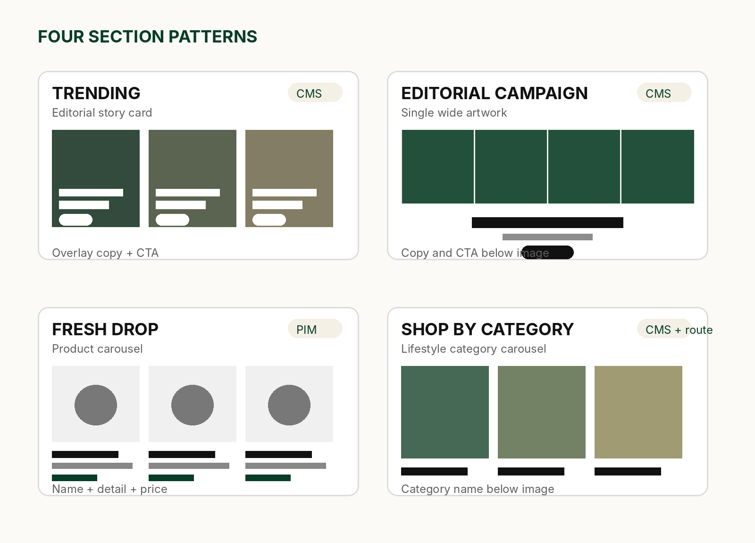

4.6 Editorial Campaign Block
One large artwork followed by a dramatic headline, brief support copy, and one CTA.
Layer | Specification
Artwork | One single wide image; multi-panel appearance may be designed inside the artwork
Copy placement | Below the image when the artwork is visually busy; overlay only when safe negative space exists
Headline | Large condensed display, one or two lines
Subheadline | One sentence
CTA | One centered action
Source | CMS custom upload with separate desktop/mobile image

- Do not rebuild a designed four-panel banner as four browser cards when the intended visual is one artwork.
- Text remains separate from the image so it can be edited, translated, and kept accessible.

4.7 Fresh Drop
The principal product carousel: real products, real information, clean catalog presentation.
Element | Locked Rule
Source | Products selected from PIM by admin
Desktop | Three full cards plus a visible teaser of the next item
Mobile | Approximately 1.3 cards visible
Image | 4:5 product master
Metadata order | Product name → short detail → price
Controls | Native drag/trackpad + arrows
Autoplay | Not allowed
Click target | Image and product information lead to product detail

Product integrity
Names, categories, prices, variants, and product imagery remain governed by PIM. CMS chooses placement; it does not duplicate product truth.

4.8 Shop by Category
Lifestyle-led navigation inspired by the clarity of a premium sport/category carousel.
Order | Category
1 | Kaos Polos
2 | Jaket & Hoodie
3 | Jersey
4 | Headwear
5 | Sablon DTF
6 | Cetak Sublim
7 | Kaos Polos Anak

- Custom 4:5 lifestyle image for each category; do not pull random product images automatically.
- Category name sits below the image. No price, overlay, heavy gradient, or button inside the image.
- Desktop shows three full cards plus the next-card teaser; mobile shows about 1.3 cards.
- The entire card links to the corresponding public category route.

4.9 Store & Cara Order
Business-specific support blocks that help users complete real-world orders.
STORE  Show four active locations with concise address/context, WhatsApp action, and link to the Store page. | CARA ORDER  A compact explanation and clear CTA to the dedicated order flow; avoid turning the homepage into a long instruction manual.

- Use flat editorial blocks, not bulky shadowed cards.
- Store links and WhatsApp destinations must be editable by admin.

4.10 Tentang DEBRODER
A short brand statement near the end of the journey.
Suggested editorial direction: “BUILT TO CREATE — DEBRODER membantu individu, tim, komunitas, dan perusahaan membangun identitas melalui apparel.”
- One strong image, one concise statement, and one optional link to Tentang Kami.
- Do not insert a long corporate essay into the landing page.

4.11 Footer
A quiet, functional close with large white space and clear utility links.
Desktop Columns | Recommended Content
Belanja | Kaos Polos, Jaket & Hoodie, Jersey, Headwear, Sablon DTF, Cetak Sublim
Bantuan | Cara Order, Panduan Ukuran, Pembayaran, Pengiriman, FAQ, Hubungi Kami
DEBRODER | Tentang, Store, Kontak, kebijakan yang relevan
Right rail | Indonesia / Bahasa Indonesia and compact social/contact icons
Bottom legal | Copyright, Syarat & Ketentuan, Kebijakan Privasi

- White background with a thin top divider; no giant black footer block.
- Mobile footer becomes accordion groups followed by social/contact and legal information.
05
CMS & PIM OWNERSHIP
Content management must be clear enough that campaign updates never require editing source code.

Source-of-Truth Matrix
Section | Primary Source | Admin Capabilities
Smart Header | Site settings / CMS | Utility links, promo message, enable/disable
Hero Slider | CMS | Desktop/mobile image, copy, CTA, order, visibility
Trust Strip | CMS / Site settings | Items, labels, order, visibility
Featured | CMS | Two custom campaigns, links, copy, order
Trending | CMS | Custom cards, copy, CTA, target links
Editorial Campaign | CMS | Desktop/mobile artwork, copy placement, CTA
Fresh Drop | PIM + CMS placement | Select products, order, limit; product data stays in PIM
Shop by Category | CMS + category routes | Custom image, label, destination, order
Store & Cara Order | Store data + CMS | Locations, WhatsApp links, copy, visibility
Tentang DEBRODER | CMS | Image, headline, body, CTA
Footer | Site settings / CMS | Columns, links, legal copy, social destinations

Required CMS Fields for Campaign Components
Field | Purpose
status | Draft / published / hidden
sort_order | Stable section/item ordering
desktop_image | Desktop artwork
mobile_image | Mobile artwork
eyebrow | Optional small label
headline | Primary campaign message
subheadline | One-sentence context
cta_label | Short action label
cta_url | Internal route or approved external destination
text_placement | Overlay / below image
overlay_strength | Optional constrained value for readability
image_alt | Accessible image description

No hardcoded campaign copy
Except for safe fallback UI labels, landing campaign content must not be embedded permanently in source components.

06
RESPONSIVE & SCROLL EXPERIENCE
The premium feeling depends on direct input response, stable layout, predictable carousels, and clean breakpoint composition.

Responsive Rules
Component | Desktop | Mobile
Header | Full navigation and search | Compact navigation; same state logic adapted to available space
Hero | Wide cinematic composition | Dedicated vertical composition
Featured | Two columns | Vertical stack
Trending | Three cards | 1.3-card horizontal carousel
Editorial Campaign | Wide single artwork + centered copy | Dedicated vertical artwork + centered copy
Fresh Drop | 3 cards + teaser | 1.3-card horizontal carousel
Shop by Category | 3 cards + teaser | 1.3-card horizontal carousel
Footer | Multi-column | Accordion groups

Scroll & Motion Specification
Native Page Scroll  Do not use Lenis, Locomotive, or a global scroll interpolation layer. | Passive Listeners  Any scroll listener must be passive and limited to lightweight state detection.
No Input Interception  Never call preventDefault on the main wheel/touchmove path. | Sticky by CSS  Use position: sticky for the main navbar whenever possible.
Transform/Opacity Only  Header state transitions should avoid animating height, margin, or layout-critical properties. | No Residual Motion  When touchpad or touch input ends, page content and UI must settle immediately.
Reserved Media Space  Every image/video declares aspect ratio or dimensions before load. | Reduced Motion  Respect prefers-reduced-motion and avoid essential information depending on animation.

Carousel Behavior
Rule | Requirement
Scrolling | Native horizontal overflow with smooth touch/trackpad response
Snap | Use scroll snap where it improves stopping alignment without fighting the user
Buttons | Previous/next controls mirror the native position and disabled state
Autoplay | Not allowed for Trending, Fresh Drop, or Shop by Category
Teaser | Expose a portion of the next card to communicate horizontal continuity
Idle state | No drifting, bouncing, or automatic movement

Experience target
Finger or touchpad moves → page moves immediately. Input stops → the interface becomes completely still.

07
IMPLEMENTATION ROADMAP
Build from the stable frame inward, preserve existing PIM/category logic, and validate each section before continuing.

Recommended Sequence
Phase | Work
1. Backup & branch | Create a dedicated implementation branch and preserve the current working production state.
2. Read-only audit | Map existing landing components, CMS tables, product selectors, category routes, image pipeline, and header behavior without modifying code.
3. Shared foundations | Implement spacing tokens, typography, media component, carousel primitive, section shell, and accessibility helpers.
4. Header & scroll | Complete and test the frozen three-state header before other visual sections.
5. Hero | Implement desktop/mobile assets, controls, content fields, and stability safeguards.
6. Editorial sections | Featured → Trending → Editorial Campaign.
7. Commerce sections | Fresh Drop from PIM → Shop by Category routes.
8. Support sections | Trust Strip → Store & Cara Order → Tentang → Footer.
9. Responsive pass | Validate actual desktop, tablet, and mobile breakpoints; do not rely only on browser scaling.
10. Performance & regression | Build, Lighthouse/Web Vitals review, route tests, Supabase data checks, and Vercel preview QA.

Risk Controls
- Do not redesign the PIM while rebuilding the landing page.
- Do not delete working category fallbacks until migrated data is verified.
- Do not deploy all sections in one unreviewed change set.
- Do not use temporary hardcoded content as the final CMS implementation.
- Do not force one desktop image across all mobile layouts.
- Do not optimize away image quality before visual approval; optimize delivery after composition is approved.

Definition of Ready Before Coding
- Current landing components and data sources are documented.
- The implementation branch and backup are confirmed.
- Required CMS fields are mapped against existing Supabase schema.
- Desktop and mobile media requirements are accepted.
- Section order and source ownership match this frozen blueprint.
08
QUALITY GATE & CHANGE CONTROL
The landing page is complete only when visual quality, interaction quality, content management, data integrity, and performance all pass together.

Acceptance Checklist
Area | Pass Condition
Architecture | All 11 sections appear in the frozen order or are intentionally hidden through CMS.
Header | Only the correct bars appear in each of the three states; no flicker or layout jump.
Scroll | Native touchpad/touch response; no residual motion; no intercepted wheel behavior.
Hero | Desktop/mobile composition, readable copy, working controls, stable loading.
Featured | Exactly two campaign items; desktop two-column, mobile vertical.
Trending | Editorial cards, no PIM metadata, no autoplay, correct 1.3-card mobile behavior.
Campaign | One artwork, editable copy, correct below-image/overlay placement.
Fresh Drop | PIM-sourced product data, accurate price/detail, working product links.
Category | Custom imagery and correct public category routes; no product metadata.
CMS | Admin can change campaign images, copy, links, order, and visibility without code.
Media | Aspect ratios reserved; no visible layout shift; alt text present.
Footer | White editorial layout; desktop columns and mobile accordion work.
Build | Production build passes; no TypeScript or Vercel deployment errors.
Responsive | Desktop, tablet, and mobile reviewed on real viewport sizes.

Frozen Decisions
- Landing order: Smart Header → Hero → Trust Strip → Featured → Trending → Editorial Campaign → Fresh Drop → Shop by Category → Store & Cara Order → Tentang DEBRODER → Footer.
- Featured contains two items and is not a carousel.
- Trending is CMS-driven editorial content, not an automatic product feed.
- Editorial Campaign uses one desktop artwork and one mobile artwork, with editable text and CTA.
- Fresh Drop is selected from PIM and displays product truth from PIM.
- Shop by Category uses custom lifestyle imagery and links to category routes.
- Content carousels never autoplay.
- Page scrolling remains native; no global smooth-scroll library.
- Product and category masters use 4:5 ratio at 2000 × 2500 px.
- Hero/campaign desktop masters use 1920 × 900 px; mobile masters use 1080 × 1350 px.
- Flat editorial style: no heavy shadows, no oversized rounded cards, no unnecessary visual effects.
Change-control rule
A proposed change must state: what is changing, why it improves the business or user experience, which sections/data sources are affected, and how it will be tested. No silent structural drift is allowed.

Final Direction
Build a landing page that feels fast, calm, visual, and confident — then make every part manageable from the admin panel.
This blueprint is now the implementation contract for DEBRODER Landing Page v1.0.
END OF FROZEN BLUEPRINT

