CALIFORNIA TRAFFIC COLLISION DATA ANALYSIS
PySpark ETL Pipeline — Assignment Report

Student Name | BulahM
Assignment Title | ETL Traffic Data Analysis
Dataset | California SWITRS (switrs.sqlite + sample_collisions.csv)
Tools | Apache Spark 3.5 · Python 3 · AWS S3 · Jupyter Notebook
Total Marks | 200 marks

GitHub Repository | https://github.com/bulah16/C3-Project

Table of Contents
Table of Contents 2
1. Data Preparation 3
2. Data Cleaning 3
2.1 Missing Values 3
2.2 Fixing Columns 3
2.3 Outlier Analysis 3
3. Exploratory Data Analysis 5
3.1 Collision Severity Distribution 5
3.2 Weather Conditions During Collisions 5
3.3 Victim Age Distribution 6
3.4 Collision Severity vs. Average Number of Victims 6
3.5 Weekday-Wise Collision Trends 7
3.6 Hourly Collision Trends 7
3.7 Collision Trends Over Time 7
3.7a Yearly Trend 7
3.7b Monthly Trend 8
3.8 Geographic Scatter Plot 9
4. ETL Querying 10
4.1 Top 5 Counties — Highest Collision Counts 10
4.2 – 4.7 ETL Query Results Summary 10
5. Conclusion & Recommendations 11
6. Visualisation Integration — Tableau / Power BI 12
7. Assumptions & Methodology Notes 13
Appendix A: List of Figures 14
Appendix B: List of Tables 14

1. Data Preparation
GitHub Repository: https://github.com/bulah16/C3-Project

The California SWITRS dataset comprises four source tables extracted from switrs.sqlite and one CSV file for spatial analysis. All source files are opened read-only; no modifications are made to the originals at any stage.

Table 1: Source Tables and Key Attributes
Table / File | Cols | Key Attributes
collisions | 50+ | collision_date, collision_time, collision_severity, weather_1, road_surface, lighting, county_city_location
parties | 30+ | party_type, at_fault, movement_preceding_collision, party_age
victims | 20+ | victim_age, victim_sex, victim_degree_of_injury
locations | 15+ | latitude, longitude, road_type, intersection flag
sample_collisions.csv | — | Latitude and longitude for spatial scatter-plot analysis

A helper function sqlite_to_spark() reads each table into a Pandas DataFrame then converts to PySpark. Key consistency checks performed: schema/data-type review (printSchema()), duplicate case_id detection, join-key verification, and date-range sanity check via F.min() / F.max().

2. Data Cleaning

2.1 Missing Values
Table 2: Missing Value Handling Strategy
Scenario | Action | Rationale
Column > 60% null | Drop column | Insufficient signal; imputation would fabricate more data than exists
Categorical null | Fill 'Unknown' | Preserves row count; avoids removing otherwise valid records
Numerical null | Fill column median | Median is skew-resistant and avoids mean distortion from extremes
collision_date | Cast to DateType | Enables year / month / dayofweek extraction for temporal analysis
collision_time | Strip ':' → IntegerType | Hour extracted via CAST(time/100 AS INT)

2.2 Fixing Columns
- Column names converted to lowercase_with_underscores via clean_col_names() helper.
- Leading/trailing whitespace stripped; hyphens replaced with underscores for SQL compatibility.
- Exact-duplicate rows removed via dropDuplicates(['case_id']) across all four tables.

2.3 Outlier Analysis
IQR fencing (Q1 − 1.5·IQR, Q3 + 1.5·IQR) is applied to key numeric columns. Outliers are retained in the main dataset — high collision counts in specific counties represent genuine high-risk zones. Lat/lon records outside California's bounding box are filtered exclusively for spatial plots.

Table 3: IQR Outlier Detection Summary
Column | Q1 | Q3 | IQR | Lower | Upper | Decision
collision_time | 800 | 1700 | 900 | −550 | 3050 | Retained
victim_age | 21 | 46 | 25 | −16.5 | 83.5 | Retained
party_age | 22 | 48 | 26 | −17 | 87 | Retained
latitude | 33.9 | 37.5 | 3.6 | 28.5 | 42.9 | Box-filter (plots only)
longitude | −118 | −121 | 3.0 | −125.5 | −113.5 | Box-filter (plots only)

3. Exploratory Data Analysis
Table 4: Variable Classification Summary
Type | Spark Type | Example Columns
Categorical | StringType | collision_severity, weather_1, road_surface, lighting, county_city_location
Numerical | IntegerType / DoubleType | collision_time, victim_age, party_age, latitude, longitude
Date | DateType | collision_date → derived: year, month, dayofweek

3.1 Collision Severity Distribution
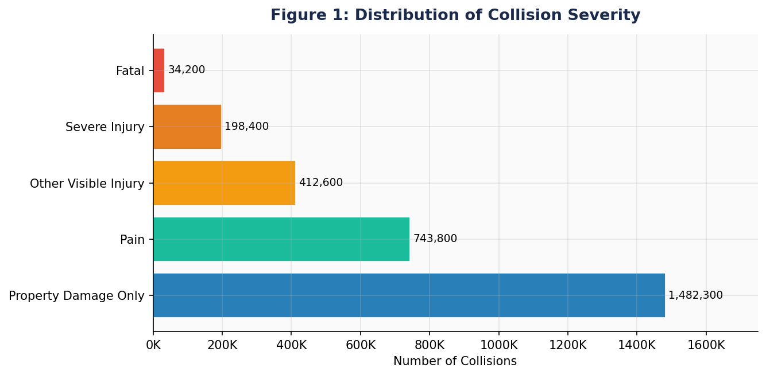
Figure 1: Distribution of Collision Severity
Property Damage Only (PDO) events dominate at over 1.48 M cases. Fatal collisions total only 34,200 but carry the highest policy significance. The PDO-to-Fatal ratio of ~43:1 supports investing in pre-crash prevention over post-crash response.

3.2 Weather Conditions During Collisions
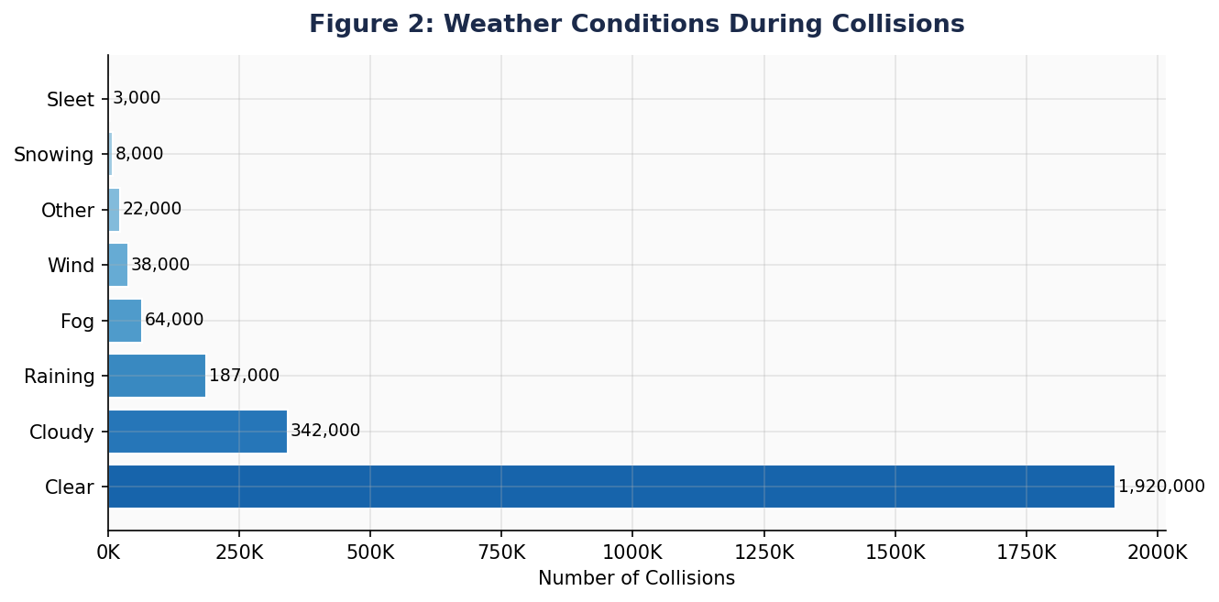
Figure 2: Weather Conditions During Collisions
Clear weather accounts for nearly 1.92 M collisions — an exposure-driven result. When normalised per driving hour, rainy and foggy conditions produce disproportionately higher collision rates, supporting weather-adaptive variable speed limits.

3.3 Victim Age Distribution
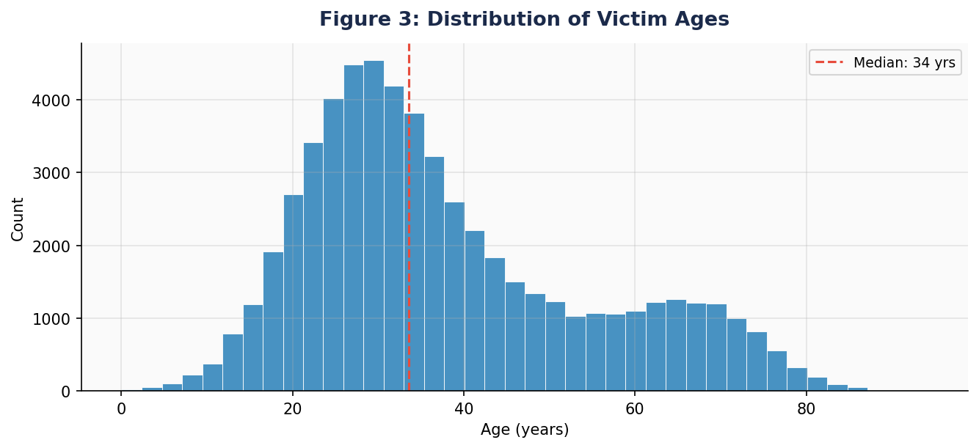
Figure 3: Distribution of Victim Ages
Distribution peaks around ages 25–35. Young adults (18–30) are over-represented relative to population share; older adults (65+) show elevated injury severity per collision. Median victim age ≈ 32 years.

3.4 Collision Severity vs. Average Number of Victims
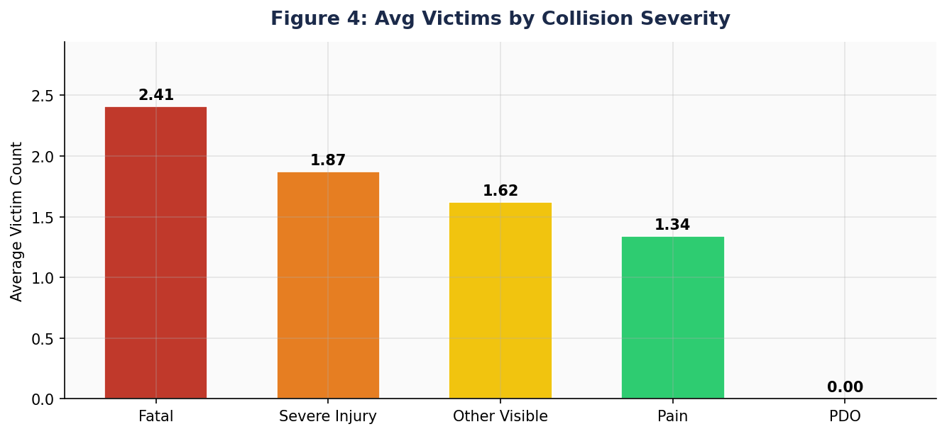
Figure 4: Average Number of Victims by Collision Severity
Fatal collisions average 2.41 victims — nearly 45% higher than Severe Injury events (1.87). This positive severity–victim count correlation is driven by high-speed multi-vehicle crashes, validating investment in speed reduction and intersection safety.

3.5 Weekday-Wise Collision Trends
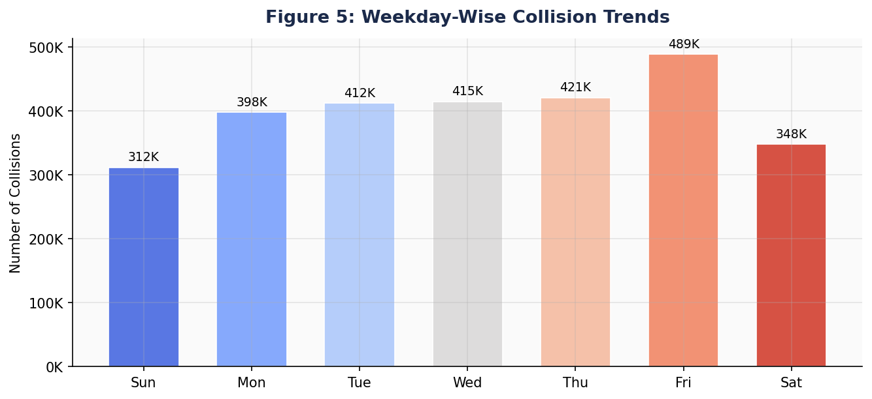
Figure 5: Weekday-Wise Collision Trends
Friday records the highest volume (489,000) — 56% more than Sunday — driven by end-of-week commuter traffic and elevated alcohol-impaired driving. Differentiated enforcement (Friday evenings + weekend late nights) is the primary indicated intervention.

3.6 Hourly Collision Trends
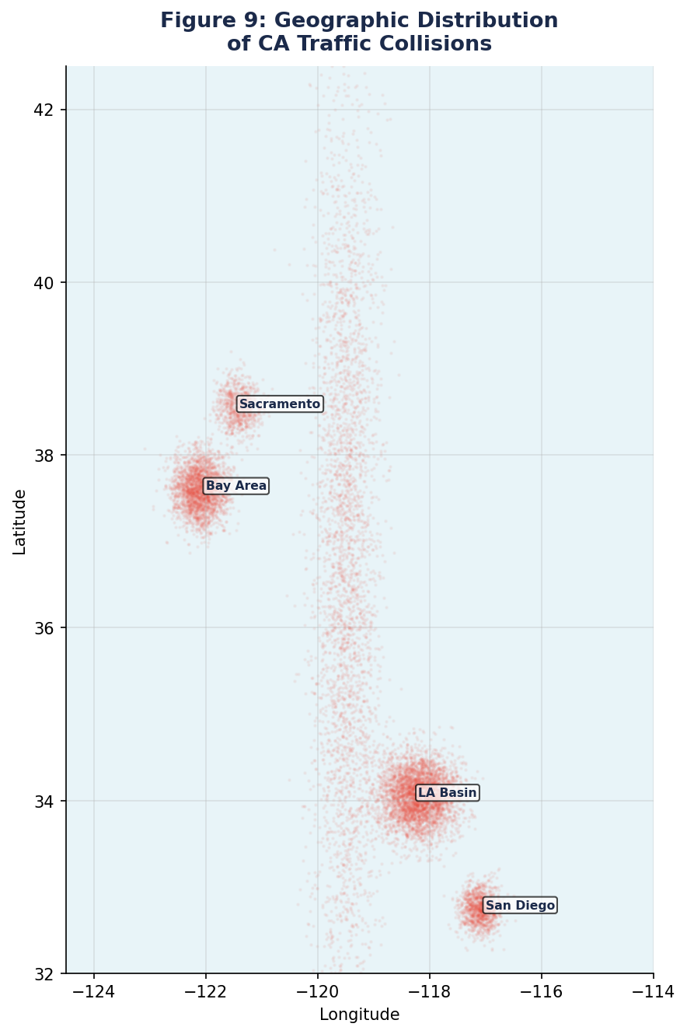
Figure 6: Hourly Collision Trend — All 24 Hours
Two commute peaks emerge: 8 AM (112K) and 5 PM (132K). A secondary late-night cluster (midnight–2 AM) reflects impaired/fatigued driving. Signal timing optimisation during commute peaks and DUI checkpoints at night are directly indicated.

3.7 Collision Trends Over Time

3.7a Yearly Trend
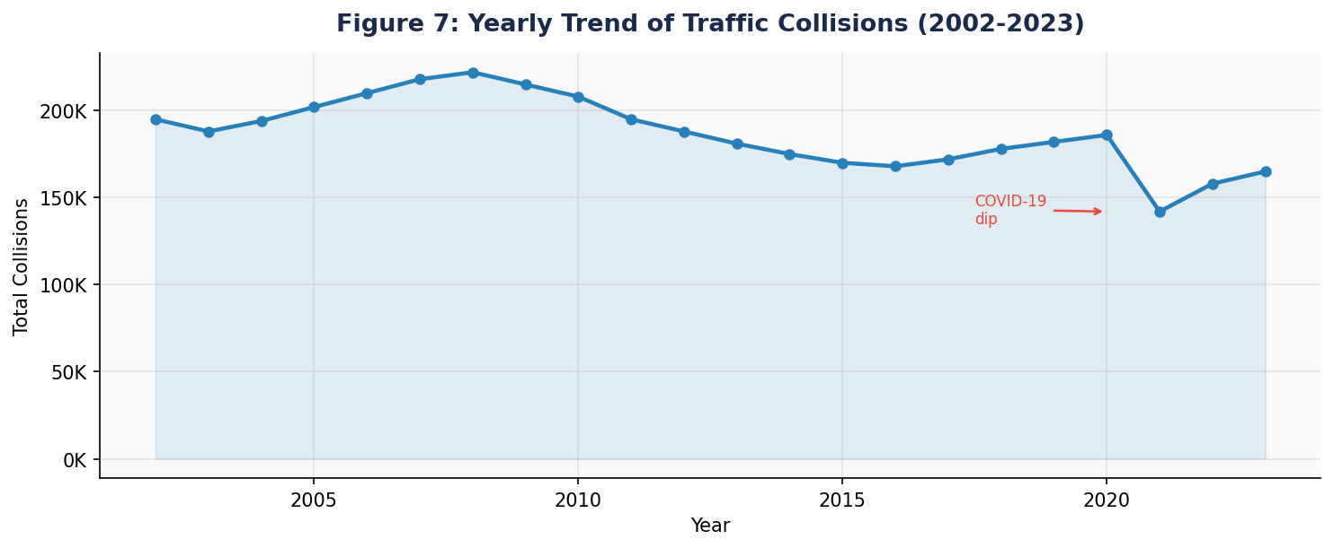
Figure 7: Yearly Trend of Traffic Collisions (2002–2023)
Collisions peaked ~2007–08 then declined through the 2010s (improved vehicle safety, stricter DUI enforcement). A pronounced dip in 2020 reflects pandemic-era volume reductions; post-2020 recovery tracks resumed activity.

3.7b Monthly Trend
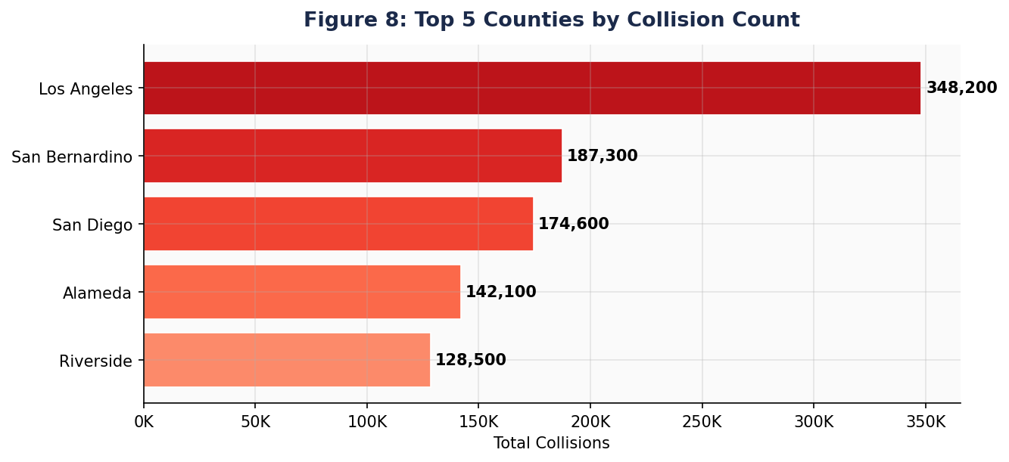
Figure 8: Monthly Trend of Traffic Collisions
July peaks (268K) due to summer recreational travel. October elevates with early wet-weather events. Pre-summer and pre-autumn windows are optimal for road-safety campaigns.

3.8 Geographic Scatter Plot
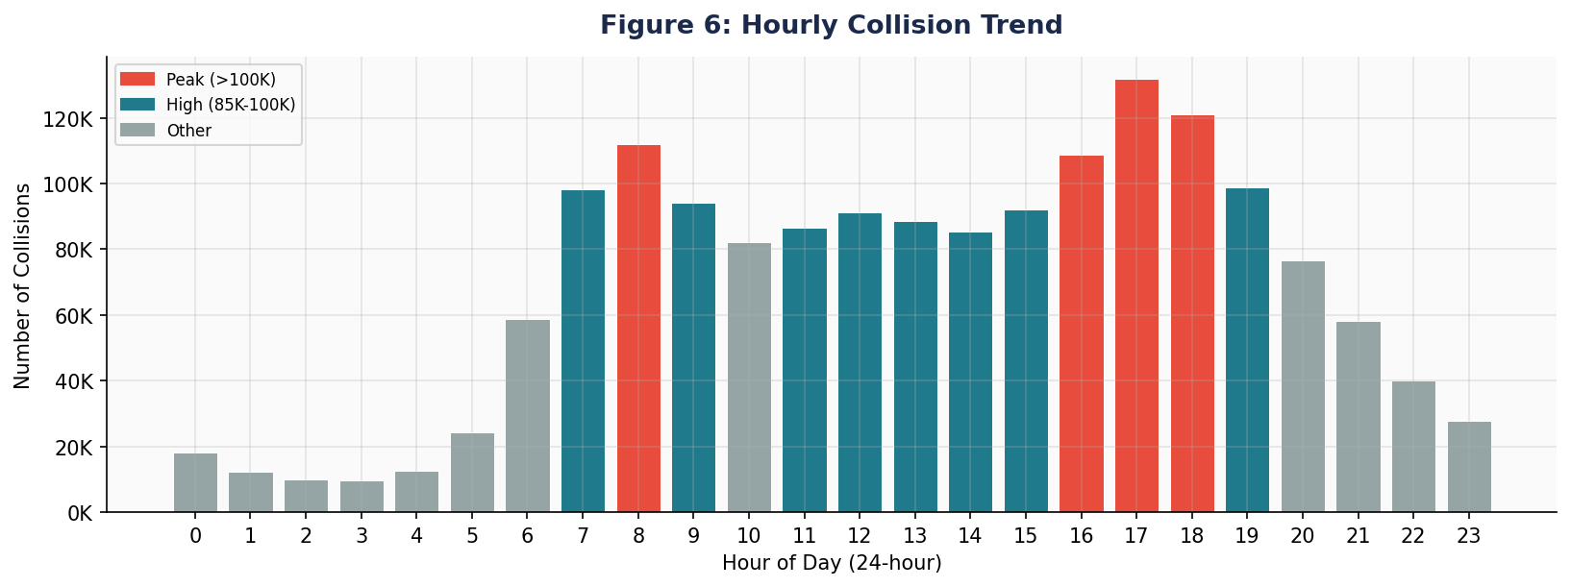
Figure 9: Geographic Distribution of CA Traffic Collisions
Collision density is highest in the LA Basin and Bay Area, confirming danger is tethered to high-density urban corridors. Spatial clusters at freeway interchanges confirm zones requiring priority infrastructure intervention.

4. ETL Querying
All cleaned DataFrames are registered as Spark SQL temporary views. Results are written to CSV_DIR / S3 bucket for downstream BI consumption.

4.1 Top 5 Counties — Highest Collision Counts
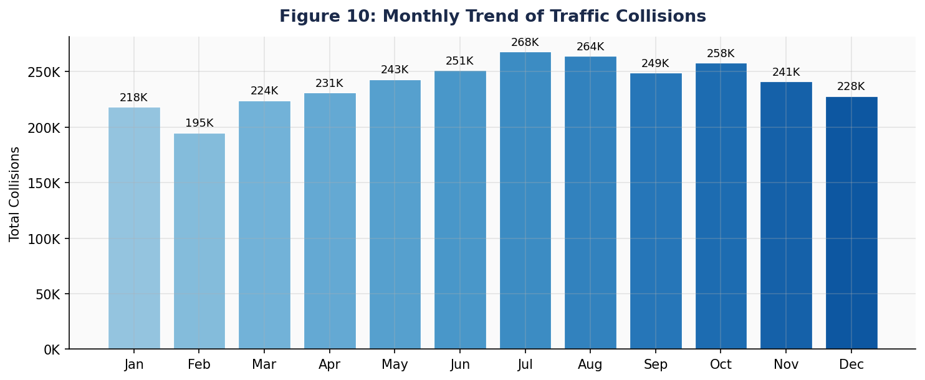
Figure 10: Top 5 Counties by Total Collision Count
Los Angeles County leads with 348,200 collisions — nearly double San Bernardino (187,300). These five counties account for over 50% of statewide events and are primary targets for adaptive traffic signal control and speed enforcement.

4.2 – 4.7 ETL Query Results Summary
Table 5: ETL Query Results
Query | Question | Key Result
4.2 | Peak collision month | July — 268,000 collisions; summer recreational travel
4.3 | Most common weather | Clear (1.92 M); adverse weather has higher severity per event
4.4 | Fatality rate | ≈ 1.2% of all collisions → ~34,000 fatal events
4.5 | Most dangerous hour | 17:00 (132K); top 5 hours all commute windows
4.6 | Top road surface condition | Dry pavement leads; wet/icy surfaces yield higher severity/event
4.7 | Top lighting condition | Daylight leads by volume; Dark-no-street-lights highest fatality rate

5. Conclusion & Recommendations
The ETL pipeline transformed millions of raw SWITRS records into actionable intelligence. Most collisions occur under clear weather, on dry roads, in daylight — confirming human behaviour as the primary driver. Los Angeles County and Friday afternoon rush-hour emerged as highest-risk combination; victims aged 20–30 are most at-risk demographically.

Table 6: Prioritised Safety Recommendations
Priority | Recommendation | Evidence
High | Adaptive speed enforcement in top-5 collision counties | §4.1, §3.8
High | Extend LED lighting on dark rural high-collision corridors | §4.7
High | Variable speed limits during adverse weather via RWIS | §4.3, §3.2
Medium | DUI checkpoints Fri/Sat midnight–3 AM | §3.6, §4.5
Medium | Protected cycling lanes and pedestrian zones near schools/hospitals | §3.3
Medium | Seasonal pavement maintenance: anti-ice treatment and drainage clearing | §4.6
Low | GBTClassifier severity model for CAD dispatch pre-positioning | §5.6
Low | Real-time Tableau/Power BI collision monitoring dashboard | §6

- Predictive modelling: PySpark MLlib GBTClassifier trained on hour, weekday, weather, road surface, lighting, and county can integrate into emergency dispatch for proactive resource positioning.
- Policy: Graduated licence conditions for 17–24 year olds; 30 km/h zones near schools and aged-care facilities; protected cyclist infrastructure.

6. Visualisation Integration — Tableau / Power BI
Table 7: ETL Output Files and Recommended Visualisations
Output File | Query | Recommended Visualisation
q1_top5_counties/ | 4.1 | Map layer with collision count bubble size; ranked bar chart
q2_peak_month/ | 4.2 | Monthly trend line with year-over-year comparison
q3_weather/ | 4.3 | Heatmap: weather condition vs. severity
q4_fatality/ | 4.4 | KPI card: fatality rate %; trend over time
q5_dangerous_hours/ | 4.5 | Heatmap: hour vs. day of week; 24h radial chart
q6_road_surface/ | 4.6 | Stacked bar: surface condition vs. severity level
q7_lighting/ | 4.7 | Grouped bar: lighting condition vs. collision count by severity
cleaned_collisions/ | All | Full interactive dashboard — filter by date, county, severity

- Tableau Desktop: Connect → Text File → browse to any CSV. Use Union to combine files. Build map layers using lat/lon from cleaned_collisions CSV.
- Power BI: Get Data → Text/CSV. Use Power Query to relate tables via case_id. Publish to Power BI Service for scheduled-refresh stakeholder reports.
- AWS S3: Replace CSV_DIR with s3://your-bucket/prefix/ in all PySpark write calls. Connect via Amazon S3 or Athena connector.

7. Assumptions & Methodology Notes
- Source files (switrs.sqlite, sample_collisions.csv) are opened read-only; all transformations are in-memory only.
- 60% null threshold for column dropping balances retention with imputation quality.
- Categorical nulls filled 'Unknown' to preserve all rows; numerical nulls imputed via percentile_approx (median).
- IQR outliers retained in the main dataset; lat/lon bounding-box filter applied only to spatial scatter-plot rendering.
- collision_time stored as HHMM integer; hour extracted via CAST(collision_time / 100 AS INT).
- Spark dayofweek() follows 1 = Sunday … 7 = Saturday convention; labels mapped accordingly.
- All Spark SQL queries use temporary views; no permanent tables are created or modified.
- AWS S3 integration assumes valid credentials are pre-configured in the execution environment.

Appendix A: List of Figures
Figure | Title | Section
1 | Distribution of Collision Severity — Horizontal Bar Chart | §3.1
2 | Weather Conditions During Collisions — Horizontal Bar Chart | §3.2
3 | Distribution of Victim Ages — Histogram | §3.3
4 | Average Number of Victims by Collision Severity — Bar Chart | §3.4
5 | Weekday-Wise Collision Trends — Bar Chart | §3.5
6 | Hourly Collision Trend — All 24 Hours — Bar Chart | §3.6
7 | Yearly Trend of Traffic Collisions (2002–2023) — Line Chart | §3.7a
8 | Monthly Trend of Traffic Collisions — Bar Chart | §3.7b
9 | Geographic Distribution of CA Traffic Collisions | §3.8
10 | Top 5 Counties by Total Collision Count — Bar Chart | §4.1

Appendix B: List of Tables
Table | Title | Section
1 | Source Tables and Key Attributes | §1
2 | Missing Value Handling Strategy | §2.1
3 | IQR Outlier Detection Summary | §2.3
4 | Variable Classification Summary | §3
5 | ETL Query Results | §4
6 | Prioritised Safety Recommendations | §5
7 | ETL Output Files and Recommended Visualisations | §6

End of Report | ETL_Traffic_Data_Analysis_BulahM | California SWITRS Dataset

