Car Price Prediction via Regularized Regression
A Comparative Study of Ridge, Lasso, and ElasticNet Approaches

Author | MBulah
Submission Title | RR Car Price Prediction
Dataset | CarPrice_Assignment.csv
Dataset Size | 205 vehicles × 26 attributes
Prediction Target | Selling price (USD)
GitHub Repository | https://github.com/bulah16/C4-Project.git
Submission Date | June 2026

Study Objective
Geely Auto, a Chinese vehicle manufacturer, intends to establish a presence in the North American automobile market. To support that strategic initiative, this study constructs and evaluates a set of supervised regression models — ordinary least-squares Linear Regression alongside three penalty-based variants (Ridge, Lasso, and ElasticNet) — using a labelled dataset of US car specifications and sale prices. The central aims are to identify which physical, mechanical, and brand-related attributes exert the strongest influence on vehicle pricing, and to determine which modelling approach delivers the most reliable price predictions on unseen data.

Table of Contents

Section | Page
1. Library Imports and Data Loading | 3
2. Exploratory Data Analysis (EDA) | 4
2.1 Initial Inspection of the Dataset | 4
2.2 Distribution of the Target Variable (Price) | 5
2.3 Extracting the Car Manufacturer from CarName | 6
2.4 Categorical Attributes and Their Relationship with Price | 6
2.5 Correlation Structure of Numerical Attributes | 7
2.6 Outlier Screening via Box Plots | 9
3. Data Preprocessing | 9
3.1 Categorical Variable Encoding | 9
3.2 Train / Test Partitioning and Feature Standardization | 10
4. Multicollinearity Assessment — Variance Inflation Factor (VIF) | 10
5. Regression Model Development | 12
5.1 Baseline — Ordinary Linear Regression (OLS) | 12
5.2 Ridge Regression with L2 Regularization | 12
5.3 Lasso Regression with L1 Regularization | 13
5.4 ElasticNet — Blended L1 and L2 Regularization | 13
6. Cross-Model Performance Comparison | 14
7. Findings, Assumptions, and Strategic Recommendations | 15-16
8. References | 17

1. Library Imports and Data Loading

The analytical workflow begins by importing the complete set of required Python packages: pandas and numpy for data manipulation, matplotlib and seaborn for visualisation, scikit-learn for modelling and preprocessing utilities, and statsmodels for the VIF diagnostic. The CarPrice_Assignment.csv file is loaded into a DataFrame, and a structural check verifies that all 205 rows and 26 columns have been read correctly before any analysis proceeds.
Table 1: Structural Summary of the Loaded Dataset
Property | Detail
Row count | 205
Column count | 26
Response variable | price (USD)
Missing entries | None (0 across all columns)
Numeric columns | 16 (8 float64, 8 int64)
Text / categorical columns | 10 (object dtype)

Table 2: Attribute Glossary
Attribute | Kind | Meaning
car_ID | Integer | Sequential record identifier — excluded from modelling
symboling | Integer | Actuarial risk rating assigned by insurers (-3 = safest, +3 = riskiest)
CarName | Text | Combined manufacturer and model name string
fueltype | Categorical | Propulsion fuel: gas or diesel
aspiration | Categorical | Induction method: std (naturally aspirated) or turbo
doornumber | Categorical | Door count: two or four
carbody | Categorical | Bodywork configuration: convertible, hatchback, sedan, wagon, hardtop
drivewheel | Categorical | Driven axle: fwd, rwd, or 4wd
enginelocation | Categorical | Longitudinal engine position: front or rear
wheelbase … carheight | Float | Four body dimension measurements in inches
curbweight | Integer | Vehicle mass (lbs) without occupants or cargo
enginetype | Categorical | Valvetrain architecture: dohc, ohc, ohcv, l, rotor, etc.
cylindernumber | Categorical | Cylinder count expressed as a word (two through twelve)
enginesize | Integer | Engine swept volume in cubic inches
fuelsystem | Categorical | Fuel delivery system type: mpfi, 2bbl, idi, spfi, etc.
boreratio / stroke | Float | Cylinder bore diameter ratio and piston stroke length
compressionratio | Float | Ratio of maximum to minimum cylinder volume
horsepower / peakrpm | Integer | Rated power output and the RPM at which it is achieved
citympg / highwaympg | Integer | Fuel economy ratings for urban and motorway driving cycles
price | Float | TARGET — transaction sale price in US dollars

2. Exploratory Data Analysis (EDA)

Exploratory analysis serves as the foundation for every subsequent modelling decision. This section examines the dataset from multiple angles: the overall structure and descriptive statistics, the shape of the target price distribution, the pricing signal embedded in categorical columns, linear associations among numerical attributes, and the presence of extreme values that might distort model behaviour.

2.1 Initial Inspection of the Dataset
A structural audit using df.info() and df.describe() established that the dataset is complete — not a single cell is empty across all 205 records. This eliminates the need for any imputation strategy. The table below captures central-tendency and dispersion statistics for the six most analytically relevant numerical columns.
Table 3: Descriptive Statistics for Key Numerical Columns
Measure | price ($) | enginesize | horsepower | curbweight | citympg | highwaympg
N | 205 | 205 | 205 | 205 | 205 | 205
Mean | 13,276.71 | 126.91 | 104.12 | 2,555.57 | 25.22 | 30.75
Std Dev | 7,988.85 | 41.64 | 39.54 | 520.68 | 6.54 | 6.89
Min | 5,118.00 | 61 | 48 | 1,488 | 13 | 16
Q1 | 7,788.00 | 97 | 70 | 2,145 | 19 | 25
Median | 10,295.00 | 120 | 95 | 2,414 | 24 | 30
Q3 | 16,503.00 | 141 | 116 | 2,935 | 30 | 34
Max | 45,400.00 | 326 | 288 | 4,066 | 49 | 54

2.2 Distribution of the Target Variable (Price)
Vehicle prices in this dataset span a wide interval — from a floor of $5,118 to a ceiling of $45,400 — with an arithmetic mean of $13,276.71 against a median of $10,295.00. The gap between these two central measures is diagnostic: it signals a positively skewed distribution in which a cluster of high-priced vehicles stretches the right tail while the majority of records sit in the sub-$16,000 range. A computed skewness coefficient of approximately 1.78 confirms this visual impression. Applying a log1p transformation compresses the tail and brings the distribution closer to symmetry, a property that can benefit certain modelling pipelines.
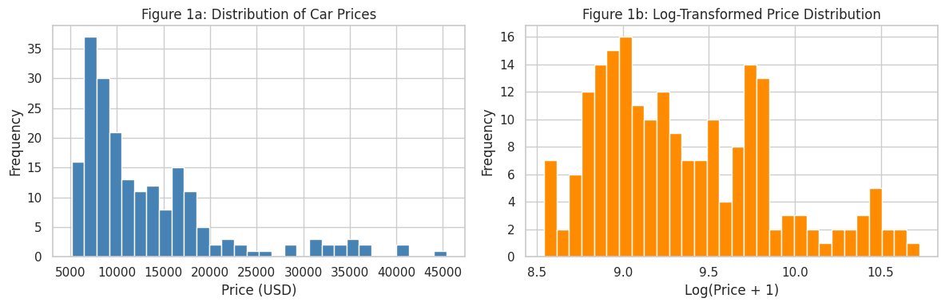
Figure 1: Histograms of the raw price variable (left) and its log1p-transformed counterpart (right)

2.3 Extracting the Car Manufacturer from CarName
The CarName column stores a free-text string that concatenates manufacturer and model (e.g. "alfa-romero giulia"). A new carcompany feature was engineered by splitting each string on whitespace and retaining the leading token, then converting to lowercase. Manual inspection uncovered six misspelled manufacturer names — maxda, toyouta, vokswagen, vw, porcshce, and alfa-romero — each of which was corrected through a purpose-built lookup dictionary (to mazda, toyota, volkswagen, volkswagen, porsche, and alfa-romeo respectively). After cleaning, the column resolves to 22 distinct manufacturers. Toyota accounts for the highest vehicle count (32), followed by Nissan (18) and Mazda (17).
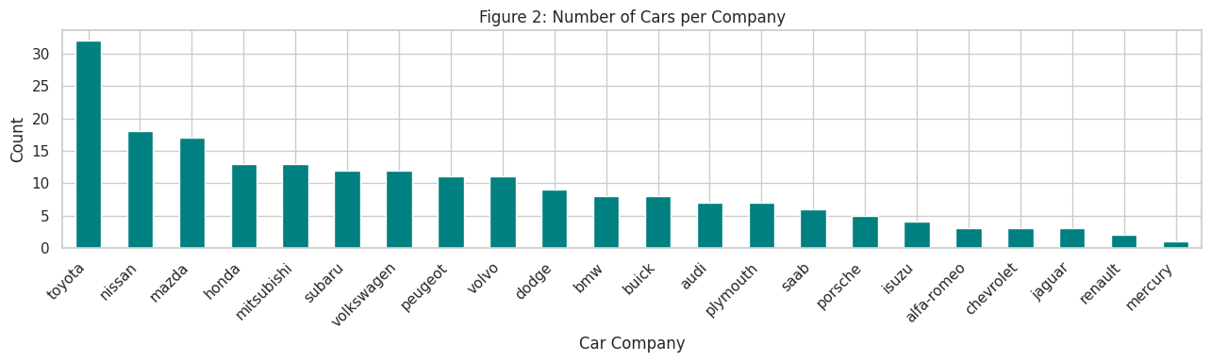
Figure 2: Vehicle count per manufacturer after name-spelling corrections

2.4 Categorical Attributes and Their Relationship with Price
Mean sale price was computed for every level of six categorical columns and plotted as bar charts. The resulting patterns provide qualitative insight into which product characteristics the market rewards with a premium:
- Fuel type: On average, diesel-engined vehicles fetch a higher price than petrol equivalents, reflecting their typical use in larger or more specialised body styles.
- Aspiration: Turbocharging is associated with a sizeable average price premium relative to standard naturally aspirated induction.
- Door count: Two-door body styles average higher prices, consistent with coupe and sports-car segments commanding a desirability premium.
- Body style: Hardtops and convertibles sit at the top of the average price ladder; hatchbacks and wagons occupy the lower rungs.
- Drive configuration: Rear-wheel-drive vehicles carry substantially higher average prices than front-wheel-drive counterparts — a proxy for performance-oriented models.
- Engine position: Rear-engine layouts are associated with the highest average price bracket in this dataset, characteristic of exotic and high-performance vehicles.

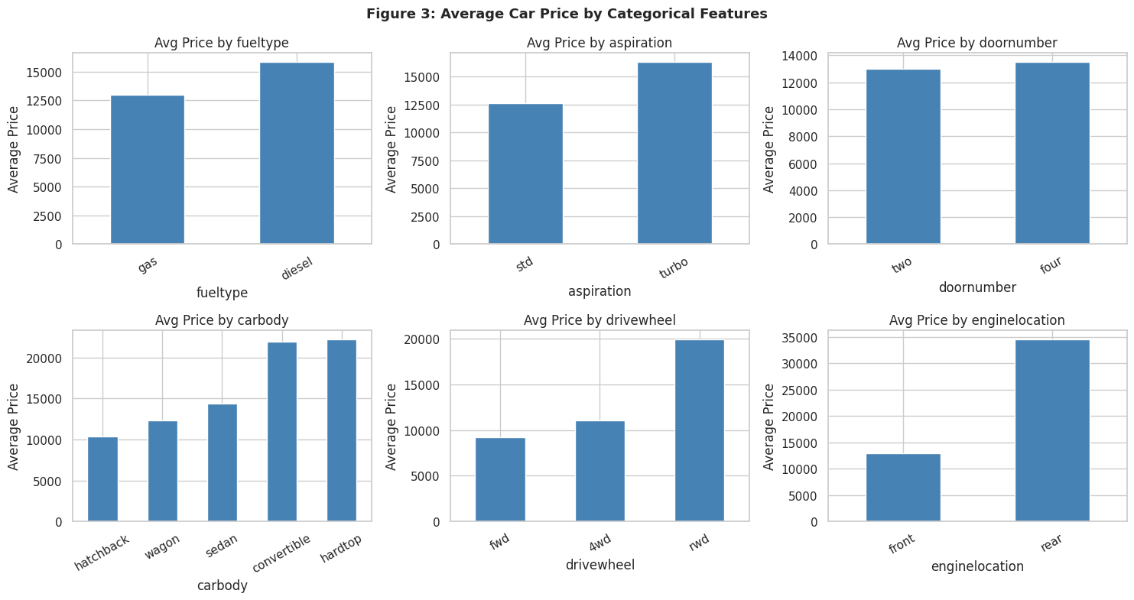
Figure 3: Average sale price broken down by category for six categorical attributes

2.5 Correlation Structure of Numerical Attributes
Pairwise Pearson correlation coefficients were computed for all 15 numerical columns and displayed as a lower-triangular heatmap. The six attributes with the highest absolute correlation with price were subsequently plotted as individual scatter diagrams to verify the direction and approximate linearity of each relationship.
Table 4: Ranked Pearson Correlations with Sale Price
Attribute | Pearson r | Relationship Class
enginesize | 0.874 | Strong positive
curbweight | 0.835 | Strong positive
horsepower | 0.808 | Strong positive
carwidth | 0.759 | Strong positive
highwaympg | -0.698 | Strong negative
citympg | -0.686 | Strong negative
carlength | 0.683 | Moderate positive
wheelbase | 0.578 | Moderate positive
boreratio | 0.553 | Moderate positive
carheight | 0.119 | Negligible
symboling | -0.080 | Negligible
stroke | 0.079 | Negligible
compressionratio | 0.068 | Negligible

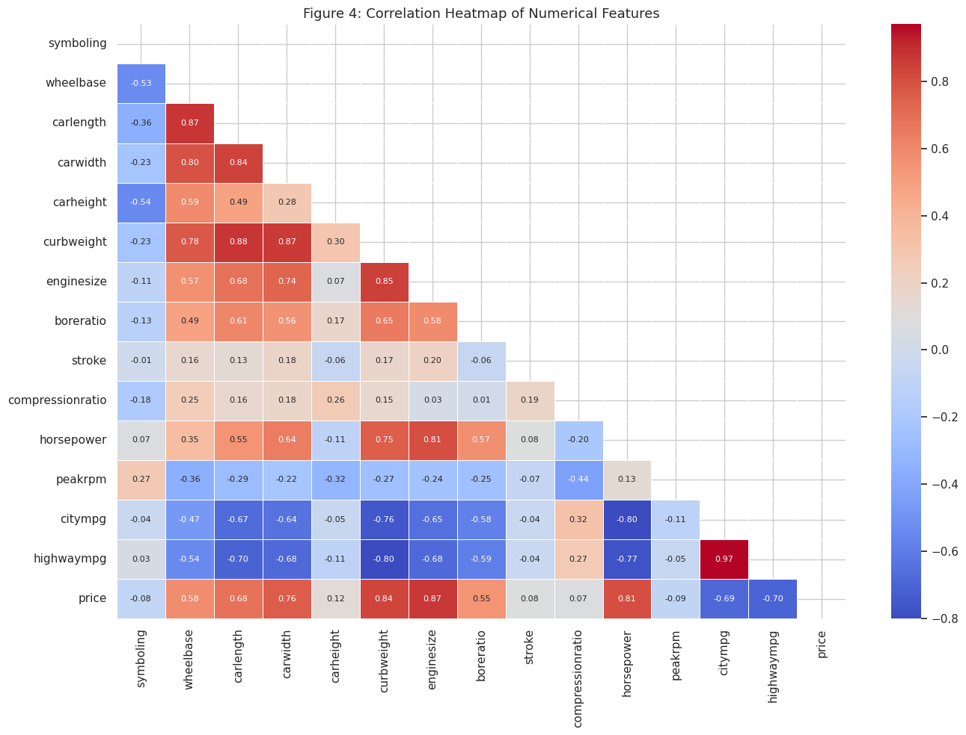
Figure 4: Lower-triangular Pearson correlation heatmap across all 15 numerical attributes
The scatter plots corroborate the direction and relative strength seen in the heatmap. Engine size, curb weight, horsepower, and body width each exhibit an upward trend with price, whereas city and highway fuel-economy ratings trend downward — physically intuitive given that heavier, more powerful vehicles consume more fuel and carry higher price tags.
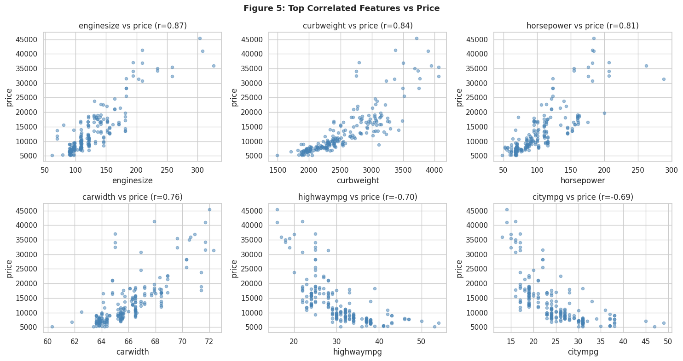
Figure 5: Pairwise scatter plots of the six attributes most correlated with price

2.6 Outlier Screening via Box Plots
Box plots for the same six top-correlated attributes reveal that engine size and horsepower each contain a handful of observations that lie well beyond the upper whisker. Cross-referencing these records with manufacturer and model information confirms they represent genuine high-specification luxury and performance vehicles (e.g. Jaguar and Porsche entries) rather than recording errors. Accordingly, these observations were retained without modification to preserve the full representational range of the dataset.
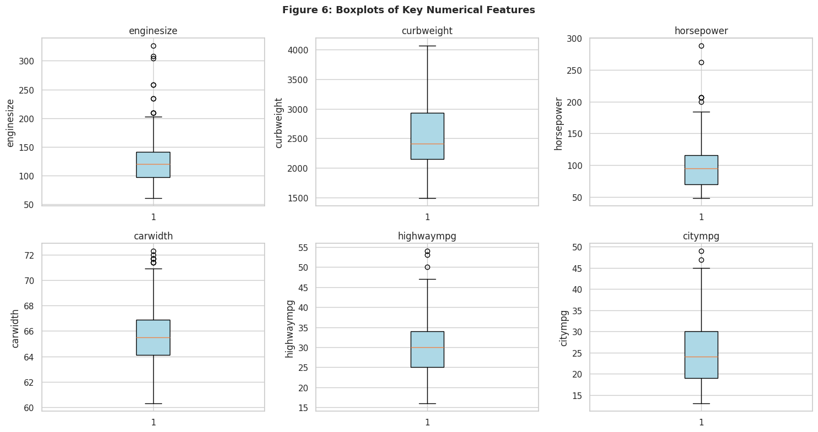
Figure 6: Box plots of the six key numerical attributes — circles denote observations beyond 1.5xIQR

3. Data Preprocessing

Prior to fitting any model, the dataset underwent three preparation steps: transformation of categorical variables into numeric form, partitioning into training and evaluation subsets, and standardization of the feature scale. Each step is motivated by the requirements of the regularized estimators used in Section 5.

3.1 Categorical Variable Encoding
Attributes carrying exactly two distinct values were converted to binary integers through direct dictionary mapping (fueltype: gas=1, diesel=0; aspiration: turbo=1, std=0; doornumber: two=1, four=0; enginelocation: front=1, rear=0). Attributes with three or more distinct values were processed using pandas get_dummies() with drop_first=True, which drops the first dummy column to prevent perfect linear dependence among predictors.
Table 5: Dummy Column Expansion from One-Hot Encoding
Original Column | Unique Levels | Dummy Columns Produced
carbody | 5 | 4
drivewheel | 3 | 2
enginetype | 7 | 6
cylindernumber | 7 | 6
fuelsystem | 8 | 7
carcompany | 22 | 21

Following the removal of car_ID and CarName and the application of both encoding strategies, the feature matrix widened from 24 usable input columns to 64 predictors, with no new missing values introduced at any stage.

3.2 Train / Test Partitioning and Feature Standardization
The encoded feature matrix (X, 64 columns) and target vector (y = price) were divided using an 80/20 random split seeded at 42, producing a training partition of 164 rows and a test partition of 41 rows. A StandardScaler was then fitted on the training rows alone, learning the per-feature mean and standard deviation exclusively from that subset. The learned parameters were subsequently applied to transform both partitions. This sequencing is essential: scaling the test set using statistics derived from training data prevents any leakage of test-set information into the fitted models.
Table 6: Partitioning and Scaling Configuration
Setting | Value
Total observations | 205
Training rows | 164 (80%)
Test rows | 41 (20%)
Random seed | 42
Input feature count | 64 columns
Scaling method | StandardScaler — zero mean, unit variance; fit on train only

4. Multicollinearity Assessment — Variance Inflation Factor (VIF)

When two or more predictors convey substantially the same information, the ordinary least-squares estimator can become numerically unstable and coefficient estimates may carry inflated standard errors. The Variance Inflation Factor (VIF) quantifies how much of a given predictor's variance is attributable to its linear relationships with the remaining predictors. A VIF of 1 indicates complete independence; values above 10 are widely treated as indicative of multicollinearity severe enough to merit attention. VIF scores were computed on the 14 base numerical attributes (prior to one-hot encoding) to focus the diagnostic on the continuous-variable cluster.
Table 7: VIF Scores — Numerical Attributes Ranked by Severity
Attribute | VIF Score | Severity Assessment
citympg | 25.86 | Critical — well above the VIF = 10 threshold
highwaympg | 20.18 | Critical — well above the VIF = 10 threshold
curbweight | 15.46 | Elevated — exceeds threshold
carlength | 8.79 | Moderate — approaching threshold
wheelbase | 8.42 | Moderate
horsepower | 7.83 | Within acceptable range
enginesize | 6.70 | Within acceptable range
carwidth | 5.05 | Within acceptable range
compressionratio | 2.27 | Low — no concern
carheight | 2.25 | Low — no concern
peakrpm | 2.11 | Low — no concern
boreratio | 1.97 | Low — no concern
symboling | 1.95 | Low — no concern
stroke | 1.18 | Low — no concern

The three highest-VIF attributes — citympg, highwaympg, and curbweight — form a physically coherent cluster: heavier vehicles tend to have less efficient engines and thus worse fuel economy, creating a web of inter-predictor correlations. This redundancy does not disqualify these attributes as predictors; rather, it underscores why regularized models such as Ridge and Lasso, which penalise large or unstable coefficients, are preferable to plain OLS in this setting.
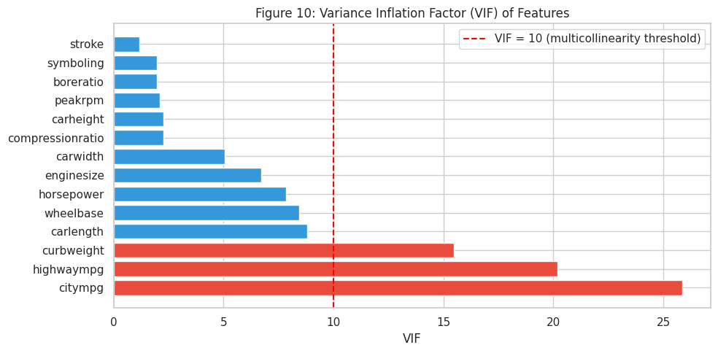
Figure 10: Horizontal bar chart of VIF scores — red bars flag attributes exceeding the VIF = 10 threshold

5. Regression Model Development

Four regression estimators were trained on the 164-row standardized training matrix and subsequently evaluated on the 41-row held-out test partition. Performance is reported using three complementary metrics: Root Mean Squared Error (RMSE), which penalises large individual prediction errors more severely; Mean Absolute Error (MAE), which provides a more outlier-robust average; and R-squared (R2), which expresses the proportion of price variance accounted for by the model.

5.1 Baseline — Ordinary Linear Regression (OLS)
The classical OLS estimator was fitted first to set a performance reference point. OLS minimises the total squared prediction error across all training observations without imposing any constraint on the magnitude of the learned coefficients:
Objective: Minimise sum (y_i - y_hat_i)^2
Applied to the test partition, this unconstrained model delivered an RMSE of $2,669.93, an MAE of $1,763.57, and an R2 of 0.9097, explaining just over 91% of price variability.

5.2 Ridge Regression with L2 Regularization
Ridge regression augments the OLS objective with a term proportional to the sum of squared coefficients. This L2 penalty discourages any single predictor from dominating the solution, shrinking all coefficients toward zero while retaining all of them in the final model:
Objective: Minimise sum (y_i - y_hat_i)^2 + alpha x sum (beta_j)^2
The regularization intensity alpha was identified through 5-fold cross-validation on the training partition, sweeping the candidate grid [0.01, 0.1, 1, 10, 50, 100, 200, 500, 1000]. The candidate yielding the highest mean cross-validated R2 (0.9153) was alpha = 10. The model refitted at this alpha produced test-set results of RMSE = $2,928.00, MAE = $1,984.33, and R2 = 0.8914.
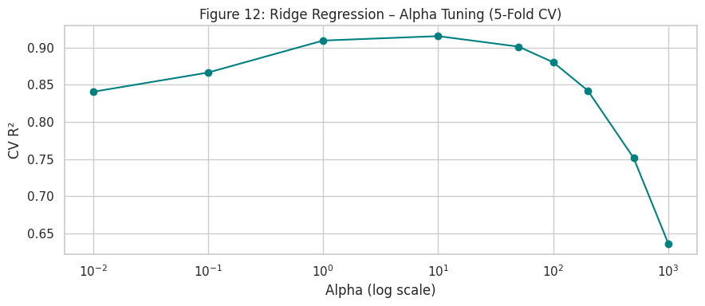
Figure 12: Cross-validated R2 plotted against candidate Ridge alpha values on a log scale (5-fold CV)

5.3 Lasso Regression with L1 Regularization
Lasso regression substitutes an absolute-value (L1) penalty for the squared penalty used in Ridge. A critical difference in behaviour emerges: the L1 geometry can drive individual coefficients to exactly zero, achieving built-in variable selection alongside regularization:
Objective: Minimise sum (y_i - y_hat_i)^2 + alpha x sum |beta_j|
At alpha = 50, the Lasso solution attained RMSE = $3,001.34, MAE = $2,090.68, and R2 = 0.8859 on the test set. Of the 64 candidate coefficients, 25 were reduced to exactly zero and 39 remained non-zero. This sparse solution carries a practical advantage: it identifies a smaller, more interpretable subset of the original 64 predictors that collectively still explains nearly 89% of price variance.
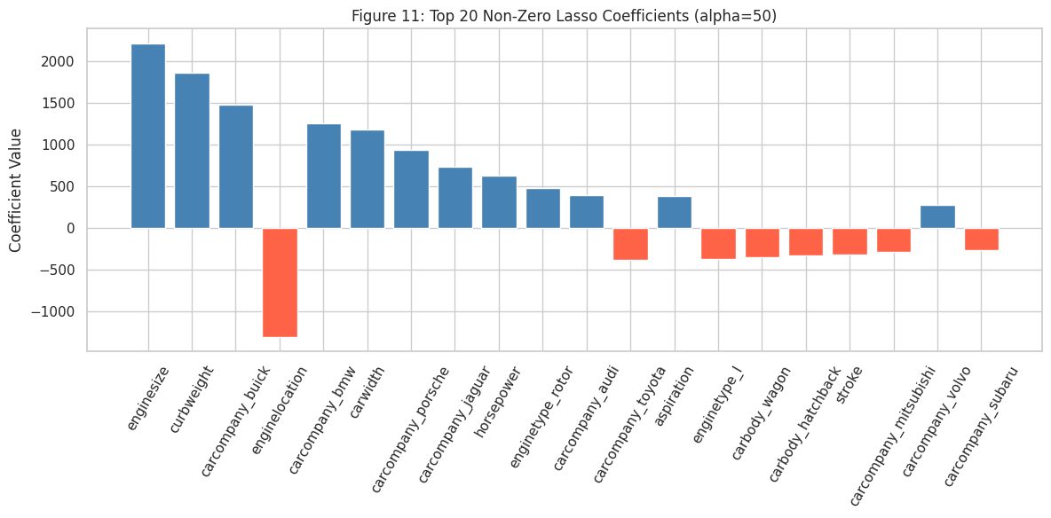
Figure 11: The 20 largest non-zero Lasso coefficients at alpha = 50 — upward bars increase predicted price, downward bars reduce it

5.4 ElasticNet — Blended L1 and L2 Regularization
ElasticNet merges both penalty types into a single objective function governed by two hyperparameters: the overall regularization strength alpha and the mixing ratio l1_ratio that controls the relative weighting of the two penalties (l1_ratio = 0 reduces to Ridge; l1_ratio = 1 reduces to Lasso):
Objective: Minimise sum (y_i - y_hat_i)^2 + alpha x [r x sum|beta_j| + (1-r) x sum(beta_j)^2]
Running ElasticNet with alpha = 50 and l1_ratio = 0.5 (an equal blend of both penalties) yielded RMSE = $7,000.77, MAE = $4,862.51, and R2 = 0.3792 on the test set. This result is considerably weaker than all other models, suggesting that the combined penalty magnitude at alpha = 50 is excessive relative to the informational content of this 64-feature dataset. A systematic joint grid search over both alpha and l1_ratio would be the appropriate next step.

6. Cross-Model Performance Comparison

This section consolidates the test-set evaluation across all four models and examines the predictions visually through actual-versus-predicted plots and residual diagnostics.
Table 8: Test-Set Metrics Summary (41 held-out observations)
Model | RMSE (USD) | MAE (USD) | R2 | Rank
Linear Regression (OLS) | $2,669.93 | $1,763.57 | 0.9097 | 1st
Ridge (alpha = 10) | $2,928.00 | $1,984.33 | 0.8914 | 2nd
Lasso (alpha = 50) | $3,001.34 | $2,090.68 | 0.8859 | 3rd
ElasticNet (alpha = 50) | $7,000.77 | $4,862.51 | 0.3792 | 4th

Table 9: Interpretation of Reported Evaluation Metrics
Metric | Calculation | Practical Interpretation
RMSE | sqrt[ sum(y_i - y_hat_i)^2 / n ] | Average dollar-magnitude error; larger errors are penalised quadratically
MAE | sum |y_i - y_hat_i| / n | Mean absolute dollar deviation; less sensitive to isolated large residuals
R2 | 1 - SS_residual / SS_total | Fraction of price variance captured; 1.00 indicates a perfect fit

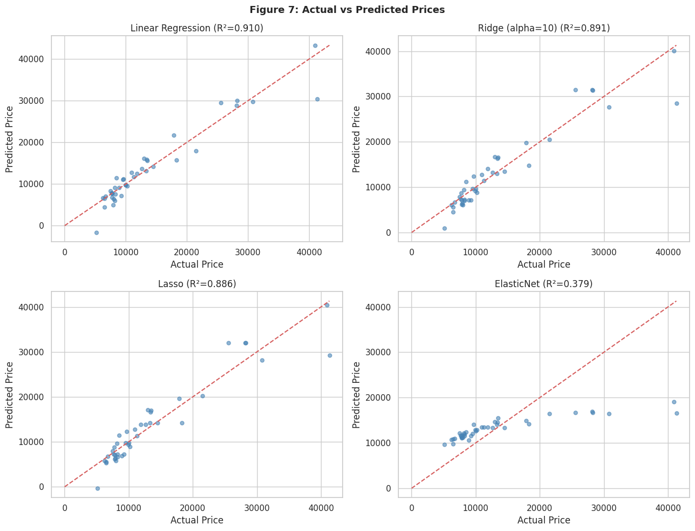
Figure 7: Actual vs. predicted price scatter plots for all four models — points on the dashed diagonal indicate perfect predictions
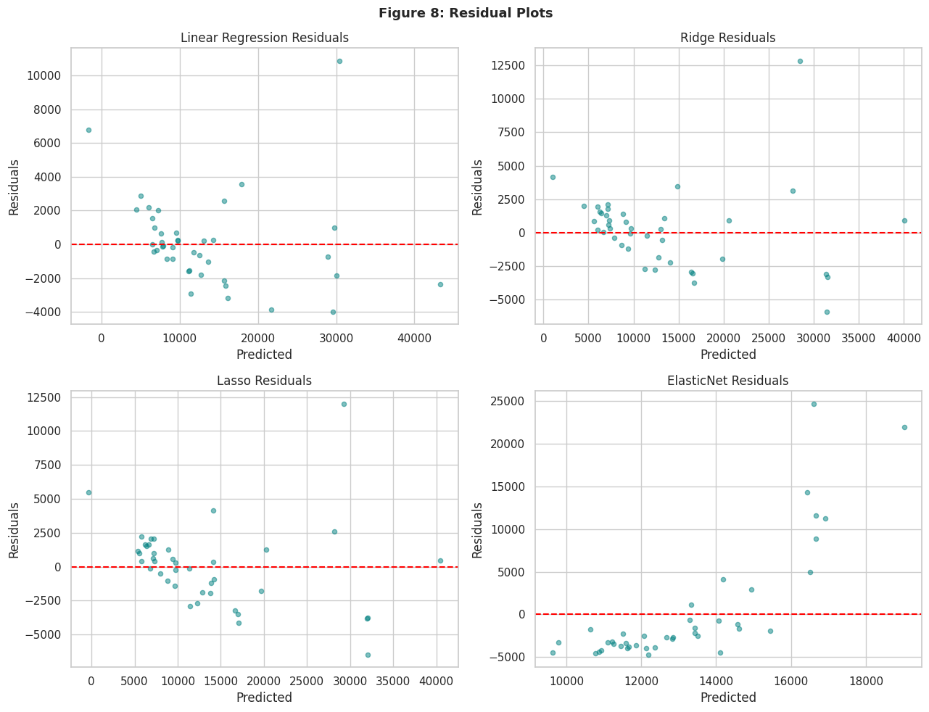
Figure 8: Residual plots (actual minus predicted) against predicted price — ideal behaviour is random scatter centred on zero
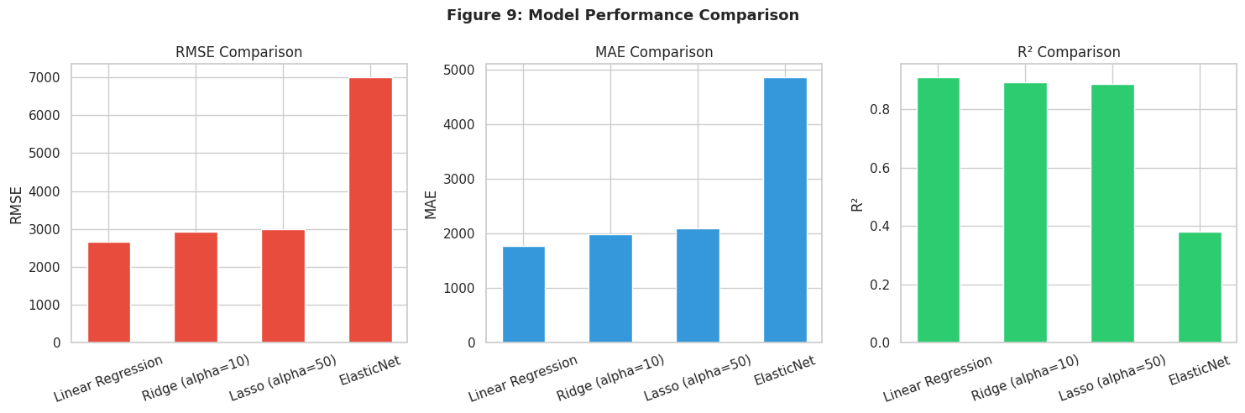
Figure 9: Bar chart comparison of RMSE, MAE, and R2 across all four models

7. Findings, Assumptions, and Strategic Recommendations

7.1 Principal Findings
- Price concentration and spread: The sale price distribution is right-skewed (skewness approx. 1.78). While the median transaction sits near $10,295, the mean is pulled to $13,277 by a subset of premium vehicles, indicating that a realistic pricing strategy must account for two distinct market tiers.
- Dominant positive pricing drivers: Engine displacement (r = 0.874), vehicle weight (r = 0.835), rated power output (r = 0.808), and body width (r = 0.759) are the four strongest upward predictors — collectively capturing the premium that buyers place on performance and size.
- Dominant negative pricing drivers: Highway fuel economy (r = -0.698) and city fuel economy (r = -0.686) move inversely with price, reflecting the market positioning of compact, efficient vehicles in lower price brackets.
- Manufacturer premium: Brand affiliation contributes meaningfully to predicted price. Luxury marques — notably Jaguar, Buick, and Porsche — command average prices substantially above the dataset mean even after controlling for mechanical specifications.
- Multicollinearity among numerical attributes: City MPG (VIF = 25.86), highway MPG (VIF = 20.18), and curb weight (VIF = 15.46) each exceed the VIF = 10 threshold, forming a cluster of inter-dependent predictors that destabilises plain OLS estimation.
- Best overall predictive accuracy: The ordinary Linear Regression model achieved the strongest test-set results (R2 = 0.9097, RMSE = $2,669.93), attributable in part to the dataset size and the post-encoding dimensionality being modest enough that OLS does not catastrophically overfit.
- Lasso as an interpretability tool: At alpha = 50, Lasso eliminated 25 of 64 predictors while maintaining R2 = 0.8859. This sparser model offers a shortlist of the 39 most informative features for stakeholder communication.
- Ridge as a stability-preserving alternative: Ridge (alpha = 10, R2 = 0.8914) retains all 64 predictors but constrains their magnitudes, providing smoother coefficient estimates than OLS in the presence of the collinearity identified in Section 4.
- ElasticNet with default blending is over-penalised: The combined L1+L2 penalty at alpha = 50 and l1_ratio = 0.5 compressed predictions too aggressively (R2 = 0.3792). A targeted hyperparameter search is necessary before conclusions can be drawn.

7.2 Documented Modelling Assumptions
- No imputation or row-removal was performed because the dataset is fully populated with zero missing values in all 26 columns.
- The car manufacturer was defined as the first whitespace-delimited token of the CarName string, converted to lowercase, and corrected for the six documented misspellings.
- Binary categorical attributes were label-encoded using a fixed mapping to 0/1 integers. Multi-level categoricals were expanded using one-hot encoding with the reference category dropped to avoid redundant dummy variables.
- StandardScaler was calibrated exclusively on the training partition, and its stored parameters were used to transform both partitions, preventing test-set statistics from influencing the scaling step.
- All four models were evaluated on the same 41-row test partition, generated using an 80/20 random split with random_state = 42, ensuring comparisons are valid.
- Extreme observations in engine size and horsepower were verified as legitimate high-specification vehicles and retained; no outlier removal was performed.
- Ridge alpha was optimised via 5-fold cross-validation restricted to the training partition. Lasso and ElasticNet were run at a fixed alpha of 50 as an initial configuration rather than an exhaustively tuned setting.
- ElasticNet was run with l1_ratio = 0.5 as a symmetric starting blend; this parameter was not optimised.
- All financial figures are in US dollars as supplied in the source file — no currency adjustments were made.

7.3 Strategic Recommendations for Geely Auto
- Position new US-market models with engine displacement, vehicle weight, output power, and body width as the primary specification levers — these four variables collectively exert the strongest upward pressure on market price.
- A log-transformation of the price target should be explored in subsequent modelling iterations; the positive skew can introduce heteroscedastic residuals that violate OLS assumptions.
- The citympg / highwaympg / curbweight cluster warrants further examination. Removing one of the three highly collinear members — or constructing a composite index — would simplify the feature space without meaningfully sacrificing predictive power.
- ElasticNet deserves a second evaluation with a full grid search spanning both alpha and l1_ratio before being discounted. Its theoretical advantage makes it well-suited to this dataset structure.
- The 39-feature Lasso subset should be reviewed by domain experts as a candidate for a leaner, more transparent production pricing model that can be explained to non-technical stakeholders.
- Brand positioning should be treated as an independent strategic input: Lasso coefficients show that manufacturer dummies for premium marques carry some of the largest positive weights, meaning that market perception commands a measurable price premium beyond specifications alone.

8. References

[1] GeeksforGeeks (2024). Ridge Regression vs Lasso Regression. Retrieved from https://www.geeksforgeeks.org/machine-learning/ridge-regression-vs-lasso-regression/
[2] DataCamp (2024). Ridge and Lasso Regression: A Complete Guide with Python Scikit-Learn. Retrieved from https://www.datacamp.com/tutorial/tutorial-lasso-ridge-regression
[3] GeeksforGeeks (2024). One Hot Encoding vs Label Encoding. Retrieved from https://www.geeksforgeeks.org/machine-learning/one-hot-encoding-vs-label-encoding/
[4] GeeksforGeeks (2024). Feature Engineering: Scaling, Normalization and Standardization. Retrieved from https://www.geeksforgeeks.org/machine-learning/feature-engineering-scaling-normalization-and-standardization/
[5] GeeksforGeeks (2024). Regression Metrics. Retrieved from https://www.geeksforgeeks.org/machine-learning/regression-metrics/
[6] Kumawat, S. (2023). Performance Metrics for Regression Models. Medium. Retrieved from https://medium.com/@Sunil_Kumawat/performance-metrics-for-regression-39d43d9ba2e0
[7] GeeksforGeeks (2024). Detecting Multicollinearity with VIF in Python. Retrieved from https://www.geeksforgeeks.org/python/detecting-multicollinearity-with-vif-python/
[8] scikit-learn Developers (2024). Linear Models — scikit-learn User Guide. Retrieved from https://scikit-learn.org/stable/modules/linear_model.html

End of Report — Car Price Prediction via Regularized Regression | Author: MBulah | June 2026

