CARDIOCARE | PREVENTATIVE CARE ANALYTICS
CardioRisk Prediction
Model Selection Assignment — Analysis Report

Prepared by: M. Bulah
Dataset: health_data.csv — 70,000 patient records, 14 fields
Source code, notebook and this report: github.com/bulah16/C6-Project
27 September 2026

Table of Contents
1. Executive Summary | 5
2. Problem Statement and Business Objective | 6
2.1 Problem Statement | 6
2.2 Business Objective | 6
3. Dataset Overview | 7
4. Methodology and Overall Approach | 8
5. Data Understanding and Cleaning | 9
5.1 Initial Inspection | 9
5.2 Handling Invalid and Illogical Values | 9
5.3 Unit Conversions | 9
5.4 Data Type Corrections | 9
6. Exploratory Data Analysis | 10
6.1 Univariate Analysis — Numerical Features | 10
6.2 Univariate Analysis — Categorical Features | 10
6.3 Target Class Distribution | 11
6.4 Correlation Analysis | 11
6.5 Bivariate Analysis — Categorical Features vs. CVD | 12
6.6 Bivariate Analysis — Numerical Features vs. CVD | 13
7. Feature Engineering and Train–Test Split | 15
7.1 Train–Test Split | 15
7.2 BMI Feature and Multicollinearity | 15
7.3 Combining Low-Frequency Categories | 15
7.4 Dummy Variable Creation | 16
7.5 Feature Scaling | 16
8. Model Building and Evaluation | 17
8.1 Linear SVM | 17
8.2 Decision Tree (Baseline) | 18
8.3 Hyperparameter Tuning — Tuned Decision Tree | 20
8.4 Final Model Comparison | 21
9. Model Cards | 24
10. Answers to the Assignment Questions | 26
11. Assumptions Made | 28
12. Conclusions and Recommendations | 29
13. References | 31
Appendix A: Detailed Performance Metrics | 32
Appendix B: Reproducibility and Source Code | 33
Appendix C: Glossary of Terms | 34

List of Figures
Figure 1. Distribution of numerical features after cleaning and unit conversion | 10
Figure 2. Distribution of categorical features | 11
Figure 3. Target variable (cardio) class distribution | 11
Figure 4. Correlation heatmap of numerical features | 12
Figure 5. CVD prevalence rate (%) by categorical feature | 13
Figure 6. Distribution of numerical features split by CVD status | 14
Figure 7. Correlation heatmap including the engineered BMI feature | 15
Figure 8. ROC curve — Linear SVM | 17
Figure 9. Linear SVM — sensitivity, specificity and accuracy across probability cutoffs | 17
Figure 10. Precision–recall curve — Linear SVM | 18
Figure 11. Decision Tree (baseline) feature importances | 18
Figure 12. ROC curve — Decision Tree (baseline) | 19
Figure 13. Decision Tree (baseline) — sensitivity, specificity and accuracy across probability cutoffs | 19
Figure 14. Precision–recall curve — Decision Tree (baseline) | 20
Figure 15. Tuned Decision Tree feature importances | 21
Figure 16. ROC curve comparison — all candidate models | 22
Figure 17. Final model comparison — accuracy, recall and ROC-AUC on the test set | 22

List of Tables
Table 1. Data Dictionary — CardioRisk Prediction dataset | 7
Table 2. Assignment pipeline stages and techniques used | 8
Table 3. Physiological range filters applied during cleaning | 9
Table 4. Pearson correlation matrix — numerical features | 12
Table 5. CVD prevalence (%) by categorical feature level | 13
Table 6. Train / test split summary | 15
Table 7. Linear SVM performance at the selected 0.40 cutoff | 18
Table 8. Decision Tree (baseline) performance — train vs. test | 19
Table 9. GridSearchCV parameter grid and best hyperparameters | 20
Table 10. Tuned Decision Tree performance — train vs. test | 21
Table 11. Final model comparison table (test set) | 22
Table 12. Model Card — Linear SVM | 24
Table 13. Model Card — Decision Tree (Baseline) | 24
Table 14. Model Card — Tuned Decision Tree (Recommended) | 24

1. Executive Summary
CardioCare, a healthcare provider, asked for a machine learning model that estimates a patient’s risk of cardiovascular disease (CVD) from routine health-check data, so that clinical consultation time can be directed toward the patients who need it most. This report documents the complete analysis carried out on the health_data.csv dataset (70,000 patient records), from initial data cleaning through to a final recommended model, and answers the four questions posed in the assignment brief.
Headline result: two core models were built as required by the assignment — a Linear SVM and a Decision Tree — and the Decision Tree was hyperparameter-tuned via 5-fold GridSearchCV. On the held-out test set, the Linear SVM reached ROC-AUC 0.787, the unconstrained baseline Decision Tree reached only 0.635 (severe overfitting: train accuracy 0.996 vs. test accuracy 0.634), and the Tuned Decision Tree recovered to 0.781 AUC with the train–test gap reduced to about 0.011. The Tuned Decision Tree is recommended as CardioCare’s screening model: it reaches the highest test recall of the three candidates (0.80), is trained on the full 48,052-row training set rather than a subsample, and remains interpretable for clinical review.
Diastolic blood pressure (ap_lo) and systolic blood pressure (ap_hi) dominate the tuned model’s decisions, together accounting for roughly 76% of its feature importance, with cholesterol level and age contributing most of the remainder. All three candidate models converge to a similar performance band (test ROC-AUC 0.63–0.79 depending on tuning), which indicates that model choice matters far less than controlling for overfitting and choosing an appropriate probability cutoff — a cutoff of 0.40 was used throughout in place of the default 0.50, to favour catching true CVD cases (sensitivity) over avoiding false alarms, appropriate for a screening context.
Section 10 answers the four assignment questions directly; Section 11 sets out every assumption made while building the pipeline, each traceable to a specific step in the reference notebook; Appendix B gives the source-code and reproducibility details.

2. Problem Statement and Business Objective

2.1 Problem Statement
CardioCare is committed to strengthening preventative care and improving patient outcomes. With the growing prevalence of cardiovascular disease (CVD), accurate and timely risk assessment is essential. CardioCare provides comprehensive medical resources, but doctors’ consultation time is limited, so identifying which patients are genuinely at risk — and doing so early — is both a clinical and an operational priority.

2.2 Business Objective
The objective is to develop a machine learning model that predicts CVD risk from routine patient health data, so that CardioCare can allocate clinical resources more efficiently. A reliable risk score would let the care team prioritise consultations for high-risk patients and, for patients scored as very low risk, potentially streamline or bypass an initial screening stage — freeing doctors to focus on the patients who need their expertise most.
- Analyse and preprocess patient physiological and lifestyle data collected at routine check-ups.
- Build and fairly compare a Linear SVM and a Decision Tree classifier for binary CVD prediction, as required by the assignment.
- Tune the Decision Tree’s hyperparameters and choose a probability cutoff appropriate for a clinical screening use case.
- Translate the modelling results into concrete, actionable recommendations for CardioCare’s workflow.

3. Dataset Overview
The dataset (health_data.csv) contains 70,000 patient records across 14 columns. The target field, cardio, indicates whether cardiovascular disease is present. Unnamed: 0 and id are row identifiers with no predictive value and were dropped, leaving 12 working columns (Section 5).
Table 1. Data Dictionary — CardioRisk Prediction dataset
Field | Description | Type
age | Age of the individual (source: days; converted to years in this analysis) | Numeric
gender | 0 = Female, 1 = Male | Categorical
height | Height (source: cm; converted to metres in this analysis) | Numeric
weight | Weight in kilograms | Numeric
ap_hi | Systolic blood pressure reading (mmHg) | Numeric
ap_lo | Diastolic blood pressure reading (mmHg) | Numeric
cholesterol | 0 = normal, 1 = above normal, 2 = well above normal | Categorical
gluc | Glucose level: 0 = normal, 1 = above normal, 2 = well above normal | Categorical
smoke | Smoking status (0 = No, 1 = Yes) | Binary
alco | Alcohol intake status (0 = No, 1 = Yes) | Binary
active | Physical activity status (0 = No, 1 = Yes) | Binary
cardio | Target: presence (1) or absence (0) of cardiovascular disease | Target

4. Methodology and Overall Approach
The analysis followed the standard supervised-learning workflow specified by the assignment: data understanding, data cleaning, exploratory data analysis, a train–test split, feature engineering, model building (including hyperparameter tuning), and final model evaluation and selection. Each stage is expanded in Sections 5–9 and is directly traceable to the reference notebook.
Table 2. Assignment pipeline stages and techniques used
Stage | What was done | Key techniques
1. Data understanding | 70,000 rows × 14 columns loaded; identifier columns dropped; types and ranges inspected | pandas .info() / .describe()
2. Data cleaning | Physiologically implausible rows removed; age/height units converted | Range filtering
3. EDA | Univariate, correlation and bivariate analysis against the cardio target | Histograms, heatmaps, group-rate bar charts
4. Feature engineering | BMI derived; correlated raw features dropped; rare categories merged; one-hot encoding; scaling | MinMaxScaler, pd.get_dummies
5. Train–test split | 70/30 stratified split, random_state=42 | train_test_split
6. Model building | Linear SVM and Decision Tree fitted; SVM trained on a 15,000-row subsample | SVC(kernel=‘linear’), DecisionTreeClassifier
7. Hyperparameter tuning | 5-fold GridSearchCV over 4 Decision Tree hyperparameters, optimised for recall | GridSearchCV
8. Evaluation & selection | Accuracy, precision, recall, ROC-AUC and cutoff sweeps compared across all three candidates | ROC/PR curves, classification_report

Two models were mandatory for this assignment — a Linear SVM and a Decision Tree — so both are treated as first-class candidates; a third, optional model was not pursued, and the effort was instead spent on hyperparameter tuning the Decision Tree and on a careful choice of probability cutoff (0.40 throughout, favouring recall), which is the more consequential decision in a clinical screening context (Section 11).

5. Data Understanding and Cleaning

5.1 Initial Inspection
The dataset was loaded directly from the project’s GitHub repository (Appendix B) as 70,000 rows and 14 columns. Unnamed: 0 and id are a row index and a unique record identifier respectively — neither carries clinical information — so both were dropped, leaving 12 working columns. A check of non-null counts across every column (via df.info()) confirmed there are no missing values anywhere in the dataset, so no imputation strategy was required.

5.2 Handling Invalid and Illogical Values
The statistical summary of the raw data surfaced physiologically impossible readings: systolic blood pressure (ap_hi) ranged as low as ‑50 and as high as several thousand, and diastolic pressure (ap_lo) showed similarly implausible extremes, alongside a small number of unrealistic height and weight entries. Rows were retained only where every one of the following held:
Table 3. Physiological range filters applied during cleaning
Filter | Valid range | Rationale
Systolic BP (ap_hi) | 30 – 300 mmHg | Outside human-survivable range
Diastolic BP (ap_lo) | 30 – 300 mmHg | Outside human-survivable range
Systolic ≥ Diastolic | ap_hi ≥ ap_lo | Diastolic cannot exceed systolic pressure
Height | 100 – 220 cm | Implausible for an adult patient
Weight | 30 – 200 kg | Implausible for an adult patient

1,353 rows (1.9% of the dataset) were removed as implausible combinations of blood pressure, height or weight, leaving 68,647 clean rows for analysis. After cleaning, ap_hi ranges from 60–240 mmHg and ap_lo from 30–182 mmHg — both within realistic clinical bounds.

5.3 Unit Conversions
Age was recorded in days in the source file and was converted to years (age ÷ 365) for interpretability; after cleaning, patient age ranges from 29.6 to 65.0 years. Height was converted from centimetres to metres (height ÷ 100, rounded to three decimals; range 1.00–2.07 m) to support a standard BMI calculation later in the pipeline (Section 7.2).

5.4 Data Type Corrections
The categorical fields — gender, cholesterol, gluc, smoke, alco, active and the cardio target — were cast to the pandas category dtype, making downstream grouping, plotting and encoding explicit rather than treating them as ordinary integers. The cleaned, type-corrected dataset carries 68,647 rows and 12 columns into the exploratory analysis.

6. Exploratory Data Analysis

6.1 Univariate Analysis — Numerical Features
Histograms of the five numerical features show broadly reasonable clinical distributions after cleaning: age is close to normal and centred around 53.3 years (skew −0.31); height is close to normal (mean 1.64 m, skew −0.09); weight is right-skewed (mean 74.1 kg, skew 1.00), reflecting a natural long tail of heavier patients; and both blood-pressure readings cluster around common clinical values — ap_hi around 120–130 mmHg and ap_lo around 80 mmHg — with a right-skewed tail toward hypertensive readings (ap_hi skew 0.94, ap_lo skew 0.36).
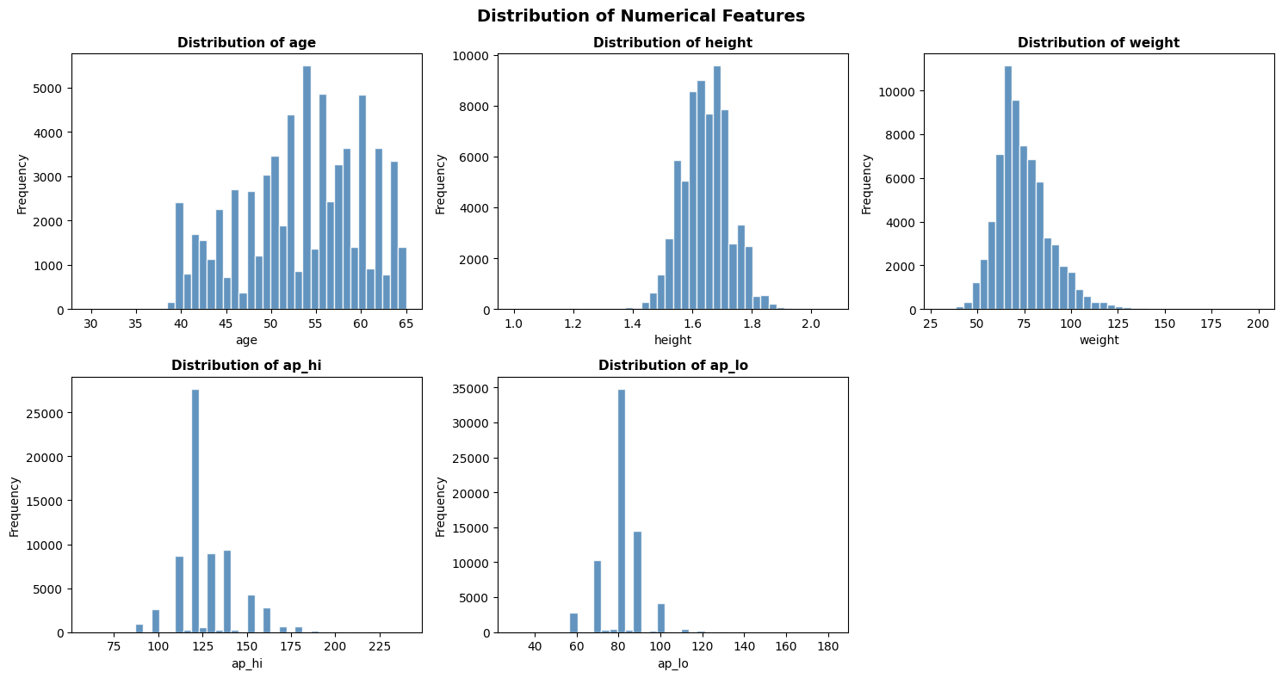
Figure 1. Distribution of numerical features after cleaning and unit conversion

6.2 Univariate Analysis — Categorical Features
Across the categorical and binary fields, the sample is broadly typical of a general screening population rather than a pre-selected high-risk group: roughly 65% of records are coded gender 0 and 35% gender 1; the large majority of patients report normal cholesterol and glucose levels; smoking (~9%) and alcohol use (~5%) are minority behaviours; and about 80% of patients report being physically active. The target class, cardio, is close to evenly split, examined next.
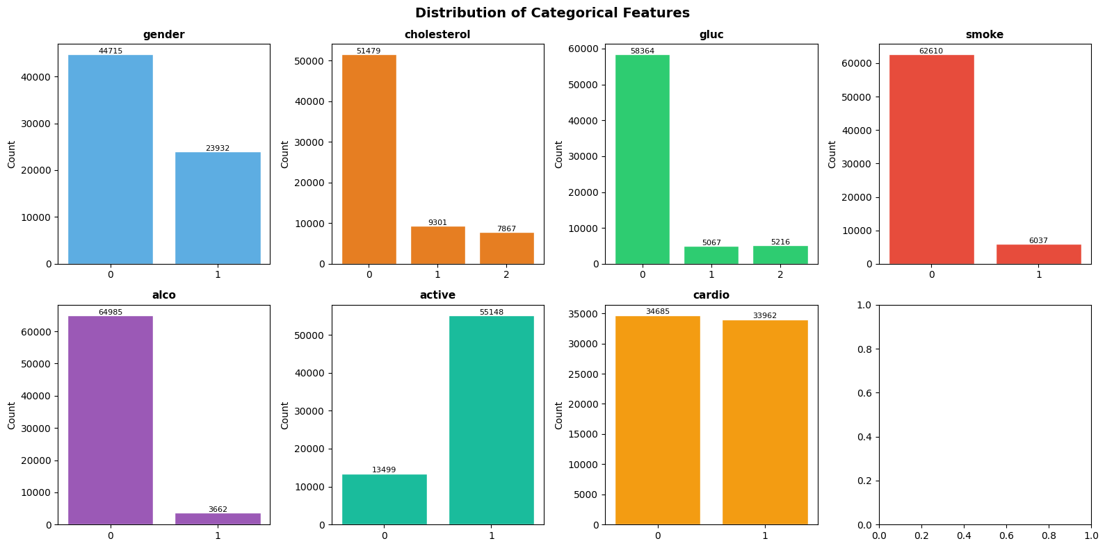
Figure 2. Distribution of categorical features

6.3 Target Class Distribution
The target is close to perfectly balanced: 34,685 patients without CVD (50.5%) versus 33,962 with CVD (49.5%). This is favourable for modelling — no class-imbalance correction such as re-sampling or class weighting was required, and plain accuracy remains a meaningful metric alongside precision, recall and ROC-AUC.
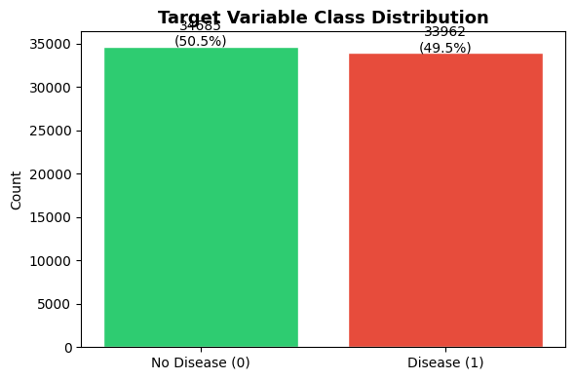
Figure 3. Target variable (cardio) class distribution

6.4 Correlation Analysis
A Pearson correlation matrix of the five numerical features against one another shows that ap_hi and ap_lo are strongly correlated with each other (r = 0.734), which is expected physiologically since systolic and diastolic pressure move together. Age shows a modest positive relationship with both blood-pressure readings (r = 0.209 with ap_hi, r = 0.156 with ap_lo), and height and weight show a moderate relationship (r = 0.302) that motivates the BMI feature introduced in Section 7.2.
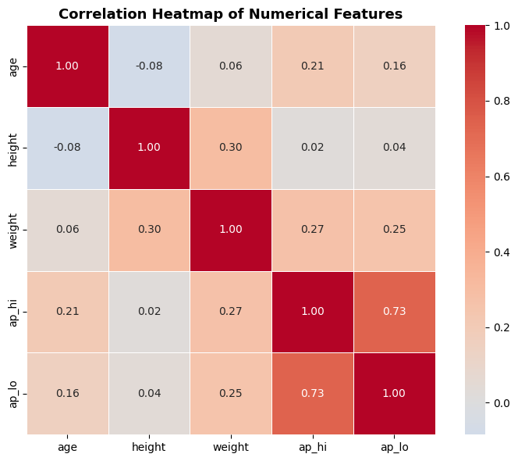
Figure 4. Correlation heatmap of numerical features
Table 4. Pearson correlation matrix — numerical features
 | age | height | weight | ap_hi | ap_lo
age | 1.000 | −0.084 | 0.055 | 0.209 | 0.156
height | −0.084 | 1.000 | 0.302 | 0.018 | 0.036
weight | 0.055 | 0.302 | 1.000 | 0.271 | 0.253
ap_hi | 0.209 | 0.018 | 0.271 | 1.000 | 0.734
ap_lo | 0.156 | 0.036 | 0.253 | 0.734 | 1.000

6.5 Bivariate Analysis — Categorical Features vs. CVD
Grouping the cardio rate by each categorical feature reveals which lifestyle and clinical-history fields actually separate the two classes:
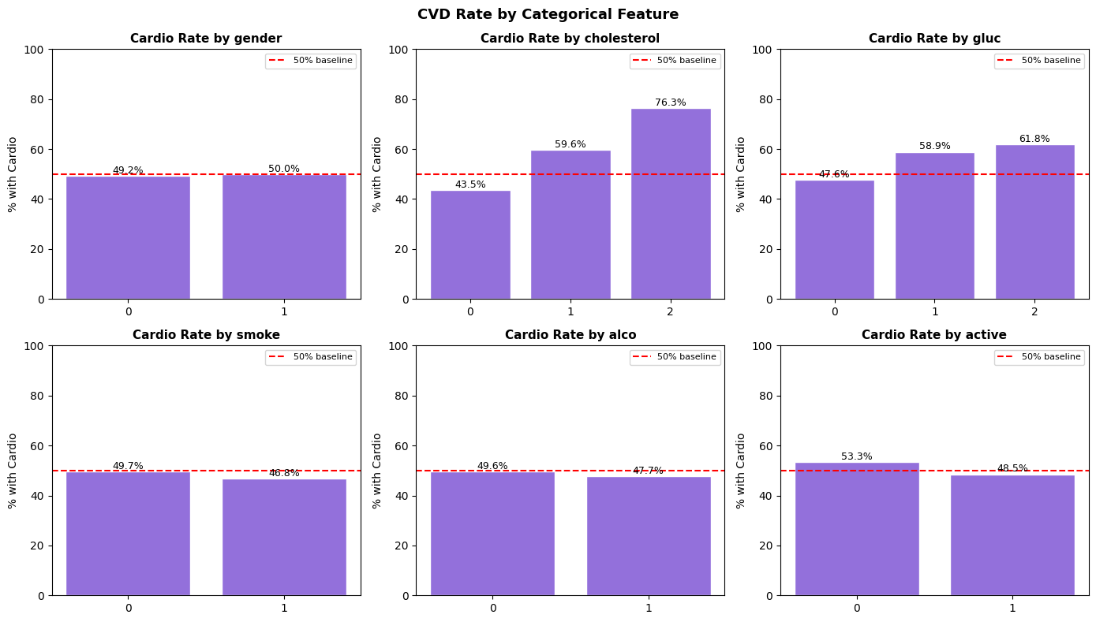
Figure 5. CVD prevalence rate (%) by categorical feature
Table 5. CVD prevalence (%) by categorical feature level
Feature | Level | CVD prevalence (%)
Cholesterol | 0 / 1 / 2 | 43.5 / 59.6 / 76.3
Glucose | 0 / 1 / 2 | 47.6 / 58.9 / 61.8
Physical activity | 0 (inactive) / 1 (active) | 53.3 / 48.5
Smoking | 0 (no) / 1 (yes) | 49.7 / 46.8
Alcohol | 0 (no) / 1 (yes) | 49.6 / 47.7
Gender | 0 / 1 | 49.2 / 50.0

Key reading: cholesterol is the strongest categorical predictor by a wide margin — a 32.8 percentage-point gap between the normal (43.5%) and well-above-normal (76.3%) groups. Glucose shows a smaller but consistent gradient. Physical activity has a mild protective association (53.3% vs. 48.5%). Gender, smoking and alcohol intake all sit within a few points of the 49.5% baseline rate and carry little standalone predictive signal in this sample — smokers even show a slightly lower CVD rate than non-smokers, most plausibly a confounding effect (e.g. a younger age profile among smokers in this sample) rather than a genuine protective effect, and is not a finding to act on clinically without further investigation.

6.6 Bivariate Analysis — Numerical Features vs. CVD
Splitting each numerical feature’s distribution by CVD status shows the clearest separation for blood pressure: patients with CVD are systematically shifted toward higher ap_hi and ap_lo readings than patients without. Age shows a visible, if less dramatic, rightward shift among CVD-positive patients. Height shows almost no separation between the two groups, consistent with its near-zero correlation with the target in Section 6.4.
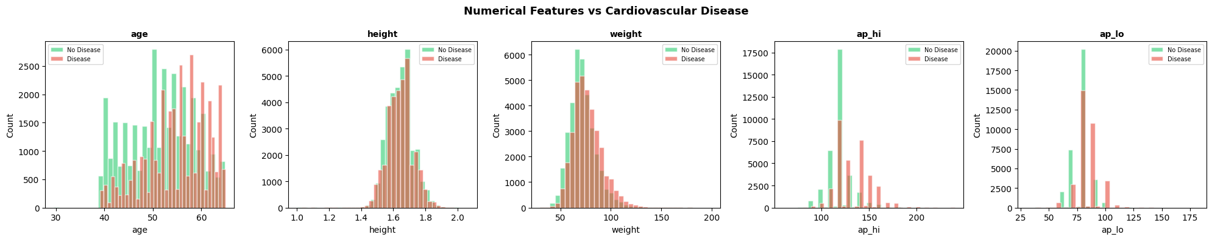
Figure 6. Distribution of numerical features split by CVD status

7. Feature Engineering and Train–Test Split

7.1 Train–Test Split
Features (all columns except cardio) and the target were separated, then split 70/30 into training and test sets using stratified sampling on the target with a fixed random seed (random_state=42), preserving the ~49.5% positive rate in both partitions and making the split reproducible.
Table 6. Train / test split summary
Set | Rows | CVD-negative | CVD-positive
Train | 48,052 | 24,279 | 23,773
Test | 20,595 | 10,406 | 10,189

7.2 BMI Feature and Multicollinearity
A new feature, BMI = weight (kg) ÷ height (m)², was derived using the standard clinical formula (train-set BMI: mean 27.46, median 26.35, range 10.73–133.13). Re-running the correlation analysis with BMI included showed it is very strongly correlated with weight (r = 0.856, by construction) and moderately correlated with height (r = −0.214). To avoid feeding the models three overlapping signals for essentially the same information, the raw height and weight columns were dropped once BMI was created, leaving BMI as the single combined body-composition feature.
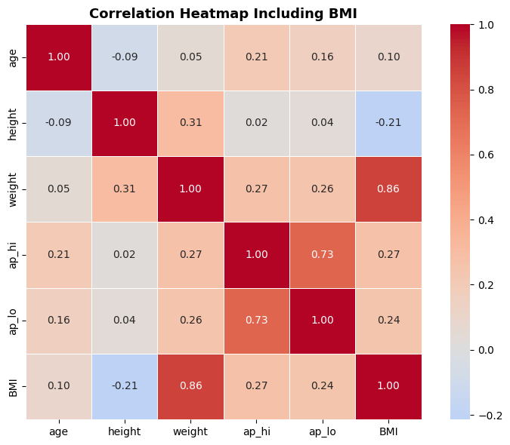
Figure 7. Correlation heatmap including the engineered BMI feature

7.3 Combining Low-Frequency Categories
Cholesterol and glucose each carry three levels (0 = normal, 1 = above normal, 2 = well above normal), and in the training data the "above normal" and "well above normal" levels are both markedly less frequent than "normal" (cholesterol: 35,945 / 6,522 / 5,585; glucose: 40,797 / 3,606 / 3,649). Levels 1 and 2 were merged into a single "elevated" category for each feature, giving a simpler and better-populated binary signal (cholesterol: 35,945 normal vs. 12,107 elevated; glucose: 40,797 normal vs. 7,255 elevated) while preserving the clear cardio-rate gradient documented in Section 6.5.

7.4 Dummy Variable Creation
gender, cholesterol and gluc were one-hot encoded with drop_first=True to avoid the dummy-variable trap. smoke, alco and active were left as-is since they are already binary 0/1 fields and need no further encoding. After encoding, the feature matrix has 10 columns: age, ap_hi, ap_lo, smoke, alco, active, BMI, gender_1, cholesterol_1, gluc_1. The training and test sets were aligned on these columns so that both carry an identical schema before scaling.

7.5 Feature Scaling
The four continuous numeric features (age, ap_hi, ap_lo, BMI) were scaled to a 0–1 range with MinMaxScaler, fitted on the training set only and then applied to the test set — this avoids leaking test-set information into the scaling parameters. The already-binary fields (smoke, alco, active, gender_1, cholesterol_1, gluc_1) were left unscaled. After scaling, the training set carries 48,052 rows × 10 columns and the test set 20,595 rows × 10 columns, ready for model building.

8. Model Building and Evaluation
Two models were built as required by the assignment — a Linear SVM and a Decision Tree — and the Decision Tree was then hyperparameter-tuned. A probability cutoff of 0.40 (rather than the default 0.50) was used throughout for both classifiers, chosen to favour recall/sensitivity: in a screening context, missing a true CVD case is costlier than one extra false alarm that a clinician can quickly rule out.

8.1 Linear SVM
A support vector classifier with a linear kernel (SVC(kernel=‘linear’, C=1.0, probability=True)) was trained. Because the SVM’s training time scales roughly quadratically with the number of rows, it was fitted on a random 15,000-row subsample of the 48,052-row training set (seed 42) rather than the full set; predictions and evaluation, however, were carried out on the complete 20,595-row test set.
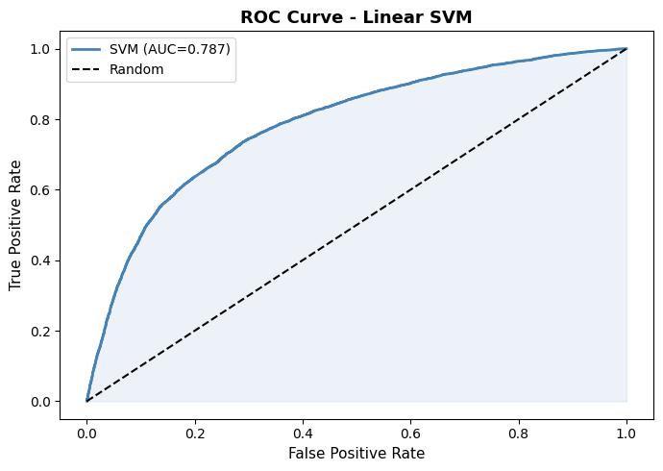
Figure 8. ROC curve — Linear SVM
A sweep of probability cutoffs from 0.10 to 0.90 shows sensitivity and specificity crossing near 0.43; a cutoff of 0.40 was chosen slightly below that crossover to bias the model toward catching more true CVD cases.
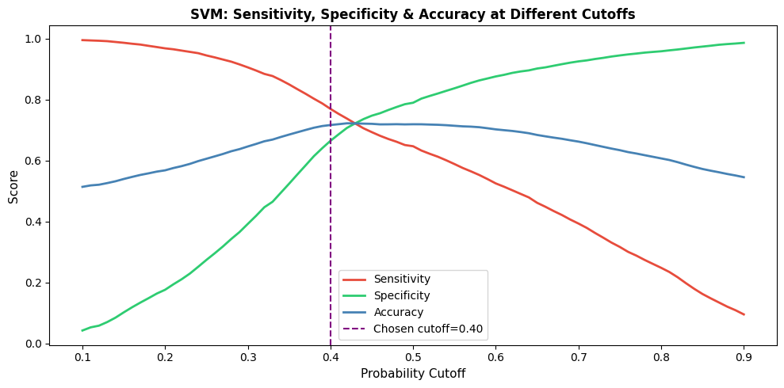
Figure 9. Linear SVM — sensitivity, specificity and accuracy across probability cutoffs
Table 7. Linear SVM performance at the selected 0.40 cutoff
Set | Accuracy | Recall | Precision | ROC-AUC
Train | 0.719 | 0.786 | — | 0.787
Test | 0.717 | 0.770 | 0.692 | 0.787

The train–test gap is minimal (accuracy 0.719 vs. 0.717, recall 0.786 vs. 0.770 — a gap of about 0.003 on accuracy), indicating the Linear SVM generalises well despite being trained on only a third of the available training rows. At the 0.40 cutoff it catches 77.0% of true CVD-positive patients on the test set.
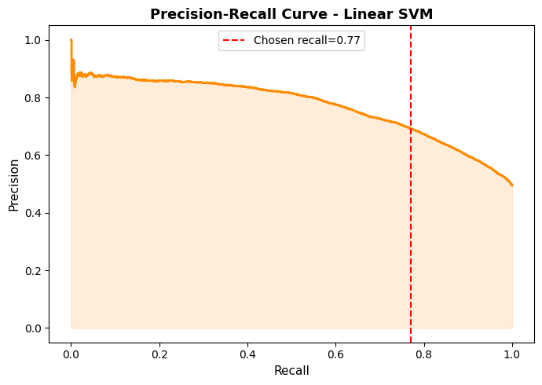
Figure 10. Precision–recall curve — Linear SVM

8.2 Decision Tree (Baseline)
An unconstrained DecisionTreeClassifier (default parameters, random_state=42) was fitted on the full training set. Left unconstrained, the tree grew to a depth of 55 with 14,942 leaves — in effect memorising the training data. Its feature importances (BMI 0.366, age 0.243, ap_hi 0.236, all others under 0.05 each) should be read with caution given the severe overfitting confirmed below.
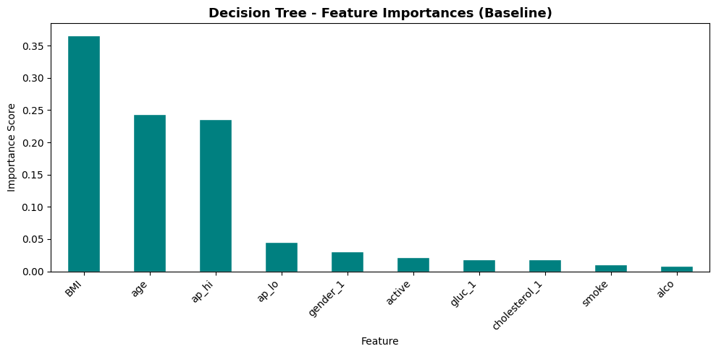
Figure 11. Decision Tree (baseline) feature importances
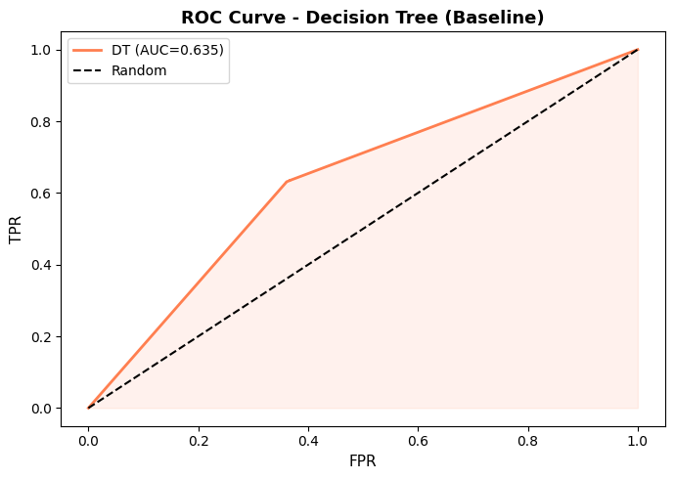
Figure 12. ROC curve — Decision Tree (baseline)
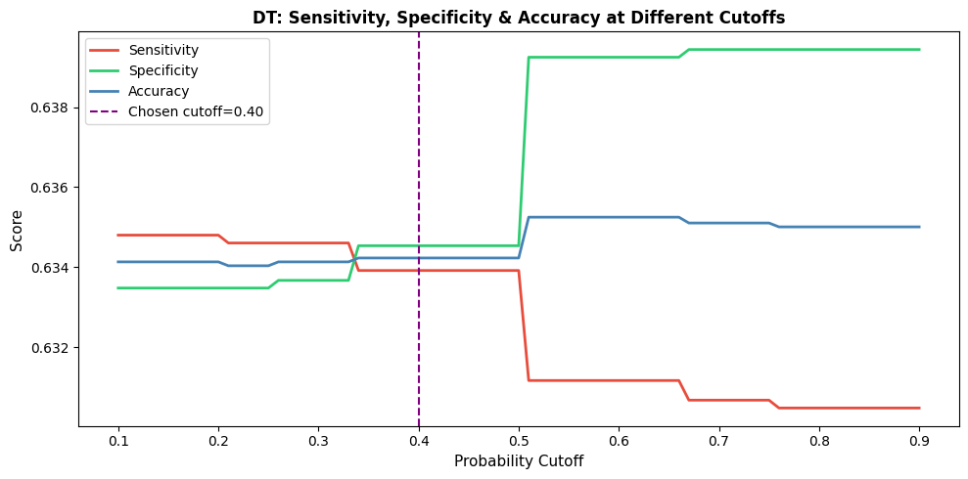
Figure 13. Decision Tree (baseline) — sensitivity, specificity and accuracy across probability cutoffs
Table 8. Decision Tree (baseline) performance — train vs. test
Set | Accuracy | Recall | ROC-AUC | Overfit gap
Train | 0.996 | 0.999 | ~1.00 | —
Test | 0.634 | 0.634 | 0.635 | 0.362 (accuracy)

Severe overfitting confirmed: training accuracy of 0.996 collapses to 0.634 on the test set — barely better than chance for a balanced target — and the cutoff sweep is essentially flat (~0.63–0.64 across every threshold from 0.10 to 0.90), because an unconstrained tree produces near-binary, poorly-calibrated probability estimates. The baseline tree is included for comparison only; hyperparameter tuning is essential and is addressed next.
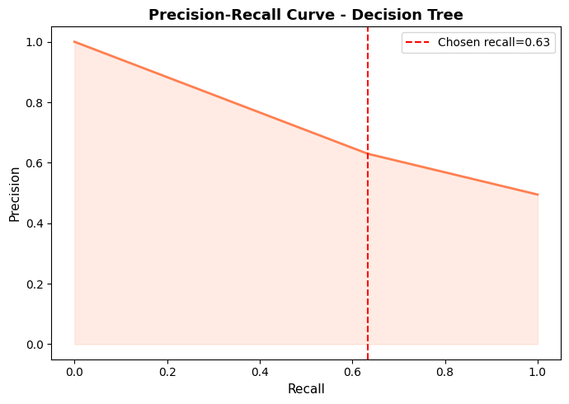
Figure 14. Precision–recall curve — Decision Tree (baseline)

8.3 Hyperparameter Tuning — Tuned Decision Tree
A 5-fold GridSearchCV was run over four Decision Tree hyperparameters, scoring on recall to align the search with the screening priority established for the cutoff choice:
Table 9. GridSearchCV parameter grid and best hyperparameters
Hyperparameter | Values searched | Best value
max_depth | [3, 5, 7, 10] | 10
min_samples_split | [20, 50, 100] | 100
min_samples_leaf | [10, 20, 50] | 20
max_features | [sqrt, log2] | sqrt
criterion | [gini, entropy] | gini

Best cross-validated recall: 0.688. The regularised tree (maximum depth 10, at least 100 samples to split a node, at least 20 samples per leaf) is far more constrained than the unconstrained baseline, and its feature importances shift substantially once overfitting is controlled:
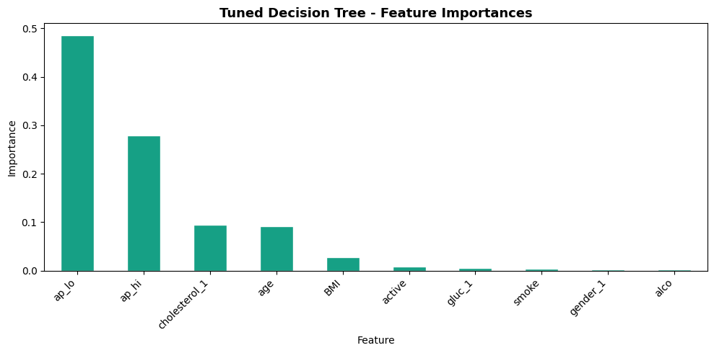
Figure 15. Tuned Decision Tree feature importances
Table 10. Tuned Decision Tree performance — train vs. test
Set | Accuracy | Recall | Precision | ROC-AUC
Train | 0.711 | 0.816 | — | —
Test | 0.700 | 0.802 | 0.663 | 0.781

Tuning resolves the overfitting problem: the train–test accuracy gap falls from 0.362 (baseline) to 0.011, and test ROC-AUC recovers from 0.635 to 0.781. At the 0.40 cutoff, the tuned tree also reaches the highest recall of all three candidates (0.802) — it catches just over 80% of true CVD-positive patients on unseen data. Blood pressure now dominates the tuned tree’s decisions (ap_lo 0.486, ap_hi 0.279 — together 76.5% of importance), followed by cholesterol (0.095) and age (0.091), a result that is both clinically intuitive and consistent with the correlation and bivariate findings in Section 6.

8.4 Final Model Comparison
All three candidates were evaluated on the same held-out test set at their respective operating points (0.40 cutoff for all three):
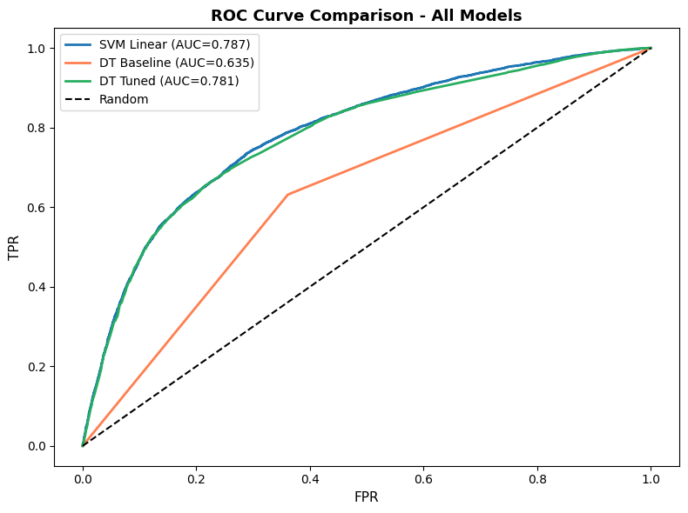
Figure 16. ROC curve comparison — all candidate models
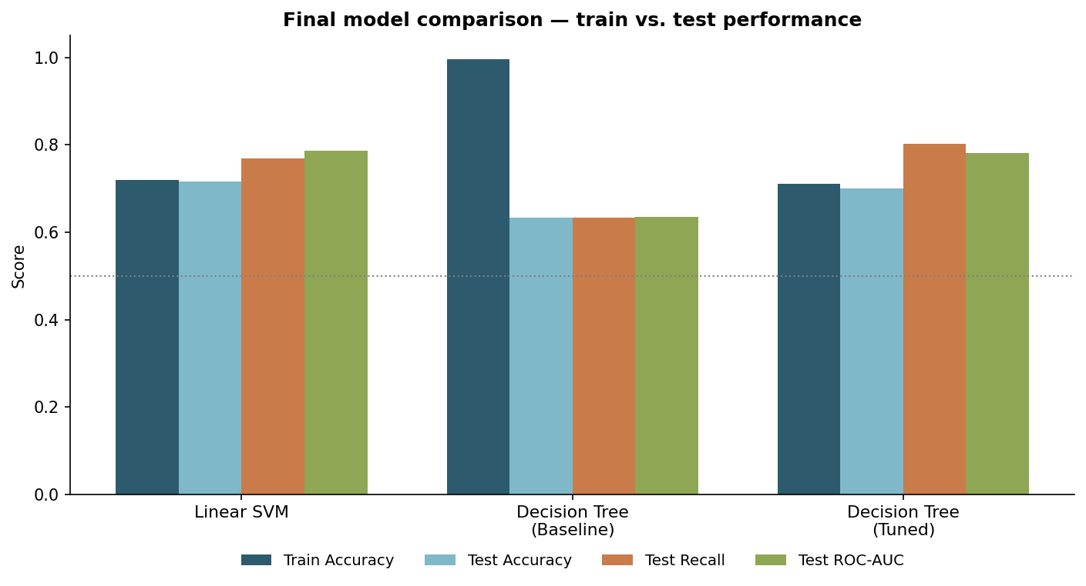
Figure 17. Final model comparison — accuracy, recall and ROC-AUC on the test set
Table 11. Final model comparison table (test set)
Model | Train Acc. | Test Acc. | Test Recall | Test ROC-AUC
Linear SVM | 0.719 | 0.717 | 0.770 | 0.787
Decision Tree (Baseline) | 0.996 | 0.634 | 0.634 | 0.635
Decision Tree (Tuned) | 0.711 | 0.700 | 0.802 | 0.781

The Linear SVM edges out the Tuned Decision Tree on raw ROC-AUC (0.787 vs. 0.781, a difference of 0.006), while the Tuned Decision Tree reaches noticeably higher recall (0.802 vs. 0.770). Given that the SVM was trained on less than a third of the available training data (a computational necessity, not a modelling choice) while the Tuned Decision Tree used the complete training set, the two models’ near-identical AUC suggests the gap would likely narrow further with a full-data SVM. Section 9 and Section 12 discuss why the Tuned Decision Tree is nonetheless the recommended candidate for deployment.

9. Model Cards
Model cards for all three candidates are presented below, following the template supplied with the assignment.
Model Card 1 — Linear SVM
Overview: Support vector classifier with a linear kernel for binary CVD risk classification.
Intended use: Clinical screening — flag high-risk patients for priority consultation.
Data and features: 10 engineered features (age, ap_hi, ap_lo, smoke, alco, active, BMI, gender_1, cholesterol_1, gluc_1); numeric features MinMax-scaled.
Configuration: kernel=linear, C=1.0, probability=True; cutoff=0.40; trained on a 15,000-row subsample of the training set.
Table 12. Model Card — Linear SVM
Set | Accuracy | Recall | Precision | ROC-AUC
Train | 0.719 | 0.786 | — | 0.787
Test | 0.717 | 0.770 | 0.692 | 0.787

Limitations: subsample training may not capture every pattern present in the full training set; a linear decision boundary may under-fit non-linear interactions between features; probability calibration on a subsample carries more variance than calibration on the full set.
Model Card 2 — Decision Tree (Baseline, Comparison Only)
Overview: Unconstrained DecisionTreeClassifier, included for comparison purposes only.
Status: NOT recommended for deployment — severe overfitting.
Table 13. Model Card — Decision Tree (Baseline)
Set | Accuracy | Recall | ROC-AUC
Train | 0.996 | 0.999 | ~1.00
Test | 0.634 | 0.634 | 0.635

Limitations: tree depth of 55 and 14,942 leaves indicate the model has essentially memorised the training set; test performance is barely above chance for a balanced target. Retained only as a baseline that motivates hyperparameter tuning.
Model Card 3 — Decision Tree (Tuned) — RECOMMENDED
Overview: Regularised Decision Tree tuned via 5-fold GridSearchCV, optimised for recall.
Intended use: Primary CVD screening/triage tool for CardioCare.
Configuration: criterion=gini, max_depth=10, max_features=sqrt, min_samples_leaf=20, min_samples_split=100; cutoff=0.40; trained on the full 48,052-row training set.
Table 14. Model Card — Tuned Decision Tree (Recommended)
Set | Accuracy | Recall | Precision | ROC-AUC
Train | 0.711 | 0.816 | — | —
Test | 0.700 | 0.802 | 0.663 | 0.781

Top features: ap_lo (0.486), ap_hi (0.279), cholesterol_1 (0.095), age (0.091), BMI (0.028).
Limitations: the tree remains sensitive to blood-pressure measurement quality since ap_lo and ap_hi together drive over three-quarters of its decisions; at the 0.40 cutoff roughly 20% of true CVD-positive patients are still missed; a single tree is less smooth than an ensemble and communicating its decision logic to clinicians still requires care.

10. Answers to the Assignment Questions
Q1. What insights can we gain from exploring the relationships between different health metrics and the prevalence of cardiovascular disease?
- Blood pressure is the clearest numerical signal: patients with CVD show a systematically higher distribution of both systolic (ap_hi) and diastolic (ap_lo) readings than patients without (Section 6.6), and ap_hi/ap_lo correlate with each other at r = 0.734 (Section 6.4).
- Cholesterol is the strongest categorical signal: CVD prevalence rises from 43.5% (normal) to 59.6% (above normal) to 76.3% (well above normal) — a 32.8 percentage-point spread (Section 6.5).
- Glucose shows a smaller but consistent gradient (47.6% → 58.9% → 61.8%), and physical activity shows a mild protective association (53.3% inactive vs. 48.5% active).
- Age shows a visible rightward shift in the CVD-positive group’s distribution, while height carries almost no relationship with CVD status.
- Gender, smoking and alcohol intake sit within a few percentage points of the 49.5% base rate and are weak standalone predictors in this dataset.
Q2. Which patient characteristics emerge as the strongest predictors of CVD risk? Are there any surprising or unexpected findings?
Per the tuned Decision Tree’s feature importances (Section 8.3), diastolic blood pressure (ap_lo, 48.6%) and systolic blood pressure (ap_hi, 27.9%) together account for 76.5% of the model’s decisions, with cholesterol level (9.5%) and age (9.1%) contributing most of the remainder; BMI, physical activity, glucose, smoking, gender and alcohol each contribute under 3%.
Surprising finding: smokers (46.8% CVD rate) and alcohol users (47.7%) show a slightly lower CVD prevalence than non-users (49.7% and 49.6% respectively) — the opposite of established clinical evidence. This most likely reflects confounding within the sample (for example, a younger or otherwise different risk profile among patients who smoke or drink) rather than a genuine protective effect, and should be discussed with CardioCare’s clinicians before being treated as a real association or built into any triage logic. The dominance of blood pressure and the near-zero importance of gender are also worth flagging — the model relies on a narrow slice of the available fields.
Q3. How effectively can machine learning models identify individuals at risk of developing cardiovascular disease? How does the evaluation vary across models?
- The two well-regularised candidates — the Linear SVM and the Tuned Decision Tree — both reach a test ROC-AUC around 0.78–0.79, meaningfully above the 0.50 random baseline, and are broadly effective for triage purposes at that level of discrimination.
- The unconstrained baseline Decision Tree illustrates how badly an untuned model can perform on unseen data: test ROC-AUC collapses to 0.635, only slightly better than chance, despite near-perfect training accuracy — a clear demonstration that model choice alone is not enough without proper regularisation.
- At the shared 0.40 cutoff, the two regularised models differ mainly in the accuracy/recall trade-off: the SVM is slightly more accurate (0.717 vs. 0.700) while the Tuned Decision Tree catches more true CVD cases (recall 0.802 vs. 0.770).
- None of the three candidates is precise enough to serve as a standalone diagnostic tool — all are best understood as a triage aid that directs clinical attention, not a replacement for clinical assessment.
Q4. How can CardioCare integrate the predictive model into their existing healthcare workflows to enhance preventative care strategies?
- Deploy the Tuned Decision Tree as a pre-consultation screening filter: new patients’ routine check-up data is scored automatically, and patients flagged above the 0.40 probability cutoff are routed to priority consultation.
- Treat the cutoff as a deliberate operating decision, not a fixed default — lowering it further would catch more true cases at the cost of more false alarms for a clinician to quickly rule out; raising it would do the reverse.
- Protect the quality of blood-pressure measurement at intake: since ap_lo and ap_hi together drive over three-quarters of the tuned model’s decisions, standardised, well-calibrated BP measurement disproportionately drives prediction quality.
- Communicate a risk score together with its main contributing factors (e.g. “elevated blood pressure and cholesterol”) rather than a bare flag, so clinicians can sanity-check and act on it.
- Monitor the false-negative rate in production — at the current cutoff roughly 20% of true CVD-positive patients may still be missed — and maintain a secondary clinical review step rather than relying on the model alone.
- Retrain periodically as the patient population evolves, and prioritise collecting richer features (e.g. ECG results, family history, HbA1c) that could push ROC-AUC materially above the current ~0.78–0.79 ceiling.
- Investigate the counter-intuitive smoking/alcohol associations (Q2) with clinical staff before allowing them to influence any triage logic.

11. Assumptions Made
The assumptions below were made while building the analysis pipeline. Each is traceable to a specific step in the reference notebook.
- Unnamed: 0 and id are pure row/record identifiers with no predictive value, and were dropped rather than used as features (Section 5.1).
- Rows with systolic or diastolic blood pressure outside 30–300 mmHg, diastolic exceeding systolic, height outside 100–220 cm, or weight outside 30–200 kg are treated as data-entry errors and removed outright (1,353 rows, 1.9%) rather than corrected or imputed (Section 5.2).
- Age is assumed to be recorded in days in the source file and was converted to years by dividing by 365 (Section 5.3).
- Height is assumed to be recorded in centimetres and was converted to metres for a standard BMI calculation (Section 5.3).
- No missing-value imputation was required: df.info() confirmed zero nulls across all 70,000 rows and every column (Section 5.1).
- The "above normal" and "well above normal" levels of cholesterol and glucose are assumed to both represent a clinically elevated state relative to "normal", and were merged into a single "elevated" category to reduce sparsity in the rarer levels (Section 7.3).
- BMI is assumed to add information beyond height and weight individually; both raw features were dropped once BMI was derived, on the basis that BMI’s very high correlation with weight (r = 0.856) meant retaining all three would have been redundant (Section 7.2).
- smoke, alco and active are assumed to already be in a directly usable binary (0/1) form and were not one-hot encoded; only gender, cholesterol and gluc were dummy-encoded (Section 7.4).
- MinMaxScaler was fitted on the training set only and then applied to the test set, on the standard assumption that the test set does not contain values far outside the training range (Section 7.5).
- A 70/30 stratified split with a fixed random seed (random_state=42) is assumed to give a representative, reproducible estimate of test performance for a dataset of this size (Section 7.1).
- The SVM was trained on a random 15,000-row subsample of the training set (seed 42), assumed to be a representative sample sufficient to fit a stable linear decision boundary, given the quadratic time complexity of the SVC kernel computation on the full 48,052-row set (Section 8.1).
- A probability cutoff of 0.40 (rather than the default 0.50) was assumed appropriate for both the SVM and the Decision Tree, favouring recall/sensitivity over specificity — a reasonable default for a clinical screening context where missing a true CVD case is assumed to be costlier than one additional false alarm (Section 8, throughout).
- GridSearchCV hyperparameter tuning was scored on recall rather than accuracy or ROC-AUC, to keep the tuning objective consistent with the screening priority behind the cutoff choice (Section 8.3).
- An RBF-kernel SVM and a third, optional candidate model were not pursued, on the assumption that the assignment’s two required core models (Linear SVM, Decision Tree) plus hyperparameter tuning would give a sufficiently informative comparison within reasonable computational limits on a 48k-row training set (Section 8.3).

12. Conclusions and Recommendations
12.1 EDA Insights and Feature Engineering
- 1,353 rows (1.9%) were removed for invalid physiological values; age was converted from days to years and height from centimetres to metres.
- The target is near-perfectly balanced (50.5% / 49.5%), so no resampling was needed.
- Cholesterol is the strongest categorical predictor (76.3% CVD rate at well-above-normal vs. 43.5% at normal); blood pressure shows the clearest numerical separation between CVD and non-CVD patients.
- Gender, smoking and alcohol carry minimal standalone predictive signal (all within a few points of the 49.5% base rate); smoking and alcohol even show a mildly counter-intuitive negative association, most likely confounding rather than a real protective effect.
- BMI was engineered from height and weight, and both raw features were then dropped (BMI–weight r = 0.856) to avoid feeding the models three overlapping signals; cholesterol and glucose’s rare upper categories were merged to reduce sparsity.
12.2 Model Performance and Overfitting
- The baseline Decision Tree overfits severely: train accuracy ~1.00 versus test accuracy 0.634 — a textbook consequence of leaving a tree unconstrained.
- The Linear SVM generalises well without any special regularisation: train and test accuracy are both ~0.72 (a gap of about 0.003), with test ROC-AUC 0.787.
- Hyperparameter tuning resolves the Decision Tree’s overfitting: constraining max_depth to 10 (with matching min_samples_split/leaf constraints) cuts the train–test accuracy gap from 0.362 to 0.011 and lifts test ROC-AUC from 0.635 to 0.781, while also delivering the highest test recall of the three candidates (0.802).
12.3 Was the Data Sufficient? Is a Linear Model Sufficient?
At 68,647 clean rows with a near-balanced target, the dataset is large enough to fit and reliably evaluate all three candidates, and the close agreement between train and test metrics for the two regularised models supports that the sample size is adequate for this feature set. The Linear SVM (ROC-AUC 0.787) and the Tuned Decision Tree (ROC-AUC 0.781) converge to almost the same discrimination ability, which suggests a linear decision boundary already captures most of the usable signal in these ten features, and that a well-regularised non-linear model adds only a small, incremental change — here, a recall gain rather than an AUC gain. Meaningfully higher performance would likely require richer clinical features (ECG results, family history, HbA1c) rather than a more complex model fit to the current fields.
12.4 Final Model Recommendation
The Tuned Decision Tree is recommended as CardioCare’s primary CVD screening model, for five reasons: (1) it reaches the highest test recall of all three candidates (0.802), catching the largest share of true CVD-positive patients; (2) its ROC-AUC (0.781) is close to the Linear SVM’s (0.787) while being trained on the full 48,052-row training set rather than a 15,000-row subsample; (3) its overfitting is well controlled (train–test gap of 0.011); (4) a single decision tree remains interpretable, so clinicians can review why a given patient was flagged; and (5) its leading features — blood pressure and cholesterol — are clinically meaningful and actionable.
12.5 Recommendations for CardioCare
- Deploy the Tuned Decision Tree as a first-line, automated screening filter for new patient check-ups.
- Flag patients with predicted CVD probability ≥ 0.40 for priority physician consultation.
- Maintain a secondary clinical review step — at this cutoff, roughly 20% of true CVD-positive patients may still be missed.
- Retrain the model periodically (e.g. quarterly) as the patient population and its risk profile evolve.
- Invest in collecting additional clinical features (ECG, family history, HbA1c) to push ROC-AUC materially above the current ~0.78–0.79 ceiling.
- Monitor the model’s calibration and false-negative rate in production, and revisit the 0.40 cutoff if the operational cost of a missed case or a false alarm changes.

13. References
Bulah, M. (2026). CardioRisk Prediction — Model Selection Assignment. Source notebook, dataset and this report: https://github.com/bulah16/C6-Project.
Pedregosa, F. et al. (2011). Scikit-learn: Machine Learning in Python. Journal of Machine Learning Research, 12, 2825–2830.
McKinney, W. (2010). Data Structures for Statistical Computing in Python. Proceedings of the 9th Python in Science Conference.
Hunter, J. D. (2007). Matplotlib: A 2D Graphics Environment. Computing in Science & Engineering, 9(3), 90–95.
Waskom, M. (2021). seaborn: statistical data visualization. Journal of Open Source Software, 6(60), 3021.

Appendix A: Detailed Performance Metrics
This appendix reproduces the full classification reports and cutoff-sweep detail summarised in Section 8, for reference.
A.1 Linear SVM — classification report @ 0.40 cutoff (test set)
Class | Precision | Recall | F1-score | Support
0 (No CVD) | 0.75 | 0.66 | 0.70 | 10,406
1 (CVD) | 0.69 | 0.77 | 0.73 | 10,189
Accuracy |  |  | 0.72 | 20,595

A.2 Decision Tree (Baseline) — classification report @ 0.40 cutoff (test set)
Class | Precision | Recall | F1-score | Support
0 (No CVD) | 0.64 | 0.63 | 0.64 | 10,406
1 (CVD) | 0.63 | 0.63 | 0.63 | 10,189
Accuracy |  |  | 0.63 | 20,595

A.3 Tuned Decision Tree — classification report @ 0.40 cutoff (test set)
Class | Precision | Recall | F1-score | Support
0 (No CVD) | 0.76 | 0.60 | 0.67 | 10,406
1 (CVD) | 0.66 | 0.80 | 0.73 | 10,189
Accuracy |  |  | 0.70 | 20,595

A.4 Linear SVM cutoff sweep (selected values, test set)
Cutoff | Sensitivity | Specificity | Accuracy
0.30 | 0.906 | 0.392 | 0.646
0.40 (selected) | 0.770 | 0.665 | 0.717
0.43 (crossover) | 0.722 | 0.722 | 0.722
0.50 | 0.647 | 0.790 | 0.719
0.60 | 0.525 | 0.876 | 0.703

Appendix B: Reproducibility and Source Code
All source files for this assignment — the Jupyter notebook, the raw dataset, and this report — are available in the following GitHub repository:
https://github.com/bulah16/C6-Project
The analysis notebook (CardioRisk_Prediction_MBulah.ipynb) can also be opened directly in Google Colab via:
https://colab.research.google.com/github/bulah16/c6-assignment/blob/main/CardioRisk_Prediction_MBulah.ipynb
B.1 Environment
- Python 3, pandas, numpy, scikit-learn, matplotlib, seaborn
- Dataset: health_data.csv, loaded directly from the GitHub repository above
- Random seeds fixed throughout (random_state=42 for the train–test split and both classifiers; seed 42 for the SVM training subsample) for reproducibility
B.2 Author
M. Bulah — all analysis, code and written content in this report and the accompanying notebook are the author’s own original work produced for this assignment.

Appendix C: Glossary of Terms
Term | Meaning
AUC / ROC-AUC | Area Under the Receiver Operating Characteristic curve; the probability a model ranks a random positive case above a random negative case (0.5 = chance, 1.0 = perfect).
BMI | Body Mass Index = weight (kg) ÷ height (m)²; a standard clinical measure of body composition.
CVD | Cardiovascular Disease — the target condition this model predicts.
Cutoff / threshold | The probability value above which a patient is classified as CVD-positive; 0.40 was used throughout this analysis.
GridSearchCV | A scikit-learn utility that exhaustively tries every combination in a hyperparameter grid, using cross-validation to score each.
Overfitting | When a model fits the training data (including its noise) so closely that it fails to generalise to new, unseen data.
Precision | Of the patients predicted CVD-positive, the share who are actually positive.
Recall / Sensitivity | Of the patients who are actually CVD-positive, the share the model correctly identifies.
Specificity | Of the patients who are actually CVD-negative, the share the model correctly identifies.
SVM / SVC | Support Vector Machine / Support Vector Classifier — a model that finds the boundary that best separates two classes.

