COTEMS-National
Campus Occupant Tracking & Emergency Mustering System
A Fiji-Wide, Multi-Campus Design for Fiji National University
System Design Report
Prepared for CIN815 — Postgraduate Diploma in Information Systems
Fiji National University

1. Executive Summary
Fiji National University (FNU) operates across multiple campuses spanning the Central, Western, and Northern divisions of Fiji, including Nasinu (headquarters), Nasese, Koronivia, Pasifika, Namaka (Nadi), Natabua (Lautoka), Ba, and Labasa. Each campus currently relies on manual sign-in sheets or no occupancy record at all, and emergency roll calls are conducted by physical headcount — a process that can take 15–40 minutes per building and is prone to error and omission.
COTEMS-National extends the original single-campus COTEMS concept into a Fiji-wide system. A Campus Warden registers each student and staff member once, and the system generates their unique FNU ID QR code automatically at that moment. From then on, every student and staff member checks in and out of buildings by scanning that QR code at building entrances. This produces a live, continuously updated occupancy record for every building, on every campus, which is used for two purposes: (1) day-to-day Occupational Health & Safety (OHS) and space-utilisation visibility, and (2) an instant, accurate muster roll the moment a fire drill or real emergency is declared — on a single campus or, if required, nationally.
This report sets out the system's scope, actors, data model, workflows (AS-IS and TO-BE), deployment architecture, and a phased implementation plan. It accompanies a working HTML prototype (cotems-national-system.html) and supporting diagrams.

2. Problem Statement
- Manual attendance/sign-in registers are slow to complete and slow to consolidate during an emergency.
- Wardens have no live view of who is inside a building at the moment an alarm sounds.
- There is no national view: OHS and Security leadership at HQ cannot see occupancy or emergency status across campuses simultaneously.
- Visitor and contractor presence is often untracked entirely, creating a mustering blind spot.
- Paper-based roll call records are not searchable, cannot be audited, and are easily lost.

3. Scope

3.1 Campuses covered
The system is designed to operate identically across all major FNU campuses, so that the same QR-based process works for any student or staff member at any location:
Campus | Division | Notes
Nasinu Campus | Central | University HQ; VC's Office; CBHTS & CHE colleges
Nasese Campus | Central | Postgraduate / EMBA centre
Koronivia Campus | Central | College of Agriculture, Fisheries & Forestry
Pasifika Campus | Central | Suva teaching hub
Namaka Campus (Nadi) | Western | Hospitality & tourism training
Natabua Campus (Lautoka) | Western | School of Education; largest lecture theatre in Fiji (680 seats)
Ba Campus | Western | Outreach campus
Labasa Campus | Northern | Vanua Levu outreach campus

3.2 In scope
- Warden-driven registration of students and staff, with the FNU ID QR code generated automatically at the moment of registration
- QR-based check-in / check-out for students and staff at building entrances, via camera scan or manual FNU ID entry fallback
- A searchable registered-persons directory per campus, with the ability to re-download or reprint any person's QR code
- Live occupancy dashboards per room, building, campus, and nationally
- Emergency declaration and live muster roll per campus
- National OHS/Security command view across all campuses
- Audit logging of all registration, check-in, check-out, and emergency actions

3.3 Out of scope (this phase)
- Visitor/contractor self-registration kiosks (visitors are registered by the warden in this phase, using the same workflow as staff)
- Turnstile / physical access control integration (future phase)
- Integration with the student information system (SIS) for automatic enrolment sync (future phase)
- CCTV or biometric identity verification

4. Actors
Actor | Description
Student / Staff | Is registered once by a Campus Warden; from then on, scans their auto-generated FNU ID QR code (or enters their ID number as a fallback) to check in/out of a building
Campus Warden | OHS-designated role per campus; registers new students/staff and triggers automatic QR code generation; declares/clears emergencies; manages the muster roll; maintains the registered persons directory
Campus Security | Physically verifies unaccounted persons during an emergency
National OHS Command (HQ) | Nasinu-based oversight role with read access to all campuses; coordinates multi-campus incidents
System Administrator | Manages buildings, rooms, muster points, and warden accounts

5. AS-IS vs TO-BE

5.1 AS-IS (manual process)
- Students/staff sign a paper register or are not tracked at all
- Where ID cards exist, they carry no scannable code tied to a live system — QR codes, where used at all, are produced separately by an ID office or print shop
- On alarm, wardens manually shout roll or check paper lists room by room
- Security physically walks buildings to confirm they are clear
- Headcount is reconciled by radio/phone call between building wardens and campus security — typically 15–40 minutes
- No cross-campus visibility; each campus operates in isolation

5.2 TO-BE (COTEMS-National)
- A Campus Warden registers each student/staff member once, in the warden's own account; the system generates a unique QR code automatically at that moment — no ID office visit, no separate card printer
- Students/staff scan that QR at building entry/exit (or enter their FNU ID number as a fallback); the system maintains a live occupant list per room and building
- On emergency declaration, the system freezes the current occupant list into a muster roll automatically
- Occupants assemble at a designated muster point and confirm presence to the warden
- The warden's dashboard highlights unaccounted persons in real time; security is dispatched only to check specific outstanding locations
- National OHS Command sees every campus's status simultaneously and can coordinate a multi-campus response if needed
- Every action — registration, check-in, check-out, emergency declaration, accounting — is timestamped and logged for audit

6. Registration & QR Issuance Workflow
The defining change from the original COTEMS concept is where the QR code comes from. Rather than assuming students already hold a pre-printed QR card, COTEMS-National makes registration itself part of the system: a Campus Warden enters a new student's or staff member's details directly into their warden account, and the system generates a unique QR code automatically, ready to download or print on the spot. This removes any dependency on a separate ID office, card printer, or manual code allocation, and keeps a full audit trail of who registered whom, when, and at which campus.
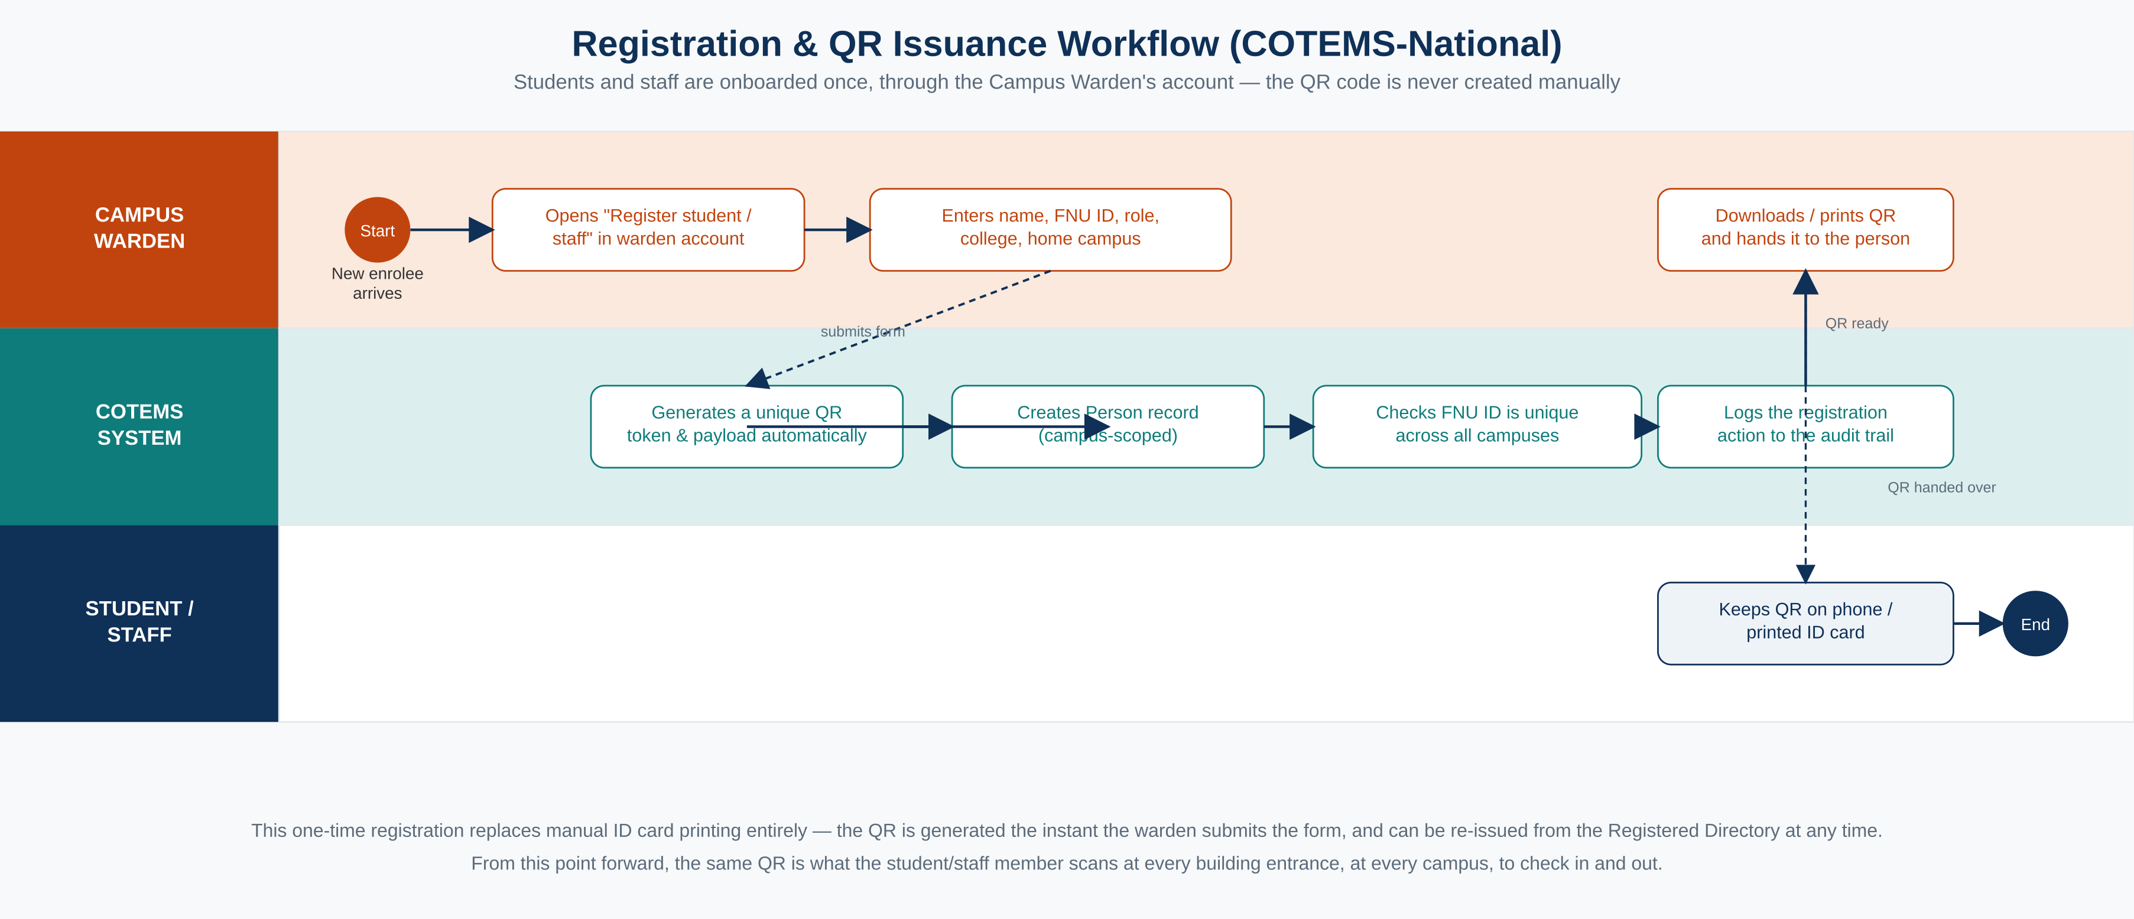
Figure 1. Registration and QR issuance workflow — from warden data entry to a scannable QR in the student's hand.

6.1 What the generated QR encodes
Each QR code encodes a payload combining the person's FNU ID number with a unique, randomly generated token (for example, COTEMS|FNU20230012|TNXKE6JRMJ). The token — not the ID number alone — is what the check-in scanner matches against, so a QR code cannot be guessed or recreated from a known ID number alone.

6.2 Reprinting and lost cards
If a student loses their ID or QR code, the warden looks them up in the Registered Directory and reprints or re-downloads the same QR from their existing record — no re-registration is required.

7. Process Diagram — TO-BE Multi-Campus Emergency Mustering
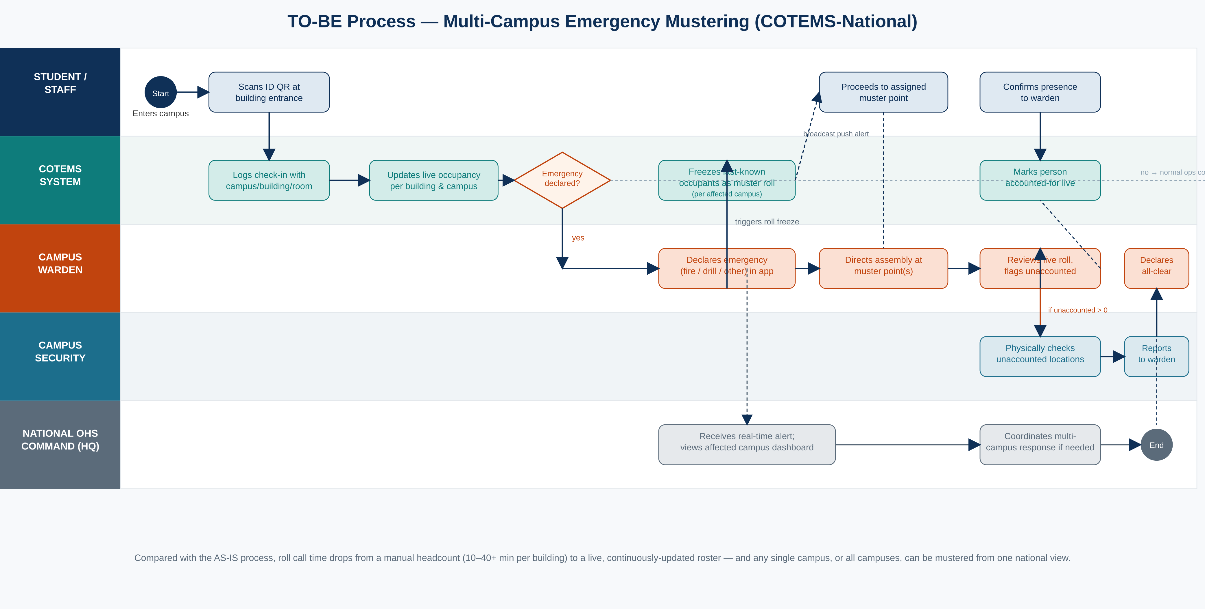
Figure 2. BPMN swimlane diagram of the TO-BE emergency mustering workflow across student/staff, the COTEMS system, campus warden, campus security, and National OHS Command.

8. Data Model
The data model extends the original single-campus schema with campus as a first-class dimension. Every operational record (building, room, check-in event, muster record) carries a campus_id, which is what allows the same schema to serve both a single campus warden view and the aggregated national view without duplicating logic. Person records now also carry the fields needed for warden-driven registration: a unique QR token/payload generated at registration, and who registered the person and when.
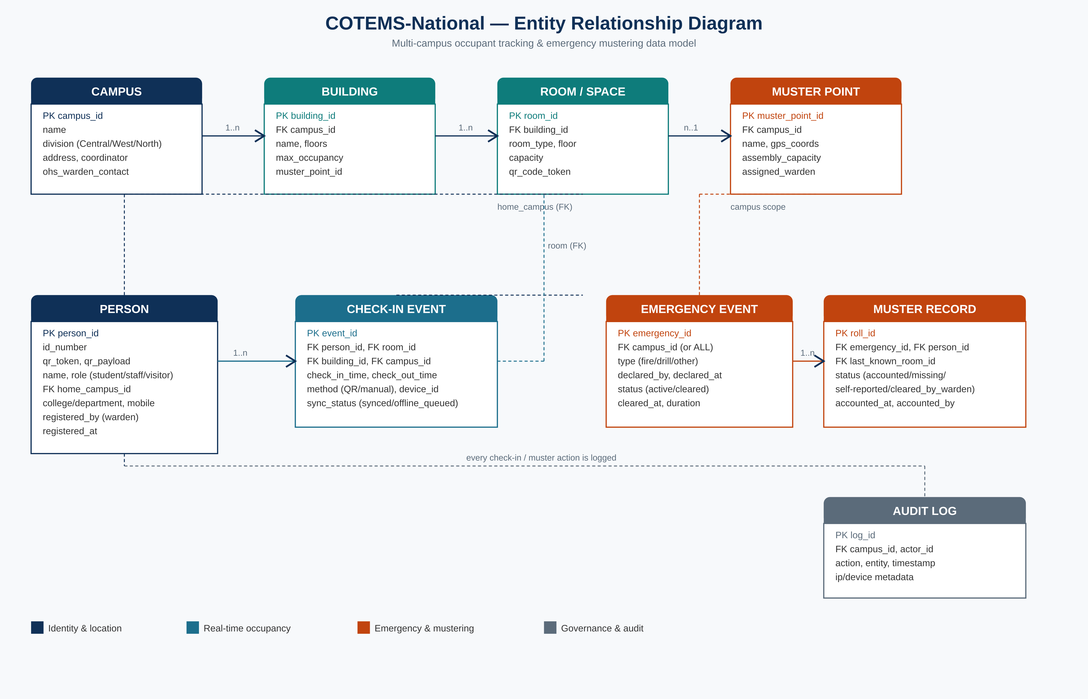
Figure 3. Entity-relationship diagram for COTEMS-National.

8.1 Core entities
Entity | Purpose
Campus | One of the 8 FNU campuses; groups buildings and muster points
Building | A physical building within a campus; has a max occupancy and an assigned muster point
Room / Space | A tracked room, lecture theatre, lab, or office within a building; has a QR-readable entry point
Person | A student, staff member, or visitor; linked to a home campus, a unique qr_token/qr_payload generated at registration, and the warden who registered them
Check-in Event | One QR scan-in/out pairing; records person, room, building, campus, and timestamps
Emergency Event | A declared fire/drill/other incident, scoped to one campus or nationally
Muster Record | One person's status within an Emergency Event's frozen roll (accounted / unaccounted)
Audit Log | Immutable record of every registration, check-in, check-out, and emergency-related action

9. Deployment & Network Architecture
Because campuses are geographically dispersed across Viti Levu and Vanua Levu with varying connectivity, COTEMS-National is designed local-first: each campus runs a lightweight edge cache so that QR check-in/out and emergency mustering continue to function during an internet outage, syncing to the national cloud platform once connectivity is restored.
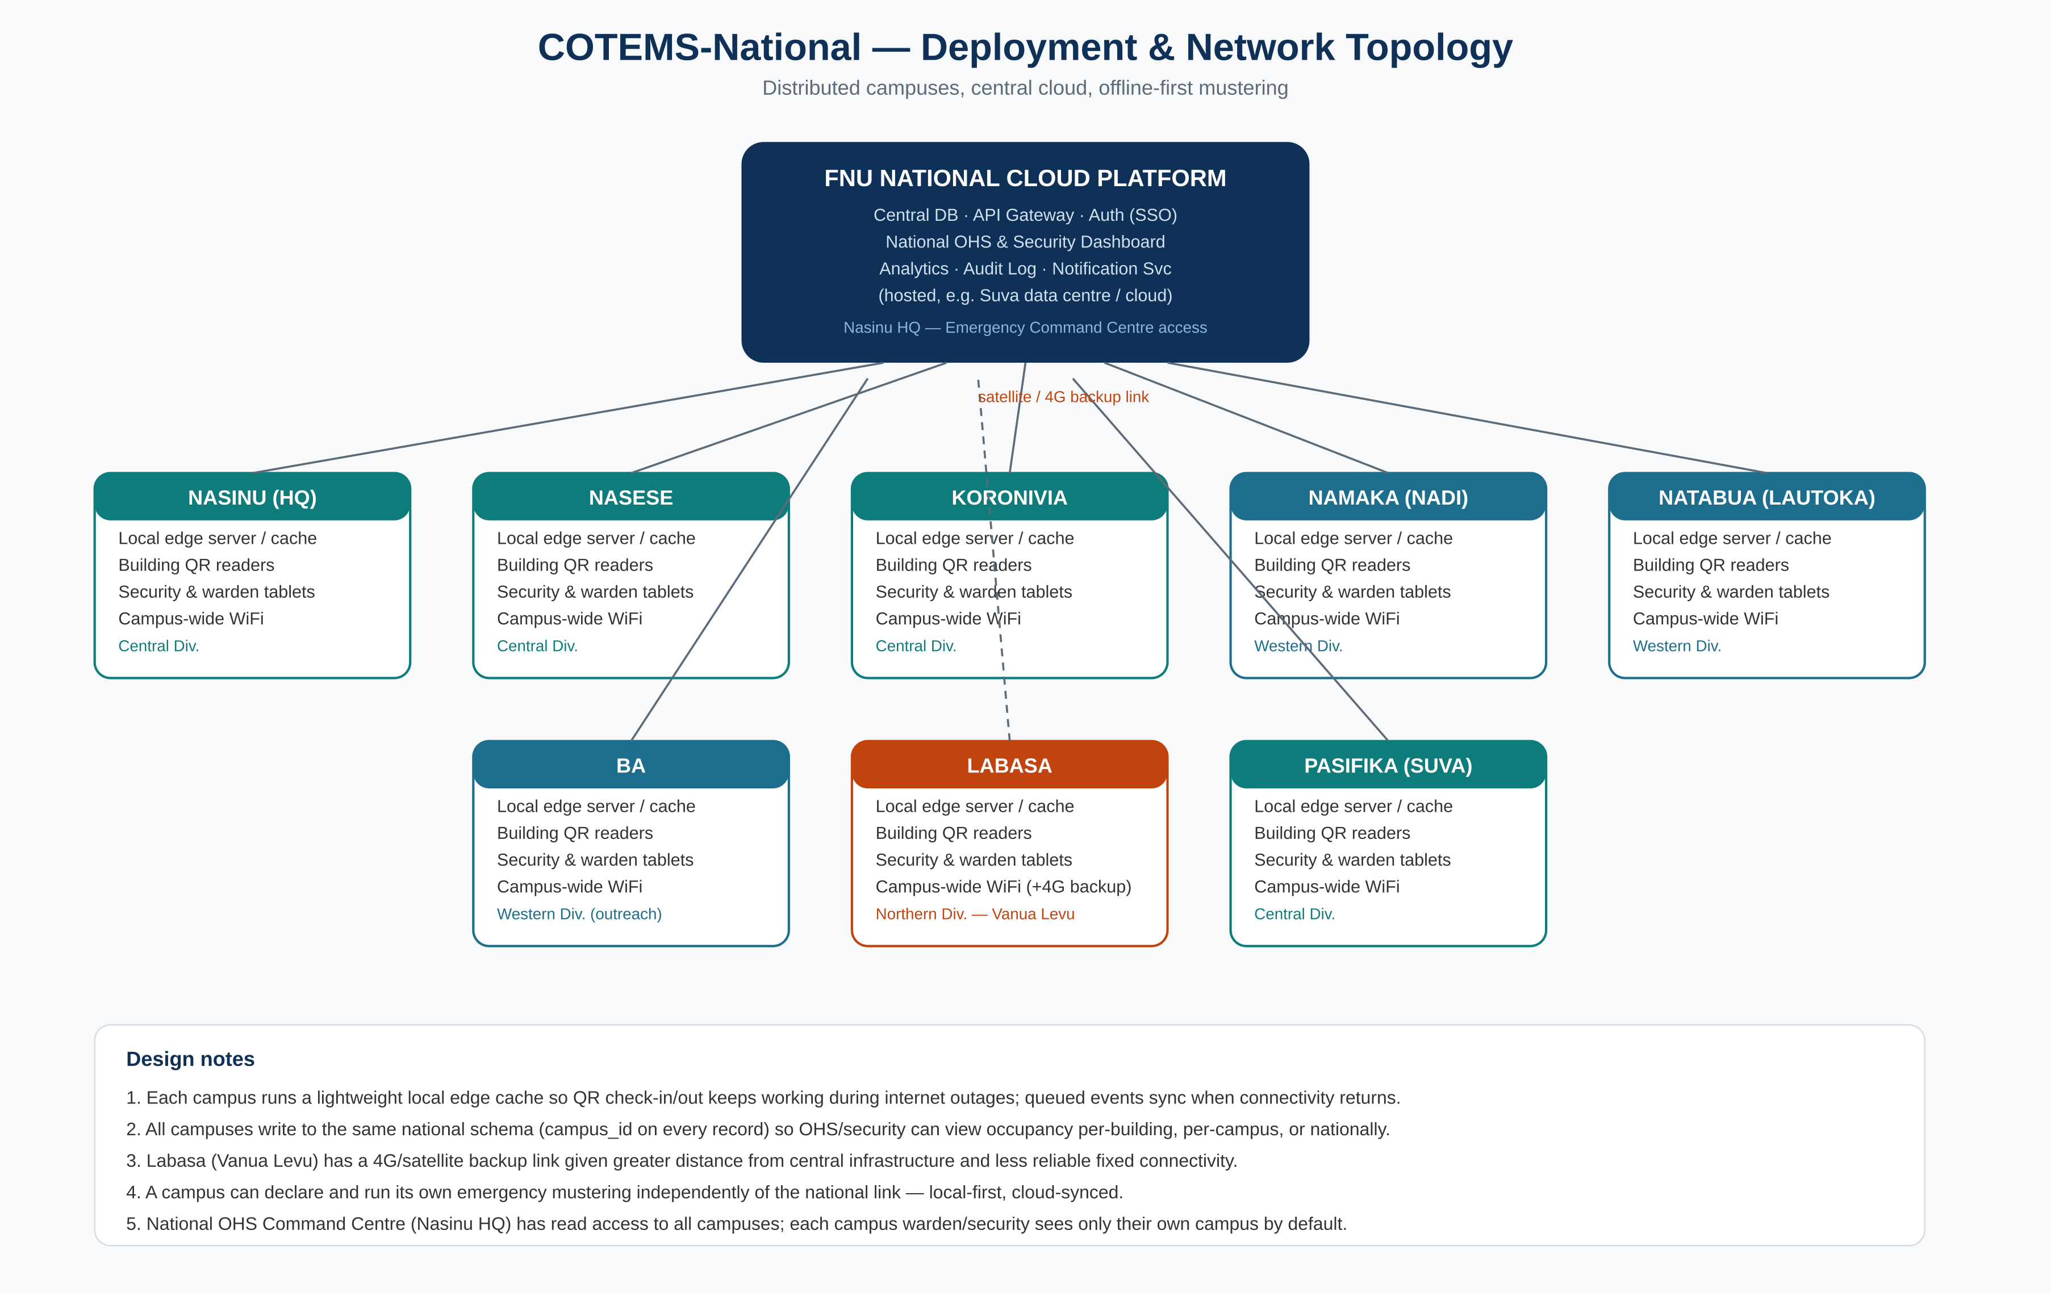
Figure 4. Deployment and network topology across the national cloud platform and 8 campus sites.

9.1 Key architectural decisions
- Central cloud platform hosts the national database, API gateway, single sign-on, national dashboard, analytics, and audit log.
- Each campus has a local edge cache so check-in/out and emergency declaration work offline; queued events sync automatically when the link returns.
- Labasa (Vanua Levu) has a 4G/satellite backup link, reflecting its greater distance from central infrastructure.
- A campus warden can declare, run, and clear an emergency entirely locally if the national link is down — mustering must never depend on connectivity to HQ.
- Role-based access: campus wardens/security see only their own campus by default; National OHS Command has read access across all campuses.

10. Non-Functional Requirements
Requirement | Target
Check-in scan response time | < 2 seconds under normal connectivity
Offline resilience | Check-in/out and emergency mustering fully functional with no internet for at least 4 hours
Muster roll freeze time | Live occupant list frozen into a muster roll within 5 seconds of emergency declaration
Availability | 99.5% for the national dashboard; local edge cache must remain available independently
Data privacy | Occupancy and personal data accessible only to authorised OHS/Security/Admin roles per campus, per FNU data governance policy
Auditability | Every check-in, check-out, emergency action, and admin change is logged with actor, timestamp, and campus
Scalability | Must support all 8 campuses concurrently with headroom for additional outreach sites

11. Implementation Roadmap
Phase | Focus | Indicative timeframe
Phase 1 | Pilot at Nasinu HQ: QR check-in/out, warden dashboard, single-campus mustering | Months 1–3
Phase 2 | Roll out to Nasese, Koronivia, Pasifika (Central Division campuses) | Months 4–6
Phase 3 | Roll out to Western Division: Namaka, Natabua, Ba | Months 7–9
Phase 4 | Roll out to Labasa (Northern Division) with offline-first hardening | Months 10–11
Phase 5 | National OHS Command dashboard, cross-campus analytics, SIS integration | Month 12+

12. Prototype
An interactive HTML/JavaScript prototype (cotems-national-system.html) accompanies this report. It simulates the three primary roles — Student/Staff Check-in, Campus Warden & Security, and National OHS Command — across all 8 campuses listed in Section 3.1. The Campus Warden role includes a working registration form that generates a real, scannable QR code for each new student or staff member, a registered-persons directory with reprint capability, live occupancy tiles, emergency declaration, and a working muster roll. The Student/Staff role scans a QR code using the device camera (with manual FNU ID entry as a fallback) to check in and out. The National OHS Command role adds cross-campus analytics and an audit log. It is intended for demonstration and stakeholder walkthroughs, not production deployment.

13. Conclusion
COTEMS-National turns emergency mustering from a slow, manual, single-campus process into a live, auditable, Fiji-wide capability. By making campus a core dimension of the data model from the outset, the same check-in/out mechanism that gives OHS everyday occupancy visibility also produces an accurate muster roll within seconds of an emergency being declared — on one campus, or on every campus FNU operates, at once.

