PORTFOLIO TECHNICAL REPORT
HSL Bus Reliability Analyzer
GTFS vs GTFS-RT Transit Performance Dashboard
Helsinki Region Transport (HSL) | Urban Mobility Data Science Project
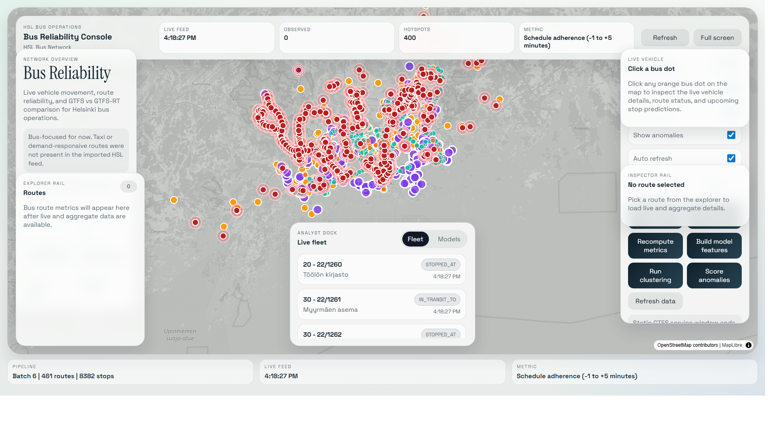
Figure: Live HSL bus reliability dashboard with GTFS-RT vehicle and model layers.
Project question: How reliably are HSL bus routes operating compared with planned schedules, and where should transport planners investigate delays, weak realtime coverage, or unusual service behavior?
Prepared as an illustrated project overview for portfolio, competition, and presentation use.

Executive Summary
The HSL Bus Reliability Analyzer is an end-to-end urban mobility data science project focused on Helsinki bus operations. It combines planned public transport schedules from static GTFS with live operational evidence from GTFS-RT. The project stores time-series and spatial data, transforms raw updates into model-ready route-stop-hour features, applies unsupervised learning, evaluates the resulting patterns, and communicates insights through an interactive map-first dashboard.
The official analysis scope is intentionally bus-only. The raw HSL feed contains multiple modes, but the modelling and dashboard focus on extended GTFS bus-family route types 701, 702, and 704. This keeps the reliability story consistent and avoids mixing bus behavior with rail, metro, tram, or ferry operations.
FEATURE WINDOWS  164,538 | CLUSTER ASSIGNMENTS  6,000 | DBSCAN HOTSPOTS  416 | PREDICTION COVERAGE  97.4%
Snapshot note: These metrics come from the saved bus-only API snapshot generated on 2026-04-27T06:20:30.639Z. Values can change when the pipeline and model jobs run again.

What The Project Delivers
- A reproducible Docker Compose environment for database, backend API, GTFS-RT poller, and frontend dashboard.
- Static GTFS ingestion for planned routes, stops, trips, stop times, calendars, and route shapes.
- GTFS-RT background polling for live vehicle positions and trip updates.
- Bus-only feature engineering for schedule adherence, delays, prediction coverage, freshness, and spatial context.
- KMeans and DBSCAN clustering for broad reliability profiles and hotspot discovery.
- Isolation Forest and Local Outlier Factor (LOF) for unusual bus-operation windows.
- A React and MapLibre dashboard for live vehicle inspection, route comparison, model layers, and statistical analytics.

1. Problem Background And Objective
Transport planners need more than a timetable. They need to understand how planned bus service compares with real operations. Static schedules answer where and when buses should run. Realtime feeds show where vehicles are being reported and what arrival predictions are available. The project connects these two views to analyze schedule adherence and reliability.
Core objective: Provide an explainable bus reliability workflow that helps identify reliable service patterns, delay-prone areas, low-coverage windows, and unusual operations using real HSL mobility data.

Why A Bus-Only Scope?
HSL operates a multimodal public transport system. For this project, the analysis is narrowed to buses because buses operate in road traffic and their reliability is directly connected to stop-level delays, route performance, prediction quality, and schedule adherence. The focused scope also makes model interpretation fairer and clearer.
Extended GTFS route_type | Meaning in this project | Reason included
701 | Regional bus service | Bus-family reliability analysis
702 | Express bus service | Bus-family reliability analysis
704 | Local bus service | Bus-family reliability analysis
Important distinction: route_type is a transport mode/category code. It is not an individual bus line number such as 30, 52, 510, or 560.

Schedule Adherence Definition
The dashboard uses On-Time Performance (OTP) as its central reliability concept. A scored observation is considered on time when it arrives between one minute early and five minutes late relative to the schedule.
Status | Delay rule | Interpretation
Early | Earlier than -1 minute | Vehicle is ahead of the accepted schedule window
On time | -1 to +5 minutes | Vehicle is within the accepted operating window
Late | Later than +5 minutes | Vehicle is behind the accepted schedule window
Static only | No usable live comparison | Schedule exists, but realtime context is insufficient

2. Data Sources And Data Understanding

Static GTFS: The Planned Network
Static GTFS is the scheduled description of the public transport network. It is imported from the HSL GTFS package and provides the baseline against which realtime behavior is interpreted.
GTFS table | Purpose
routes.txt | Route identifiers, user-facing route names, and route types
stops.txt | Stop names and geographic coordinates
trips.txt | Scheduled service trips associated with routes
stop_times.txt | Scheduled stop arrival and departure times
shapes.txt | Route geometry used to draw map lines
calendar.txt / calendar_dates.txt | Service days and exceptions

GTFS-RT: The Operational Evidence
Realtime feed | Purpose
VehiclePositions | Where buses are currently reported on the map
TripUpdates | Predicted stop arrival/departure context and delay evidence
Service Alerts | Potential disruption notices; available as a future enhancement

Data Types
- Numerical: delay minutes, speed, coverage ratio, freshness, and vehicle observation count.
- Categorical: route id, stop id, route type, vehicle status, and model reliability label.
- Temporal: GTFS-RT recorded timestamps, scheduled times, hour of day, weekday, and weekend flag.
- Spatial: stop latitude/longitude, vehicle coordinates, and route geometry.

Key Data Challenges
- Realtime trip identifiers may be missing or may not cleanly match static GTFS trip identifiers.
- A missing TripUpdate does not automatically mean that a bus is on time.
- Prediction coverage varies by route and time window.
- Historical GTFS-RT accumulates only while the poller is running unless an external archive is used.

3. System Architecture
The system is modular: ingestion, storage, feature engineering, analytics, API delivery, and visualization are separated so each layer can be improved without rewriting the entire application.
1 | HSL Static GTFS | planned routes, stops, trips, times, shapes
2 | GTFS-RT Poller | vehicle positions and trip updates
3 | PostgreSQL + PostGIS + TimescaleDB | relational, spatial, and time-series storage
4 | Feature Builder | route-stop-hour model windows
5 | Models + FastAPI | clusters, hotspots, anomalies, analytics endpoints
6 | React + MapLibre Dashboard | live map and statistical intelligence

Architecture Explanation
Module | What it does | Why it matters
Static GTFS importer | Loads scheduled routes, stops, trips, stop times, shapes, and calendars | Provides the planned network
GTFS-RT poller | Fetches VehiclePositions and TripUpdates repeatedly | Stores realtime movement and predictions
PostgreSQL + PostGIS + TimescaleDB | Stores relational, spatial, and time-series records | Supports route, stop, map, and history analysis
Feature builder | Aggregates raw evidence into route-stop-hour windows | Creates machine-learning rows
Model jobs | Runs clustering and anomaly detection | Finds patterns, hotspots, and unusual windows
FastAPI backend | Serves ingestion status, live map layers, route metrics, and model outputs | Connects notebooks and dashboard
React + MapLibre frontend | Displays live operations and statistical analytics | Makes model evidence understandable

End-To-End Data Flow
- Import static HSL GTFS to store planned bus routes, stops, trips, scheduled stop times, and route geometry.
- Poll HSL GTFS-RT VehiclePositions and TripUpdates in the background.
- Store raw realtime history in time-series tables while preserving spatial coordinates.
- Filter analysis to bus-family route types 701, 702, and 704.
- Aggregate matched evidence into route-stop-hour feature windows.
- Run clustering and anomaly scoring jobs, then persist model outputs.
- Serve the same evidence to notebooks and the React dashboard through FastAPI.

4. Preprocessing And Feature Engineering
Raw realtime feeds are not directly suitable for machine learning. The feature builder converts noisy event-level updates into route-stop-hour windows. A feature window is one summarized row for a particular bus route, stop, and hourly time bucket.
Simple explanation: A feature window turns many raw bus updates into one compact row that describes how a route-stop-hour behaved.

Feature Window Contents
Feature group | Examples | Why it matters
Delay | Mean, median, p95 absolute delay, delay standard deviation | Measures reliability and variability
Adherence | On-time ratio, late ratio, early ratio | Shows schedule performance
Realtime quality | Prediction coverage ratio, feed age/freshness | Prevents missing data from being treated as good performance
Volume | Vehicle observation count | Shows how much evidence supports the window
Time | Hour, weekday, weekend flag | Captures daily mobility patterns
Spatial | Stop latitude and longitude | Supports maps and DBSCAN hotspot interpretation
Mode | Route type | Keeps analysis bus-focused

Missing-Value Handling
Missing realtime information is handled cautiously. Missing prediction data is not silently converted to zero delay. Instead, the project uses coverage and freshness features and can classify a location as static-only or low-realtime-coverage. This avoids the false conclusion that every vehicle with incomplete realtime data is on time.

5. Part 3: Data Mining Techniques
The course requires at least two data mining techniques. This project implements two categories: clustering/pattern discovery and anomaly detection. Each category uses two algorithms so their behavior can be compared.

KMeans: Broad Reliability Profiles
KMeans divides feature windows into a selected number of groups. It is useful for reducing thousands of bus route-stop-hour windows into a small number of understandable reliability profiles.
- Selected latest snapshot parameters: k = 2 and n_init = 20.
- Interpretation: the model creates broad groups such as more reliable behavior and windows requiring attention.
- Evaluation: silhouette = 0.681, Davies-Bouldin = 0.557, Calinski-Harabasz = 9,292.197.

DBSCAN: Hotspot Discovery
DBSCAN groups dense neighborhoods of similar points and leaves sparse points outside clusters as noise. It is useful because reliability problems may concentrate around corridors, terminals, or groups of stops rather than forming equal-sized clusters.
- Selected latest snapshot parameters: eps = 0.4 and min_samples = 15.
- Evaluation: silhouette = 0.621, noise share = 0.045, and cluster count = 4.
- Operational output: 416 saved DBSCAN hotspot assignments in the latest snapshot.

Isolation Forest: Global Unusual Windows
Isolation Forest identifies observations that are easier to separate from the main population. It is suitable for unusual delays, low prediction coverage, stale feed windows, or combinations of abnormal behavior.
- Selected latest snapshot parameters: n_estimators = 100, max_samples = 256, contamination = 0.05.
- Evaluation: Precision@K = 0.508, recall = 0.506, false-alarm share = 0.025.

Local Outlier Factor: Local Deviations
LOF compares each feature window with its local neighbors. This is useful because a value that is ordinary for one route or time period may be unusual in another context.
- Selected latest snapshot parameters: n_neighbors = 10 and contamination = 0.02.
- Evaluation: Precision@K = 0.141, recall = 0.056, false-alarm share = 0.017.
Model interpretation: Clustering explains recurring reliability patterns. Anomaly detection creates a watchlist of unusual windows. An anomaly is a planner investigation signal, not a confirmed disruption.

6. Part 4: Model Evaluation And Interpretation

Why Internal Clustering Metrics Are Used
There are no official ground-truth cluster labels for HSL bus reliability. Therefore, clustering is evaluated with internal metrics that measure separation, compactness, and structure.
Metric | Better direction | Meaning
Silhouette Score | Higher | Clusters are more clearly separated with less overlap
Davies-Bouldin Index | Lower | Clusters are more compact and distinct
Calinski-Harabasz Score | Higher | Between-cluster separation is stronger relative to within-cluster spread

Why Pseudo-Labels Are Used For Anomalies
There is no complete official label set saying which bus-operation windows are truly anomalous. The project therefore uses operational pseudo-labels such as extreme delays, stale feeds, low prediction coverage, and late-heavy windows. These provide a practical evaluation baseline while remaining an explicitly stated limitation.
Metric | Meaning
Precision@K | How many top-ranked alerts overlap with operational pseudo-labels
Recall | How much pseudo-labeled suspicious behavior is captured
F1 proxy | Balance between precision and recall
False-alarm share | Share of alerts that may not overlap with operational triggers
Honest interpretation: Model metrics support prioritization and comparison. They do not prove the external cause of a delay, which may require traffic, weather, roadworks, or service-alert context.

7. Interactive Dashboard Walkthrough
The React and MapLibre dashboard connects the data science workflow to a planner-facing interface. It separates live operational evidence from model interpretation while keeping both visible on a shared map.
Figure: Live map view. Orange vehicle dots come from GTFS-RT; cluster and anomaly layers can be shown for investigation.

Map Layers And Colors
Color or visual | Meaning
Orange vehicle dots | Live GTFS-RT bus locations
Green markers | On-time stop comparison or reliable pattern
Red markers | Late stop comparison, poor reliability, or anomaly signal
Blue markers | Early stop comparison
Grey markers | Static-only schedule context without sufficient realtime comparison
Purple cluster markers | Low realtime prediction coverage
Teal cluster markers | Reliable or default cluster pattern
Strong route line | Selected static GTFS route geometry
Faint network lines | Planned background bus network

Planner-Facing Dashboard Areas
Dashboard area | What it explains
Executive KPIs | Live buses, observed routes, prediction coverage, and anomaly watchlist
Selected route intelligence | Route OTP, average delay, live buses, hotspots, and route coverage
Route explorer | Bus routes that currently have live or model evidence
Analyst dock | Live vehicle details and Part 3 model evidence
Control center | Layer toggles plus GTFS import, poll, metric, feature, clustering, and anomaly jobs
Statistical intelligence | Route health, coverage, anomaly pressure, rankings, labels, and reasons

8. Statistical Analytics View
The statistical intelligence section translates model outputs into concise operational summaries suitable for a presentation or planner review.
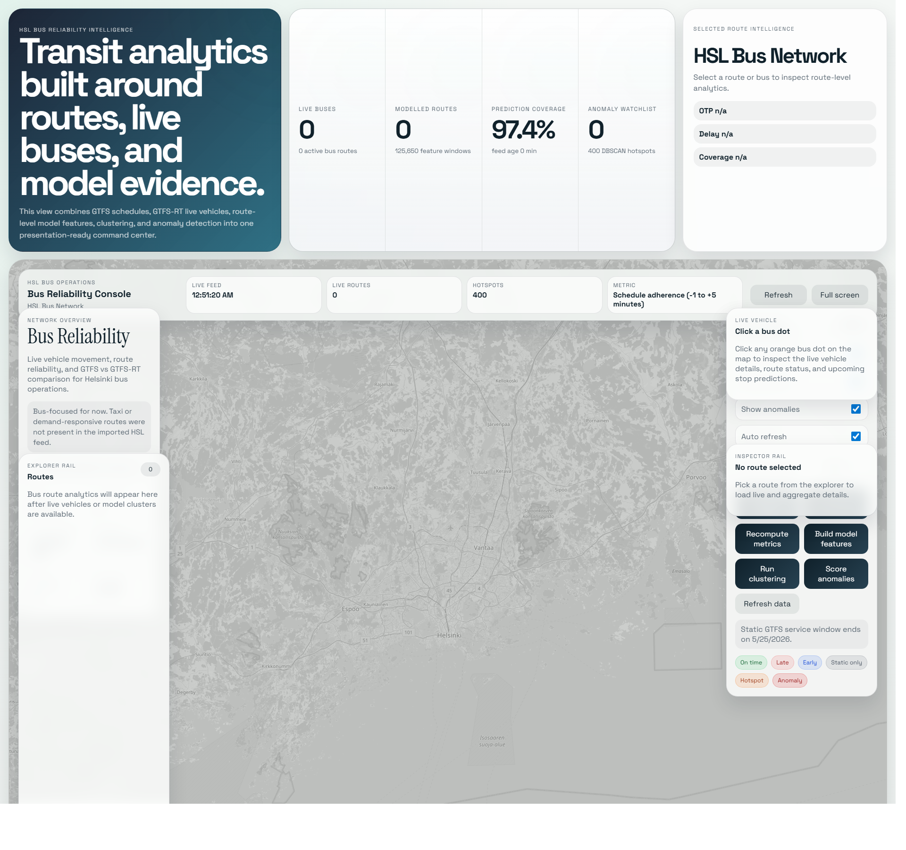
Figure: Industry-style dashboard layout with KPI cards, route intelligence, live-map stage, and control rail.
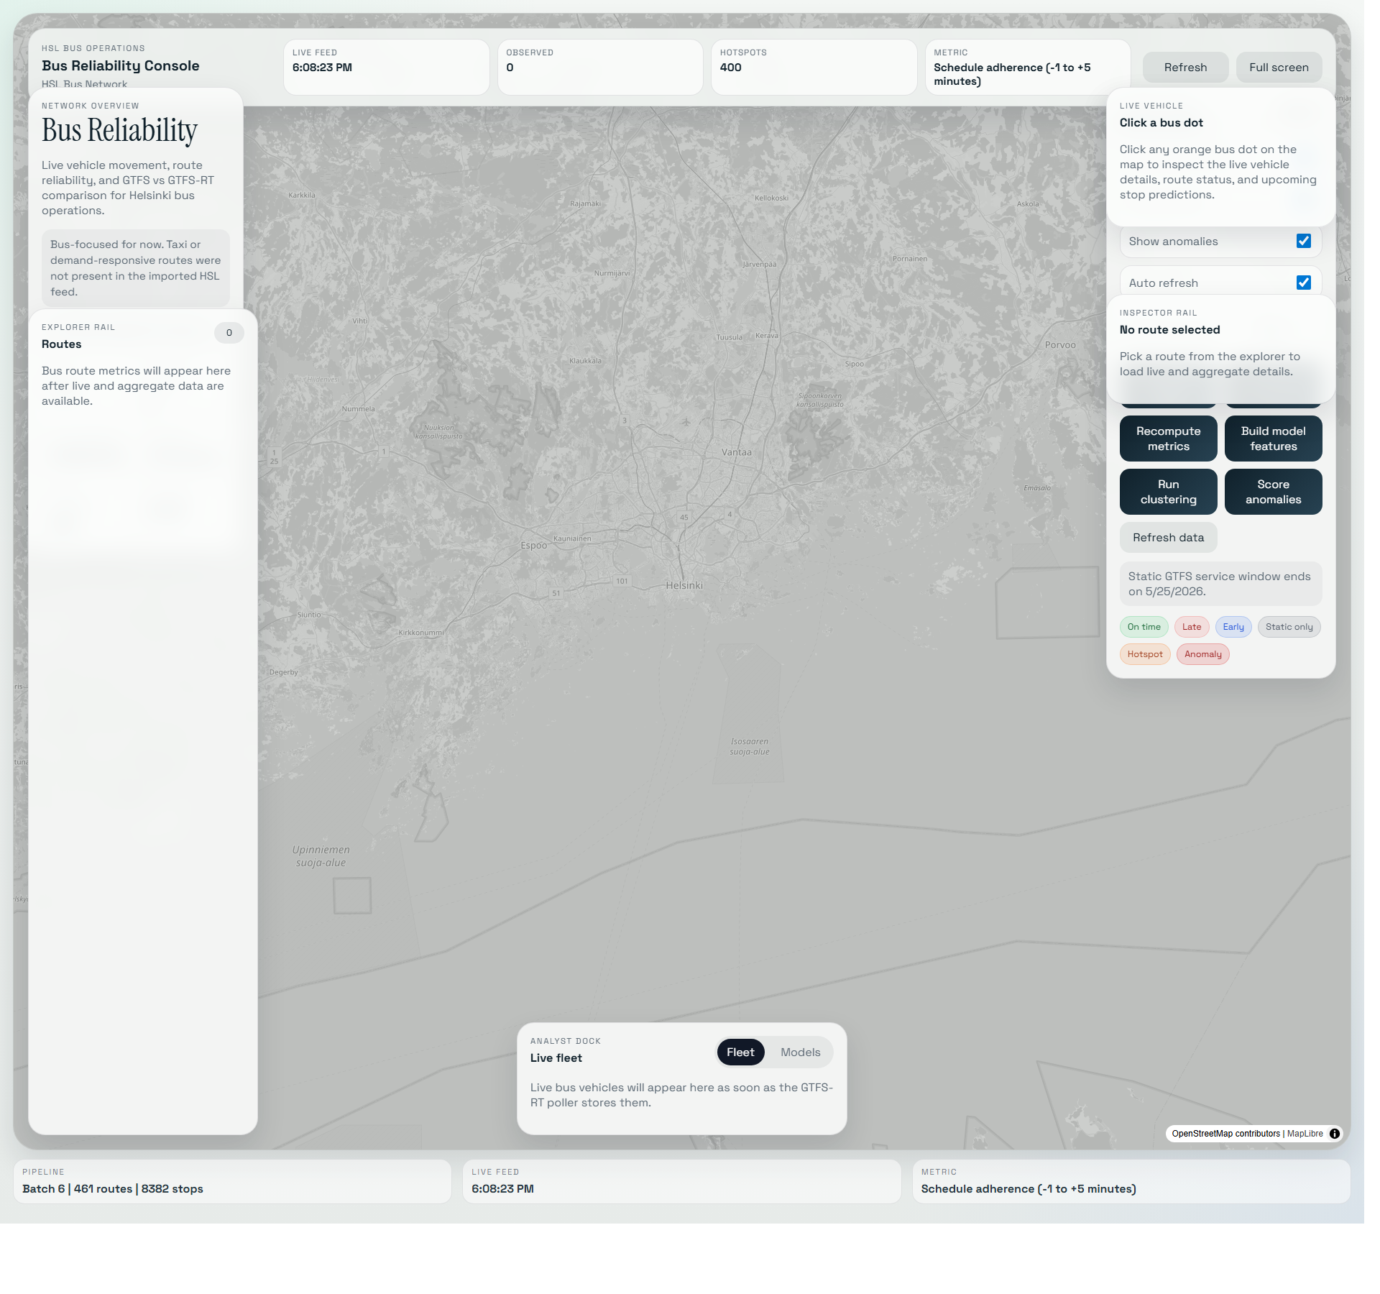
Figure: Map-first dashboard state showing the reliability legend and operational controls.

How To Explain The Analytics Cards
- Route health distribution groups OTP-scored routes into good, watch, and poor bands.
- Prediction coverage shows how much usable realtime signal exists for the feature windows.
- Live model watchlist shows anomaly pressure; it is a prioritization queue, not a confirmed incident list.
- Highest average delay ranks routes that deserve investigation.
- Vehicle status split summarizes buses reported as IN_TRANSIT_TO, INCOMING_AT, or STOPPED_AT.
- Reliability labels summarize recurring model patterns such as reliable, watch, delay_hotspot, and low_realtime_coverage.
- Anomaly reasons explain why unusual windows were flagged, for example extreme delay or coverage dropout.

9. Insights For Urban Mobility Planning
The project supports operational prioritization rather than automated decision-making. It helps planners decide where deeper investigation is most valuable.
- Use route health and average delay rankings to identify routes that may need timetable review or corridor-level investigation.
- Use DBSCAN hotspots to identify stop areas or corridors where reliability concerns concentrate.
- Use low-realtime-coverage labels to distinguish weak data quality from genuine service performance.
- Use anomaly windows as a focused watchlist for unusual operations requiring planner review.
- Use live vehicle popups and upcoming-stop context to connect network-level analytics back to individual bus movements.

10. Limitations And Future Work
Current limitation | Why it matters | Future improvement
Limited continuous GTFS-RT history | History accumulates only while the local poller runs | Deploy a persistent cloud poller and retention policy
No perfect GTFS-to-GTFS-RT match | Trip identifiers can be missing or noisy | Improve fuzzy linking with shape progress and stop sequence context
Pseudo-label anomaly evaluation | Operational triggers are not absolute ground truth | Add planner-reviewed labels and service-alert overlap
Bus-only analysis | Other HSL modes are excluded intentionally | Add mode-specific models without mixing behavior
No supervised ETA model | Project focuses on required unsupervised techniques | Train delay or ETA prediction after collecting longer history
Local dashboard deployment | Current Docker stack is not yet public-hosted | Deploy behind HTTPS with restricted admin operations

11. Reproducibility And Evidence
The project stores both human-readable and machine-readable evidence so the analysis can be reproduced and presented even when the live poller is not running.

Main Evidence Files
- notebooks/03_data_mining_gtfs_rt.ipynb - clustering and anomaly detection workflow.
- notebooks/04_model_evaluation_interpretation.ipynb - metrics, visualizations, and interpretation.
- reports/snapshots/bus_model_snapshot_latest.json - detailed saved API/model snapshot.
- reports/snapshots/bus_model_snapshot_compact.json - compact saved snapshot.
- reports/history_exports/ - recent bus GTFS-RT and model CSV exports.
- reports/screenshots/ - dashboard evidence screenshots.
- docs/dashboard-readme.md - dashboard teaching guide.
- docs/code-walkthrough-for-presentation.md - code and architecture explanation.

How To Run Locally
Start Docker Desktop, then run: docker compose up -d
Dashboard: http://localhost:5173/
FastAPI docs: http://localhost:8000/docs
Stop safely without deleting stored data: docker compose down
Data retention warning: Do not use docker compose down -v unless you intentionally want to delete the database volume and collected GTFS-RT history.

12. Competition And Portfolio Summary
This project demonstrates a complete applied urban mobility data science workflow: open-data ingestion, spatial and time-series storage, careful preprocessing, feature engineering, unsupervised learning, quantitative evaluation, API design, and an explainable live dashboard.
One-sentence portfolio summary: Built an end-to-end HSL bus reliability analyzer using static GTFS and GTFS-RT feeds, PostgreSQL/PostGIS/TimescaleDB, FastAPI, clustering, anomaly detection, and a React/MapLibre dashboard for live operations and planner-facing insights.

Suggested Closing Statement
The project turns raw HSL schedule and realtime feeds into interpretable reliability evidence. Static GTFS describes the planned network, GTFS-RT adds live operational context, the feature builder creates route-stop-hour model windows, clustering reveals recurring reliability patterns and hotspots, anomaly detection prioritizes unusual behavior, and the dashboard makes the results understandable for transport planners.

Appendix: Five-Minute Demo Sequence
- Open the dashboard and explain the four executive KPIs.
- Select a route and show the static route geometry against live orange bus dots.
- Click a bus dot to explain vehicle, trip, next-stop, speed, status, and update context.
- Enable clusters and explain reliable, watch, delay_hotspot, and low_realtime_coverage labels.
- Enable anomalies and explain that red signals form an investigation watchlist.
- Scroll to the statistical analytics section and summarize route health, coverage, delay ranking, and anomaly reasons.

