**浙江大学2021–2022学年春夏学期**

**《普通物理学Ⅰ（H）》课程期中考查试卷**

课程号： 061R0060_，开课学院：_物理学系__

考试试卷：√A卷、B卷（请在选定项上打√）

考试形式：√闭、开卷（请在选定项上打√），允许带_纸质词典_入场

考试日期： 2022 年 4 月 30 日,考试时间： 90 分钟

诚信考试，沉着应考，杜绝违纪。

考生姓名： 学号： 所属院系： _

|  |  |  |  |  |  |  |  |  |  |
| --- | --- | --- | --- | --- | --- | --- | --- | --- | --- |
| 题序 | 一 | 二 | 三 | 四 | 五 | 六 | 七 | 八 | 总 分 |
| 得分 |  |  |  |  |  |  |  |  |  |
| 评卷人 |  |  |  |  |  |  |  |  |  |

**Ⅰ. Multiple-choice: (there is one correct answer only) (3points each)**

1. An object is traveling around a circular orbit, speeding up as it goes. This means that:

A. the radial component of its acceleration is decreasing in magnitude.

B. the radial component of its acceleration remains constant in magnitude.

C. the tangential component of its acceleration is in the direction of its velocity.

D. the tangential component of its acceleration is opposite its velocity in direction.

E. the tangential component of its acceleration is zero

答: 切向速度变大，切向加速度于速度同向，向心加速度变大 C

2. The position vector of a particle is . What is the tangential and centripetal acceleration, at *t* =0?

A. (1,3) B. (2,4) C. (4,2) D. (3,1) E. (3,2)

答: $\vec{a}=4 \hat{i}+2 \hat{j}$, t=0时, $\vec{r}=(-5,0)$, tangential=2, centripetal=4 B

3. A ball of mass 1kg vertically drops to the ground with speed 40m/s, and rebounds vertically with speed 10m/s. The collision is assumed to be elastic and the interval of the collision is 0.1 second. What is the average force acting on the ball during the collision?

A. 300N

B. 310N

C. 500N

D. 510N

E. 490N

答: average force acting on the ball 包括了重力的总的力 = 50 / 0.1 = 500 C

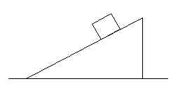4. A large wedge rests on a horizontal frictionless surface, as shown. A block starts from rest and slides down the inclined surface of the wedge, which is rough. During the motion of the block, the center of mass of the block and wedge:

A. does not move

B. moves horizontally with constant speed.

C. moves horizontally with increasing speed.

D. moves vertically with increasing speed.

E. moves both horizontally and vertically.

答: 水平方向不受外力，质心不在水平方向移动。滑块垂直方向质心加速向下，三角体垂直方向质心不动。所以最终选 D

5.. Two solid steel balls, one small and one large, are on an inclined plane. The large ball has a diameter twice as large as that of the small ball. Starting from the rest, the two balls roll without slipping down the incline until their centers of mass are 1 m below their staring positions. What is the speed of the large ball (*VL*) relative to that of the small ball (*VS*) after rolling 1 m?

A. *VL*=4*VS* B. *VL*=2*VS* C. *VL*=*VS* D. *VL*=0.5*VS* E. *VL*=0.25*VS*

答: 🡪 , 都是滚1m, 最后速度相等 C

16. As shown in the Figure, the length of the thin rod is *l* = 3m and its density is *λ* = 4*x*2 kg/m. Then, where is the center of mass from the origin *O*?

A．1.50m.

B．1.75m.

C．2.00m.

D．2.25m.

E．2.40m.

答: 🡪 D

7. A wheel starts from rest and has an angular acceleration that is given by *α*(*t*)=6*t*2, where *t* is in seconds and is *α* in radians per second-squared. After it has turned through 10rev its angular velocity is:

A．63rad/s

B．75rad/s

C．89rad/s

D．130rad/s

E．210rad/s

答: 🡪 t = 3.3 B

8. A uniform disk has radius *R* and mass *M*. When it is spinning with angular velocity *ω* about an axis through its center and perpendicular to its face, its angular momentum is *Iω*. When it is spinning with the same angular velocity about a parallel axis a distance *h* away, its angular momentum is:

1. *Iω*.
2. (*I*+*Mh*2)*ω*.
3. (*I*-*Mh*2)*ω*.
4. (*I*+*MR*2)*ω*.

E．(*I*-*MR*2)*ω*.

答: 转动惯量必然增加，并且与h有关，所以选B

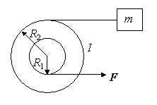9. A small disk of radius *R*1 is fastened coaxially to a larger disk of radius *R*2. The combination is free to rotate on a fixed axle, which is perpendicular to a horizontal frictionless table top and through the disk centers. The rotational inertia of the combination is *I*. a string is wrapped around the larger disk and attached to a block of mass *m*, on the table. Another string is wrapped around the smaller disk and is pulled with a force *F* as shown. The tension in the string pulling the block is:

A．*R*1*F*/*R*2.

B．*mR*1*R*2*F*/(*I-mR*22).

C．*mR*1*R*2*F*/(*I+mR*22).

D．*mR*1*R*2*F*/(*I-mR*1*R*2).

E．*mR*1*R*2*F*/(*I+mR*1*R*2).

答: 🡪 🡪 C

10. A spaceship is returning to the Earth with its engine turned off. Consider only the gravitational field of the Earth and let *M* be the mass of the Earth, *m* be the mass of the spaceship, and *Ri* be the distance from the center of the Earth. In moving from position 1 to position 2, the kinetic energy of the spaceship increases by

A. *GMm/R*2

B. *GMm/R*22

C. *GMm*(*R*1*-R*2)*/R*12

D. *GMm*(*R*1*-R*2)*/R*1*R*2

E. *GMm*(*R*1*-R*2)*/R*12*R*22

答: D

11. Consider a binary star system *M* and *m* with circular orbit, rotating at velocity *ω*, what is the radius ratio *R*/*r*.

A. *M/m*

B. *m/M*

C. *M2/m2*

D. *m2/M2*

E. *Gω/Mm*

答: B

12.  At time *t*=0, a 2-kg particle has a velocity of 4*i*-3*j* and at *t*=3s its velocity is 2*i*+3*j* (SI). During this time the work done on it was:

A. 4J .

B. -4J .

C. -12J .

D. -40J .

E. (4J)*i* +(36J)*j*

答：两时刻动能相减 C

13. What is the work done by the force *F*=(3*x*2+2)(N) from the position *x*=0 to *x*=4m ?

A. 72J

B. 200J

C. 104J

D. 208J

E. 0J

答: 积分得 A

14. An iron shelf of uniform density, where is the center of mass

A. (1.5L, 1.5L)

B. (1.3L, 1.3L)

C. (1.1L, 1.1L)

D. (0.9L, 0.9L)

E. (1.2L, 1.2L)

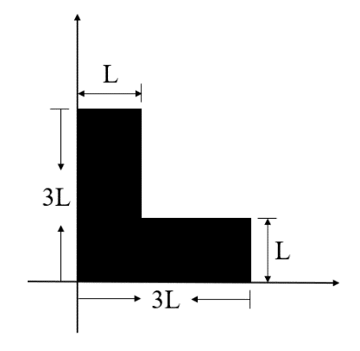

*答: 🡪 C*

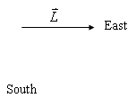15. The angular momentum vector for a spinning wheel lies along its axle and pointed east. To make this vector point south, it is necessary to exert a force on the east end of the axle. Which direction is this force?

A. Up.

B. Down.

C. North.

D. South.

E. East.

答: $\vec{r}×\vec{F}=\frac{d\vec{L}}{dt}$, 想让 $\frac{d\vec{L}}{dt}$ 向南, F要垂直纸面向外，(UP), A

**Ⅱ. Calculation problems (present the necessary equations in solution):**

1. (15 points) A pipeline has a circle cross section with the radius *R*. A liquid with the mass density ρ steadily flows inside the pipeline which is upright placed (竖直放置) due to the gravitation force. Assume the mass flux at the open end is *Q=dm/dt*. Calculate (a) the viscosity η of the liquid and (b) the flow speed at the center of the pipeline.

答: 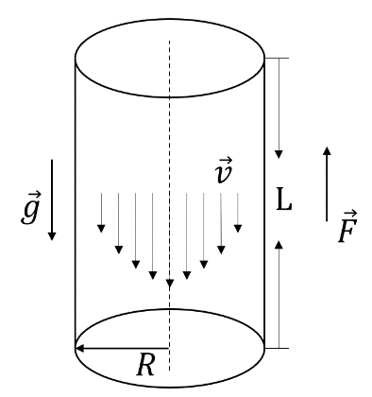

$$F=2πrLη\left(-\frac{dv}{dr}\right)=Mg=πr^{2}Lρg$$

$$2η\frac{dv}{dr}=-rρg$$

$$dv=-\frac{ρg}{2η}rdr$$

$$v=v_{0}-\frac{ρg}{4η}r^{2}$$

设管壁处的*v=0*

$$v_{0}=\frac{ρg}{4η}R^{2}$$

$$v=v_{0}\left(1-\frac{r^{2}}{R^{2}} \right)$$

$$dm=\int_{0}^{R}{2πrdrρvdt}=\frac{1}{2}πρv_{0}R^{2}dt$$

得:

$$v_{0}=\frac{2Q}{πρR^{2}}, η=\frac{πg{ρ^{2}R}^{4}}{8Q}$$

1. (15 points) A small slider (滑块) A is located on a smooth horizontal table, and a small slider B is located on a smooth groove (凹槽) on the table. The mass of the two sliders is , and they are connected by an unextendible (不可伸长的) and inelastic (无弹性的) light rope of length . At the beginning, the distance between A and B is , and the line between A and B is perpendicular to the small groove. Now give a shock to slider A. Then slider A obtain a velocity  which is parallel to the groove. Then the velocity at which the slider B starts to move is ___________________.

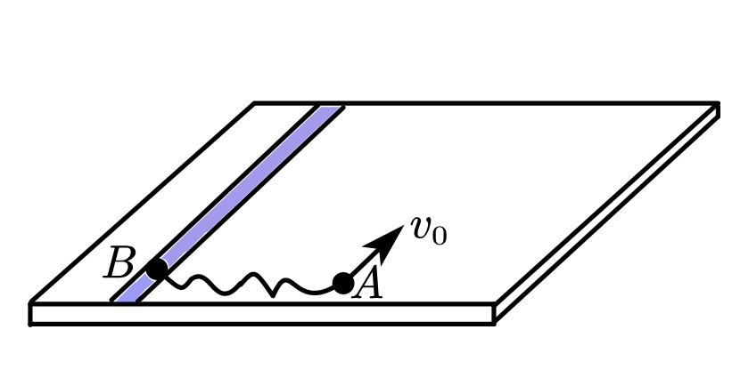

**Solution**

Suppose the moment when the rope tightens, the slider A has the velocity , the slider B has the velocity . When the rope is tightened, the motion of slider A relative to slider B is circular motion centered on B. The relative speed  is perpendicular to the rope, so the speed of slider A is 

From the picture, we have

 (1)

 (2)

From the geometry, we get  (3)

During the movement of the slider, the  direction system is free from external forces. From conservation of momentum, we have

 (4)

The angular momentum of slider A to the original position of slider B is conserved

 (5)

From Eq.1 to 5, we can easily get , the direction is along the Y-axis.

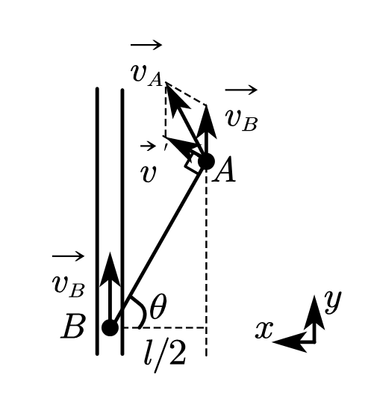

1. (15 points) A chain with mass  and length  is placed on a smooth horizontal table. One end of the chain is tied to a thin rope, which is hanging by a pulley with a mass of , as shown in Figure 5. When , the system starts to move from rest, with . Assuming that the rope does not extend, the mass of the pulley, the rope, and the friction of the pulley shaft (轮轴) and the edge of the table are ignored. Find the magnitude of the velocity and acceleration of object  when the chain has just all slide onto the table?

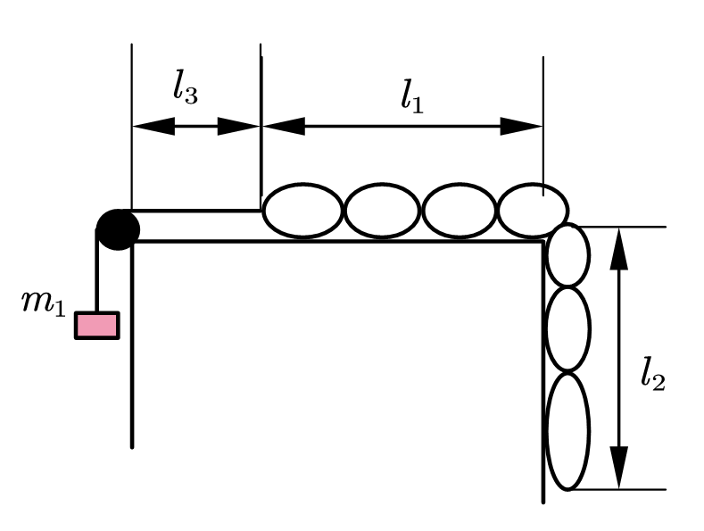



**Solution**

Assume that the chain is hanging off the edge of the table with a length ,



, we got 

When the chain has just all slide onto the table , 





Integrate both sides of this equation







4. (10 points) Two wheels of same radius *R* and mass *m* are held on the shelf. They cannot move horizontally, but can rotate freely. A belt is put on the ground, one side is connected and wound on wheel 2. From the beginning, wheel 1 rotates at *ω0*, and wheel 2 at rest. Then wheel 1 touch the ground, and drive the wheel 2 to rotate. Pressure given to the two wheels by the ground are both *mg*. Friction coefficient between wheel 1 and the belt is *η*. After a moment *t*, the two wheels rotate at same *ω’*.

(1) Express *t* by *ω0*, *g*, *η*, *R.*

(2) Calculate the energy loss by friction.

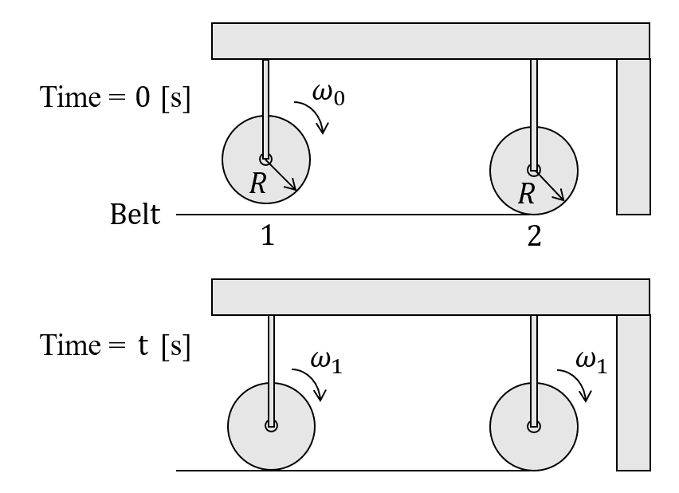

答: (1)

$$L=\vec{r}×\vec{p}=\frac{1}{2}mR^{2}ω$$

$$\vec{r}×\vec{F}=\frac{dL}{dt} → ηmgR=\frac{1}{2}mR^{2}\frac{dω}{dt}$$

$$ηmgRt=\frac{1}{2}mR^{2}(ω_{0}-ω_{1})$$

$$ηmgRt=\frac{1}{2}mR^{2}ω_{2}$$

when 🡪

(2)

$$E_{0}=\frac{1}{4}m{ω_{0}}^{2}R^{2}$$

$$E_{1}+E_{2}+E_{loss}=E_{0}$$

$$E_{loss}=\frac{1}{8}m{ω_{0}}^{2}R^{2}$$