Displaying PDF in React app

[](https://medium.com/@sagar.shrestha?source=post_page-----6e9d1fffa1a9--------------------------------)

[Sagar Shrestha](https://medium.com/@sagar.shrestha?source=post_page-----6e9d1fffa1a9--------------------------------)

Follow

[Jun 5](https://levelup.gitconnected.com/displaying-pdf-in-react-app-6e9d1fffa1a9?source=post_page-----6e9d1fffa1a9--------------------------------) · 2 min read

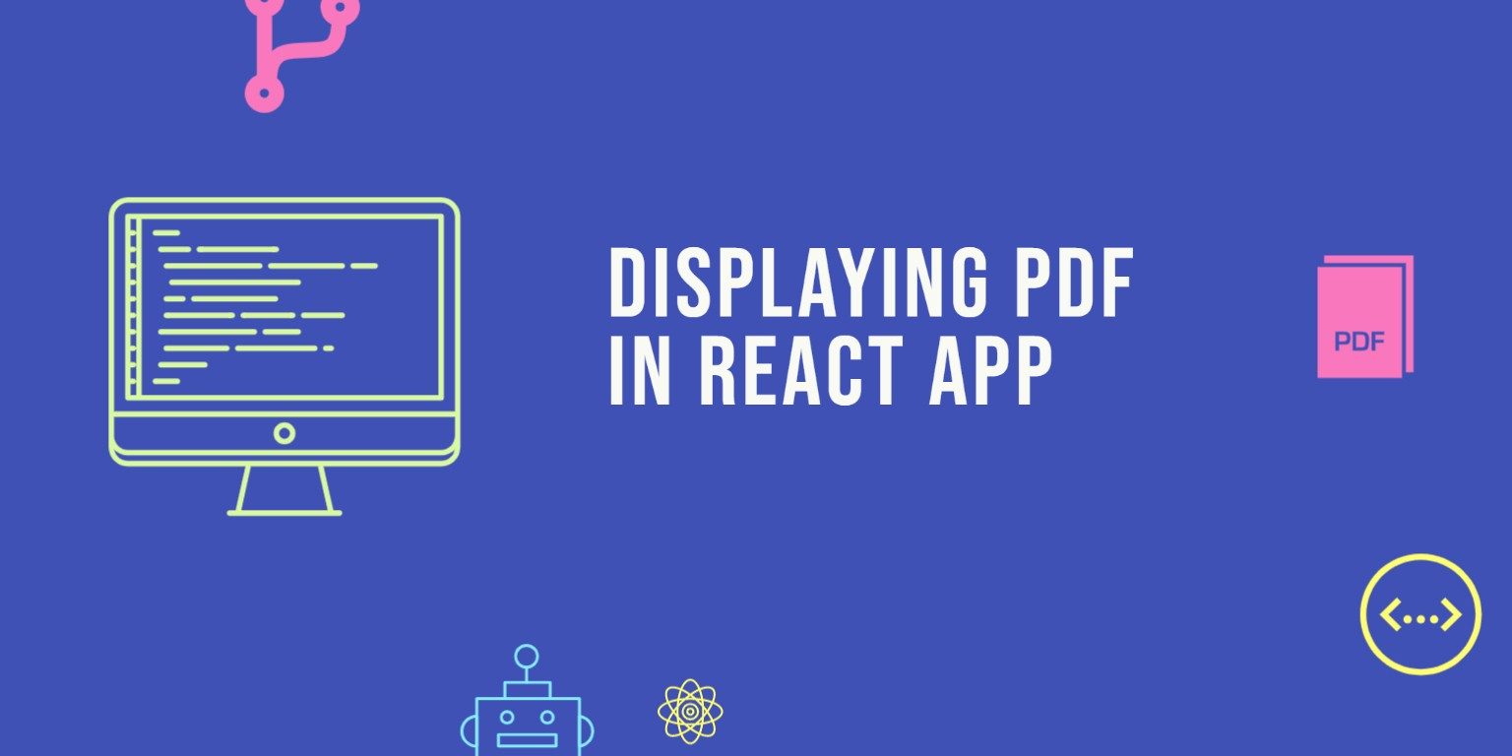

I want to show you an easy and simple way to display PDF files using React in the browser. I will be using a library called [react-pdf](https://github.com/wojtekmaj/react-pdf). This library is capable of rendering PDF files given an URL or a local file inside the project or base64 encoded version.

To get started, create a simple React application using [Create React App](https://github.com/facebook/create-react-app). To do this you can run the following commands:

npx create-react-app display-pdf-app  
cd display-pdf-app  
npm start

After this, add the react-pdf library to the project using the following command:

npm install --save react-pdf

To render the PDF file, react-pdf has a Document component where you need to pass a file prop. Then inside the Document component, you need to create a Page component. Simple isn’t it? Sample code:

import React from 'react';  
import { Document, Page } from 'react-pdf';  
  
  
export default function Test() {  
 return (  
 <Document file={samplePDF}>  
 <Page pageNumber={1} />  
 </Document>  
 );  
}

The final project structure will look like this:

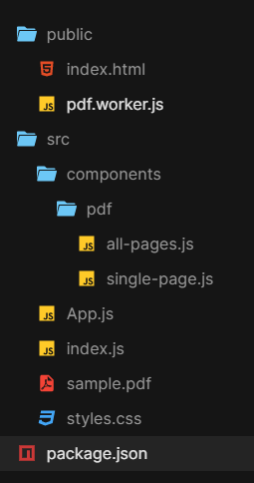

Let’s start with creating single-page.js and all-pages.jsinside the components -pdf folder with the following contents:

* single-page.js

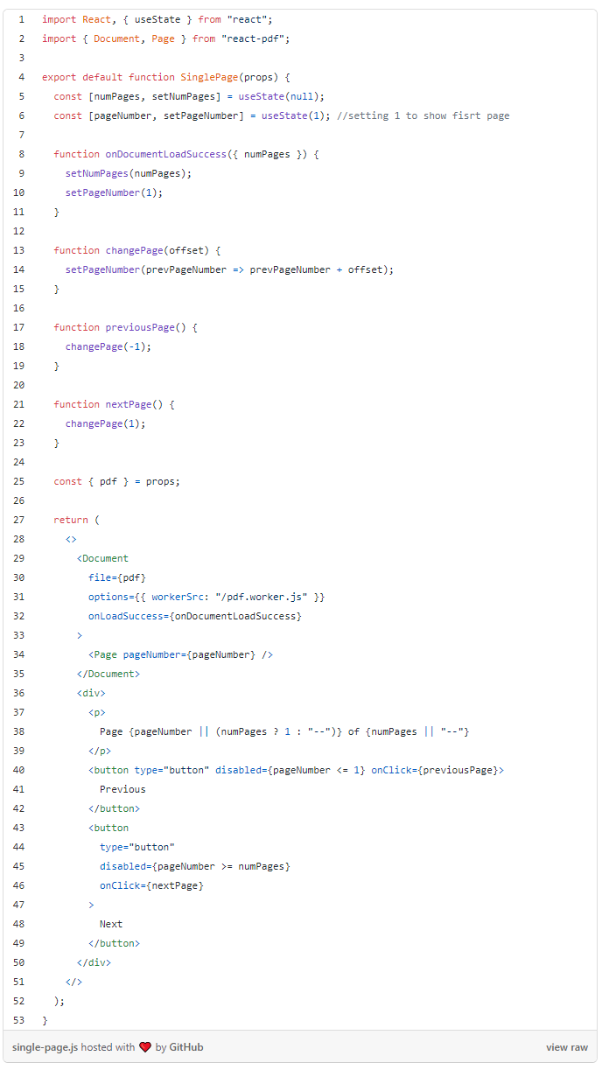

* all-pages.js

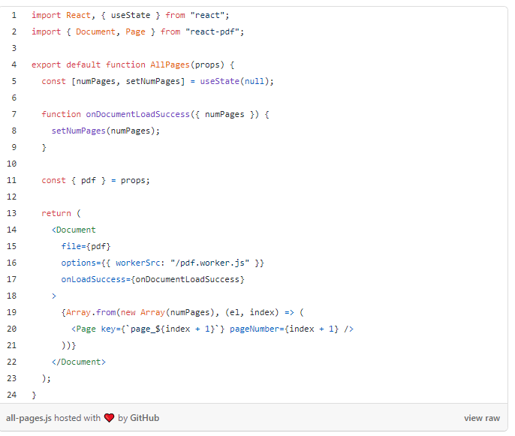

Now navigate to App.js and replace the content with the following code:

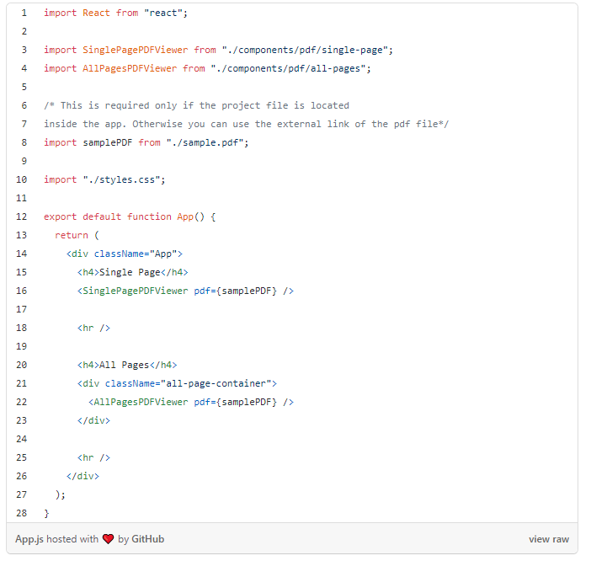

As you have noticed we have to create buttons to change the page of the document in single-page.js component. This is because react-pdf does not provide a user interface.

The full project code can be found here [github](https://github.com/webisora/displaying-pdf-using-react) and you can see the demo below:

https://codesandbox.io/s/displaying-pdf-using-react-5d003?from-embed=&file=/src/components/pdf/single-page.js

If you get the following error in console:

Uncaught SyntaxError: Unexpected token < <http://project_server.dev/app_folder/d58d9dd3a5c5f2a8eafb.worker.js>...

then follow the steps below:

1. Copy node_modules/pdfjs-dist/build/pdf.worker.js to public/pdf.worker.js
2. options={{workerSrc: "pdf.worker.js"}} Add this props inside the Document component from react-pdf . [It is already done in the above project. ]

END

**simple page code:**

import React, { useState } from "react";

import { Document, Page } from "react-pdf";

export default function SinglePage(props) {

const [numPages, setNumPages] = useState(null);

const [pageNumber, setPageNumber] = useState(1); //setting 1 to show fisrt page

function onDocumentLoadSuccess({ numPages }) {

setNumPages(numPages);

setPageNumber(1);

}

function changePage(offset) {

setPageNumber(prevPageNumber => prevPageNumber + offset);

}

function previousPage() {

changePage(-1);

}

function nextPage() {

changePage(1);

}

const { pdf } = props;

return (

<>

<Document

file={pdf}

options={{ workerSrc: "/pdf.worker.js" }}

onLoadSuccess={onDocumentLoadSuccess}

>

<Page pageNumber={pageNumber} />

</Document>

<div>

<p>

Page {pageNumber || (numPages ? 1 : "--")} of {numPages || "--"}

</p>

<button type="button" disabled={pageNumber <= 1} onClick={previousPage}>

Previous

</button>

<button

type="button"

disabled={pageNumber >= numPages}

onClick={nextPage}

>

Next

</button>

</div>

</>

);

}

**All page code**

import React, { useState } from "react";

import { Document, Page } from "react-pdf";

export default function AllPages(props) {

const [numPages, setNumPages] = useState(null);

function onDocumentLoadSuccess({ numPages }) {

setNumPages(numPages);

}

const { pdf } = props;

return (

<Document

file={pdf}

options={{ workerSrc: "/pdf.worker.js" }}

onLoadSuccess={onDocumentLoadSuccess}

>

{Array.from(new Array(numPages), (el, index) => (

<Page key={`page_${index + 1}`} pageNumber={index + 1} />

))}

</Document>

);

}

**App.js code**

import React from "react";

import SinglePagePDFViewer from "./components/pdf/single-page";

import AllPagesPDFViewer from "./components/pdf/all-pages";

/* This is required only if the project file is located

inside the app. Otherwise you can use the external link of the pdf file*/

import samplePDF from "./sample.pdf";

import "./styles.css";

export default function App() {

return (

<div className="App">

<h4>Single Page</h4>

<SinglePagePDFViewer pdf={samplePDF} />

<hr />

<h4>All Pages</h4>

<div className="all-page-container">

<AllPagesPDFViewer pdf={samplePDF} />

</div>

<hr />

</div>

);

}