Q3) Boost Converter

3.1)

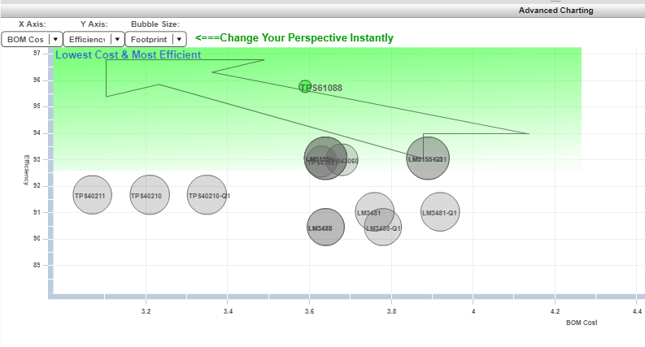

Figure X: advanced charting

There are so many factors to select electronic components in order to construct your electronic devices. The three most important factors among them: Cost, Efficiency, and Footprint. Cost is important because we want to reduce the cost of the product to increase the revenue of the company. Also, efficiency is important because we want the product to work with high performance for more efficient working performance. In addition, the smaller the area of the product, the more aesthetic in the product design, the ease of transport and other electric components provide space.

We can easily observe the impact of these three factors on Figure ”” X”” Advance Charting. Y represents axis efficiency, X represents the axis cost and Bubble Size represents the footprint. In evaluating these three factors while making our selection, we found the TPS61088 component to be the most optimum. Because the number of products that we will produce will be low, it will tolerate itself as a price. In addition, with reduced efficiency of component could deform over time and cause more serious cost losses. Also the heat energy released by the decrease of efficiency will increase and because of this reason, it also reduces the sustainability of the device. Therefore, efficiency is the most important factor for us. In addition, the TPS61088 component has a very small footprint, which further increases the accuracy of our selection.

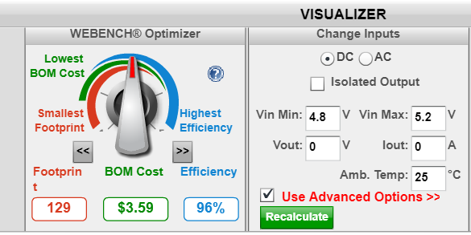  
Figure x: Webench Optimizer Tool

3.2)

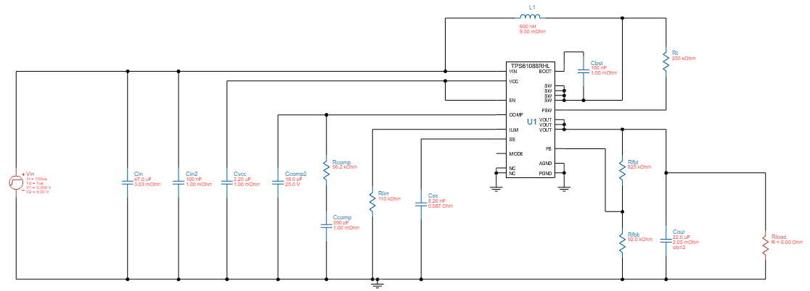

Figure x+2: Schematic TPS61088 (Boost Converter)

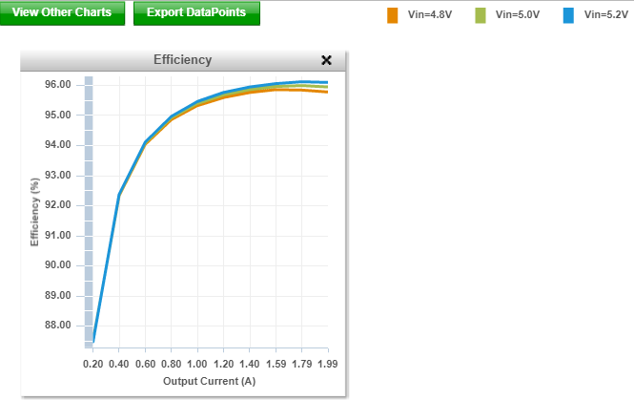

Figure x+3: Efficiency Vs Output Current Graph

Power is increasing in proportion to the square of the current. We expect Power loss to increase correctly with the square of the current. However, the power loss ratio of compenents with respect to load power is decreasing gradually. This is due to some factors that do not depend on the increase of the current. For example , voltage drop on diode isnt observed considerable change on diode related to increasing of current at operation mode.Then, while Load power increases on related to increasing current, most of the losses are increasing with a slower rate. Therefore, efficiency increases.

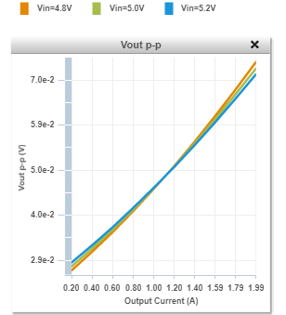

Figure x+4: Output Voltage Ripple Vs Output Current Graph

Principle of boost converter working systems similar like Ramp Pump systems. At boost converter when diode is open, the load is charging by source . Also when diode is closed , the load is fed from capacitor. Therefore more output current flows, the more capacitor supplies current to the load. As capacitor discharges more with increasing load current, more output voltage is observed on capacitor voltage(ripple voltage.)

**Op-Vals Section**

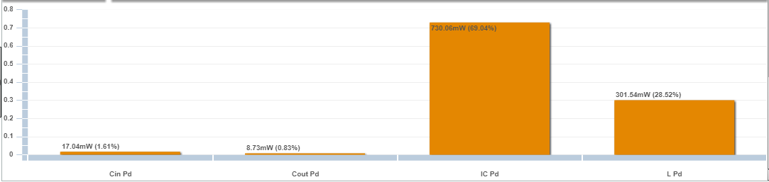

Figure x+5: Power loss graph of components

|  |  |
| --- | --- |
| Inductor Current Peak to Peak Value | 8.204A |
| Output Voltage Peak to Peak Value | 0.074V |
| Efficiency | 95.78 % |
| IC Junction Temperature | 53.3 degC |
| Mode | Boost CCM |
| Footprint | 123mm2 |
| BOM Cost | 3.53$ |

3.3)

**Steady state operation**

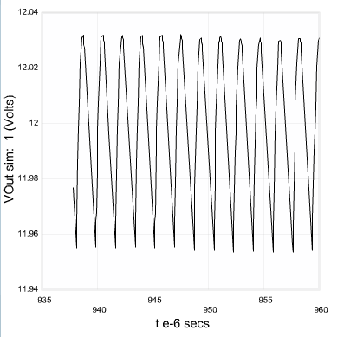

Figure x+5: Vout vs time graph at steady state

Based on our expectations, we obtained approximately 12 volts on the output voltage graph. Because of the high efficiency of the selected device, our ripple value is also very low. The Ripple value is approximately 0.1 Volts and these results are the desired value.

Also, the time that switch is opened, the capacitor is fed from source current , then voltage increases. On the other hand, the time that switch is closed, the capacitor feeds the load ,then voltage ecreases. Because of this mechanism, we observed this voltage ripple in this figure. 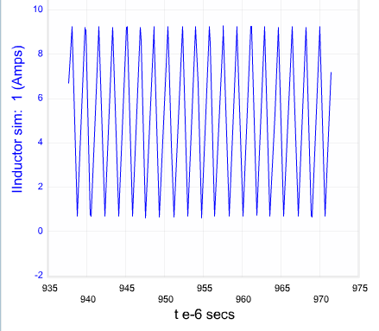

Figure x+5: inductor Current vs Time Graph **for Steady-State**

Also, the time that switch is opened, the inductor is fed from the voltage(Vout - Vin) which is negative value, then current decreasses. On the other hand, the time that switch is closed, the inductor is fed the source Voltage (Vin) ,then current increases.

**Load Transient**

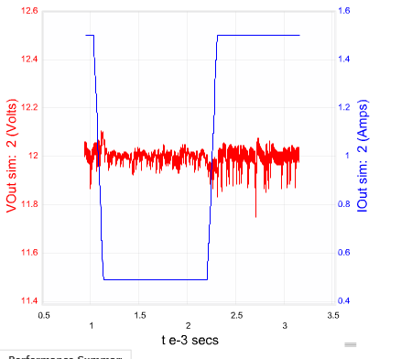

* Figure: Output Voltage & Load Current vs Time for Load Transient