Automated Custom Placement and Routing for Advanced Nodes

Mayank, Varshney, Bhupendra Vishwakarma, Indushekar Benjwal

Intel Corporation
Bangalore, India

www.intel.com

ABSTRACT

Lower Process nodes have manufacturing rules that make hand crafted custom digital and analog layout process challenging not just due to the routing limitations but also due to the methodology requirements starting from the beginning of the Layout Design. The choices available for placement for devices, standard cells and even block level instances are all constrained by the DFM rules.
The placement and routing complexities pose challenges to the manual Layout design due to both the nature and the number of rules. A methodology gets established to build a layout with consistency to abide by the DRC rules at each of the Placement and Routing stages to make the design creation a manageable task. Automation when integrated with a sound methodology seems to show the best possible results converting the problems in Lower process nodes to benefits which actually aid the layout design cycle to stay fast and efficient.
Constraints based Layout Generation Flow provides a solution to capture the design intent and enables an automated/assisted Layout Generation by customizing the constraints based on evolving design requirements. This paper highlights the usage of Constraint driven automated placement using Synopsys Helix Placer and constrained routing using Titan SBR to work around these complex challenges.

With placement constraints like Rows, Colums, partitions, halos, overlaps and guard rings, and enabling of extraction of these from pre-existing circuits facilitates the user to apply the design intent and routing constraints like Differential pair, shielding, bus and matched length routing enable specialized custom routing.

This flow has been developed and deployed across design teams and the results verified over different Custom and Mixed Signal testcases. The quality of results has been benchmarked for productivity benefits and process rule cleanliness using this flow.

Table of Contents
1. Introduction 4
2. Automated Custom Placement Flow 4
3. Placement Constraints Extraction 5
4. Constraints Aware Routing Flow 6
5. Results 6
6. Conclusions 6
7. References 6

Table of Figures
Figure 1 Automated Custom Placement Flow 5
Figure 2: Placement Constraints Extraction 6

Table of Tables
Table 1 Automated Custom Placement and Routing Results 9

Introduction

With the advent of Advanced Process Nodes, we get numerous scaling benefits but only at the cost of many process rule complexities penetrating foremost into the Design cycles. Complex DRC rules force not just Routing complexties but also the placement of every device, standard cell and transition ring has to abide by a methodology in order to yield DRC, LVS and reliability clean layouts.

The flip side of these limitations is that customizations to fine tune the Analog circuits are limited within the realm of this methodology and a minor area scaling is compromized to meet the methodology. But a hidden benefit of the complex rules is the scope of considerable automation even within the Analog world to speed up the design cycle.

In this paper, we use constraints as a way of providing customization within the Analog ICs and highlight the ways to automate the analog placement much like digital placement so that the process methodology is abided and still the design cycles gain due to the regularity of the process. We explore ways to auto-extract constraints from the schematic or a older-process layout and then use constraint aware routing to complete the design primarily with automation.

Thus with a little manual intervention in defining and refining constraints, bulk of the layout task is executed through automated tools like Helix and SBR. Additional benefits like ease of refinement and ECOs is also highlighted as a significant change in the Layout Design process which with the above approach can now be more incremental, parallel and flexible rather than manual, hard and sequential.

Automated Custom Placement Flow

A typical placement flow as shown in Figure 1, is composed of hierarchical floorplanning, devices & standard cell placement, optimizing instance and pin locations and finally creating block boundaries to prepare the block for placement at next hierarchy. We utilize the benefits of Hierarchical floorplanning within Helix and the freedom to integrate customized scripts, to achieve the above tasks. Thus, the recommended flow is usable from the beginning of the floorplanning uptil a point when optimum placement of instances and pins has reached.

Helix is launched from the top level schematic netlist and populates all the block hierarchies. Relevant constraints are applied to instances at each hierarchy, starting from the lower level hierarchies.
At leaf level hierarchy, different constraints are applied to devices & standard cells so that the process specifications on these instances are met. We apply partition constraints for standard cells and a customizable inline template constraint on devices in order to provide flexibility to design teams in specifying device placement methodology. Guard rings, Halo spaces and Finish constraint are used at various levels of hierarchies to separate different types of devices and abide by the block level placement methodology.

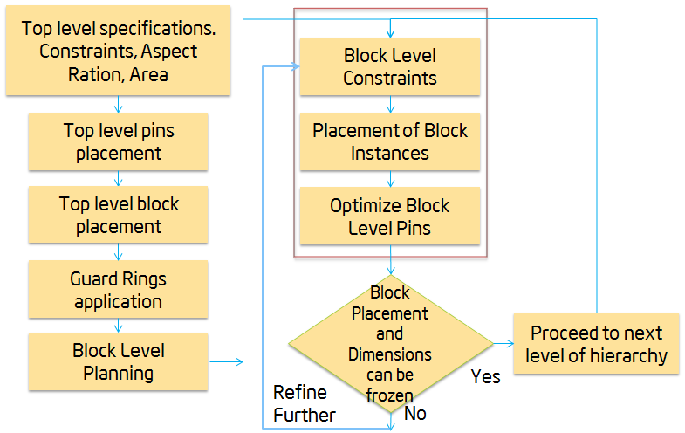
Figure 1 Automated Custom Placement Flow
Helix allows users to create hierarchical constraints and thus user can group few instances together under one constraint and then apply another constraint on this group. Thus the constraints created are granular and their intent is clear and unique. Since the constraints management is hierarchical, the user can define constraints at multiple levels of hierarchy and then re-generate the whole hierarchy in a single iteration. Helix also allows multiple placement solutions all of which abide by the constraints specified by the user. Thus, user gets a choice of Aspect Ratio and relative placement while sticking to the constraints intent between the instances which are critical for their designs.
Given the fact that multiple hierarchies can be run together, the user gets a choice to refine few hierarchies from the requirements at another level of hierarchy. For blocks which are hard or frozen after manual layout can be excluded from runs. Thus, with the above flow refining the blocks hierarchically and using the utilities to stick to a process methodology, the design teams are able to close complete design hierarchies with >20% reduction in design time

Placement Constraints Extraction
In Automated Custom Placement flow, the only manual inputs that are required are constraints. In order to truly automate the Layout Design, we explore different ways to extract placement constraints and thus provide a reasonably good starting point for constraints specification. Another useful input for constrained instance placement is pin location, which can be extracted from a pre-existing floorplan or a real layout from a previous process node.

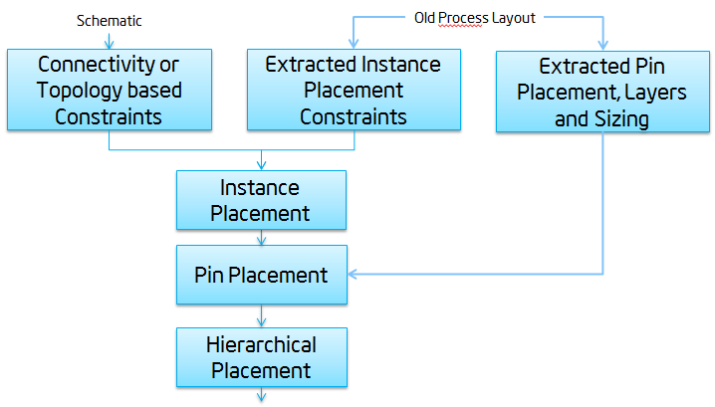
Figure 2: Placement Constraints Extraction

Both these options are discussed in detail in the following sections:

Instance Placement Extraction
Extracting the placement of instances is an important step to automate the layout design efforts using constraints since it reduces the efforts to create constraints. The tools to extract placement constraints can either extract these constraints from the schematic netlist or from the equivalent layout designed in a previous process node.
Connectivity based constraints extraction from netlist is an inbuilt feature within Helix called Helix First Look. This tool alongwith a topology extraction for common analog circuits like Differential Pair and Current Mirror, provides a natural schematic driven starting point by grouping connected devices as constraints. Some additional work can be done to improve the quality of extracted constraints further to match the target process placement methodology.
Another approach to extract placement constraints is from a reference layout from a previous process node. In this approach, we extract the placement of devices and cells from the older process node, by establishing relations between instances like rows, columns, partitions etc. These extracted constraints with the help of a mapping chart are applied to the equivalent set of instances in the target schematic. This techniques effectively captures the design intent if it consistent between processes and further improvement have been made like filtering out Fill and tap instances and extracted special structures like transisiton rings and guard rings. For designs with a reasonable similarity between old and new process nodes, this approach proves to be more effective than starting from scratch.

Pin Placement Extraction
For blocks which have similar aspect ratio, dimensions and metal routing as the older process node designs, we can extract pin placement on the similar lines as instance placement. We have written utilities outside Helix to parse the pin placement, sizing and layer information from a source layout and scale these values by an overall process scaling factor to find the rough pin placement estimates in the new process node.
Extracted pin placement information is provided to Helix as yaml files which are directly read in Helix and used as guides for Instance Placement optimization. The pin layers also form guides to the metal routing within the equivalent cells, thus creating a design with a very similar placement and routing as the older process node. Providing design intent alongwith automation to save design time proves to be effective automation solution for many design teams.

Constraints Aware Routing Flow
The routing flow has primarily two inputs, design data and technology information. Design information is composed of the OA design cell view and design specific user constraints. The technology information necessary for the routing consists of routing layers, vias and DRC constraints. SBR infers the routing layers and standard vias from the OA technology directly. The spacing, width and other technology constraints for routing are read in by SBR from the OA technology. Other advanced constraints are mapped to equivalent SBR constraints.
SBR, by default, routes the nets and pins at the top level to the pins of the sub-blocks. The pins of the blocks are the terminal points for the router. the pin based routing can causes limitations in two cases.
- In designs with standard cells with small pin geometries, the attempt to connect to these geometries can be obstructed by other blocking structures.
- In complex top level design with block level pins located on the interior on the blocks, the routing time can go up in finding error free routes.
SBR provides all the basic tools to enable custom routing. The SBR core needed to be leveraged further to meet various types of design and ease of usability. In this regard, we have developed a customized automatic violation fixing flow and enhanced the router to support a connectivity extracted routing as mentioned in section
SBR is enabled to support analog routing contraints like Diffpair, Matched length, Shielding, Bus and parallel routing. Flow has been enabled to support width based routing for a net on a particular layer.
SBR flow is customized to automatically fix violation without manually running fixing commands by user. . The router allows designer control of the rip up radius for the repair phase. SBR provides some recommend practices for deciding this rip up radius. It was noticed that user decision on the rip up radius can lead to longer time to converge to a DRC/LVS clean solution.Based on understanding gained about the repair passes through our extensive testing on multiple testcases two methods for automatic violation fixing were explored. The two methods were introuduced randomized repair and systematic repair; to fix the violations.

Results
Table 1 shows the placement and routing results from the Automated Constraint Driven Placment and routing flow. It also lists the placement time, DRCs and productivity improvement, for different blocks exercised:

Block | Number of placed cells | Placement time (% improved) | Number of Routes | DRC | Routing time (% improved)
Custom Blocks (Device Placement)
Opamp | 16 | 35 | 18 | 2 | 50
LowLeakage | 86 | 28 | 953 | Clean | 65
Analog | 86 | 28 | 951 | 3 | 65
Custom Dig | ~200 | 34 | 2152 | 3 | 78
Digital Blocks(Stdcell Placement)
Ring Oscillator | 46 | 45 | 56 | Clean | 56
Demgen | 48 | 55 | 70 | Clean | 35
Memory Control | 124 | 70 | 140 | Clean | 84
Gen Delay | 36 | 50 | 33 | Clean | 30

Table 1: Automated Custom Placement and Routing Results

We see the results on these testcases to be fairly promising for the range of testcases used and further refinements are underway to make this solution scalable to bigger blocks with wider range of mixed signal variations within the designs.

Conclusions

In this paper, a constraint driven placement and routing flow has been enabled. The benefits of automation with constraints have been extended further by different ways of automatically generating placement constraints and pin locations.
The results have been verified on a wide variety of testcases and scope of further improvements has been identified to make this flow scalable to various design teams with large block sizes.

References

- Helix User Training Documentation
- Synopsys Titan SBR Documentation

