UDP flood in Farm Flow data
Packet evidence and mathematical detector model
Prepared for Polra Victor and software engineers | Created and updated 26 October 2026

Context and purpose
This report examines the supplied August, September and October UDP_Flood recordings. It supports farm IoT security research by identifying observed addresses, packet signatures, timing and detector results. Use it to inspect similar traffic in a capture analysis tool or monitoring pipeline and to design validation experiments.
Main finding: each recording contains a sustained stream of empty UDP datagrams to 192.168.1.5 at destination port 5683. The same observed sender MAC appears under three source IPs. The rate detector triggers in all 46 complete five second windows. This establishes a repeatable packet pressure signature; it does not establish service failure or a validated detection accuracy.

Attack characteristics
A UDP flood sends many datagrams toward a host or service, potentially consuming packet processing, network or application resources. UDP has no connection establishment and no inherent congestion control. Application protocols must supply any required reliability and rate control. [2, 3]
Port 5683 is the default CoAP UDP port. However, every selected datagram here has UDP length 8, leaving zero application bytes. A CoAP message needs a four byte base header, so these are not valid CoAP requests. The supported description is an empty UDP packet flood toward a CoAP associated port. A port number alone does not prove what service was listening. [4]

Observed addresses and roles
Recording | Sender IP | Sender MAC | Target
August | 192.168.1.9 | 5c:ba:ef:e5:02:dd | 192.168.1.5  e4:5f:01:b3:6c:1b
September | 192.168.1.16 | 5c:ba:ef:e5:02:dd | 192.168.1.5  e4:5f:01:b3:6c:1b
October | 192.168.1.136 | 5c:ba:ef:e5:02:dd | 192.168.1.5  e4:5f:01:b3:6c:1b

The sender is the observed traffic generation endpoint; the target is a farm network host. The packet signature does not establish either device’s exact board, operating system or physical farm purpose. The repeated MAC associates an observed interface across recordings, but does not prove physical ownership, DHCP allocation or that an IP could not be forged.
Confidence of validity: counts and address fields are directly measured in the supplied files. A numerical probability for hardware identity, malicious intent or successful denial of service is not calibrated by these captures and is therefore not assigned.

Dated recording results
Times derive from packet timestamps expressed in UTC. The first split filename clock is one hour ahead in every archive; its timezone is unspecified. These are discrete recordings on three dates, not continuous monitoring of the intervening months.
Date in 2022 | Capture interval UTC | All packets | Selected UDP
19 August | 17:49:00.539–17:51:17.716 | 220,097 | 219,735
19 September | 15:22:58.207–15:23:37.702 | 100,000 | 99,851
8 October | 10:50:08.755–10:51:19.204 | 199,073 | 196,694

Observed signature
Field or measure | August | September | October
Destination port | 5683 | 5683 | 5683
IPv4 length per selected packet | 28 bytes | 28 bytes | 28 bytes
UDP length including header | 8 bytes | 8 bytes | 8 bytes
UDP application payload | 0 bytes | 0 bytes | 0 bytes
Distinct selected source ports | 63,857 | 52,416 | 49,233
Reverse UDP from target to sender | 0 | 0 | 0
Valid IPv4 checksums | 219,735 | 99,851 | 196,694
Valid nonzero UDP checksums | 219,733 | 99,851 | 196,692
UDP checksums absent | 2 | 0 | 2

A transmitted zero UDP checksum in IPv4 means no UDP checksum was supplied; it is not a failed checksum. All nonzero selected UDP checksums pass verification. No selected datagram was rejected for a length inconsistency, and no fragmented IPv4 packets were encountered in these recordings. [2]

Packet examples and background activity
Frame 1 of each original is already part of the selected stream. Its source port is 14324 in August, 1146 in September and 29374 in October. Each targets .5:5683, has a valid IPv4 checksum and nonzero valid UDP checksum, and contains no UDP application data.
Separate UDP traffic to the same destination port is present: .20 → .5 has 12 packets and .5 → .20 has 11 in August; .13 → .5 and .5 → .13 each have 10 in September; October has 60 and 25 respectively. These background exchanges are not responses to the dominant sender and are not an independently labelled normal control.

Time based activity graphs
Each point is the selected UDP packet count divided by five for a complete UTC aligned five second window. Partial bins at capture boundaries are excluded. The dashed line is an illustrative threshold rather than a threshold learned from normal operation.
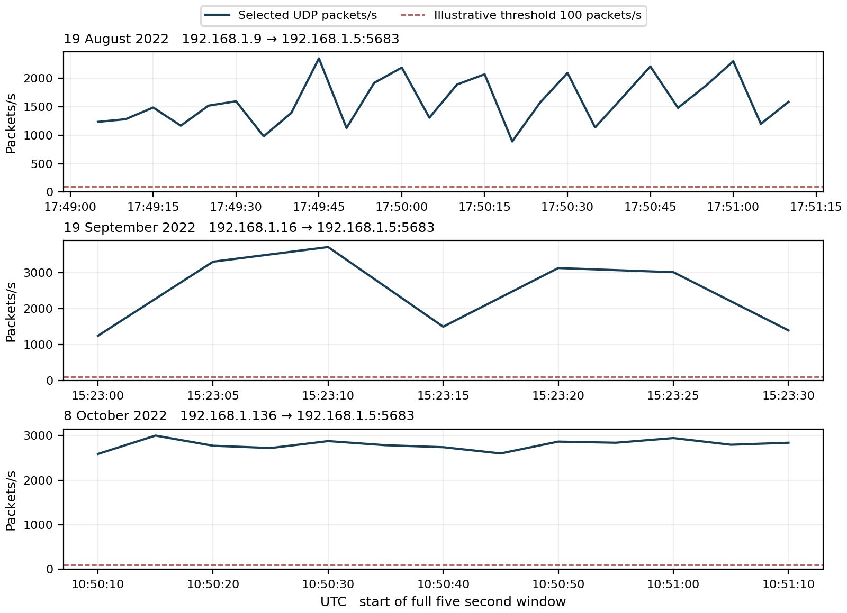
Figure 1 Empty UDP datagram rate toward 192.168.1.5 at port 5683. The three panels have separate time axes and show the observed recording intervals only.

Before during and after the observed activity
Pre activity: all three recordings begin with the selected stream, so none establishes a clean baseline or the true onset. During activity: all complete five second windows exceed the illustrative 100 packets/s threshold, with changing source ports and no UDP payload.
Post activity: August’s last selected datagram is at 17:51:17.397651 UTC, only 0.319 seconds before capture end. September and October selected traffic reaches the final recorded packet. None provides a sufficient post activity interval to demonstrate recovery or sustained cessation.

Mathematical model for detecting UDP pressure
For source s, destination d and destination port q, let N(s,d,q,k) count parseable UDP datagrams in window W(k) of duration five seconds. Here d = 192.168.1.5 and q = 5683. Count all source ports together so port variation does not split the signal.
$$R(s,d,q,k) = \frac{N(s,d,q,k)}{5}$$
$$D(s,d,q,k) = 𝟙[R(s,d,q,k) ≥ 100]$$
R is packets per second. D = 1 flags at least 500 datagrams in five seconds; D = 0 means the rate rule did not trigger. Missing or unreadable evidence is unscored. The value 100 is illustrative and needs independent normal traffic and capacity measurements before deployment.
Recording | Full windows | Flagged | Peak count per 5 s | Peak packets/s
August | 26 | 26 | 11,730 | 2,346.0
September | 7 | 7 | 18,544 | 3,708.8
October | 13 | 13 | 15,010 | 3,002.0

Worked result from the actual capture
In August, the full window 17:49:45–17:49:50 UTC contains 11,730 selected datagrams. The model therefore produces an explicit alarm result:
$$R = \frac{11,730}{5} = 2,346 ≥ 100 ⇒ D = 1$$
Each selected IPv4 datagram is 28 bytes. For that same window, the IPv4 bit rate is:
$$B = \frac{8 × 28 × 11,730}{5} = 525,504 bits/s$$
This excludes Ethernet and physical link overhead, replies and other traffic. Packet processing pressure can matter even when the observed IPv4 byte rate does not saturate a link.

Supporting signature
$$E(s,d,q,k) = \frac{selected datagrams with zero UDP payload}{all selected datagrams}$$
E = 1 throughout the selected streams, meaning 100% are empty UDP datagrams. This is a composition ratio, not a probability that an attack succeeded. Use rate together with E, source port diversity and persistence to describe the observed pattern; the evaluated alarm rule above depends on rate alone.
The 46 flagged windows belong to three recordings. They are not 46 independently labelled attacks. Precision, recall and calibrated attack confidence cannot be calculated without independent normal and attack labels.

Attack direction and evidence of impact
The observed direction is sender → 192.168.1.5:5683. No reverse UDP from .5 to the dominant sender and no ICMP packets were observed in the originals. UDP does not require a reply, so silence alone proves neither packet loss nor a service outage. The traffic does not demonstrate reflection or amplification through responding intermediaries.
Successful denial of service would require independent evidence such as authorized request failures, increased latency, receive queue drops, CPU load or interface loss compared with normal operation. Separate background UDP exchanges continue, but their presence alone does not establish complete farm service health.

What to look for and how to combat it
Monitor per source and aggregate target UDP rate, packet length, payload length, destination port, source port diversity and persistence. Track authorized application transactions separately. Many empty datagrams to a normally structured application port are a useful investigation signal; a single empty datagram is insufficient to establish malicious intent.
Apply measured rate limits and access policy at the host and an upstream enforcement point, preserving required farm communication. Validate application framing before expensive processing. If a link is saturated, filtering only at the receiving host cannot protect that link. Application authentication helps control legitimate operations but does not remove incoming network load.

ML approaches and validation
Start with the transparent rate detector. Compare an online change detector or an anomaly model using packet rate, empty payload fraction, length distribution, source port diversity and duration. Supervised tree models are candidates once independent labelled normal and flood sessions exist. Add service health measurements if the prediction target is actual disruption.
Split training and testing by recording and time; keep originals and identical splits together to avoid data leakage. Avoid letting a model learn only the sender IP or MAC. The present recordings support detecting an existing pattern, not a proven forecast of an attack before traffic begins.

Conclusion
The repeated observed signature is high rate, empty UDP datagrams toward .5:5683 with many source ports. All 46 full windows trigger the illustrative rate rule. Hardware identity, service exhaustion and physical farm consequences remain unverified.

Using the result as an E Unit
Data: packet fields and timestamps are direct observations from supplied captures. Information: the report groups these into addresses, signatures and time windows. Knowledge: the equations connect counts to explicit alarms. Expertise: apply the detector in a monitored trial, validate outcomes and share reproducible findings. Primary protocol specifications ground terminology; hardware and impact interpretations remain separate hypotheses.

Appendix A Understanding the equations and UDP terms

Reading the detector
$$R(s,d,q,k) = \frac{N(s,d,q,k)}{5} D(s,d,q,k) = 𝟙[R ≥ 100]$$
s identifies source IP; d identifies destination IP; q is the destination UDP port; k indexes time window W(k). N counts datagrams regardless of source port. Divide by five to obtain packets per second. The indicator 𝟙[condition] returns 1 if its condition is true and 0 otherwise; ≥ means greater than or equal to.
For the August peak, N = 11,730 gives R = 2,346 packets/s and D = 1. An alarm is evidence that this rule triggered, not evidence that the target stopped working.

Reading packet size and payload
IPv4 total length includes its header and transported UDP bytes. Here 28 bytes comprise a 20 byte IPv4 header plus an 8 byte UDP header. UDP length includes its own header, so UDP payload length is 8 − 8 = 0 bytes. There is no application message to decode in the selected stream. [2]
$$E = \frac{number of empty selected datagrams}{number of selected datagrams} = 1$$
E = 1 means all selected datagrams are empty. It is not confidence of maliciousness or detector accuracy. Source port diversity counts distinct field values, not devices or successful sessions. UDP has no transport handshake that would justify a connection completion percentage.

Reading the bit rate
$$B(s,d,q,k) = \frac{8 × L(s,d,q,k)}{5}$$
L sums selected IPv4 lengths in the window. Multiply bytes by eight and divide by five seconds to get bits/s. Here B = 8 × 28 × R. This is IPv4 traffic rate, not full wire rate, and does not measure a device’s actual CPU or link capacity.

Changing sensitivity
Lower the 100 packets/s threshold to flag smaller surges, accepting potential extra alerts. Raise it to require a stronger rate. Shorter windows react faster and fluctuate more; longer windows emphasize sustained pressure and can dilute brief bursts. If duration changes, divide N by the new duration and retain a threshold expressed in packets/s.
Select a threshold from independently observed normal sessions and acceptable false alarm rates. Test against held out recordings, varying device schedules and measured service capacity. The current threshold is not optimized or validated. Normal background packets inside a labelled attack capture do not replace an independent normal evaluation set.

Scope and validity
Scale: packet and host observations are linked to network behavior; they do not establish physical crop effects. Time: these are retrospective 2022 recordings. Clarity: counts and flags are reproducible; identity, intent and future generalization have greater uncertainty. No invented numerical confidence is attached to these unvalidated inferences.

Appendix B Provenance and evidence limits

Source recordings
August udp_flood_august_original.pcap
SHA256 8e15bc3aa6cac94c9123c657ecc87047ca8534af9d4916f38b907c91565b77ed
September udp_flood_september_original.pcap
SHA256 0a92bda85c5491f4965e999e1b04c4ec2875b19d56425a08a1448d2c82fc9443
October udp_flood_original.pcap
SHA256 965af79fbac3ad0a104761c21896c859270bcb589733d1db744258ba85c51940
Sources are 08_2022_UDP_Flood.zip, 09_2022_UDP_Flood.zip and 10_2022_UDP_Flood.zip. Their 28, 8 and 15 split files reproduce their respective originals exactly as timestamp and packet byte multisets. Only originals were counted: 519,170 packets in total. No exact timestamp and byte duplicates were found within any original.
First split filename clocks are 18:49:00 on 19 August, 16:22:58 on 19 September and 11:50:08 on 8 October 2022. Each is one hour ahead of the packet UTC clock; no filename timezone is assumed. Frame numbers are one based within each named original.

Analysis method and limitations
The parser reads Ethernet IPv4 records and checks UDP header and datagram lengths against captured bytes and IP length. It aggregates by source IP, destination IP and destination UDP port. IPv4 and nonzero UDP checksums were verified in every selected datagram. The four absent UDP checksums are explicitly distinguished from failures.
All selected UDP lengths are eight bytes and all selected IPv4 lengths are 28 bytes. The selected source ports number 63,857, 52,416 and 49,233 across the three dates. The reverse UDP search considers target to selected sender traffic across ports; none was observed. No ICMP records were found in these originals.
Only complete UTC aligned five second windows inside each capture are scored. Exact equality between original and split packet sets does not establish lossless collection or visibility outside the recording point. The absence of a reply cannot establish what a target received or processed.
No synthetic traffic substitutes for capture evidence. No independent normal archive, application server log, resource measurement or device inventory was supplied for this analysis. Hence there is no measured false positive rate, attack success probability or calibrated hardware confidence.

References
[1] Supplied Farm Flow UDP_Flood archives and originals listed above. Direct analysis performed 26 October 2026.
[2] IETF RFC 768 User Datagram Protocol. https://www.rfc-editor.org/rfc/rfc768.html. Header length and checksum semantics; accessed 26 October 2026.
[3] IETF RFC 8085 UDP Usage Guidelines. https://www.rfc-editor.org/rfc/rfc8085.html. Transport behavior and congestion control; accessed 26 October 2026.
[4] IETF RFC 7252 The Constrained Application Protocol. https://www.rfc-editor.org/rfc/rfc7252.html. Four byte base header and default port 5683; accessed 26 October 2026.

