Botnet DDoS in Farm Flow data
Packet evidence and mathematical detector model
Created 26 October 2026

Context and purpose
This report examines the supplied August BotNet_DDOS recording to identify observed request behavior, device associations and usable detection signals. It supports farm IoT security research and offline detector development. Only this August archive was supplied for this attack category; no September or October findings are inferred.
Main finding: repeated HTTP GET /check requests to 192.168.1.5:1880 are dominated by 192.168.1.20. The server continues returning HTTP 200 responses. The recording supports sustained request pressure, but does not by itself prove multiple compromised bots, their controller or successful denial of service.

Attack characteristics
A botnet is a collection of compromised devices under coordinated control. A distributed denial of service attack uses multiple sources to exhaust a target’s service or network capacity. In a farm, the intended harm could be delayed monitoring or unavailable control services. Those operational consequences must be measured; they are not established by a dataset folder label. [2]

Observed addresses and roles
Observed IP and MAC | Packet evidence | Supported interpretation
192.168.1.20  bc:dd:c2:2f:bd:00 | 7,420 unique GET /check requests; ESP8266HTTPClient header | Dominant requester; ESP8266 software family is plausible, exact hardware unverified.
192.168.1.5  e4:5f:01:b3:6c:1b | HTTP 1880; Express headers; debug messages to .8 | Farm application service host; Node RED is strongly suggested, board model unknown.
192.168.1.2  78:21:84:9b:14:40  192.168.1.24  24:62:ab:f1:91:48 | 115 GET /check requests each; ESP32HTTPClient headers | Lower rate polling clients; neither bot status nor malicious intent is established.
192.168.1.8  5c:ba:ef:e5:02:dd | Receives debug data from .5 and sends TCP acknowledgments | Monitoring or editor client is plausible; not established as a traffic controller.

Hardware and role statements are inferences. User Agent strings are changeable, and a MAC identifies an observed Ethernet sender rather than proving ownership or physical device identity. No calibrated confidence percentage is available. [3, 4]

Dated recording results
Date: 20 August 2022. Packet timestamps span 10:29:36.102905–10:32:02.191378 UTC, a duration of 146.088 seconds. Split filenames span starts 11:29:36–11:32:01, one hour ahead of UTC packet time; the filename timezone is unspecified. HTTP Date headers independently use 10:29:36 GMT near the capture start.
The full original contains 30,306 packets. The 30 split files reproduce exactly the same timestamp-and-packet-byte multiset; only the original was counted. There are no exact timestamp-and-byte duplicates within it. The splits use PCAPNG format despite their .pcap extension. [1]
Source IP | Unique GET /check messages | Peak messages per 5 s | First request frame
192.168.1.20 | 7,420 | 279 | 3
192.168.1.2 | 115 | 4 | 42
192.168.1.24 | 115 | 4 | 24
192.168.1.10 | 4 | 1 | 4308

There are 7,654 unique captured GET /check messages in total; .20 contributes 96.94%. Its observed interval is 10:29:36.117093–10:32:02.185911 UTC. Fourteen repeated request segments were collapsed by TCP flow, sequence and identical payload; repeated requests at different sequence positions remain separate events.
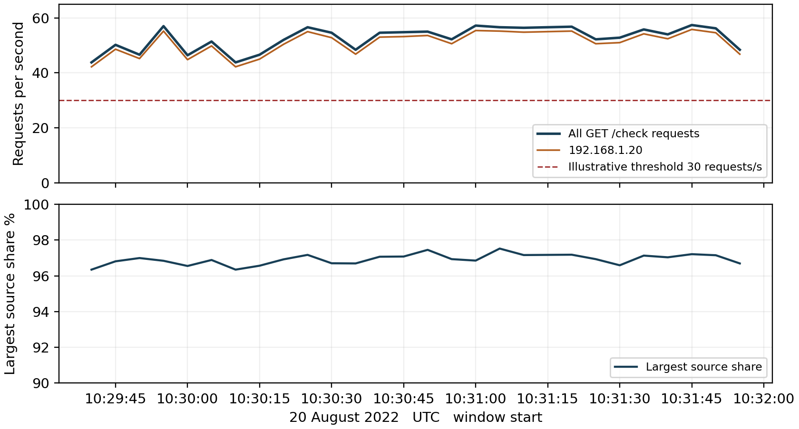
Figure 1 Request rate and source concentration in 28 complete five second windows. Boundary windows are excluded. The rate threshold is illustrative; source share is a traffic proportion, not confidence of maliciousness.
The high rate is already present when recording begins and persists to its end. A clean pre attack baseline, true onset, cessation and recovery are not captured. Low rate clients in the same recording are comparisons, not independently verified normal controls.

Mathematical model for detecting request pressure
Scope: complete GET /check HTTP messages to 192.168.1.5:1880, after removing repeated TCP segments. For each source s and fixed UTC aligned five second window W(k), let n(s,k) be its message count. Score only windows entirely inside the capture interval; missing or unreadable evidence is unscored.
$$N(k) = Σ n(s,k)$$
$$R(k) = \frac{N(k)}{5} C(k) = \frac{max n(s,k)}{N(k)}$$
N is total requests; R is requests per second; C is the largest source’s fraction of those requests. Define C = 0 when N = 0. A high C describes concentration; it does not identify a distributed botnet.
$$D(k) = 1[R(k) ≥ 30]$$
D is an illustrative request pressure alert. The threshold is 30 requests/s, equivalent to 150 messages per five seconds. All 28 complete windows trigger: their aggregate rates range from 43.8 to 57.4 requests/s. These are 28 alert windows in one short recording, not 28 independently established attacks.

Testing evidence of distribution
$$A(k) = Σ 1[\frac{n(s,k)}{5} ≥ 5]$$
$$B(k) = D(k) × 1[A(k) ≥ 2]$$
A counts sources individually producing at least five GET /check requests/s. B flags high aggregate pressure with at least two such active sources. In every complete window A = 1 and B = 0: the chosen model sees one dominant source, not concurrent high rate contributions from several sources. This does not disprove the study label; low rate, unseen or differently behaving bots would require other evidence.

Worked example from the capture
In the window 10:31:45–10:31:50 UTC, .20 sends 279 messages; .2 and .24 send four each. Therefore:
$$N = 279 + 4 + 4 = 287 R = \frac{287}{5} = 57.4$$
$$C = \frac{279}{287} ≈ 0.9721 D = 1 A = 1 B = 0$$
Interpretation: strong request pressure, 97.21% concentrated in .20, and no distributed signature under the illustrative concurrency threshold. Neither D nor B measures malicious intent, compromise or service failure. Both thresholds require validation against normal and independently labelled data.

Attack direction and success
Observed direction is requester → farm HTTP service, followed by service replies and debug delivery to a monitoring client. The application service is Node RED compatible: TCP 1880 is its default port, and the observed debug payload schema supports that interpretation. Port choice alone would not identify software. [3]
All 7,654 deduplicated GET /check requests have a later captured HTTP 200 response on the reverse flow whose TCP acknowledgment equals the request’s final sequence position. Their capture side delays are below one second; for .20 the median is 3.13 ms and maximum 42.77 ms. This supports continued response delivery on this endpoint during the recording, not system wide health or correct physical operation.
$$M(j) = 1[matching HTTP 200 response within 1 second]$$
$$Q = \frac{Σ M(j)}{number of observed requests} = \frac{7,654}{7,654} = 1$$
Q is observed response coverage for these selected requests, not detector accuracy. There are 7,655 unique HTTP 200 response segments in total, including one at frame 1 before the first captured request. Capture boundaries explain why raw reply and request totals need not match. Repeated response segments were deduplicated separately.
Successful denial of service would need additional evidence: failures or delay relative to a normal baseline, resource exhaustion, application errors, interrupted authorized telemetry or unavailable control functions. Server CPU, memory, queue depth, user experience and crop effects are not measured here. Bot infection, command and control and coordinated malicious participation are also not established.

What to look for and how to combat it
Monitor request rates per endpoint and per device, source concentration, response errors and latency, and persistence across windows. Establish expected polling intervals before setting limits. Protect /check with suitable access control, rate limits and request budgets; apply both per source and aggregate limits. Segment device, service and administration traffic, and investigate a high rate sender before isolating it so farm safety functions remain available.
Investigate whether verbose debug streaming adds avoidable service work. Preserve captures and logs, verify device firmware and authorization, and isolate a confirmed compromised endpoint under the farm’s response plan. For an external capacity attack, upstream mitigation may be necessary; local HTTP limits cannot protect an already saturated link. [2]

ML approaches and validation
Begin with this transparent rule, then compare time series change detection or anomaly models using endpoint rate, periodicity, source mix and response features. A supervised model needs independent normal and labelled attack sessions. Split by recording, time and device; never place an original and its identical split packets in different folds. This one recording supports a demonstration, not precision, recall, early warning performance or calibrated maliciousness probabilities.

Appendix A Understanding the detector equations

Counting requests
$$N(k) = Σ n(s,k) R(k) = \frac{N(k)}{5}$$
s identifies a source IP. k identifies a five second time window W(k). n(s,k) counts that source’s unique GET /check messages inside the window. The summation symbol Σ means add across sources. N(k) is the combined count; dividing by five converts it into requests per second. TCP acknowledgment packets are not requests.
Retransmitting identical TCP data at the same sequence position does not create a new application request. A repeated GET at a new position in the byte stream is a new request, even if its text is identical. Counting packets would mix requests with acknowledgments, retransmissions and replies and would give a different metric.

Measuring concentration
$$C(k) = \frac{max n(s,k)}{N(k)}$$
max selects the largest source count. Dividing it by all request counts gives the largest source’s share. For 279 of 287 messages, C = 0.9721, or 97.21%. This percentage describes traffic concentration; it is not a 97.21% confidence that the sender is malicious. For an empty window, define C = 0.

Turning a rate into an alert
$$D(k) = 1[R(k) ≥ 30]$$
The indicator 𝟙[condition] returns 1 if the condition is true and 0 otherwise. The symbol ≥ means greater than or equal to. D = 1 when the selected endpoint receives at least 30 requests/s in that window. D = 0 means this threshold did not trigger; it does not prove safe traffic. A time window lacking usable evidence is unscored.

Looking for several active sources
$$A(k) = Σ 1[\frac{n(s,k)}{5} ≥ 5]$$
$$B(k) = D(k) × 1[A(k) ≥ 2]$$
A counts source IPs contributing at least five requests/s each. B is 1 only when the aggregate rate threshold is met and at least two sources meet that individual rate. Multiplication implements “both conditions must be true.” The example window has source rates of 55.8, 0.8 and 0.8 requests/s: A = 1 and B = 0.
Source IP count is not physical bot count. Address changes, shared gateways, forged identifiers and incomplete visibility can affect attribution. B is a proposed distributed activity signature; it cannot establish malware infection or coordinated control. Distributed low rate traffic can evade this particular rule.

Appendix B Response evidence and sensitivity

Reading the response equations
$$M(j) = 1[matching HTTP 200 response within 1 second]$$
$$Q = \frac{Σ M(j)}{number of observed requests}$$
j identifies one deduplicated GET /check request. M(j) = 1 means a response is seen within one second on the reversed TCP flow, with an acknowledgment equal to the request sequence number plus its byte length, modulo 2³². The response starts with HTTP/1.1 200 OK. M(j) = 0 means that qualifying response was not found; capture loss or a boundary may explain it.
Q divides matched requests by observed requests. Here Q = 1, meaning 100% observed response coverage for this selected request set. It is not 100% security, detector accuracy, end user availability or farm process correctness. Request to response timing is measured at the capture point, not as an independent client or server measurement.

Changing sensitivity
Lower the aggregate rate threshold below 30 to flag smaller surges, or raise it to require more traffic. Lowering the per source threshold below five admits slower contributors into A; raising it excludes more sources. The requirement A ≥ 2 expresses multiple active sources, but does not prove those sources are malicious.
A longer window can reveal sustained low rate pressure but may combine unrelated legitimate activity. Shorter windows can expose bursts but increase timing variability. Reassess rate thresholds whenever the endpoint, authorized polling policy or service capacity changes. Both boundary windows were excluded here rather than treated as fully observed five second intervals.

Proof and limits of detection
The demonstrated result is D = 1 in 28 of 28 complete windows and B = 0 in all 28. These proportions report rule behavior on the supplied recording, not sensitivity or specificity against ground truth. No separate normal capture, attack start and end annotations or known bot membership were supplied for this analysis. No synthetic cases replace the research data.
Messages were recognized as complete HTTP request or response payloads in individual IPv4 TCP segments. Identical flow, TCP sequence and payload copies were collapsed. This is not a general HTTP stream reassembler: segmentation, coalesced messages, encryption or IP fragmentation in other captures require a fuller parser. TCP keep alive streams already exist at the start of this recording.

Sources and reproducibility
[1] Supplied 08_2022_BotNet_DDOS.zip; primary recording BotNet_DDOS/bot_net_original.pcap and its 30 splits. Frame references are one based in the full original. SHA256 of original: 4ca0631f157a4ad0064c9f8b5aaba1fa38d3b402f1f1f4b4bf6e1c8ba69a6959.
[2] FBI Internet Crime Complaint Center, Botnets DDoS and TDoS. https://www.ic3.gov/CrimeInfo/Botnet-DDoS. Definitions and response guidance; accessed 26 October 2026.
[3] Node RED runtime configuration. https://nodered.org/docs/user-guide/runtime/configuration. Default service port and endpoint configuration; accessed 26 October 2026.
[4] ESP8266 Arduino HTTPClient implementation. https://github.com/esp8266/Arduino/blob/master/libraries/ESP8266HTTPClient/src/ESP8266HTTPClient.cpp. Default and configurable User Agent; accessed 26 October 2026.

