MQTT flooding in Farm Flow data
Packet evidence and mathematical detector model
Created 26 October 2026

Context and purpose
This report analyzes the supplied August, September and October MQTT_Flood capture archives. It identifies observed devices, traffic direction, timing and detector signals for the farm MQTT service. It separates a recorded service load pattern from claims about application message flooding, broker failure or physical farm consequences.
Main finding: each dominant sender repeatedly attempts TCP connections to 192.168.1.5:1883 and sends no TCP payload on that flow. No MQTT CONNECT, PUBLISH or other MQTT control packet from those senders is therefore demonstrated. These captures directly support connection pressure against the MQTT service; they do not demonstrate a PUBLISH message flood from the dominant sender.

Attack characteristics
MQTT is a publish and subscribe messaging protocol. Clients send messages on named topics to a broker, which routes them according to subscriptions. Flooding can target connection establishment or, after a session exists, application messages and broker queues. The intended harm is degraded service availability. A large packet count aimed at port 1883 does not by itself establish a high MQTT message rate or a failed broker. [2]

Observed addresses and roles
Recording | Dominant sender IP and MAC | Broker endpoint IP and MAC
August | 192.168.1.9  5c:ba:ef:e5:02:dd | 192.168.1.5  e4:5f:01:b3:6c:1b
September | 192.168.1.16  5c:ba:ef:e5:02:dd | 192.168.1.5  e4:5f:01:b3:6c:1b
October | 192.168.1.25  5c:ba:ef:e5:02:dd | 192.168.1.5  e4:5f:01:b3:6c:1b

The shared sender MAC associates an observed interface across changing IPs. It does not prove DHCP assignment, hardware identity or operator intent. The sender is a connection traffic source; these packets do not identify it as a temperature sensor or establish its operating system.
The target behaves as a broker endpoint: separate client traffic contains decoded MQTT exchanges. Its exact broker implementation, board model and agricultural control responsibilities are not established by these captures alone. Device and role inferences have no calibrated confidence percentage here.

Dated recording results
The recording dates are 19 August, 19 September and 9 October 2022. Times below use packet timestamps in UTC. Split filename clocks are one hour ahead; their timezone is unspecified. These are three discrete sessions, not continuous monitoring across the three months.
Date in 2022 | Capture interval UTC | All captured packets | Sender SYN packets to .5:1883 | Reverse SYN/ACK packets
19 August | 18:07:27.140–18:09:41.407 | 210,201 | 118,988 | 89,261
19 September | 12:35:19.609–12:35:39.124 | 100,000 | 33,685 | 30,694
9 October | 11:03:34.727–11:04:46.162 | 200,000 | 154,002 | 45,092

All three dominant sender flows have zero TCP payload packets and zero payload bytes. Their other packets to the same service are resets: 1,488 in August, 6,995 in September and 538 in October. Those SYN and reset counts account for every recorded sender packet on the selected port 1883 flow; no final handshake ACK from that sender is observed.
September additionally contains 28,563 SYN packets from the same sender to TCP destination port 0. These packets are excluded from the port 1883 model and are not MQTT application messages. Total recording packet counts also include reverse replies and other device activity.

Packet evidence and MQTT content
First selected SYN frames are August 1, September 7 and October 1. The first reverse SYN/ACK frames are August 419, September 8 and October 9604. A SYN/ACK is a transport response, not a MQTT CONNACK or proof that an application session was established.
Separate background traffic contains MQTT 3.1.1 CONNECT packets in August and October, plus topic publications and broker messages. August frame 3559 carries a QoS 0 PUBLISH from .19 to .5 on topic3/1 with payload 27.4. October frame 138144 carries a QoS 0 PUBLISH from .11 to .5 on topic1/1/1 with payload 0.89. Numeric values do not establish units or sensor calibration.
October frame 14008 contains a broker PUBLISH to .4 on mqtt_3_response with payload actuatorOFF. This is a recorded message string, not proof that a physical actuator changed state or that flooding caused a control response. September has two decoded background SUBACK packets but no decoded PUBLISH in this capture.

Before during and after the observed activity
August and October begin with selected connection attempts at frame 1. September begins selected port 1883 attempts at frame 7, roughly 0.002 seconds after capture start. Activity spans the short recordings, so a clean normal baseline, true onset, cessation and recovery are not established. Observations between these recordings are unavailable.

Time based activity graphs
Blue shows initiating SYN packets from the dominant sender to port 1883; orange shows reverse SYN/ACK packets. The dashed line is an illustrative 100 SYN/s threshold. Each panel uses its own labelled vertical scale. Reverse responses are not counted as new client attempts or MQTT messages.
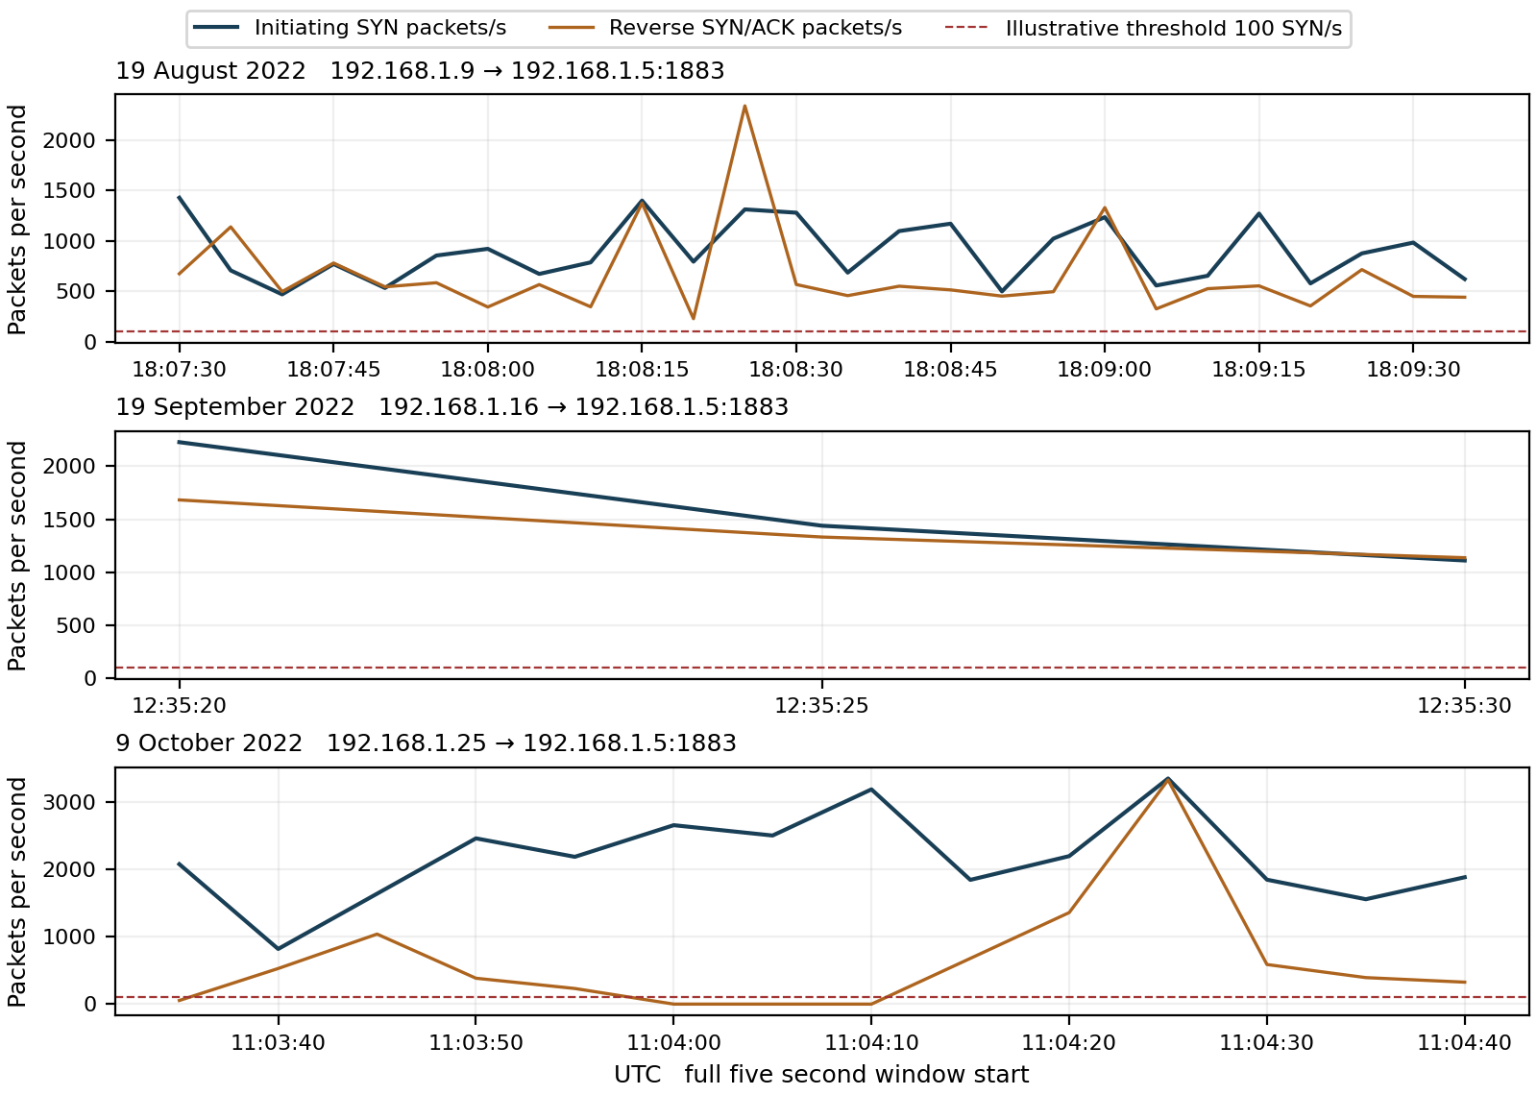
Figure 1 Observed connection pressure in full UTC aligned five second windows. Boundary windows are excluded. Every plotted window exceeds the illustrative connection rate threshold; this is a traffic screen rather than a validated measure of service failure.
Recording | Peak SYN packets/s | Full windows flagged | Decoded dominant sender CONNECT or PUBLISH
August | 1,427.2 | 26 of 26 | 0
September | 2,226.6 | 3 of 3 | 0
October | 3,345.0 | 14 of 14 | 0

Decoded background PUBLISH counts across all other flows are 92 in August, none in September and 24 in October. They are separate from the dominant sender. These parsed application records show that MQTT content exists in some recordings; they do not turn the payload free dominant flow into a message flood.

Mathematical model for detecting MQTT service pressure
For source s, broker address b and full five second window W(k), let N(s,b,k) count TCP packets to destination port 1883 with SYN set and ACK clear. Repeated attempts are retained because they contribute observed load; they are not claimed to be distinct successful connections.
$$R(s,b,k) = \frac{N(s,b,k)}{5}$$
$$Dconn(s,b,k) = 1[R(s,b,k) ≥ 100]$$
R is initiating packets/s. Dconn = 1 flags connection pressure at or above 100 SYN/s, equivalent to 500 packets in five seconds. The threshold is illustrative and requires independent normal data and host capacity measurements before operational use. Missing or unreadable evidence is unscored.

Worked result from the actual capture
During 11:04:25–11:04:30 UTC on 9 October, .25 sends 16,725 initiating SYN packets to .5:1883. Therefore:
$$R = \frac{16,725}{5} = 3,345 ≥ 100 ⇒ Dconn = 1$$
The connection rule flags all 43 complete windows across these recordings. That is 43 alert windows, not 43 independent attacks, and not a detector precision or recall result.

Testing application message pressure separately
Let M(s,b,k) count decoded client to broker MQTT PUBLISH control packets after TCP reassembly and transport retransmission removal. The application rate and illustrative application rule are:
$$P(s,b,k) = \frac{M(s,b,k)}{5}$$
$$Dpub(s,b,k) = 1[P(s,b,k) ≥ 100]$$
For every dominant sender, M = 0 because it sends no TCP payload. Thus P = 0 and Dpub = 0 in every scored window. No application message flood is demonstrated from those senders, even when Dconn = 1. A zero application alert does not prove that the broker is healthy or that other traffic is benign.
The example value 100 PUBLISH packets/s is a proposed setting, not a validated boundary or a setting tested against a supplied positive PUBLISH flood. A broker can also be stressed by low rate expensive operations, large messages or many clients. Future scoring should distinguish CONNECT, PUBLISH and SUBSCRIBE rates rather than treating all MQTT packets alike.

Attack direction and evidence of impact
The dominant direction is client side connection attempts → broker port 1883, with SYN/ACK responses in reverse and some sender resets. No completed TCP handshake or MQTT session from the dominant sender is established by these packets. Successful MQTT session acceptance would require a CONNECT exchange and a corresponding successful CONNACK, beyond merely observing the port or a SYN/ACK. [2]
The broker emits background MQTT messages in August and October. This supports some continued application activity, not normal throughput or healthy farm operations. The short September capture does not establish successful telemetry delivery. Background traffic is neither an independently labelled normal control nor a service availability test.
To establish successful denial of service, correlate connection pressure with authorized client reconnect failures, publish or delivery delays, broker logs, pending connection queues, CPU, memory and dropped packets. None of those outcomes is established by packet rate alone. A message labelled actuatorOFF does not establish a physical response to this load.

What to look for and how to combat it
Track connection attempts separately from completed handshakes, MQTT CONNECT acceptance, PUBLISH traffic, queue growth and subscriber delivery. Use per source and aggregate views so a change of IP or many low rate senders does not defeat observation. Baselines should reflect the farm’s expected telemetry and reconnect schedule.
For the observed payload free load, prioritize upstream or host filtering and appropriate connection rate controls before broker application processing. Preserve legitimate clients during containment. Broker authentication, topic permissions and encryption protect application access, but do not by themselves prevent traffic from exhausting a link or pending TCP connection resources.
At the application layer, bound accepted clients, message size and queued or in flight data using features supported by the deployed broker. Mosquitto documents controls for connections, message size and queues; these are examples, not evidence that Mosquitto or those settings were used in this experiment. Queue and in flight limits are not universal incoming PUBLISH rate limits. [3]

ML approaches and validation
Begin with separate connection and message rate rules. Compare streaming anomaly or change point models using SYN rate, completed sessions, client churn, MQTT packet type mix, publication rates, topic mix, QoS and broker health. A supervised application flood model needs independently labelled message flooding examples; these dominant flows do not provide that positive class.
Split validation by recording, time and device, keeping an original and its identical split packets in the same fold. Avoid learning only the sender MAC or IP. No detector accuracy, calibrated maliciousness confidence or preemptive protection percentage is inferred from these three sessions.
Conclusion: connection pressure against the MQTT service is directly observed and flagged in every full window. A PUBLISH message flood from the dominant sender and a successful broker outage are not demonstrated. Both claims require additional application evidence.

Appendix A Understanding the equations and MQTT terms

Counting connection attempts
$$R(s,b,k) = \frac{N(s,b,k)}{5}$$
s identifies a source IP, b the broker IP and k five second window W(k). N counts initiating TCP packets to port 1883. SYN begins TCP connection establishment; ACK acknowledges TCP sequence progress. SYN set with ACK clear identifies the initiation form counted here. Dividing by five converts a window count into packets per second.
A repeated SYN still contributes recorded traffic load. It is not automatically a new accepted client. SYN/ACK is a TCP response from the service side, while CONNACK is an MQTT application control packet. The names describe different protocol stages.

Reading the connection alert
$$Dconn(s,b,k) = 1[R(s,b,k) ≥ 100]$$
The indicator 𝟙[condition] returns 1 when its condition is true and 0 otherwise. The symbol ≥ means greater than or equal to. In the October example, 16,725 ÷ 5 = 3,345, so Dconn = 1. This flags the chosen rate, not confirmed exhaustion or malicious intent. A result of zero means only that the rule did not trigger.

Counting actual MQTT publications
$$P(s,b,k) = \frac{M(s,b,k)}{5} Dpub = 1[P ≥ 100]$$
M counts parsed PUBLISH packets in the client to broker direction, rather than every packet carried by TCP. A topic names the message channel; the payload contains application content. Broker to subscriber PUBLISH packets are a different direction and must not be counted as new publications by the originating client.
In these dominant flows there are no TCP data bytes, so M = 0, P = 0 and Dpub = 0. This is a direct absence of application payload on the selected flows, not an assumption that every packet sent to port 1883 is an MQTT message.

Quality of service and acknowledgments
QoS means Quality of Service. The decoded background PUBLISH examples use QoS 0, which has no MQTT PUBACK. Absence of PUBACK for those messages is expected and is not evidence of failure. QoS 1 uses PUBACK; its acknowledgment concerns protocol delivery, not whether an irrigation device acted or a physical condition changed. [2]

Changing sensitivity
Lower a rate threshold to flag smaller surges, with a possible increase in false alerts; raise it to require greater pressure. Longer windows expose sustained load but blend short bursts. Shorter windows respond sooner and are more variable. Reassess each threshold when the window, endpoint or authorized reconnect and publication schedule changes.
Connection and application thresholds use different units: SYN packets/s versus MQTT PUBLISH packets/s. Their equal example values do not make them interchangeable. Both require independent validation; the application rule has no demonstrated positive flood case in the selected sender flows.

Appendix B Provenance and evidence limits

Source recordings
August mqtt_flood_august_original.pcap
SHA256 fe62e26f7bf2228a7d62b0c470cd9a23cf807631acbe299abf2c77f7e5e1e99d
September mqtt_flooding_september_original.pcap
SHA256 ea4cbcfff90a9ec67bddf7d58f2da8615831f0813f94f979cf97bc7ddecd35e5
October mqtt_flood_original.pcap
SHA256 828b52ffc7efdd12de08e0cd117056a42c7ac80152cacd71e03938e7de17d1ae
Archives: 08_2022_MQTT_Flood.zip, 09_2022_MQTT_Flood.zip and 10_2022_MQTT_Flood.zip. Their 27, 4 and 15 split files reproduce the originals exactly as timestamp-and-packet-byte multisets. Only originals were counted: 510,201 packets in total. No exact timestamp-and-byte duplicates were found within any original.
First split filename starts are 19:07:27 on 19 August, 13:35:19 on 19 September and 12:03:34 on 9 October 2022. Each is one hour ahead of packet time expressed in UTC. Frame references in this report are one based within the named full original.

Parser scope and counting limits
The analysis reads Ethernet IPv4 TCP traffic. It selects the dominant source to .5:1883, counts initiating SYN packets and inspects flags and payload length. Zero sender payload is verified directly from packet data and does not depend on guessing MQTT framing. September port 0 packets are excluded from the selected broker service flow.
For background MQTT examples, the parser groups TCP payload by direction and observed connection epoch, sorts by sequence, removes overlaps and parses contiguous chunks using MQTT Remaining Length and packet type fields. It does not join gaps. It decodes PUBLISH topic, QoS and payload and identifies CONNECT protocol level 4, meaning MQTT 3.1.1. An incomplete August chunk tail was left unparsed rather than invented.
Background decoded message counts are a bounded parser result, not a guarantee of a complete application transaction inventory. Midstream capture, missing bytes, conflicting retransmissions, sequence wrap or connection reuse can affect reconstruction. MQTT over TLS would require application logs or authorized decryption. No such application payload exists on the selected dominant flows.
Only full UTC aligned five second windows entirely inside a capture were scored. Reverse SYN/ACK totals are packet observations rather than uniquely matched successful handshakes. No packet count, TCP reply or MQTT topic string independently proves broker exhaustion, client authorization or physical actuator behavior. No synthetic traffic replaces the supplied data.

References
[1] Supplied Farm Flow MQTT_Flood archives and originals listed above. Direct packet analysis performed 26 October 2026.
[2] OASIS MQTT Version 3.1.1, 29 October 2014. https://docs.oasis-open.org/mqtt/mqtt/v3.1.1/os/mqtt-v3.1.1-os.html. Control packets, session and publication semantics; accessed 26 October 2026.
[3] Eclipse Mosquitto configuration manual. https://mosquitto.org/man/mosquitto-conf-5.html. Broker authentication, topic access and resource controls; accessed 26 October 2026.

