Port scanning in Farm Flow data
Packet evidence and mathematical detector model
Updated 26 October 2026

Attack characteristics
Port scanning probes a device’s transport ports to discover reachable services. A vertical scan tests many ports on one device; a horizontal scan tests a service across devices. Reconnaissance can precede exploitation, but an open port does not establish compromise. Authorized inventory tools may produce the same signature.
The supplied August, September and October captures directly show vertical TCP SYN scanning of 192.168.1.5. Four source IP appearances each probe 1,000 distinct destination ports. All four carry Ethernet source MAC 5c:ba:ef:e5:02:dd. This strongly associates the observed scan traffic across sessions; it does not prove physical hardware identity, DHCP allocation or operator intent.

Observed addresses and probe attribution
Capture date | Scanning source IP | Source MAC | Target IP
24 August 2022 | 192.168.1.20 | 5c:ba:ef:e5:02:dd | 192.168.1.5
19 September 2022 | 192.168.1.16 | 5c:ba:ef:e5:02:dd | 192.168.1.5
8 October 2022 | 192.168.1.18 then .17 | 5c:ba:ef:e5:02:dd | 192.168.1.5
The scanner targets MAC e4:5f:01:b3:6c:1b on the observed Ethernet path. The target behaves as a service host; its exact board model and agricultural function are not established by the scan. An SSH-compatible listener on TCP 22 is consistent with a managed computer, but does not identify a Raspberry Pi or actuator.
Source proof in each full original: August frames 1–5; September frames 37–41; October frames 53–57 for .18, and 74332, 74333, 74335, 74337 and 74338 for .17. These frames contain initiating SYN probes, rather than service replies. Frame numbering starts at one.

Dated recording results
Date and source suffix | First to last observed scan SYN in UTC | SYN packets | Peak distinct ports per 5 s | Alert bins
24 Aug .20 | 02:36:23.596–02:39:35.859 | 3,646 | 476 | 9
19 Sep .16 | 15:32:26.757–15:45:17.119 | 64,196 | 725 | 116
8 Oct .18 | 17:54:16.379–18:07:55.128 | 34,198 | 661 | 71
8 Oct .17 | 18:09:48.817–18:34:18.445 | 64,842 | 719 | 152
Each row covers 1,000 unique destination ports over that source’s observed period. SYN counts include retries and repeated scans. The 348 flagged five-second bins are alert windows, not 348 independent attacks. The four rows are source/session appearances, not a validated count of separate scan runs.
Filename dates are 24 August, 19 September and 8 October 2022. Filename clock times are one hour ahead of packet timestamps converted to UTC: first split names start at 03:36:23, 16:32:26 and 18:54:14. Their timezone is unspecified. UTC values above derive from packet timestamps; no local timezone is assumed.
Original recordings contain 12,033, 100,000 and 202,584 packets respectively, including background traffic. Their 56, 155 and 482 split files reproduce the originals exactly as timestamp-and-packet-byte multisets. Splits are PCAPNG despite the .pcap extension. Only originals were counted; no exact timestamp-and-byte duplicates were found inside them.

Attack direction and success
Observed direction is scanner → 192.168.1.5 across many ports. No gateway scan or horizontal sweep is demonstrated by these findings. On routed captures, Ethernet addresses can identify next hops rather than original endpoints.
For all four source appearances, reverse TCP responses within three seconds and acknowledging probe sequence plus one include SYN/ACK on port 22 and RST/ACK on ports 80 and 443. This supports successful reconnaissance of a responding listener and closed-port responses. These are confirmed examples, not an exhaustive service inventory. Silence on other ports remains inconclusive.

Mathematical conditions for reconnaissance success
$$O(j) = 1[correlated SYN/ACK] C(j) = 1[correlated RST/ACK]$$
For probe j, Oⱼ = 1 supports a responding listener; Cⱼ = 1 supports a closed-port response. Match reverse IPs and ports, ACK = probe sequence + 1 modulo 2³², and a reply delay of 0–3 seconds. A handshake, login, exploitation or farm-process disruption requires separate evidence; none is established here.

Mathematical model for detecting scan patterns
Select IPv4 TCP packets with SYN set and ACK clear. For source s and target d, count unique destination ports in fixed, UTC-aligned five-second windows Wₖ. Repeated probes to the same port count once per window. This suppresses retry-driven inflation in port breadth, although packet totals still include retries.
$$V(s,d,k) = |\{p : s → d:p is probed during W(k)\}|$$
$$D(s,d,k) = 1[V(s,d,k) ≥ 20]$$
The threshold 20 is an illustrative sensitivity setting, selected to demonstrate the signature on these captures. It is not fitted to an independent normal baseline. Reduce it to detect narrower sweeps at the cost of more alerts; increase it to require broader probing. Longer rolling windows are needed for slow scans. This model does not cover every UDP, stealth, distributed or horizontal technique.
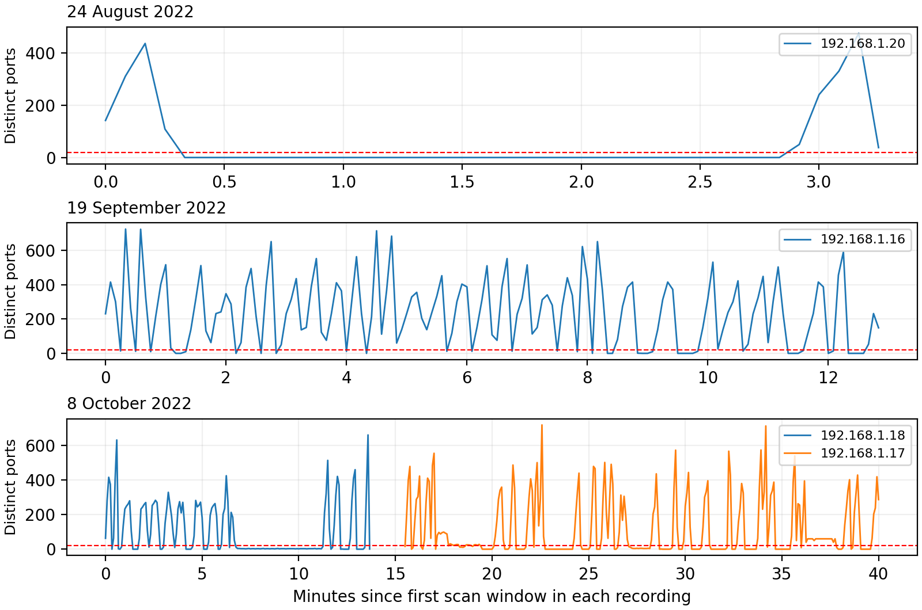
Figure 1 Observed distinct destination ports per five-second window. The dashed red line is the threshold of 20. Gaps plotted within each source period are zero observed SYN-port breadth for that source, not proof that monitoring elsewhere continued.
$$August peak: V = 476 ≥ 20 ⇒ D = 1$$
The same calculation signals September (725), October .18 (661) and October .17 (719). A high-volume background connection to port 1880 reaches only one distinct destination port per window and does not trigger this vertical-breadth rule. This is a useful within-capture contrast, not an independent normal-control evaluation.

What to look for and how to combat it
Before a scan, establish expected client-to-service connections and permitted maintenance scanners. During scanning, look for rapid destination-port expansion and correlate service replies. Repeated probes to a single service do not establish a sweep across ports. After scanning, examine new handshakes, authentication attempts and application logs; a decline in scan traffic does not prove cleanup or safety.
The August scanner is already active at the first captured frame, so this recording cannot establish a clean pre-attack period. September and October have some traffic before their first observed scan SYN, but that alone is not a validated normal baseline. The last observed SYN marks capture evidence, not necessarily the true end of attacker activity; September activity reaches the recording boundary.
Restrict service exposure by source, destination and port with host/network firewalls; disable unused listeners and segment farm telemetry, control and management networks. Protect SSH with keys and restricted management access. Review authorized scanning schedules before blocking. Detection signals reconnaissance; firewall policy and secure services reduce the opportunity for exploitation.
For ML, use port breadth, probe rate, target breadth, response classes and temporal persistence as features. Compare a transparent rule baseline with anomaly models or supervised classifiers using independent normal captures and separately labelled scan episodes. Split evaluation by time/session and device to avoid leakage from repeated probes or duplicated split files. Report precision, recall and false alerts per hour only after those labels exist.
Conclusion: packet evidence verifies vertical scan patterns in all three supplied months, involving four source IP appearances sharing one observed MAC. The example rule detects these patterns and correlated replies demonstrate limited reconnaissance success. Neither general detector accuracy nor device compromise is established. No synthetic traffic or unsupported numerical confidence percentages are used.

Sources
Primary evidence: supplied 08_2022_Port_Scanning.zip, 09_2022_Port_Scanning.zip and 10_2022_Port_Scanning.zip. Full originals: port_scanning_august_original.pcap, port_scanning_september_original.pcap and port_scan_original.pcap. Each was parsed directly; original and split packet multisets were compared.
SHA256 of full originals
August 6943a384375b7df3fc29a158e1f715b1e91aba881d5f5db5b41d08fdcc2ea43d
September dd597db89c33f23e2f2626866583fcb1e58072481f5a640dcb3e17702e5711a1
October 5a2db9ad2051b6806f5cc6e094dae9ddeea39e466138067f46c24710e9eb374d
Interpretation references: Nmap TCP SYN scan and port states, https://nmap.org/book/synscan.html and https://nmap.org/book/man-port-scanning-basics.html. Defence reference: NIST SP 800 41 Revision 1, Guidelines on Firewalls and Firewall Policy, https://csrc.nist.gov/pubs/sp/800/41/r1/final.

Appendix A Understanding probe response equations
These equations describe the reply to a particular TCP connection probe, numbered j. They distinguish evidence about a port’s response from the separate question of whether a source is scanning many ports.
$$O(j) = 1[correlated SYN/ACK]$$
$$C(j) = 1[correlated RST/ACK]$$

What the symbols mean
j identifies one probe. O(j) records open-port response evidence; C(j) records closed-port response evidence. The indicator symbol 𝟙[condition] returns 1 when the condition is true and 0 otherwise. These values are binary observations, not probabilities or confidence percentages.
SYN starts a TCP connection attempt. ACK acknowledges a received sequence. A SYN/ACK is the usual response of a listening TCP endpoint to a SYN. RST resets or rejects a connection; a matching RST/ACK response to a SYN supports a closed-port interpretation.

What correlated means
A reply must match the particular probe. Its source and destination IPs and ports reverse those of the probe; its acknowledgment equals the probe sequence number plus one, modulo 2³²; and it arrives within the selected response interval. This report uses a delay of zero to three seconds. An unrelated reply does not qualify.

How to read the result
If a probe to port 22 receives a matching SYN/ACK, O(j) = 1 and C(j) = 0. That supports a responding listener. It does not establish a successful login, the precise application behind the port or a compromised device.
If a probe receives a matching RST/ACK, C(j) = 1. That supports a closed-port response. The packet source or an intervening network device may have generated the rejection; interpretation depends on capture visibility.
If neither qualifying reply is observed, O(j) = 0 and C(j) = 0. This means the response state is unknown: filtering, packet loss, an offline device or incomplete capture visibility can explain silence. A response outside the three-second interval is not counted by this rule.
In the supplied recordings, correlated SYN/ACK replies on port 22 and RST/ACK replies on ports 80 and 443 provide examples of these indicators. They establish limited reconnaissance outcomes, rather than exploitation.

Appendix B Understanding the scan detector
$$V(s,d,k) = |\{p : s → d:p is probed during W(k)\}|$$
This equation counts how many different destination TCP ports one source probes on one target during a time window.

What the symbols mean
s is the source IP sending probes. d is the destination IP being probed. p is a destination TCP port. W(k) is time window number k; this report uses fixed five-second windows aligned to UTC. The notation s → d:p means that source s probes port p on destination d.
The braces {p : …} form the set of different ports satisfying the condition. The vertical bars |…| count the members of that set. V(s,d,k) is therefore a distinct-port count, not a packet count.
Repeated probes to the same port count only once within a window. Probing port 22 a thousand times gives V = 1; probing 25 different destination ports gives V = 25. The count is calculated separately for each source, target and window.
$$D(s,d,k) = 1[V(s,d,k) ≥ 20]$$
This second equation converts the port count into an alert. The symbol ≥ means greater than or equal to. D = 1 when at least 20 different destination ports are probed within that five-second window. D = 0 when fewer than 20 are observed. A zero means this rule did not trigger; it does not establish that activity is safe.

Example from the Farm Flow recordings
The busiest August window contains 476 distinct destination ports probed by 192.168.1.20 toward 192.168.1.5. The rule therefore signals a possible vertical port scan:
$$V = 476 ≥ 20 ⇒ D = 1$$
Peak counts also exceed the threshold in September and in both October source appearances. Each flagged window is an alert interval; adjacent alerts and repeated sweeps should not automatically be counted as independent attacks.

How to change sensitivity
Lower the threshold below 20 to catch narrower sweeps, with a possible increase in false alerts. Raise it to require more ports before signaling. A longer window can expose slower scanning but can also combine legitimate activity. Changing the window changes the meaning of the count and requires reassessment of the threshold.
The value 20 is illustrative. It is not a validated boundary between legitimate and malicious behavior. Independent normal traffic, authorized scanner records and labelled scan episodes are needed to measure precision, recall and false alerts per hour. Missing or unreadable packet fields should be reported as unscored, rather than silently treated as D = 0.

