TCP flood in Farm Flow data
Packet evidence and mathematical detector model
Created 26 October 2026

Context and purpose
This report examines the supplied August and October TCP_Flood recordings. It identifies packet signatures, MAC and IP associations, timing and detector results for farm network security research. No September TCP_Flood archive was supplied, so no September findings are inferred.
Main finding: both recordings contain sustained SYN-only traffic toward 192.168.1.5 at TCP destination port 0. The sender MAC is 5c:ba:ef:e5:02:dd under different source IPs. The selected flows contain no TCP application data and no observed reverse TCP packets with source port 0. This demonstrates packet pressure, not a proven successful connection or service outage.

Attack characteristics
TCP normally establishes a connection through SYN, SYN/ACK and ACK exchange. A SYN flood repeatedly initiates connections; on a listening service it can consume resources for pending connections. A high packet rate can also impose network or filtering work. Those mechanisms must be distinguished: observing SYN packets alone does not establish a full pending connection queue. [2, 3]
Here the destination is port 0, which IANA lists as reserved. The captures do not establish a listener on that port or show SYN/ACK replies. The supported signature is a high rate stream of SYN packets to a reserved port; classic backlog exhaustion of a listening service remains unverified. [4]

Observed addresses and roles
Recording | Dominant sender IP and MAC | Target IP and MAC
August | 192.168.1.9  5c:ba:ef:e5:02:dd | 192.168.1.5  e4:5f:01:b3:6c:1b
October | 192.168.1.136  5c:ba:ef:e5:02:dd | 192.168.1.5  e4:5f:01:b3:6c:1b

The sender is an observed traffic generation endpoint; its hardware, operating system and operator are not identified by these SYN fields. The target is a farm network host with separate application traffic, but its exact board and physical control function remain unverified.
The repeated MAC associates an observed interface across recordings. It does not prove DHCP allocation, physical ownership or that the source IP could not be forged. No calibrated numerical confidence percentage is available for those identity inferences.

Dated recording results
All times below derive from packet timestamps in UTC. Split filename clocks are one hour ahead, with no timezone specified. The sessions are discrete recordings; activity between them is unavailable.
Date in 2022 | Capture interval UTC | All captured packets | Parseable selected SYN packets | Selected reverse TCP packets
19 August | 17:24:45.767–17:26:24.397 | 125,601 | 121,864 | 0
8 October | 10:52:42.760–10:55:24.836 | 201,450 | 195,924 | 0

Selected means the dominant sender to 192.168.1.5:0; reverse packets would have source port 0. Total packet counts include other traffic. The October original contains 201,450 packets, as counted directly, irrespective of any expected file size or sample count.

Observed TCP signature
Field or measure | August | October
Destination port | 0 | 0
TCP flags in parseable selected packets | SYN only 0x02 | SYN only 0x02
Selected application payload packets | 0 | 0
Distinct selected source ports | 55,677 | 62,229
IPv4 total length per selected packet | 40 bytes | 40 bytes
Valid IP and TCP checksums in selected set | 121,864 of 121,864 | 195,924 of 195,924

October frame 26884 is an additional sender to port 0 record whose TCP data offset declares a 40 byte TCP header even though the IPv4 total length leaves only 20 bytes for TCP. It is excluded from the parseable detector count and reported as a header length inconsistency. The cause is not established; it must not be silently counted as a normal valid segment.

Packet evidence and background activity
August frames 1–5 are selected SYN examples. October examples are frames 1, 2, 3, 4 and 6. August frame 1 has source port 2927 and destination port 0; October frame 1 has source port 51311 and destination port 0. Both have SYN set, ACK clear and no application data.
Separate background flows continue exchanging application data with .5. For example, August frame 442 contains topic2/1 with value 26.9 from .13, and October frame 343 contains topic5/1 with value 24.0 from .10. These examples show observed background communication, not calibrated sensor units or proof of complete farm service health.

Time based activity graphs
The upper panels show selected SYN packets/s in full UTC aligned five second windows. The lower panel shows the August capture tail using full one second bins so its short quiet period remains visible. Boundary bins are excluded rather than assumed to cover a full interval.
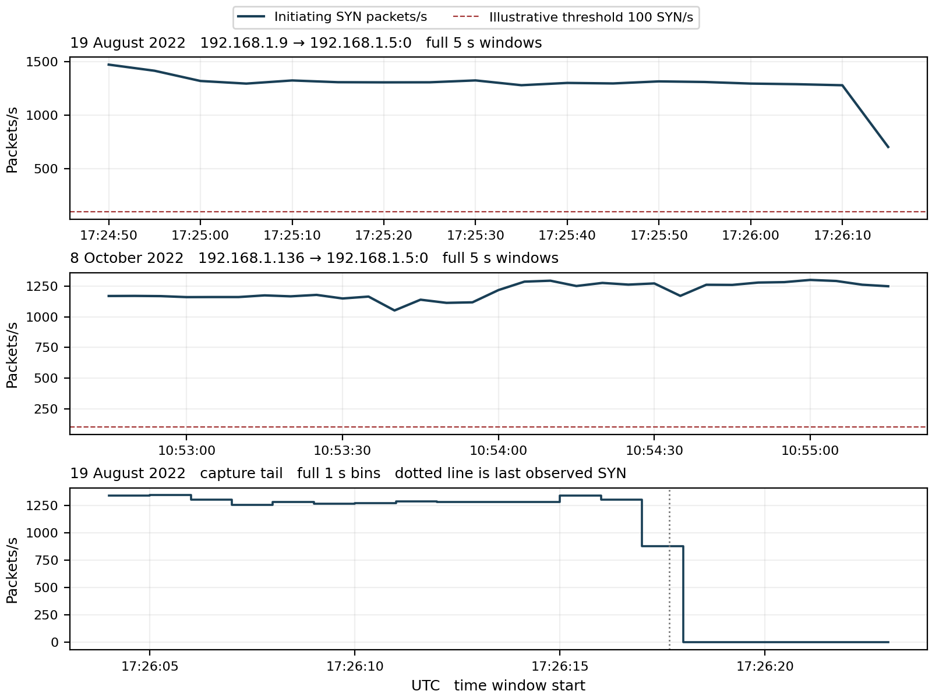
Figure 1 SYN pressure and the August tail. The 100 SYN/s threshold is illustrative. A lower or zero packet rate after observed traffic stops is not proof that a compromised host was repaired or that a service recovered.

Before during and after the observed activity
Both recordings start with selected SYN packets at frame 1, so neither establishes a clean pre attack baseline. August last records a selected SYN at 17:26:17.671417 UTC, followed by 6.726 seconds of capture without that selected stream. Other device traffic remains visible. This is a short observed quiet tail, not a validated recovery interval.
October selected traffic reaches the final recorded packet. The true start or end of the activity outside capture boundaries is unknown. The five second August detector has no complete UTC aligned quiet window after the last SYN: the final possible quiet window is cut by the end of the recording.

Mathematical model for detecting TCP SYN pressure
For source s, destination d and destination port q, let N(s,d,q,k) count parseable TCP packets with SYN set and ACK clear in five second window W(k). The evaluated port is q = 0. Count packet observations rather than claiming each SYN represents a new established connection.
$$R(s,d,q,k) = \frac{N(s,d,q,k)}{5}$$
$$D(s,d,q,k) = 1[R(s,d,q,k) ≥ 100]$$
R is initiating packets/s. D = 1 signals at least 100 SYN/s, equivalent to 500 packets in five seconds. D = 0 means the chosen rate rule did not trigger; missing or unreadable evidence is unscored. The threshold is illustrative and requires independent normal traffic and capacity measurements before operational use.
Recording | Full 5 s windows | Flagged windows | Peak SYN count per 5 s | Peak SYN packets/s
August | 18 | 18 | 7,358 | 1,471.6
October | 31 | 31 | 6,501 | 1,300.2

Worked result from the actual capture
During 17:24:50–17:24:55 UTC on 19 August, the selected stream contains 7,358 SYN packets:
$$R = \frac{7,358}{5} = 1,471.6 ≥ 100 ⇒ D = 1$$
The packet count represents 294,320 IPv4 bytes, since each selected datagram is 40 bytes. Its IPv4 bit rate is:
$$B = \frac{8 × 294,320}{5} = 470,912 bits/s$$
This excludes link overhead, replies and other traffic. It does not establish link saturation. Processing costs and policy matter as well as byte rate.

Supporting flag concentration
$$F = \frac{selected initiating SYN packets}{all selected parseable TCP packets} = 1$$
F = 1 means 100% of the selected parseable packets are initiating SYNs, not that attack detection is 100% accurate. The rule flags 49 complete windows across two recordings; these windows are not 49 independently labelled attacks. No precision, recall or calibrated maliciousness confidence is established.

Attack direction and evidence of impact
The observed direction is sender → .5:0. No reverse TCP packet with source port 0 is observed for the selected pair. No handshake completion, established session or application exchange on that flow is demonstrated. Silence could reflect policy, endpoint handling, loss or capture visibility; it does not prove that .5 was unavailable.
A classic SYN backlog mechanism depends on a listener retaining pending connection state. Because port 0 is reserved and no SYN/ACK exchange is shown here, the number of half open connections and any backlog exhaustion remain unscored. It would be incorrect to equate 121,864 or 195,924 SYN packets with that many retained connections. [2]
Successful denial of service would require evidence such as authorized connection failures, service delay, queue occupancy, CPU or interface drops and comparison with normal operation. Background traffic is visible in both recordings, but its presence alone does not prove all services or physical farm controls remained healthy.

What to look for and how to combat it
Monitor initiating packet rate per source, target and destination port; also inspect source port diversity, flag mix, payload length, repeated attempts and response behavior. Use aggregate target views to detect pressure split across senders. Keep normal diagnostic, telemetry and reconnection schedules as explicit context.
Investigate and apply appropriate policy to reserved or unused destination ports at the host and upstream filtering point. Use measured per source and aggregate rate limits, preserving necessary farm services. If traffic saturates an upstream link, filtering only at the target is too late to protect that link.
For listening services that face pending connection exhaustion, SYN cookies, suitable SYN proxies, filtering and backlog management are possible defenses, with implementation tradeoffs. They do not automatically address every high packet rate stream or explain what happened to port 0 in these captures. Validate changes against authorized client behavior and actual resource measurements. [2]

ML approaches and validation
Start with this transparent packet rate rule. Compare streaming anomaly or change point models using SYN rate, flag concentration, source and destination port patterns, packet size, response classes and persistence. Add independently measured service health to learn impact rather than merely memorize traffic volume.
Use independent normal sessions and separately labelled flood intervals. Split validation by recording, time and device; keep an original and its identical split packets in the same fold. A model that memorizes .9, .136 or one MAC is not demonstrated to generalize. These two short recordings do not establish early warning performance, precision, recall or calibrated probabilities.
Conclusion: both supplied recordings show high rate, payload free SYN streams to reserved port 0 and trigger the illustrative rate rule. Successful listener exhaustion, service denial and physical farm consequences remain unverified. August includes a short quiet tail; October ends while the selected stream is still active.

Appendix A Understanding the equations and TCP terms

Counting packet pressure
$$R(s,d,q,k) = \frac{N(s,d,q,k)}{5}$$
s identifies the source IP; d is the destination IP; q is its TCP destination port; k identifies window W(k). N counts parseable SYN packets with ACK clear. Dividing a five second count by five gives packets per second. A TCP acknowledgment packet, application data segment or packet with an inconsistent header length is not part of this selected count.
SYN requests connection synchronization. SYN/ACK is a reply in normal establishment; ACK completes the usual three way exchange when it correctly acknowledges that reply. RST resets or rejects a connection. These control flags describe observed segments, not proof that the host accepted an application transaction. [3]

Reading the detector result
$$D(s,d,q,k) = 1[R(s,d,q,k) ≥ 100]$$
The indicator 𝟙[condition] equals 1 when the condition is true and 0 otherwise. The symbol ≥ means greater than or equal to. For 7,358 SYN packets in a full five second window, R = 1,471.6 and D = 1. A result of zero means only that the threshold was not met; it does not prove safe activity.

Packet count is not connection count
Source ports help identify transport flows, but 55,677 or 62,229 distinct source ports do not establish that many successful sessions or physical devices. Retries can reuse a flow, and source ports can be reused for later attempts. New captured SYN packets remain part of traffic pressure even if their bytes or sequence values repeat.
$$F = \frac{initiating SYN count}{all selected parseable TCP packet count}$$
F = 1 here describes a 100% SYN-only selected stream. It is a flag composition measure, not confidence of maliciousness. Missing reverse replies do not supply a measured half open connection count or a valid transaction loss percentage.

Bit rate and host capacity
$$B(s,d,q,k) = \frac{8 × L(s,d,q,k)}{5}$$
L is the sum of IPv4 datagram lengths in the selected window. Multiplying by eight converts bytes to bits; dividing by five yields bits/s. These selected packets are 40 bytes, so B = 8 × 40 × R. Ethernet and physical overhead are excluded. A host may spend processing resources without a link reaching saturation.

Changing sensitivity
Lower the 100 SYN/s threshold to flag smaller surges, accepting possible extra alerts from authorized activity. Raise it to require a larger rate. Longer windows expose sustained pressure but blend short bursts; shorter windows react faster and fluctuate more. Reassess the threshold whenever the interval, service exposure or reconnection policy changes.
All 18 August and 31 October complete windows trigger, but no independent normal control was supplied. These results demonstrate rule behavior on the recordings, not validated sensitivity or specificity. The short August quiet tail is too short to supply a full quiet UTC aligned five second bin before capture ends.

Appendix B Provenance and evidence limits

Source recordings
August tcp_flood_total_original.pcap
SHA256 3c58de9d2ac1d9d2a9567c73c8b7dfbf58fcfcab6b0efb963a8f9178b4a19448
October tcp_flood_original.pcap
SHA256 9a0e84517bec48fadafff84c6e7e53804ab4e7ae0c41899e33701f59bd538dfe
Archives: 08_2022_TCP_Flood.zip and 10_2022_TCP_Flood.zip. Their 20 and 33 split files reproduce their originals exactly as timestamp-and-packet-byte multisets. Only originals were counted: 327,051 packets in total. No exact timestamp-and-byte duplicates were found within either original. No September TCP data was supplied.
First split filename starts are 18:24:45 on 19 August and 11:52:42 on 8 October 2022. These clocks are one hour ahead of packet timestamps expressed in UTC; filename timezone is unspecified. Frame references are one based within the named original.

Parser and consistency checks
The analysis reads Ethernet IPv4 TCP records, checks available header length against the IPv4 length and captured bytes, and counts SYN packets with ACK clear by source, target, port and time. It does not decode later IPv4 fragments as standalone TCP headers. Selected valid packets contain no application payload.
IPv4 and TCP checksums were verified for all 121,864 selected August packets and 195,924 selected October packets. October has one additional port zero SYN record, frame 26884, whose declared TCP header length cannot fit within its IP datagram. That inconsistent record is excluded, rather than silently treated as a complete valid TCP segment. Its cause is not diagnosed.
Reverse response lookup selects target to sender TCP packets with source port 0. None was observed. This does not prove that no other protocol or unobserved network device responded. No stateful handshake acceptance, pending queue occupancy or end user availability measurement is inferred from an absent reverse flow.
Only full UTC aligned five second windows inside each capture are scored. The August tail figure uses full one second bins to expose the short end period without the selected stream. Neither boundary exclusion nor exact split equality establishes lossless collection or complete visibility outside the capture point.
Observed addresses, flags and counts are packet evidence. Hardware, operator identity, malicious intent and physical farm impact require additional sources; no calibrated numerical confidence is available for those inferences. No synthetic traffic substitutes for the original recordings.

References
[1] Supplied Farm Flow TCP_Flood archives and originals listed above. Direct packet analysis performed 26 October 2026.
[2] IETF RFC 4987 TCP SYN Flooding Attacks and Common Mitigations. https://www.rfc-editor.org/rfc/rfc4987.html. Pending connection exhaustion and defense tradeoffs; accessed 26 October 2026.
[3] IETF RFC 9293 Transmission Control Protocol. https://www.rfc-editor.org/rfc/rfc9293.html. TCP flags, headers and connection establishment; accessed 26 October 2026.
[4] IANA Service Name and Transport Protocol Port Number Registry. https://www.iana.org/assignments/service-names-port-numbers/. TCP port 0 is reserved; accessed 26 October 2026.

