HTTP flood in Farm Flow data
Packet evidence and mathematical detector model
Prepared for Polra Victor and software engineers | Created 26 October 2026

Context and purpose
This report examines five original recordings in the supplied August, September and October HTTP_Flood archives. It identifies observable load patterns, MAC and IP associations, detector behavior and limits on conclusions about service disruption. It is intended for farm IoT research and offline security analysis.
Main finding: the two August recordings and the October port 1880 recording contain repeated HTTP GET or POST request starts toward 192.168.1.5. September and the October port 80 recording contain heavy connection attempts from the dominant sender but no application payload from it. Those recordings therefore do not demonstrate completed HTTP exchanges from that sender.

Attack characteristics
An HTTP flood repeatedly requests application resources to consume server capacity and deny or degrade service for authorized users. A request may look ordinary on its own; rate, persistence, request complexity and service impact establish its significance. Farm telemetry routes can be targets as readily as a public web page. A folder label is context, not proof of successful denial of service. [2]

Observed addresses and roles
Observed identity | Role supported by this capture | Limits
192.168.1.4 in August  192.168.1.15 in September and October  5c:ba:ef:e5:02:dd | Dominant traffic sender toward .5. HTTP examples include a testing Referer and browser style User Agent strings. | Generator software or testing host is plausible. Browser headers do not establish its operating system or board.
192.168.1.5  e4:5f:01:b3:6c:1b | Target on TCP 1880 or 80; farm application service host. Node RED is consistent with port 1880 and capture naming. | Exact board, server capacity and physical farm responsibilities are not established.
192.168.1.10 in August  192.168.1.12 in October  30:83:98:a2:a7:f7 | Additional HTTP telemetry client with ESP8266HTTPClient headers and named sensor routes. | Software family is suggested; exact hardware and every sensor association remain unverified.

In August, .8 also appears with the sender MAC 5c:ba:ef:e5:02:dd while exchanging monitoring traffic. Multiple IPs can share one interface or capture path; they must not automatically be counted as different devices. Changing IPs alone does not prove DHCP assignment. No calibrated hardware confidence percentage is available.

Dated recording results
All times below are UTC from packet timestamps. Split filename clocks are one hour ahead; their timezone is unspecified. The recordings are discrete sessions, not continuous three month monitoring. Labels A1–O2 refer only to the source files listed in Appendix B.
Session and date in 2022 | Capture interval UTC | All packets | Sender to .5 port | Observed request starts
A1 20 August | 12:26:30–12:27:17 | 202,907 | .4 → 1880 | 7,392
A2 20 August | 12:53:17–12:57:22 | 428,907 | .4 → 1880 | 20,709
S1 19 September | 10:12:26–10:15:11 | 100,000 | .15 → 1880 | 0
O1 9 October | 13:46:50–13:48:20 | 200,000 | .15 → 1880 | 6,125
O2 9 October | 13:52:22–13:53:46 | 200,000 | .15 → 80 | 0

Counts are distinct observed request start positions in the dominant sender’s TCP traffic, not proven completed requests. A request line may be visible before its headers or body finish. A1 has only 44 starts whose header terminator is in that same segment; O1 has 117. Full stream reassembly is required before asserting complete message totals.

Packet evidence and request content
A1 frame 22 contains GET /check, Referer: TESTING_PURPOSES_ONLY and a long Range header beginning bytes=0-,5-0,5-1. Continuation segments contain further ranges. A2 frame 177 contains GET /check with the same testing marker; frame 1288 starts POST /ds18b20 with Content-Length: 8000. These are generated request characteristics, not evidence of real sensor measurements.
A1 contains 1,419 GET and 5,973 POST starts; A2 contains 2,711 GET and 17,998 POST starts. Routes include /check, /dht11_t, /dht11_h and /ds18b20. O1 contains 6,125 GET starts, of which 6,037 target /check; frame 6 is an example. Familiar sensor route names do not make repeated traffic benign.
S1 contains 47,932 initiating SYN packets from .15 to .5:1880, no payload packets from that flow, and 47,932 reverse reset packets. O2 contains 98,836 initiating SYN packets from .15 to .5:80, no payload packets from that flow, and 98,835 reverse resets. These are observed packet totals, not matched transaction success rates.

Before during and after the observed activity
A1 and O1 already contain sender traffic at frame 1; S1 also starts with a connection attempt. A2 sender traffic begins at frame 165 and O2 at frame 45. None provides an independently validated normal baseline or recovery period. Gaps or lower rates inside a recording do not establish that the attack ended, and gaps between recordings are unobserved.

Time based activity graphs
Each panel covers one original recording. Blue shows observed request starts; orange shows initiating TCP packets from the same sender to the target service. Dotted lines mark illustrative thresholds of 20 HTTP starts/s and 100 initiating packets/s. Only full five second windows inside each recording are shown.
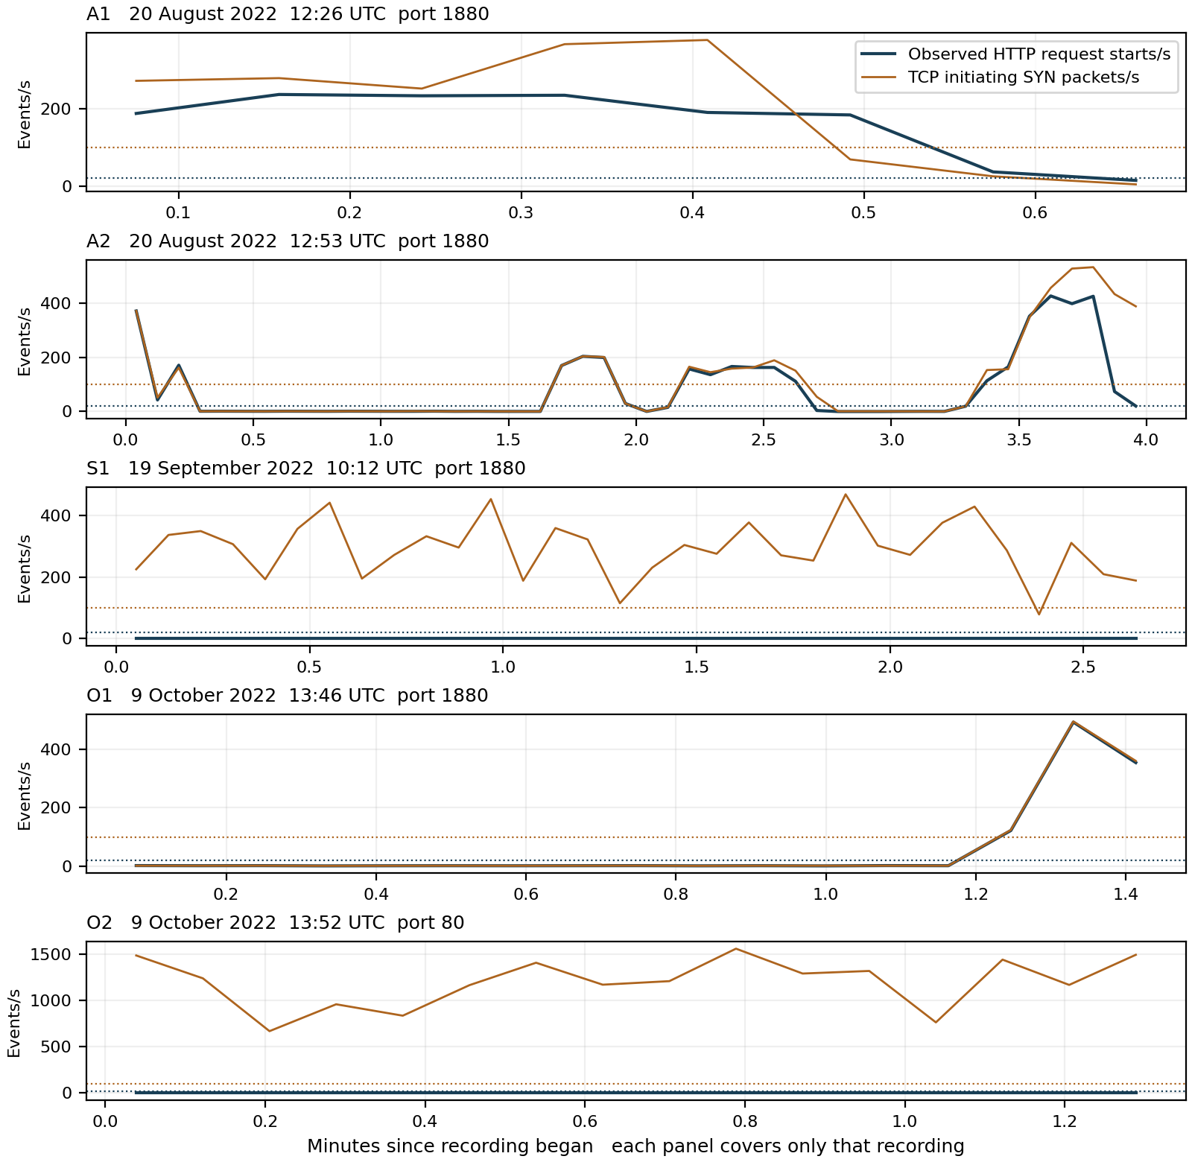
Figure 1 Observed rates in the five recordings. Different vertical scales are labelled on each panel. Zero observed HTTP starts in S1 and O2 is consistent with their absence of sender application payload; connection pressure alone is not counted as HTTP request evidence.

Mathematical model for detecting HTTP request pressure
For source s, destination d and service port q, let N(s,d,q,k) count distinct observed HTTP request start positions during window W(k). Use fixed five second windows. Repeated observations with the same TCP four tuple, sequence position, method and path are collapsed. Starts at new stream positions remain new events.
$$R(s,d,q,k) = \frac{N(s,d,q,k)}{5}$$
$$D(s,d,q,k) = 𝟙[R(s,d,q,k) ≥ 20]$$
R is observed request starts/s. D = 1 signals request pressure at or above 20/s; D = 0 means the rate rule did not trigger. The value 20 is illustrative and unvalidated. Unreadable or unavailable evidence is unscored; a zero result never proves safe traffic.
For a separate connection pressure screen, let S(s,d,q,k) count packets with SYN set and ACK clear. Repeated connection attempts are retained because they still impose observed traffic pressure. Their packet rate and screen are:
$$P(s,d,q,k) = \frac{S(s,d,q,k)}{5} T(s,d,q,k) = 𝟙[P(s,d,q,k) ≥ 100]$$
T is supporting transport evidence; it does not certify an HTTP flood. The two models remain separate so traffic without a visible HTTP request is not labelled a completed application exchange.
Session | Full 5 s windows | HTTP alert windows D | Connection alert windows T | Peak HTTP starts/s
A1 | 8 | 7 | 5 | 236.2
A2 | 48 | 21 | 19 | 426.8
S1 | 32 | 0 | 31 | 0.0
O1 | 17 | 3 | 3 | 492.6
O2 | 16 | 0 | 16 | 0.0

Worked result from the actual capture
A2 contains 2,134 distinct request starts during 12:56:55–12:57:00 UTC. Therefore:
$$R = \frac{2,134}{5} = 426.8 ≥ 20 ⇒ D = 1$$
O1 peaks at 492.6 starts/s and A1 at 236.2 starts/s. S1 and O2 produce no HTTP rate alerts under this parser, although the connection screen flags 31 of 32 and 16 of 16 full windows respectively. Alert windows are not independent attack incidents or a detector accuracy score.

Attack direction and evidence of impact
The dominant sender directs requests or connection attempts to the farm service host. HTTP 400 and 404 responses are visible in A2 and O1. They show rejected or unsuccessful requests; they do not by themselves prove resource exhaustion, loss of authorized access or physical farm disruption. A 200 response shows a successful HTTP outcome for that response, not overall service health. [4]
Session | Recognized response bearing segments to dominant sender | Interpretation
A1 | 1,581 status 200; 13 status 404 | Some successful application replies remain visible.
A2 | 30 status 200; 9,535 status 400; 126 status 404 | Mostly client error responses among the recognized segments.
O1 | 29 status 200; 209 status 400; 88 status 404 | Errors are visible, but service availability is not measured.
S1 and O2 | No recognized HTTP replies on the selected sender flow | TCP resets are visible; a successful HTTP exchange is not demonstrated.

Response counts remove identical flow, sequence and payload copies. They are not reassembled message totals or replies matched one to one to all requests. For example, 99.69% of recognized A2 response segments have status 400 or 404; this is an error segment proportion, not 99.69% detector confidence or a service failure probability.

What to look for and how to combat it
Compare per device and aggregate request rates with authorized polling schedules. Track repeated endpoints, header and body size, response latency, errors, queue depth and resource use. Long Range lists or large declared bodies justify inspection, but an individual header or user agent is not a sufficient detector.
Enforce appropriate request budgets per authenticated device and service, body/header limits, connection timeouts and bounded queues. A reverse proxy can apply both per client and aggregate rate limits; begin with observation or dry run before restricting live farm clients. Keep management access separate and preserve essential control functions during containment. [3]

ML approaches and validation
Use rate and persistence rules as a transparent baseline. Compare change point detection or anomaly models using request starts, completed message rates after reassembly, header size, endpoint mix, connection rate and measured service impact. Supervised learning requires independent normal sessions and reliable event labels. Split evaluation by recording and time, keeping identical split packets with their original. No precision, recall or calibrated maliciousness probability is established here.
Conclusion: HTTP request pressure is directly visible in A1, A2 and O1. S1 and O2 show connection attempts without sender HTTP payload, so their application level characterization remains unsupported by these packets. Service disruption requires application logs, resource monitoring and authorized client outcomes beyond these capture labels.

Appendix A Understanding the equations and sensitivity

Counting what was actually observed
$$R(s,d,q,k) = \frac{N(s,d,q,k)}{5}$$
s is the sending IP; d is the receiving IP; q is the destination service port, such as 1880; k identifies the time window W(k). N counts recognized request starts in that window. Dividing by five converts a five second count into starts per second. It does not measure completed requests or processed sensor readings.
A GET asks for a resource; a POST submits content for processing. The path names the resource, for example /check. A visible request line can be followed by headers and a body in other segments. Header completeness, body completeness, server acceptance and user impact are distinct questions.

Reading the alert rule
$$D(s,d,q,k) = 𝟙[R(s,d,q,k) ≥ 20]$$
The indicator 𝟙[condition] equals 1 when the condition is true and 0 otherwise. The symbol ≥ means greater than or equal to. Twenty starts/s is equivalent to 100 starts per full five second window. In A2, 2,134 ÷ 5 = 426.8, so D = 1. D = 0 means only that this rate threshold was not met.

Reading connection pressure separately
$$P = \frac{S}{5} T = 𝟙[P ≥ 100]$$
S counts initiating SYN packets in the selected flow and window. P is their packet rate; T flags at least 100 such packets/s. It includes retries rather than pretending they are new completed connections. S1 has zero sender application payload, so its high T cannot supply missing HTTP evidence.

Changing sensitivity
Lower the HTTP threshold below 20 to detect smaller bursts, accepting a possible increase in false alerts. Raise it to require more request starts. Longer windows expose sustained load but blend short bursts; shorter windows increase timing variability. Reassess thresholds whenever the window length, route workload or polling policy changes.
Set limits from independent normal data and measured service capacity, not from packet counts alone. Some endpoints are expensive at low rates, while others tolerate much higher rates. A production detector should combine endpoint specific baselines, reassembled request evidence and service health rather than treating 20/s as a universal malicious boundary.

Interpreting an error fraction
$$E = \frac{recognized status 400 through 599 segments}{all recognized response bearing segments}$$
For A2, E = 9,661 ÷ 9,691 ≈ 0.9969. This is a descriptive proportion of the selected response segments. HTTP 400 means Bad Request and 404 means Not Found; neither automatically means the host failed. An empty denominator is unscored. E is not detector accuracy or a probability of compromise. [4]

Appendix B Scope provenance and validation limits

Source recordings
A1 http_flood_node_red_2_original.pcap
SHA256 06b4fc8a4738215b1add4eed2e43799f1fdf1f2b9b08ead4520379b7a0fa00dd
A2 http_flood_node_red_1_original.pcap
SHA256 b47c736db34c8b54f10bfa7a06203bde4c7f4a870e77af4b5d07576ec0ab1da8
S1 http_flood_node_red_september_original.pcap
SHA256 ab17f6d46775d5a7928e888e7b93bbc5d46e9466a8506ea1ea292cff1bd9326e
O1 http_flood_node-red_original.pcap
SHA256 a70396069b5b25408df07de1a906dc7dfe7b5fd95817ab35f3516f57432be789
O2 http_flood_server_original.pcap
SHA256 ffa63769ecb3ca71d41649e340c64a5ab58386333e5022f89939f8520abd4f9c
Source archives: 08_2022_HTTP_Flood.zip, 09_2022_HTTP_Flood.zip and 10_2022_HTTP_Flood.zip. Their 60, 33 and 35 split files respectively reproduce their originals exactly as timestamp-and-packet-byte multisets. The analysis counts only the five originals: 1,131,814 packets in total. No exact timestamp-and-byte duplicates were found within any original.

Parsing and evidence limits
The parser reads Ethernet IPv4 TCP records, recognizes HTTP/1.0 or HTTP/1.1 method and path lines at the beginning of TCP payloads, and keeps the first observation of each selected request start key. It does not fully reassemble TCP streams or certify request completion. Segmentation, overlapping bytes, coalesced messages and missing data can change application message totals; the observed starts are not a complete HTTP transaction inventory.
Header continuations and request bodies are not counted as additional starts. Response status observations are deduplicated separately by flow, TCP sequence and payload. These response segments are not matched to request starts for a success ratio. The report does not interpret a TCP reset as an HTTP response or infer a service failure from an unmatched request.
Only full UTC aligned five second windows entirely within each capture interval are scored. Capture completeness at boundaries is not proof of lossless packet collection. Frame references are one based within the named original. Repeated packets with different timestamps may be real retransmissions, even when their bytes match.
Evidence strength: MAC/IP fields, request lines and recorded counts are directly inspectable observations. Software, hardware and operational roles are inferences; no calibrated confidence percentage is available. Independent normal controls, exact attack boundaries, authorized user availability and resource metrics were not supplied for this analysis. No synthetic traffic is substituted.

References
[1] Supplied Farm Flow HTTP_Flood capture archives and original files listed above. Direct packet analysis performed 26 October 2026.
[2] MITRE CAPEC 488 HTTP Flood. https://capec.mitre.org/data/definitions/488.html. Attack definition and interpretation; accessed 26 October 2026.
[3] NGINX ngx_http_limit_req_module. https://nginx.org/en/docs/http/ngx_http_limit_req_module.html. Per key and aggregate rate controls and dry run mode; accessed 26 October 2026.
[4] IETF RFC 9110 HTTP Semantics. https://www.rfc-editor.org/rfc/rfc9110.html. HTTP methods, status and message semantics; accessed 26 October 2026.
[5] Node RED runtime configuration. https://nodered.org/docs/user-guide/runtime/configuration. Default port 1880 and endpoint configuration; accessed 26 October 2026.

