ICMP flood in Farm Flow data
Packet evidence and mathematical detector model
Prepared for Polra Victor and software engineers | Created 26 October 2026

Context and purpose
This report examines the supplied August, September and October ICMP_Flood recordings. It identifies the observed senders, target, message fields and time patterns, demonstrates a rate detector and explains what would be needed to establish actual service disruption. It supports farm IoT research and offline detector development.
Main finding: all three recordings contain high rate IPv4 ICMP Echo Requests directed to 192.168.1.5. The dominant sender has observed MAC 5c:ba:ef:e5:02:dd under different IPs. Recorded replies are much fewer than requests. That asymmetry is measurable, but it does not by itself prove packet loss at the host, a crashed service or interrupted farm operations.

Attack characteristics
ICMP is the Internet Control Message Protocol. An Echo Request asks an IP endpoint to return an Echo Reply, as used by ping. A flood sends these requests rapidly enough to impose packet processing, reply generation or link load. The intended effect is degraded availability; actual impact depends on host capacity, policy and network conditions. ICMP uses message types and codes rather than TCP or UDP ports. [2]

Observed addresses and roles
Recording | Dominant sender IP and MAC | Target IP and MAC
August | 192.168.1.20  5c:ba:ef:e5:02:dd | 192.168.1.5  e4:5f:01:b3:6c:1b
September | 192.168.1.16  5c:ba:ef:e5:02:dd | 192.168.1.5  e4:5f:01:b3:6c:1b
October | 192.168.1.25  5c:ba:ef:e5:02:dd | 192.168.1.5  e4:5f:01:b3:6c:1b

The sender is an observed traffic generation endpoint; its board, operating system and operator are not established by ICMP fields. The target responds as an IP host, but these echo messages do not identify its sensors, physical actuators or exact hardware. Repeated MAC associations support continuity of an observed interface; they do not prove DHCP, ownership or an immutable device identity.
A separate August source, 192.168.1.3, uses the same observed sender MAC and sends one Echo Request before the dominant stream begins. That is a quiet comparison within this capture, not an independently verified normal device or a separate physical machine.

Dated recording results
Dates are 24 August, 19 September and 9 October 2022. All times below derive from packet timestamps in UTC. Filename clocks are one hour ahead; their timezone is unspecified. These are three short recordings across three months, not continuous monitoring.
Date in 2022 | Capture interval UTC | All captured packets | Dominant Echo Requests | Reverse Echo Replies
24 August | 01:59:21.255–02:00:59.115 | 1,121,716 | 999,169 | 121,907
19 September | 15:26:37.362–15:27:24.366 | 100,000 | 81,032 | 18,778
9 October | 11:21:30.899–11:23:27.176 | 200,000 | 93,906 | 3,569

Other protocols are included in total packet counts. October includes 102,249 IPv4 TCP packets as well as the ICMP stream; not every packet in a labelled recording is an attack packet. No fragmented ICMP records were observed in these originals.

Observed packet fields
Field | Dominant stream observation | Interpretation
IPv4 protocol | 1 | Identifies ICMP, not a transport port.
Request type and code | 8 and 0 | Echo Request.
Reverse reply type and code | 0 and 0 | Echo Reply.
Echo data length | 0 bytes in every dominant request | Empty echo data; valid by itself. Ethernet padding is not echo data.
IPv4 total length | 28 bytes per dominant request | 20 byte IPv4 header plus 8 byte ICMP echo header.
Identifier and sequence | One identifier per dominant stream; sequence values repeat | Useful correlation fields, but not unique transaction identifiers here.

Before during and after the observed activity
August has about 9.70 seconds before the first dominant request at 01:59:30.950349 UTC, frame 382. Frames 239 and 240 show the earlier single request and reply involving .3. The dominant request stream continues to the final packet; no recovery period is captured.
September begins with dominant requests at frame 1. October first records them at frame 82, about 0.004 seconds after capture start. Both streams reach the recording boundary. These captures do not establish true onset, cessation or a validated pre attack baseline. Lower observed reply counts cannot substitute for missing application availability measurements.

Time based activity graphs
Blue shows dominant Echo Requests; orange shows reverse Echo Replies in the same full five second windows. The dashed line is an illustrative alert threshold of 100 requests/s. Each panel has its own labelled vertical scale; no traffic is inferred between recordings.
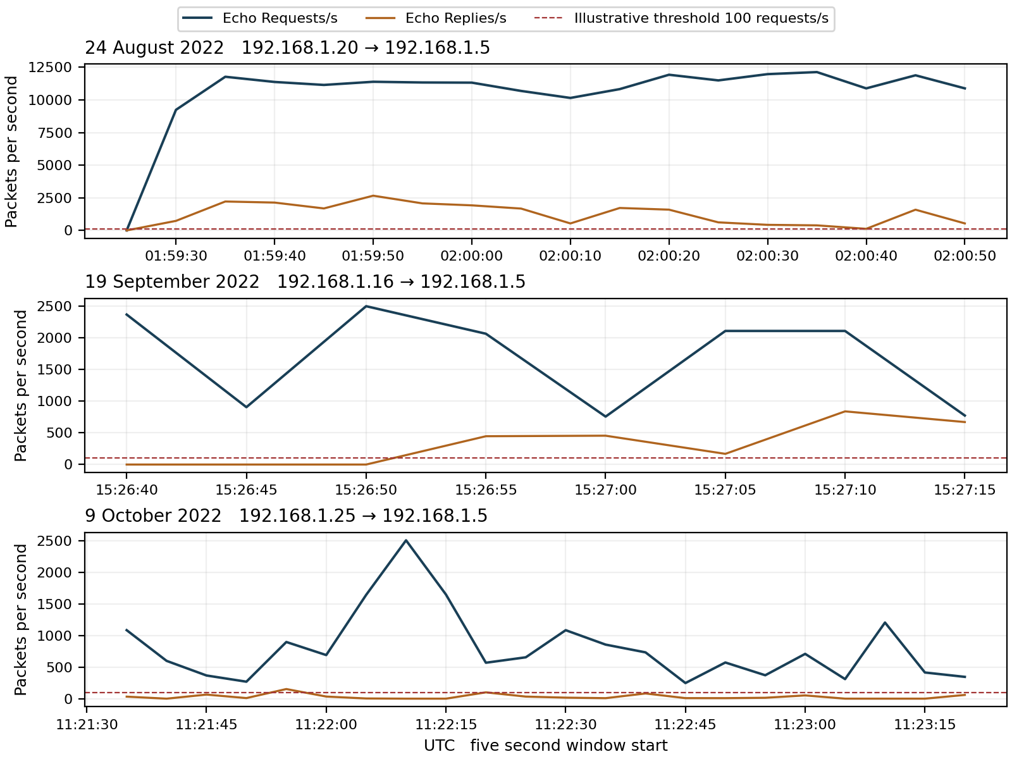
Figure 1 Request pressure and observed reply behavior. Boundary windows are excluded. August reaches a much higher request rate than the later recordings. The reply curve describes captured traffic, not a proven count of successfully handled or lost requests.
Recording | Peak requests per second | Peak request IPv4 bit rate | Meaning
August | 12,136.2 | 2.7185 Mbit/s | High packet rate from small datagrams.
September | 2,503.2 | 0.5607 Mbit/s | Repeated request pressure remains visible.
October | 2,505.4 | 0.5612 Mbit/s | Requests exceed recorded replies.

Bit rates count the request IPv4 datagrams only. They exclude Ethernet overhead, replies and other traffic, and do not establish that any link was saturated. Small packets can create processing pressure even when their IP bit rate appears modest.

Mathematical model for detecting echo request pressure
For source s and destination d, let N(s,d,k) count captured IPv4 ICMP type 8 code 0 packets in time window W(k). Use fixed UTC aligned five second windows. Count the dominant sender and target separately from all other protocol traffic.
$$R(s,d,k) = \frac{N(s,d,k)}{5}$$
$$D(s,d,k) = 𝟙[R(s,d,k) ≥ 100]$$
R is requests/s. D = 1 flags at least 100 requests/s, equivalent to 500 requests in five seconds. D = 0 means this rate rule did not trigger; it does not establish benign traffic. Missing or unreadable evidence is unscored. The threshold is illustrative, not a validated safe capacity or universal attack boundary.
Recording | Full 5 s windows | Flagged windows | Peak count in one full window
August | 18 | 17 | 60,681
September | 8 | 8 | 12,516
October | 22 | 22 | 12,527

These are alert windows, not 47 independent attacks. Every recording contains qualifying request pressure. There is no independent normal control or event level ground truth from which to calculate detector precision, recall or calibrated maliciousness confidence.

Worked result from the actual capture
During 02:00:35–02:00:40 UTC on 24 August, .20 sends 60,681 Echo Requests to .5. Therefore:
$$R = \frac{60,681}{5} = 12,136.2 ≥ 100 ⇒ D = 1$$
For the same window, 60,681 × 28 = 1,699,068 IPv4 request bytes. The associated IPv4 bit rate is:
$$B = \frac{8 × 1,699,068}{5} = 2,718,508.8 bits/s$$

Describing reply asymmetry
$$Q = \frac{captured reverse Echo Replies}{captured Echo Requests}$$
Q is 12.20% in August, 23.17% in September and 3.80% in October for the dominant pair. It is a whole recording packet count ratio, not a matched transaction success probability, measured packet loss or detector accuracy. It is supporting context rather than a condition required for D = 1.

Attack direction and evidence of impact
Observed direction is sender → 192.168.1.5 through direct addressed Echo Requests, with Echo Replies in the reverse direction. The records do not establish multiple coordinated senders or a reflection mechanism. The target remains capable of emitting some replies during the recordings; this does not establish that its application workload remained healthy.
August frames 382 and 383 contain an initial request and reverse reply with identifier 5441 and sequence 7187. These are compatible echo fields. The identifier and sequence values are reused later, and every dominant request has empty data, so matching by identifier and sequence alone can misassign replies. No per request latency or causal completion rate is claimed.
Low reply counts could reflect host reply limiting, resource contention, network loss, capture visibility or recording boundaries. To demonstrate successful denial of service, correlate request pressure with interrupted authorized telemetry, failed control operations, service delays, CPU or queue exhaustion, interface drops and an independent normal baseline. Those outcomes are not supplied by the ICMP counts.

What to look for and how to combat it
Monitor type 8 request rate per source and target, aggregate request rate across sources, byte rate, burst duration and persistence. Compare with legitimate diagnostics and monitoring schedules. Rate alone signals unusual load under the chosen policy; it does not identify malicious intent or the physical sender with certainty.
Apply appropriate Echo Request rate limits on the target and on the forwarding path before traffic reaches constrained farm equipment. Use both per source and aggregate limits, with essential operational traffic protected. If traffic targets a router itself, control plane policing can protect its local processing; it does not automatically police traffic merely forwarded toward a farm host. [3]
Preserve necessary ICMP error signaling rather than blocking every ICMP type. In IPv4, fragmentation needed messages support Path MTU Discovery. Blanket blocking can create unrelated connectivity problems. Investigate and contain a verified unauthorized sender under the farm response plan, while preserving safe local control of irrigation and other essential processes. [4]

ML approaches and validation
Use this rate rule as a transparent baseline. Compare change point detection or streaming anomaly models using packet rate, byte rate, burst persistence, source distribution, size distribution and ICMP type mix. Add application and resource metrics to distinguish detected traffic pressure from actual service damage.
Evaluate on independent normal diagnostics and separately labelled flood periods, splitting by recording, time and device. Never train on an original and test on its identical split packets. If a model depends only on the sender IP or MAC, it may memorize this testbed rather than generalize. No ML performance percentage is inferred from these three recordings.
Conclusion: packet evidence directly supports high rate Echo Request streams on all three dates. The illustrative detector signals each stream. Captured reply asymmetry justifies further investigation, while service disruption and physical farm effects remain unverified.

Appendix A Understanding the equations and sensitivity

Counting requests rather than every packet
$$R(s,d,k) = \frac{N(s,d,k)}{5}$$
s is the source IP and d is the destination IP. k identifies five second window W(k). N counts Echo Requests, type 8 code 0, from that source to that target. Dividing by five produces requests per second. Echo Replies, application packets and unrelated ICMP types are excluded from this request count.
The ICMP identifier and sequence number help distinguish echo exchanges; they are not port numbers. Repeated values do not justify removing new captured requests. In this dataset, the dominant streams reuse identifier and sequence combinations, so collapsing packets on those fields would wrongly reduce observed pressure.

Turning a rate into an alert
$$D(s,d,k) = 𝟙[R(s,d,k) ≥ 100]$$
The indicator 𝟙[condition] returns 1 when the condition is true and 0 otherwise. The symbol ≥ means greater than or equal to. A five second count of 60,681 gives R = 12,136.2 and D = 1. A result of zero means only that the selected threshold was not crossed.

Packet rate and bit rate answer different questions
$$B(s,d,k) = \frac{8 × L(s,d,k)}{5}$$
L(s,d,k) is the sum of IPv4 request lengths in the selected window. B measures IPv4 request bits/s: eight bits per byte, divided by the window duration. Here each dominant request has IPv4 length 28 bytes, so B = 8 × 28 × R. This excludes link framing, physical overhead, replies and other traffic. Packet processing can be constrained before an assumed line rate is reached; neither R nor B alone measures capacity exhaustion.

Reading the reply ratio
$$Q = \frac{reverse reply packet count}{request packet count}$$
August Q = 121,907 ÷ 999,169 ≈ 0.1220, or 12.20%. That is a proportion of recorded packet counts. It does not mean the detector is 12.20% accurate or that precisely 87.80% of requests were lost. Some replies can relate to ambiguous repeated requests or to activity outside a recording boundary. With no requests, Q is unscored.

Changing sensitivity
Lower the threshold below 100 requests/s to catch smaller surges, with a possible increase in alerts from legitimate monitoring. Raise it to require more request pressure. Longer windows expose sustained activity but blend short bursts; shorter windows react faster and have more timing variability. Reassess the threshold whenever the window duration or authorized diagnostic policy changes.
The demonstrated rule behavior is 17 of 18, 8 of 8 and 22 of 22 complete windows flagged. Those proportions are not validated sensitivity or specificity. Choose production settings from independent normal data and measured host capacity, and evaluate both false alerts and missed events.

Appendix B Provenance and evidence limits

Source recordings and packet references
August icmp_flood_august_original.pcap
SHA256 b12cb8ff257f342c6c2b98093ba79bb94c47bd21a191d7c45fd47aa05c7ba1ad
September icmp_flood_september_original.pcap
SHA256 9f2dbb79935d94c47dc160b4f88bbdb232a01b893e5b34f1a2b65a4d82d9f750
October icmp_flood_original.pcap
SHA256 2ba4afbb9e5d319f057dd27dcdc85ceaeeecb6c759027ab625f27a35851ceafc
Archives: 08_2022_ICMP_Flood.zip, 09_2022_ICMP_Flood.zip and 10_2022_ICMP_Flood.zip. Their 20, 10 and 24 split files reproduce the originals exactly as timestamp-and-packet-byte multisets. Only originals were counted: 1,421,716 packets in total. No exact timestamp-and-byte duplicates were found within any original.
The first five dominant request frames are August 382, 384, 386, 388 and 390; September 1–5; October 82–86. Frame numbering starts at one in the named original. First split filename starts are 02:59:21, 16:26:37 and 12:21:30 respectively; these are one hour ahead of packet timestamps converted to UTC.

Parser scope and matching limits
The analysis reads Ethernet IPv4 ICMP records, selects unfragmented type 8 code 0 requests and type 0 code 0 replies, and retains every recorded request in its direction. Exact timestamp-and-byte duplicate checks and full-versus-split comparisons were performed separately. ICMPv6 would require its own type definitions and is outside this detector. Checksums were not used as a validity gate.
The full recordings contain no fragmented ICMP records. A production detector should reassemble or separately account for fragments and detect capture truncation. Only full UTC aligned five second windows entirely inside each recording were scored. Excluding boundary windows does not establish lossless capture collection.
Each dominant stream uses one echo identifier. Across the entire recording, August has 65,536 distinct sequence values, September 47,047 and October 49,936; values recur. Genuine request to reply correlation requires reversed IPs, matching identifier, sequence and data, a defensible response interval and explicit handling of repeated keys. Here all dominant request data is empty, so whole recording reply ratios are reported without claiming unique causal matches. [2]
Observed MAC/IP fields and counts are directly inspectable evidence. Hardware, intent, operator identity and operational damage are inferences requiring more sources. No calibrated validity percentage is available for those claims, and no synthetic data replaces the supplied recordings.

References
[1] Supplied Farm Flow ICMP_Flood capture archives and originals listed above. Direct packet analysis performed 26 October 2026.
[2] IETF RFC 792 Internet Control Message Protocol. https://datatracker.ietf.org/doc/html/rfc792. Echo types, code, data and correlation fields; accessed 26 October 2026.
[3] IETF RFC 6192 Protecting the Router Control Plane. https://datatracker.ietf.org/doc/html/rfc6192. Router local filtering and rate limiting scope; accessed 26 October 2026.
[4] IETF RFC 1191 Path MTU Discovery. https://datatracker.ietf.org/doc/html/rfc1191. Role of IPv4 fragmentation needed signaling; accessed 26 October 2026.

