ARP spoofing in Farm Flow data
  - Evidence and mathematical model for software engineers
26 October 2026

Attack characteristics
ARP maps a local IPv4 address to an Ethernet MAC address. ARP spoofing sends a false claim that an IP belongs to a foreign MAC, impersonating the device normally associated with that IP. If a recipient accepts the claim, it may send traffic to the wrong machine. The supplied Farm-Flow captures show repeated gateway-impersonation claims; successful cache poisoning or interception has not been established. [1, 2]

Observed addresses and claims
Role in the observation | IP address | MAC address
Gateway normal reference | 192.168.1.1 | 2c:a1:7d:72:f1:9f
Client receiving false gateway claims | 192.168.1.5 | e4:5f:01:b3:6c:1b
Foreign claimant impersonating gateway | Claims 192.168.1.1 | 5c:ba:ef:e5:02:dd

The repeated message to the client is: “To reach gateway 192.168.1.1, use MAC 5c:ba:ef:e5:02:dd.” Here, the gateway is the router used to reach other networks. The principal pattern promotes one competing MAC repeatedly, rather than many changing MACs.

Dated recording results
Capture date in 2022 | ARP packets | Unexpected replies | Alerted / observed  5 second bins
23 August | 2,901 | 662 | 222 / 224
19 September | 3,309 | 1,288 | 522 / 524
8 October | 6,252 | 4,520 | 1,049 / 1,051
10 September normal reference | 1,216 | 0 | 0 / 1,490

Unexpected replies are ARP replies whose advertised sender IP–MAC association conflicts with a known normal mapping. They count messages, not distinct MACs. These totals cover baseline-known IPs, not exclusively gateway claims. The results form one sustained gateway-conflict alert run in each attack recording. Alerted bins are repeated observations, not independent attacks. [1]
These are three dated sessions across three months, not continuous three-month monitoring. Full recordings and their split copies were counted once. The September normal reference makes the August comparison retrospective. No synthetic examples or ML results are included.

Attack direction and success
Distinguish the device being impersonated from the recipient being poisoned. The table below describes possible directions; the supplied analysis established the first pattern of claims, not acceptance of either mapping.
Direction | False association advertised | Evidence of acceptance and use
Gateway impersonated to client | Gateway IP 192.168.1.1 → foreign MAC 5c:ba:ef:e5:02:dd | Client accepts the mapping and sends gateway-bound frames to the foreign MAC.
Client impersonated to gateway | Client IP 192.168.1.5 → foreign MAC 5c:ba:ef:e5:02:dd | Gateway accepts the mapping and sends client-bound frames to the foreign MAC.
Both directions poisoned | Both associations above | Both mappings are accepted and traffic is redirected in both directions.

A changed recipient ARP cache establishes mapping acceptance. Subsequent data frames addressed to the foreign MAC establish use of that mapping. Gateway-bound traffic may retain an external destination IP: the redirected field is its local Ethernet destination MAC. Routing, legitimate ownership and capture position must be verified before interpreting that change. [2]
If the attacker receives and forwards the redirected frames, communication can continue through it, creating an interception position. If it drops them, client–gateway communication can fail. Neither necessarily removes either device from the local network; other communication and other clients may remain unaffected. Continued spoofed replies, packet loss or silence alone do not prove success.

Mathematical conditions for poisoning success
Let g be the gateway IP, c the client IP, and a the foreign MAC. Let Cᵥ(x,t) be device v’s cached MAC for IP x at time t. The indicator 1[condition] is one when the condition is true and zero otherwise. The acceptance indicators below describe the client and gateway; their product describes acceptance by both.
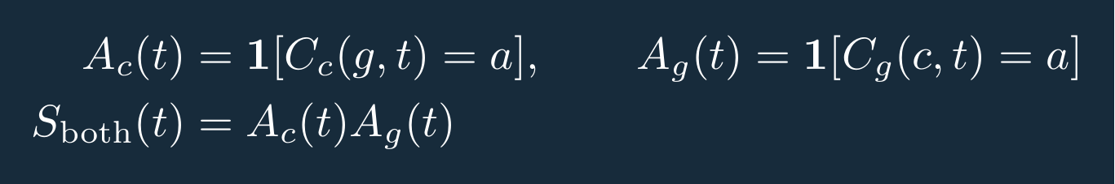
Equation 1 Conditions for accepted client and gateway mappings
These are conditions to verify, not measured Farm-Flow outcomes. Cache acceptance and subsequent traffic use establish different stages of success. Demonstrating interception additionally requires appropriately positioned evidence that the attacker received the redirected traffic; matching forwarded traffic supports forwarding. No recipient cache timeline or established forwarding result is supplied by this analysis.

Sources
[1] Supplied Farm-Flow ARP captures dated 23 August, 19 September and 8 October 2022; normal reference dated 10 September 2022. Packet-derived FarmFlow_ARP_Detector_Evaluation.xlsx, version 1, Results and Detector sheets.
[2] RFC 826 An Ethernet Address Resolution Protocol
[3] Cisco Dynamic ARP Inspection and IP Source Guard

Mathematical model for detecting conflicting replies
Evaluate each claimed IP i separately within the same network/VLAN and five-second window k. Let B(i) be its normal reference MAC, and let ℛᵢ,ₖ contain its ARP replies. For reply j, mⱼ is the advertised sender MAC. N counts all replies and U counts those that contradict B(i).
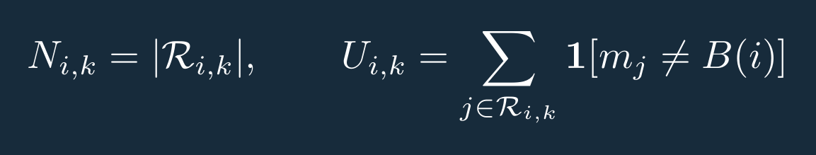
Equation 2 Counts of all replies and conflicting replies
Kᵢ equals one when a normal mapping exists. Compute U and q only for known mappings; otherwise report D as unscored. The fraction q and decision D are:
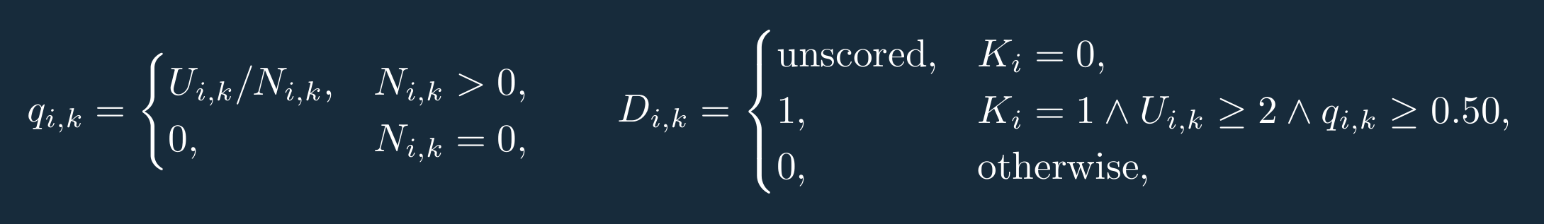
Equation 3 Conflicting reply fraction and default alert rule
The normal baseline uses the first half of the normal capture, requiring at least two sender claims and one observed MAC per IP. It is an observed reference, not an administrative authorization record. Unknown mappings are unscored, not clean. The thresholds are heuristics, not fitted probabilities. [1]
In one observed gateway window on 23 August 2022, both replies advertised the foreign MAC instead of the normal gateway MAC:
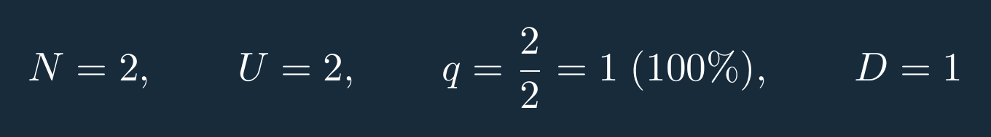
Equation 4 Observed August gateway example
The 100% value is a reply fraction, not confidence that poisoning succeeded. A single conflicting reply, slow claims spread across bins, or misleading ARP requests can escape this reply-focused rule. First and last bins may also be partial.

What to look for and how to combat it
Look for repeated claims that an established IP belongs to another MAC, especially a gateway IP. Correlate sender fields, recipients, timing, verified mappings and subsequent Ethernet destinations. Check legitimate DHCP reassignment, failover or replacement before attributing a change to an attacker.
Maintain approved IP–MAC bindings. Where supported, use Dynamic ARP Inspection to reject invalid ARP requests and replies before forwarding them. DHCP snooping can supply lease-based bindings; static devices require appropriate configured bindings or ARP access-control rules. Monitoring alone does not prevent the first misleading message from reaching a recipient. [3]
Conclusion: the supplied data supports repeated gateway-impersonation attempts directed at the client. It does not establish reverse poisoning, cache acceptance, interception, disruption or physical farm effects. The reported 99.8% recording-label agreement is not validated attack-detection accuracy; maliciousness confidence remains uncalibrated.

