- Data about revenue might be in the sql job ‘RevenuePerPmoHour’
- I can try to find more data about clients. We don’t have too much in our database, I can find something on the internet or use chatGPT
- I can also try to predict costs of providing our services
- Sometimes revenue is negative

Model 1
- Input features are:
- No_sales: how many times a given client bought our services
- Contact_no_days: the difference in days between the first and the last order
- Frequency: = no_sales / contact_no_days
- Revenue_total: total revenue for all time for a given client
- Rev1m, …, rev12m: rev1m is a revenue for last 30 days, rev2m is a revenue for a period between 30 days ago and 60 days ago, rev3m is a revenue for a period between 60 days ago and 90 days ago and so on.

- Model’s output:
- Revenue for next 3 months
- Revenue for the next month

- I was trying to use min max scaling for all the features.

- I was using neural networks

- We can cluster clients based on frequency and revenue separetely and use those clusters as another feature. Clients with higher revenue and frequency should be assigned to the cluster with higher number.

- We can combine frequency and revenue clusters to create another feature called overall score. For example if one client has frequency cluster = 1 and revenue cluster = 2 then overall score can be sum of those cluster = 2 + 1 = 3

- Instead of predicting the exact revenue for the last month we might cluster our clients based on revenue in the last month and try to predict to which cluster a given client belongs.

Model 2
- In this approach I am using two separate models:
  - One model is LSTM which takes as input daily / weekly sales for last few years
  - Another model is neural networks which takes as input clients features: no_sales, contact_no_days, frequency, clusters numbers
- Model’s output is a revenue for the next month

Model 3
- Useful website with an example of this approach: https://www.kaggle.com/code/shailaja4247/customer-lifetime-value-prediction/notebook

- At first we need to choose the threshold date and divide our dataset into a part where sales orders were made before and after that date. Those two datasets we will be calling the past and future datasets. We will be predicting a total revenue made after that date and calculating customers features based on that date.

- Some of the customers from our dataset were not active for a long time so after our choosen threshold date they didn't buy anything. We cant train and test our model on such a customers because we dont know their true revenue after the threshold date which we want to predict. In such a case we are moving in time all the sales orders for that customer such that the last order for that customer is the same as for the other customers.

- Calculate different features for customers (based on the past dataset):
  - Recency (the difference in days between last purchase date and the threshold date)
  - no_sales (number of sales orders)
  - contact_no_days (number of days for how long a client was buying from us)
  - frequency (= no_sales / contact_no_days)
  - monetary value (the total revenue)

- cluster customers based on above features.

For each feature we will be creating a separate cluster so we will cluster customers based on only recency to create the recency-cluster, then we cluster based on no_sales to create the no_sales-cluster and so on.

To each cluster we will assign a cluster number which have some meaning, for example customers with higher revenue will have higher revene-cluster number and customers with smaller recency will have higher recency-cluster number

- Calculate the overall scores using those clusters numbers. It can be for example a sum of all cluster numbers

- Model can predicting:
  - the overall score (classification)
  - We can cluster customers based on revenue in the next 3 months after the threshold date (so called future_3m_revenue) and predict a cluster number (classification)

- There is a problem with imbalanced dataset. We can remove some of the outliers and also we can create a few separate datasets.

If we have for example 2000 clients for the first future_3m_revenue cluster, 400 for the second one and 100 for the third one then we can create five datasets where each dataset contains 500 clients for the first future_3m_revenue cluster, 400 for the second one and 100 for the third one.

After creating a few separate datasets we can train one model on those datasets one by one or we can train multiple models each on a different dataset. If we train multiple models then in order to make final predictions on a new dataset we are making predictions using all the models and taking the average output.

Model 4
- We use the Autoformer to predict a sequence of numbers which represents revenue in the following months (the length of that sequence might be fixed but it doesn’t have to be. Model can also try to predict how long is that sequence, when does it stop)
- Repo with useful code: https://github.com/thuml/Autoformer/tree/main
- website with good model explanation: https://huggingface.co/blog/autoformer

Model 5
- https://www.kaggle.com/code/kemalgunay/cltv-customer-lifetime-value-method
- Use bg-nbd model to predict number of transactions in the future
- Use gamma gamma model to predict an average profit per transaction

Different options of model’s outputs:
- Predicted total value of sales orders for some time period (a single number)
- Predicted total value of sales orders for next n months: [y_1, …, y_n] where n is fixed
- Predicted total value of sales orders for next n months: [y_1, …, y_n] where n is gonna be predicted by a model. So model will not only predict a total value of sales orders for each month but also for how many months a given client will be generating a revenue.

Different options of model’s inputs:
- clients’ features like sector, number of employees, how many times they were buying from us
- Daily/weekly/monthly sales from the past for a given client (time series)
- Combination of both types of inputs mentioned above

Models which I will use:
- Autoformer. More information about how this model works can be found here: https://huggingface.co/blog/autoformer
- There some other options like LSTM RNN and ARIMA but for now I will focus on the Autoformer

Dataset which I will use:
Sales orders data from Empower and Helix. This is the table Stage.emp.tbl_SO in DNAPROD. For now the table which I am gonna use looks like this:
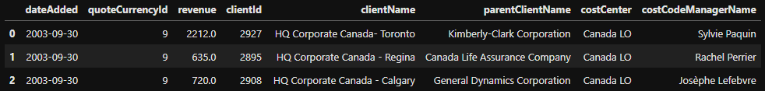

Based on this table I can create another one which can be also used as the input for a model:
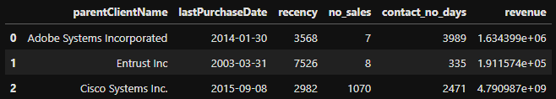

Meanings of columns:
- recency: a number of days passed since the last sale for a client
- no_sales: number of sales orders for a client
- contact_no_days: number of days for how long a client was buying from us

