2025
END-OF-YEAR FEEDBACK REPORT
MDS Simulation & Clinical Assessment Program

Prepared by: Sim & Clinic Online Program Assessment Team — A/Prof McNally, Suhrid Gupta, Kunal Patel
Survey period: 149 days • Total responses: 77 • Average completion: 31:48

77  Total responses |  | 69%  Felt training was adequate |  | 3.4  Average tool rating (/5)

Executive summary
In 2025 the MDS rolled out two online assessment platforms — Qualtrics for simulation, OSCE, viva and Mini-CEx assessments, and DASH for live clinic and pre-clinic supervision. This survey gathered end-of-year feedback from students, academic staff and clinical educators to evaluate both tools, the regular feedback reports they generate, and the wider communication around assessment.
Seventy-seven respondents participated: 38 students (49%), 20 clinical educators (26%) and 19 academic staff (25%). Coverage spans all year levels, with DDS2 (24), DDS1 (19) and DDS3 (19) the most heavily represented cohorts.

Headline findings
- Both platforms are rated above neutral but well below excellent. Qualtrics scores 3.49/5 (n = 67) and DASH 3.27/5 (n = 66). Distributions are similar in shape, but DASH attracts more low-end ratings (8 ones vs 4 for Qualtrics).
- Time burden is the single most repeated complaint across both tools — comments describe forms as "exceptionally long", taking time away from direct teaching, and producing fatigue after busy clinics.
- Binary (Yes/No) checklists are widely seen as inadequate for tertiary assessment. Students and educators independently call for a stepped scale (e.g. Incomplete / Borderline / Done well / Exemplary) to capture nuance and improve inter-rater reliability.
- 69% of respondents felt they received adequate training (52 yes, 23 no), but the qualitative evidence shows training was uneven — particularly for casual clinical educators and OHV staff stepping in on the day.
- Staff feedback reports rate lowest of all measures (mean 2.87/5). Coordinators describe data as hard to interpret, late, and not flagging students of concern in time.
- There is strong, specific demand for the 2026 clinical-educator and subject-coordinator dashboards: progress over time, item-code tallies, attendance, automatic flags for critical incidents and threshold breaches, and prior comments visible to all supervisors.
TOP PRIORITY FOR 2026
Replace binary Yes/No fields with a four-point stepped scale; ship coordinator and educator dashboards with automatic alerts; reduce form length to cut completion time without losing data quality.
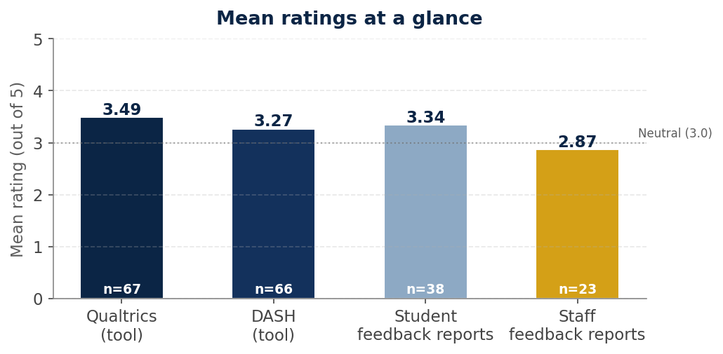
Figure 1. Mean ratings across the four core measures, with sample sizes.

1. Respondent profile
Of the 77 respondents, students made up the largest share at 49%, followed by clinical educators (26%) and academic staff (25%). One respondent identified as both an academic staff member and a clinical educator. The mix of voices is balanced enough to draw conclusions about both the user (student) and the assessor (educator) experience.
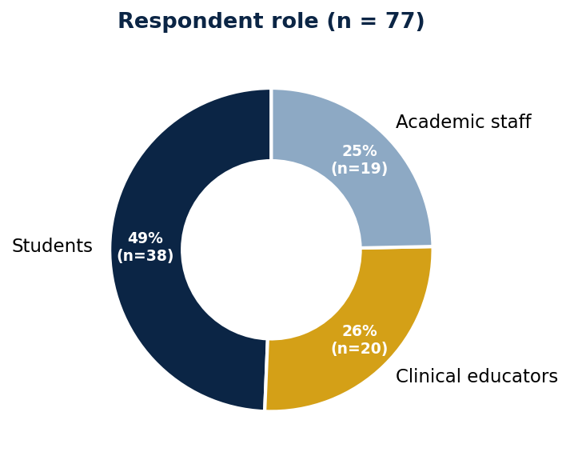
Figure 1.1 Respondent role.

Year levels covered
Year-level coverage is broad. DDS2 is best represented (24 responses), reflecting the cohort’s heavy use of both Qualtrics and DASH across simulation and clinic. DDS4 had only 12 respondents but their feedback is particularly valuable as they have used both legacy and current systems.
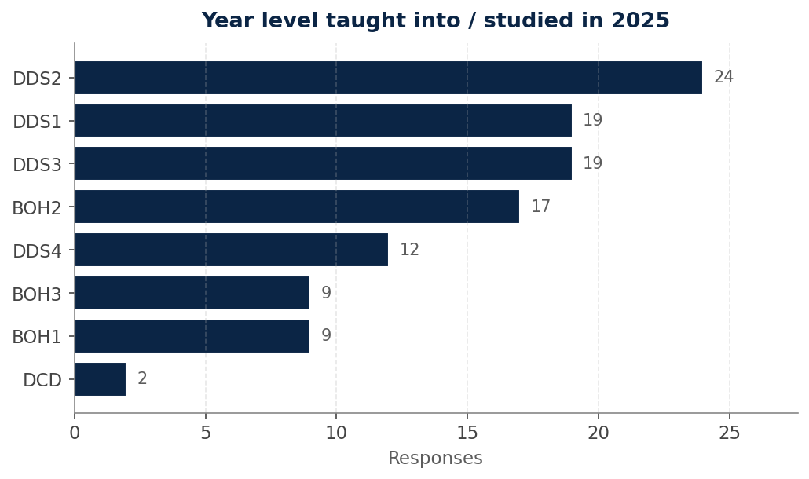
Figure 1.2 Year levels respondents studied or taught into in 2025 (multi-select).

Where the forms were used
Respondents most often encountered the online forms in clinic (53) and pre-clinical simulation (49). OSCE assessments (31) and standardised viva / case-based assessments (25) were the next most common. Mini-CEx use was lower (15), and one "Audit" response indicates the DDS3 clinical audit form.
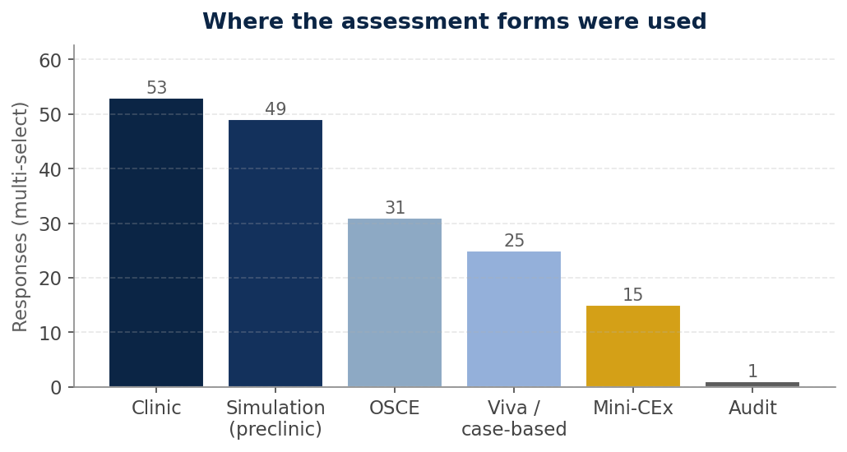
Figure 1.3 Settings in which respondents used the online assessment forms (multi-select).

2. Qualtrics — the assessment tool
Qualtrics was used for OSCEs, vivas, case-based assessments, Mini-CEx, the DDS3 clinical audit, and a portion of pre-clinical simulation work. The mean rating of 3.49 (n = 67) is the highest of any tool measured in the survey. The distribution skews positive — 39 of 67 respondents (58%) rated it 4 or 5 — but a meaningful minority (13 respondents, 19%) rated it 1 or 2.
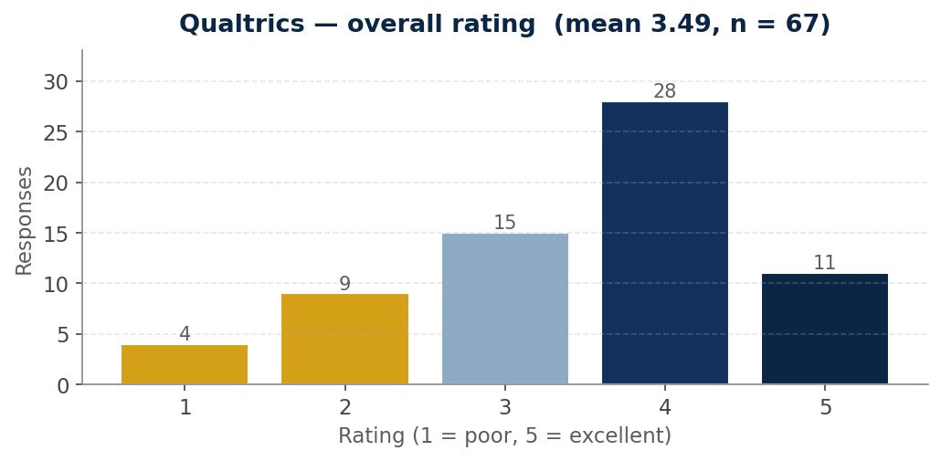
Figure 2.1 Qualtrics overall rating.

What worked
- Familiar, well-supported, off-the-shelf platform — staff can troubleshoot independently and "search for any issue and find reliable solutions".
- Multi-user real-time access reduces single-point-of-failure risk.
- Strong for short-form assessments: vivas, OSCEs and the DDS3 clinical audit form were specifically praised as "amazing" and "quick and helpful".
- Critical-incident flags trigger automatic notifications, supporting earlier remediation.
- Easy data export for analysis once familiar with the setup.

What didn’t
- Yes/No options dominate the rubric and don’t differentiate students "going above and beyond" from those meeting the minimum.
- In the clinical setting the forms are perceived as time-consuming — supervisors describe shortening treatment time to fit completion in.
- Cannot be filled in concurrently with the student — supervisors must wait until the student submits, adding administrative time at the end of session.
- Students and afternoon students are mixed in the same dashboard list, making it inefficient to find the relevant cohort.
- No autosave — accidental window closes have caused lost responses.
- Cross-discipline mismatches — a student doing general dentistry in a perio clinic must be assessed on a perio form.

Representative comments
“Qualtrics is highly user-friendly and straightforward to set up, with extensive built-in support that makes it accessible for many staff across the School ... a stable, robust, and well-supported option overall.”
— Academic staff

“For the clinical setting, it is time consuming. For the viva and OSCE, it is quick and helpful. I personally prefer to have more options than yes and no. The result should reflect the depth of knowledge of the student.”
— Clinical educator

“There are too many boxes to tick. Can be irrelevant sometimes to the task at hand. The items to be ticked take too much time away from practical teaching.”
— Clinical educator
INSIGHT
Qualtrics performs strongly where assessments are short and structured (OSCE, viva, audit). The dissatisfaction concentrates in the clinic, where binary scales and lack of concurrent access push completion outside session time.

3. DASH — the clinic assessment tool
DASH is the bespoke platform used in pre-clinical simulation and live clinic supervision. With a mean of 3.27/5 (n = 66) it sits below Qualtrics, and the gap is concentrated at the extremes — DASH has 8 ratings of 1 (vs 4 for Qualtrics) and 14 ratings of 1 or 2 in absolute terms (27% of respondents). It also has many champions: 34 respondents (51%) rated it 4 or 5.
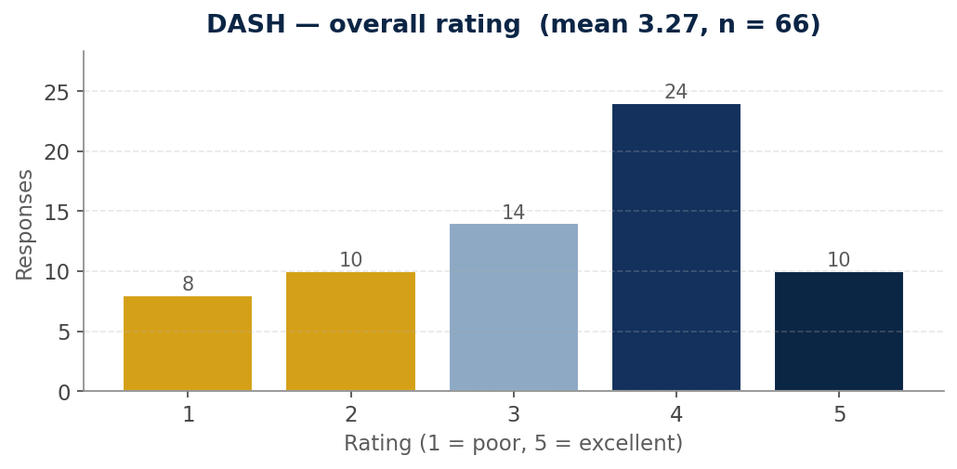
Figure 3.1 DASH overall rating.

Side-by-side: Qualtrics vs DASH
The two platforms have similar profiles, but DASH carries more low-end weight. Read together, the data suggests respondents distinguish between the two tools but see common problems — particularly around binary scoring, time burden and report quality — that aren’t fundamentally about which platform is being used.
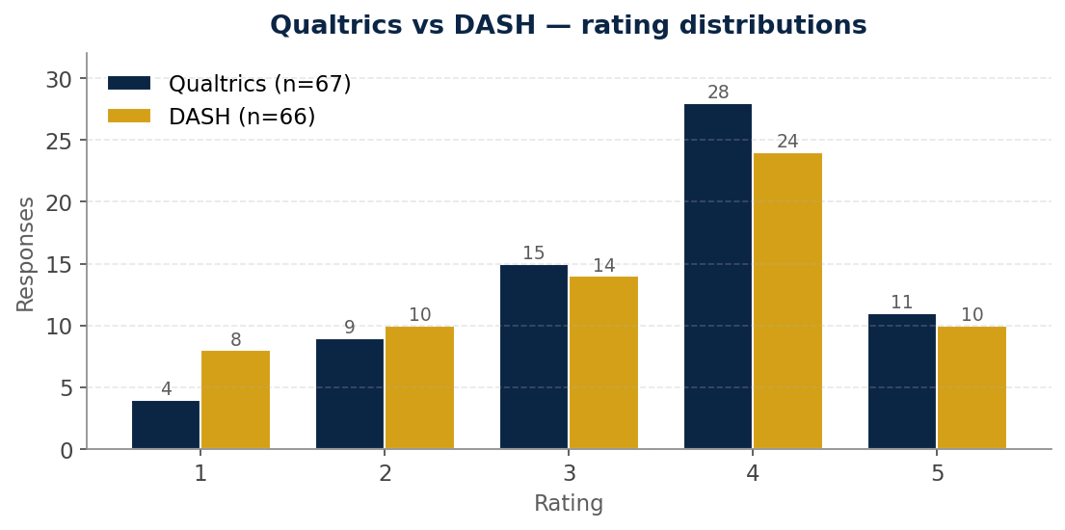
Figure 3.2 Rating distributions, Qualtrics vs DASH.

What worked
- Concurrent assessment — supervisors can mark as the student works rather than waiting until the end of session, freeing up clinic time.
- Single-page question layout introduced mid-2025 was specifically called out as an improvement.
- Multiple item codes can be added dynamically to a single form.
- Editable post-submission grades reduce errors on assessment days.
- "Wonderfully successful" at giving students a longitudinal view of progression — when used well.

What didn’t
- Binary Yes/No is the dominant complaint — repeated independently in 12+ comments. It fails to capture the "grey area" most students sit in.
- Forms are long and slow, particularly with LA, multiple canals in endo, or split-session procedures requiring multiple form openings.
- Setup friction for casual / OHV / cross-cohort staff — accounts cannot be created on the day, so supervisors have used other teachers’ names to log assessments.
- Reflections that students cannot reopen after submission — incomplete reflections become the educator’s problem.
- Supervisor dashboard is "messy" — completed and incomplete forms now appear together; the previous separation was preferred.
- Default date is wrong (1–5 days in the past), causing repeated invalid-date corrections.
- iPads — login problems, charging, and unreliable internet in the DTC eat session time.
- Bespoke-system risk — comments raise concern about over-dependence on one or two people maintaining the system.

Representative comments
“Overall DASH has been a wonderfully successful platform that has dramatically changed the way that students and educators can track overall performance and progress. Now that staff have a better understanding of the platform we can better educate students about its use.”
— Academic staff

“Hard to give useful feedback as spending all the time trying to fill in forms that don’t mean much to students bc most students are in the grey area between.”
— Clinical educator

“Didn’t get a proper gauge on how I was progressing throughout the year ... kind of just felt like a check box. Part of this was also due to staff being inadequately trained on how to use it and what each number/comment means.”
— Student

“A bespoke system that only one or two people know how to use ... creates a real point of vulnerability. If the key person who manages it is away, sick, or leaves the organisation, the entire process can stall.”
— Academic staff
INSIGHT
DASH’s lower rating reflects two distinct issues: a design issue (binary scales and form length) that the team can fix, and a robustness issue (single-person dependency, account setup) that needs operational backup. Both feed into each other in the comments.

4. Training and communication
When asked whether they received adequate training to use Qualtrics or DASH, 69% of respondents (52 of 75) said yes. The 31% who said no represent a substantial training gap, and the qualitative responses make clear it is concentrated among casual clinical educators, OHV staff stepping in on the day, and demonstrators in the early part of the year.
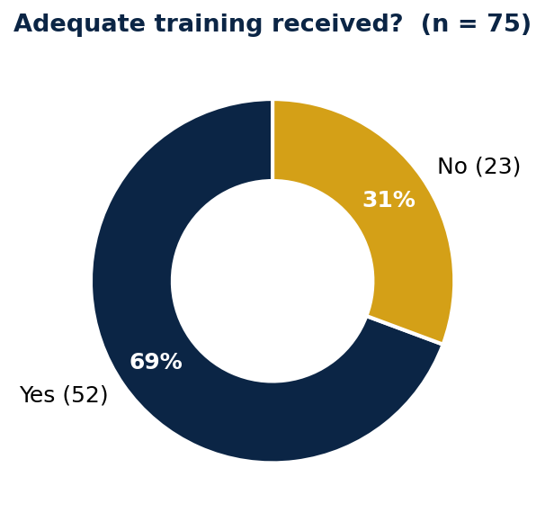
Figure 4.1 Did you receive adequate training?

What respondents want from communication
- Calibration sessions for educators with consistent language across courses — particularly around terminology like "critical incident", "entrustment", and "readiness for practice".
- Earlier announcements of exam and assessment dates — a recurring complaint that 2025 dates were released too close to the assessments.
- Faster results turnaround. The OSCE-results delay was specifically called out as "downright disrespectful".
- Email channels for major changes rather than Canvas-only, where information can be missed.
- Clearer documentation of how form data feeds into grades — many students reported not understanding how independent vs direct vs indirect supervision affected outcomes.
- A safe channel for raising concerns. One respondent describes feeling "reprimanded" for asking, which discourages further input.
“Listen to the feedback you are receiving, don’t ignore us. We haven’t ever seen an evaluation of the assessment tool and now we believe we are changing to another. Can we just find one tool that works, or amend the tool based on the feedback we provide instead of changing tools each year.”
— Student

5. Student feedback reports
Thirty-eight students rated the regular feedback reports they received with a mean of 3.34/5. The distribution is bimodal — 20 ratings of 4 (the most common response) but also 6 ratings of 1, suggesting strong views in both directions rather than middle-ground dissatisfaction.
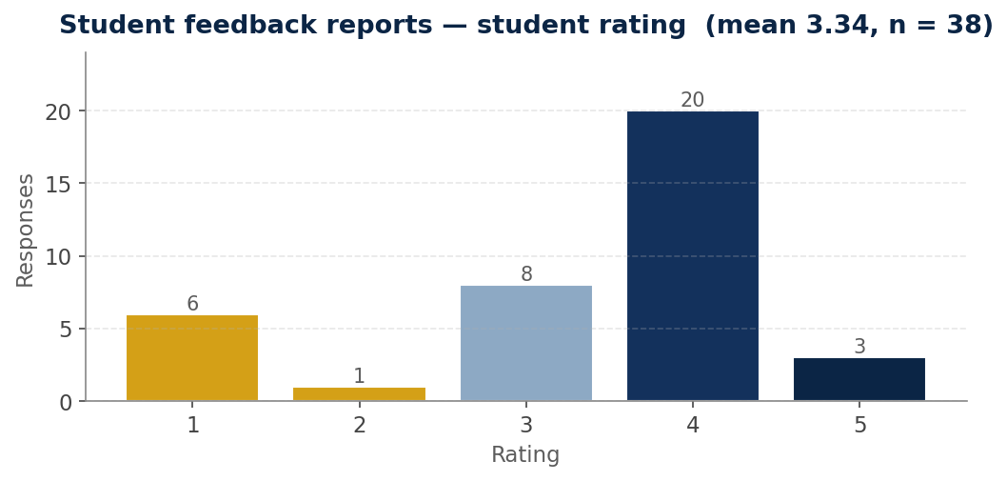
Figure 5.1 Student rating of feedback reports received.

What students want changed
- More detail in supervisor comments — "without actual comments it’s hard to add value to the DASH form/scores".
- Individual reports rather than whole-class summaries.
- Feedback for exams — the ability to see where they went wrong on the OSCE or other formal assessments, not just receive a grade.
- Layout that renders cleanly in mail apps; clearer separation of student self-assessment from supervisor assessment.
- When a "no" is recorded, an explanation of why.
- Reports timed during semester rather than two of three arriving after term ended.
“I don’t think I read a single one of them. The feedback reports varied so wildly from what the demonstrators either told us in person or between demonstrators that it was entirely pointless.”
— Student

“They were thorough and helpful.”
— Student

6. Staff feedback reports
Among the 23 staff respondents who answered, the mean rating is 2.87/5 — the lowest of any measure in the survey, and the only one below neutral. The distribution is U-shaped, with 7 staff rating 1 and 5 rating 5. Coordinators who valued the reports valued them highly; those who didn’t found them substantially unhelpful.
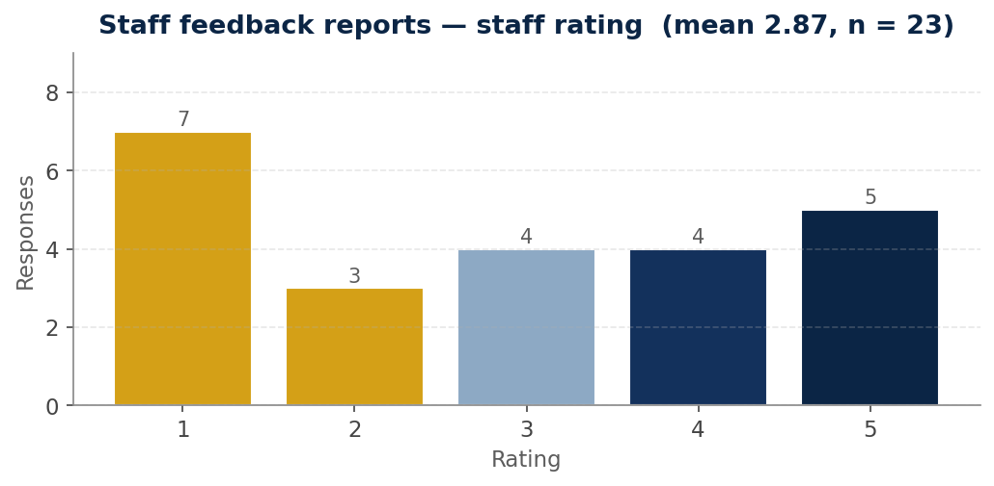
Figure 6.1 Staff rating of feedback reports received.

What staff want changed
- Reports delivered on a regular cadence without coordinators having to chase data.
- Clean data — duplicates and entry errors filtered before reports go out.
- A red threshold line on progress charts so students below standard are immediately visible.
- Critical-incident notifications throughout the semester, not just at end of semester. This is described as "a big risk" in current form.
- Transparent measurement criteria so coordinators can defend struggling-student decisions.
“The reports were difficult to interpret and were not transparent to how students who were struggling were measured.”
— Subject coordinator

“Regular reports without having to ask and chase data. Cleaned data. Making sure all notifications of critical incidents get sent and not just at the end of the semester, this is a big risk.”
— Subject coordinator

7. Clinical educator dashboard — 2026 wishlist
Clinical educators did not receive reports in 2025. Twenty-five respondents told us what they want from the 2026 dashboard. Their requests are detailed and consistent.

Most-requested elements
- Per-student profile — strengths, weaknesses, item codes attempted, infection-control issues, critical incidents, prior supervisor comments visible across clinics.
- Progress over time as a graph, with key skills (charting, perio charting, RD, LA, restorative, plaque/calc removal, debridement) tracked individually.
- Attendance — total sessions and date-by-date submission record, to make poor attendance and missing forms visible at a glance.
- Procedure tally — number of forms, item codes completed, operator vs FTA sessions.
- Areas needing supervision — so educators can plan appointments accordingly.
- Whether students have acted on previous feedback.
- Easy-to-discuss visualisations suitable for one-on-one mentoring conversations.
“Previous comments made by myself and other supervisors so that I am aware of the individual student’s strengths and weaknesses across all clinics. This would help guide my teaching to better support the student when they are under my care.”
— Clinical educator

8. Subject coordinator dashboard — 2026 wishlist
Subject coordinators received reports through varied channels in 2025. Their feedback is unanimous on one point: they need to flag students of concern faster and with less manual effort.

Most-requested elements
- Sortable spreadsheet output (attendance, item codes, grades) so coordinators can quickly find students falling behind.
- Analysis split by clinic specialty and combined.
- Item-number tally per student to gauge clinical breadth and depth.
- Sessions attended as operator vs FTA, with specialty breakdown.
- Number of unique patients seen per student.
- Grade / global rating per session and progression curve over time.
- Cohort comparison — student performance relative to cohort average / max / min.
- Automatic email notifications for students of concern; flags for incomplete forms; flags for poor performance against threshold.
- Contemporaneous, up-to-date data — particularly during remediation meetings.
DESIGN IMPLICATION
The clinical-educator and subject-coordinator dashboards have substantial overlap — both want progress over time, item-code tallies, and prior-comment visibility. A single underlying data layer with role-specific views would meet both needs and reduce build cost.

9. What’s working well
Across 38 responses on positive aspects, several themes appear repeatedly:
- Single source of truth — students and educators value having all assessments in one place, accessible at any time.
- Reflective practice is enforced — students are required to reflect on their own performance every session.
- Educators can complete forms during the session rather than after-hours.
- Longitudinal view — students can look back at progress and identify improvement areas over time.
- Standardised assessment language across pre-clinical educators.
- Strong improvement on the previous Pebble Pad system — described as "much better" and "more efficient".
- Eco-friendly — no paper-based forms.
- Critical-incident flagging supports earlier remediation, particularly with Qualtrics automations.
“It was nice to have everything in one place to be able to compare and search up results. Also I did like the concept of it initially — the focus being more on progression rather than specific formal exams where one mistake could be fatal.”
— Student

10. Challenges and pain points
Across 39 responses, the same problems recur. Listed roughly in order of frequency:
- Time burden — forms are too long, take too much time away from clinical teaching, and produce questionnaire fatigue.
- Binary scoring causes inter-rater reliability issues and fails to differentiate student performance levels.
- Hardware reliability — iPads with charging issues, internet dropouts, devices that won’t log in.
- Form architecture — preparing one tooth across multiple sessions, or assessing endo with up to 4 canals when only 2 are supported, requires multiple form openings and creates duplicate entries.
- Supervisor dashboard navigation — completed and incomplete forms not separated, students not in cohort order.
- Educator inconsistency — some demonstrators don’t fill in their half, leaving students with incomplete records.
- Checklist coverage — some procedures (e.g. tooth preparation) lack assessment items for individual steps.
- Items used as "not assessed" without clarity on whether something wasn’t done, wasn’t looked at, or wasn’t relevant.
- Casual staff cannot create accounts on the day; budget constraints discouraging educators from logging out-of-session completion time.

11. Additional requests not yet incorporated
Twenty-two respondents added ideas they felt hadn’t been captured elsewhere. The most distinctive are:
- Stepped scale across all checklist fields (Incomplete / Borderline / Done well / Exemplary) replacing Yes/No.
- Photo upload in student reflections for visual evidence of work.
- Sim-seat numbers shown on the dashboard.
- PBN section integrated into the DASH form so educators don’t need to fill out a second form.
- Form grouping by month, with item code visible before opening — to make navigation of past forms quicker.
- Mandatory short-comment box per code, ensuring at least a sentence of feedback per area.
- Voice transcription of feedback to save educator time and improve detail.
- Numerical weighting on checkbox items so students know which are critical and which are minor.
- Automated alerts when a student is marked at the lowest standard three times for infection control, professionalism, communication or entrustment.

12. Recommendations for 2026
Drawing the threads together, the survey points to seven priority actions for the coming year. They are listed in order of how directly the survey data supports them.

1. Replace binary scoring with a stepped scale
The single most-repeated request, raised independently by students, clinical educators and academic staff. A four-point scale (Incomplete / Borderline / Done well / Exemplary) preserves checklist speed while restoring nuance, and addresses the "grey area" problem that currently drives inconsistent marking.

2. Ship the educator and coordinator dashboards with automatic alerts
Both groups described detailed, overlapping requirements. Build a shared data layer with role-specific views; include automatic notifications for critical incidents, threshold breaches, and incomplete-form patterns rather than waiting for end-of-semester reports.

3. Reduce form length without reducing data quality
Curate item lists by procedure type. Add conditional logic so irrelevant items don’t appear (e.g. only show pulpotomy fields if a pulpotomy was performed). Audit the Paeds CAF and similar forms for items that are systematically left untouched.

4. Run a calibration program for clinical educators
Standardise the language of "critical incident", "entrustment", "readiness for practice" and similar terms. Provide concrete examples for each rating level. This is the lowest-cost, highest-leverage way to address inter-rater reliability complaints.

5. Address the bespoke-system risk for DASH
Document processes, train at least one backup administrator, and ensure data can be exported and reconstructed without depending on individual expertise. This was raised as a serious vulnerability.

6. Tighten the operational basics
Default the date to today on DASH forms. Separate completed and incomplete forms in the supervisor view. Add temporary-supervisor accounts for OHV and casual staff stepping in. Investigate iPad charging and Wi-Fi reliability in the DTC.

7. Improve student feedback visibility
Provide a per-student progress view that students themselves can see, with a clear pass-mark line. Add exam feedback (OSCE, viva) so students can see where they lost marks. Where a "no" is recorded, prompt the educator for a one-line reason.

CLOSING NOTE
Seventy-seven respondents took 31:48 on average to complete this survey. The level of detail in their answers is unusually high. The single clearest message is that respondents — students and staff alike — want the team to keep iterating on these tools rather than replace them, but iterate quickly enough that they see the changes they’ve asked for in 2026.

