ASSIGNMENT-4

1291822

1.

a) After stepwise selection we get the following parameters.



b) Ordinal model gives few different parameters:

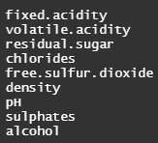

The ordinal model has “alcohol” as a parameter while the multinomial model does not.

The ordinal model does not have “citric.acid” as a parameter while multinomial model has.

Multinomial model has Residual Deviance: 5394.309, while ordinal model has Residual Deviance: 5533.829.

c)For multinomial model, P(bad wine) = 0.438.

For ordinal model, P(bad wine) = 0.446.

d) Odds ratio = exp[-567.89-3\*0.28022-otherterms]/ exp[-567.89-5\*0.28022-otherterms] ````=1.7514.

2.

b) The theoretical values fit the produced sample nicely.

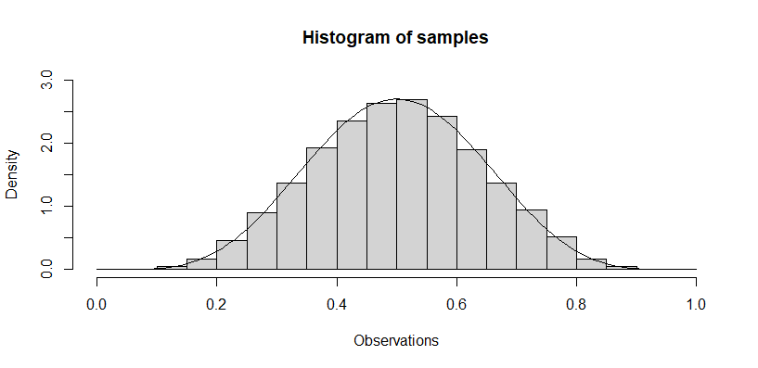

3.

a)

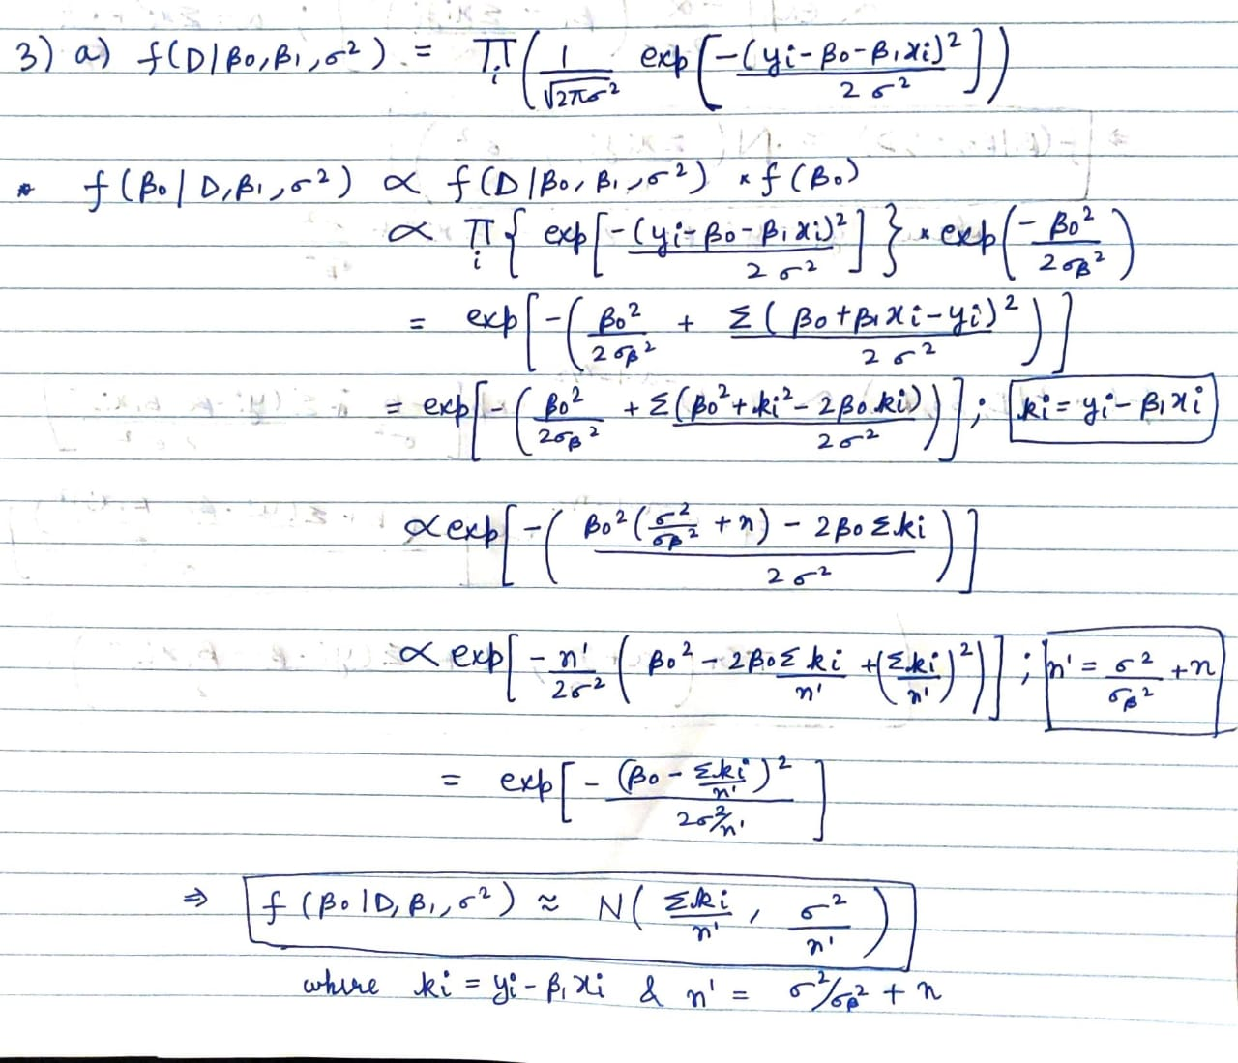

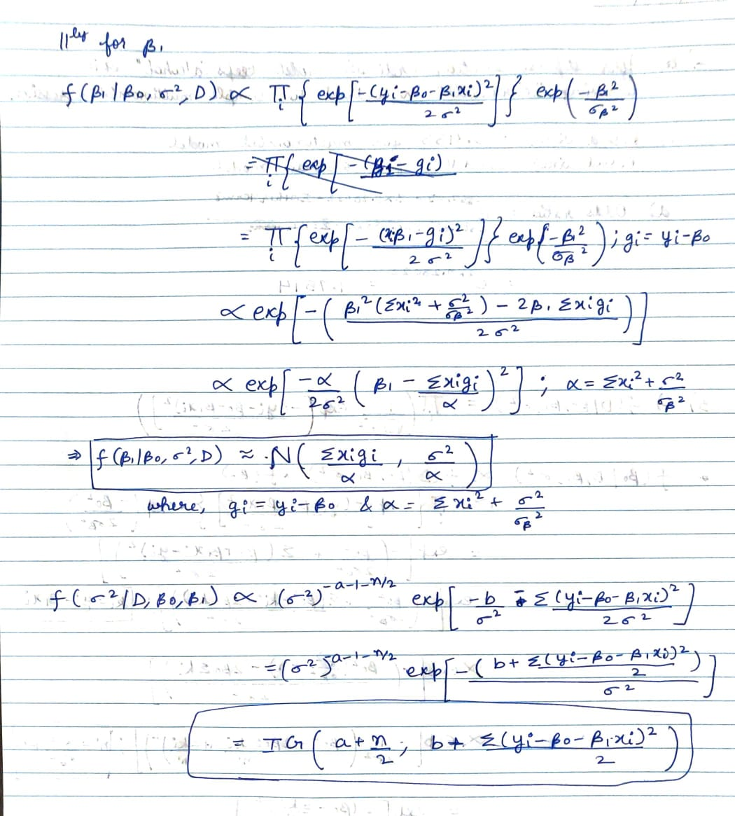

b) Posterior median:

β0=0.9065

β1=0.6672

σ2=0.4183

