|  |
| --- |
|  |
| RunTime T-Errors  Documentation: Bulky |
| |  |  |  | | --- | --- | --- | | Hlonipho Nersely | 11/7/22 | Development Software 2B | |

**GROUP NAMES**

|  |  |  |  |
| --- | --- | --- | --- |
|  | **NAMES** | **SURNAMES** | **STUDENT NO** |
|  | Hlonipho Nersley | Bila | 220080694 |
|  | Mogomotsi Thato | Gadipedi | 221028477 |
|  | Ndzulamo Michelle | Yingwani | 220122253 |
|  | Axole | Maranjana | 220023913 |
|  | Ofetse Bethuel | Makgopa | 221066447 |
|  | Junior | Maruping | 221023858 |

**Roles**

**HN BILA**

* Doing Documentation where she is giving the clarification of an app, which may help the end users to understand what and how the App Is working and how it hast been structured and been done. Also doing the code of the CartItemscreen making it work for the customers who may be buying the products, when a customer chooses the item, then it will be added to the cart items, so later may be processed.

**NM YINGWANI**

* Create a profile page that consists of user’s personal information, contact details and the balance in their wallet. The users use the money the is in the balance section to purchase what they want to buy. There will also be saved login info, data and log out option.

**T GADIPEDI**

**A MARANJANA**

**BO MAKGOPA**

**J MARUPING**

**PROBLEM**

Food Prices Increases and student allowances do not change to cover up the increase in food prices. This result in:

* Lacking their needs

Supporting articles

* <https://tradingeconomics.com/south-africa/food-inflation>

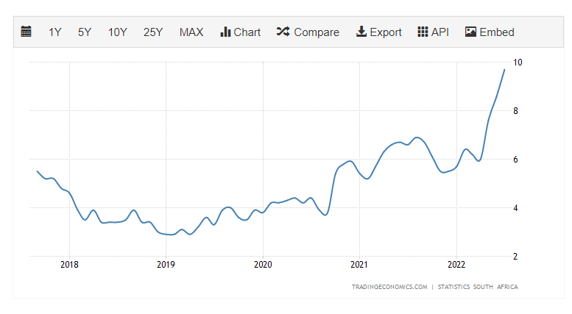

Food inflation in the last 5 years.

* <https://businesstech.co.za/news/lifestyle/523844/how-food-prices-have-changed-in-south-africa-over-the-last-5-years/>
* <https://www.statista.com/statistics/370516/unemployment-rate-in-south-africa/>

**Solution**

To create an app as a platform for varsity students to buy groceries in groups, the groceries will be bought from the wholesalers with lower prices, then distributed amongst the students. The App will allow students to register their account with their basic information, have a wallet where they can load their balances then select food items and toiletries they want to the total of their balance. Then once a month the food items will be bought from wholesalers with lowest prices then deliver to the respective students to the respective residences.

The solution will solve:

The impacts will be:

**SYSTEM ARCHITECTURE**

**USE CASE DIAGRAM**

APPLICATION USE CASE DIAGRAM

History

CART

SEARCH

WELCOME

LOGIN/REGISTER

BALANCE

REGISTER

SHOPPING BAG

DAIRY PRODUCT

DATE/TIME

RESET PASSWORD/SAVE

PHONE NUMBER

EGGS/CARBS

DAIRY/DRINKS

YOGHURT

MILK/CHOCOLATE

CHECK OUT

PRODUCTS PRICES

DATE/TYPE/AMOUNT

BALANCE

WALLET

CATEGORY

ORDER ID

SELECT/ADD

FILL UP

CANCEL

SEARCH BY CATEGORY

ACCOUNT

PROFILE

SEARCH HISTORY

DISCOUNT

LOGIN

NAMES

PROFILE

**UML DIAGRAM**

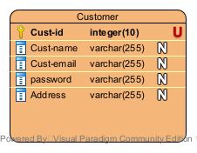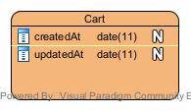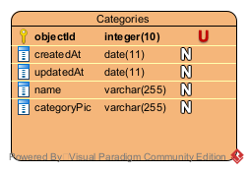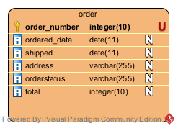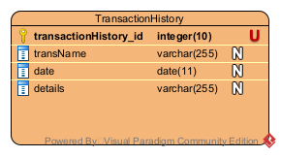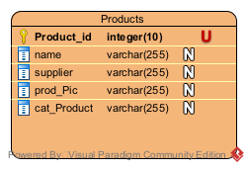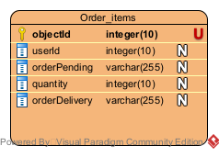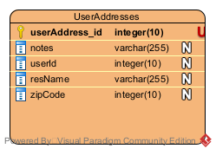

**SCREEN MOCKUPS & LAYOUTS**

Network

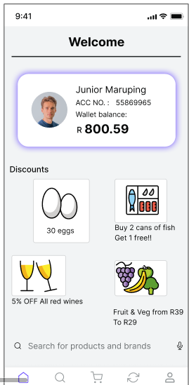

**APIs**

**REFERENCES**

1. To where
2. Exactly?