**Getting started with** **Move Access Hub**

How to make calls?

Method: POST

Host: api.olxhub.app

Path: /move

Authorization:

HeaderKey: ApiKey

HeaderValue: {{Your API Key}}

Payload:

{{Your GraphQL Query}}

**Postman-Move setup**

1. Launch PostmanA screenshot of a computer

   Description automatically generated
2. Import the MoveHttpCollection FolderA screenshot of a computer

   Description automatically generated
3. Import the collection and environment A screenshot of a computer

   Description automatically generated
4. Create a new GraphQL RequestA screenshot of a computer

   Description automatically generated
5. Set the url as https://{{AccessHubDomain}}/moveA screenshot of a computer

   Description automatically generated
6. Set the authorization to ApiKey with the Key: ApiKey and Value: {{ApiKey}}A screenshot of a computer

   Description automatically generated
7. Set the Environment to MoveEnvironmentA screenshot of a computer

   Description automatically generated
8. Import the SchemaA screenshot of a computer

   Description automatically generated
9. Save the requestA screenshot of a computer

   Description automatically generated
10. Set the request name and create a collectionA screenshot of a computer

    Description automatically generated

**Postman-How to generate Queries.**

1. Use the Query selector to specify the arguments and the fields for the response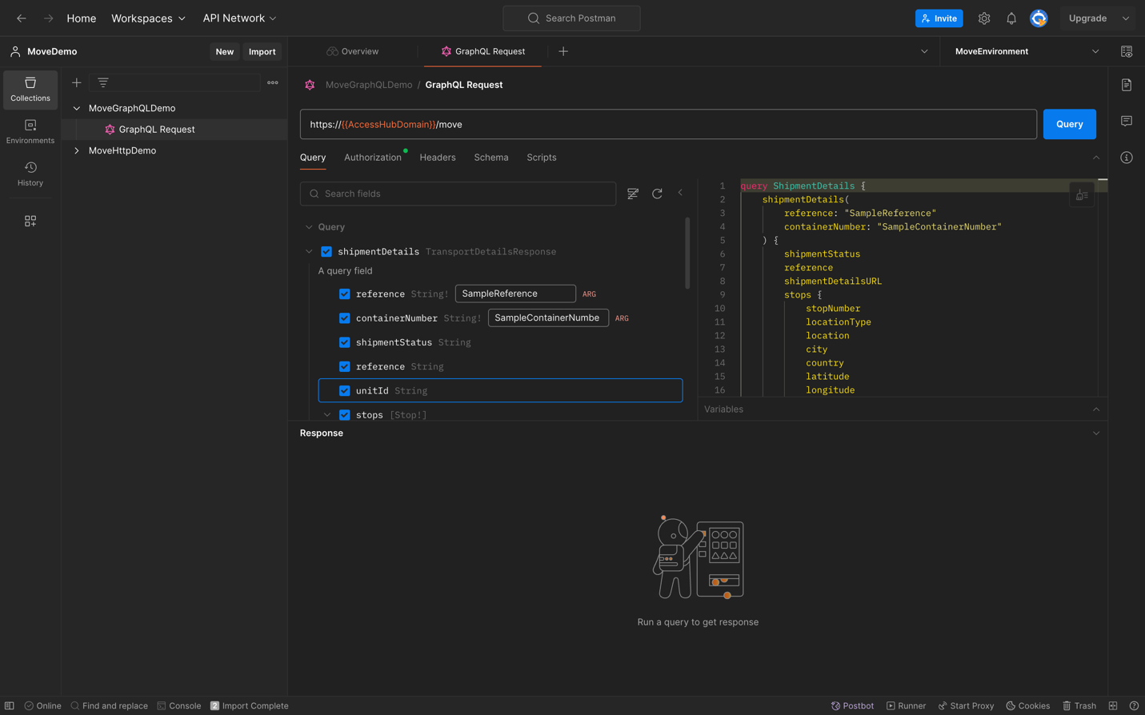
2. Test the Query by selecting QueryA screenshot of a computer

   Description automatically generated

**How to generate Code Snippets**

3) Click on code snippets

1. Select languageA screenshot of a computer

   Description automatically generated

**Connect Via Browser**

1. Navigate to [https://tf-dev-accesshub.azurewebsites.net/move/A screenshot of a computer

   Description automatically generated](https://tf-dev-accesshub.azurewebsites.net/move/)
2. Create DocumentA screenshot of a computer

   Description automatically generated
3. Open Settings, Set the ApiKey Header, and ApplyA screenshot of a computer

   Description automatically generated
4. Reload the schema A screenshot of a computer

   Description automatically generated
5. Enter your query and RunA screenshot of a computer

   Description automatically generated

Note: Sample Queries Attached